Report on the TIDAL Network Plus Feasibility Project: Bespoke entry-level wheelchair rugby chairs through Advanced Distributed Manufacturing

Authors
Dr Timothy Whitehead
RAs: William Utting, Rebecca Leatherland & Wan Fung Yeung

Acknowledgements
This project was funded by the Engineering and Physical Sciences Research Council [grant number: EP/W00717/1 ] through TIDAL Network Plus - Transformative Innovation in the Delivery of Assisted Living Products and Services.

What we set out to discover

Background and research context

Prior research carried out in South Africa, with project partners Real Steel Wheelchairs, identified a distinct lack of resources for children’s disability sports, especially wheelchair rugby. We chose rugby as this is the largest disability sport in South Africa, with World Wheelchair Rugby association operating in 15 countries (WWR, 2023). One of the main barriers to uptake is the cost of the specific chairs, which range between £2455 for a very basic chair up to £20,000 for a custom, lightweight design. In South Africa, these costs are further increased due to import costs and shipping which typically add 15-20% on to the purchase price (South Africa Trade Data, 2023). It was also identified that current designs look and sound intimidating to young children who wish to give wheelchair rugby a go (British Council project findings under review in Design Studies). Consequently, the team developed a new child’s wheelchair rugby chair which has a softer, more inviting appearance than traditional chairs.

The initial chair was designed to be rotational moulded and accommodate a range of children from 8-11years. The target was the junior division of the wheelchair rugby competitions which is open to all under the age of 12 (https://gbwr.org.uk/junior/).

However, during the prior British Council project it was suggested that the chair could be 3D printed to enable customisation and localised manufacture, which was a barrier to the original design. There was also the opportunity to reduce to support the circular economy, by re-printing the frame, if it was damaged.
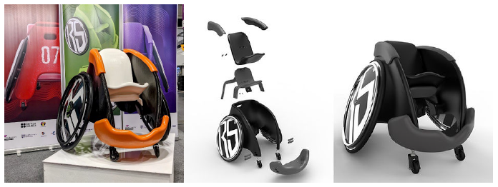

Engineering / research challenge and why it matters

This continuation project sought to develop a low-cost, customised wheelchair rugby chair made from recycled plastic waste. The project explored the potential for advanced, distributed manufacturing in the design and enable bespoke (size, shape and custom fit for a user), wheelchair chairs to be manufactured in situ, avoiding import costs. An initial design was developed to (TRL2). This proposal took the concept through prototyping and testing (TRL3) to validate if it is possible to create effective bespoke wheelchair rugby chairs that can be locally manufactured in South Africa.

The central challenge in this project was to develop an optimised design, which reduced material usage and weight, while still maintain the impact resistance outlined in the offensive wheelchair rugby standards (https://worldwheelchair.rugby/equipment/) It was important to understand material properties, impact resistance and customisation opportunities.

This is important because the wheelchair is a case study of the application of distributed manufacture and the impact this can have on the global distribution and manufacture of disability products. If this approach is successful then customised, locally manufactured wheelchairs can be produced in low-income settings, avoid the time, cost and emissions from international supply chains.

Aims and objectives for the project

Aim: To establish the topology optimisation needed to manufacture children’s wheelchair rugby chair through 3D Printing, to enable distributed manufacturing.

Objectives:

1. Understand the needs and desires of wheelchair rugby users to ensure a user centred design approach is followed.

2. Establish the impact requirements for wheelchair rugby chairs and develop a test methodology

3. Develop five internal topology structures for the wheelchair design

4. 3D Print and impact test each of the structures, enabling understanding of strength and suitability of each design.

5. Disseminate findings though existing networks, website and video.

What we did

Desk based literature study into the requirements and regulations for rugby wheelchair design and impact resistance, the output was a method to follow for the tests and topology optimisation. There was a lack of clear data on impact requirements for specific chairs, so we developed a standard methodological approach for our tests, and that the chair design would withstand an impact at a max acceleration of 5.82 m/s^2, velocity (4.7m/s) with impulse formula (E=1/2mv^2) for the average person weight of 65.35kg (this includes amputees and mixed sexes etc.) Although this is higher than children’s chairs we decided to work to adult data and then scale back as required.

Once the methodology was established, we carried out several simulations using a verity of designs and materials. The first set of simulations were based on the use of plastics (ABS, and PLA) this was based on an FDM printer, which is the most prevalent 3D printing process in Low Income Settings and least expensive. During these simulations we explored different loads, placed in different positions to understand the effect of different impacts. We investigated the design constraints, such as axle location connection and structural integrity.

Below are a selection of the tests we ran, with images of the joint at axle points that were found to be a weak area.
Structural Compliance Response | Load Case Location | Force Load | Force Vector  (X,Y,Z) | Fixing Location
1 | 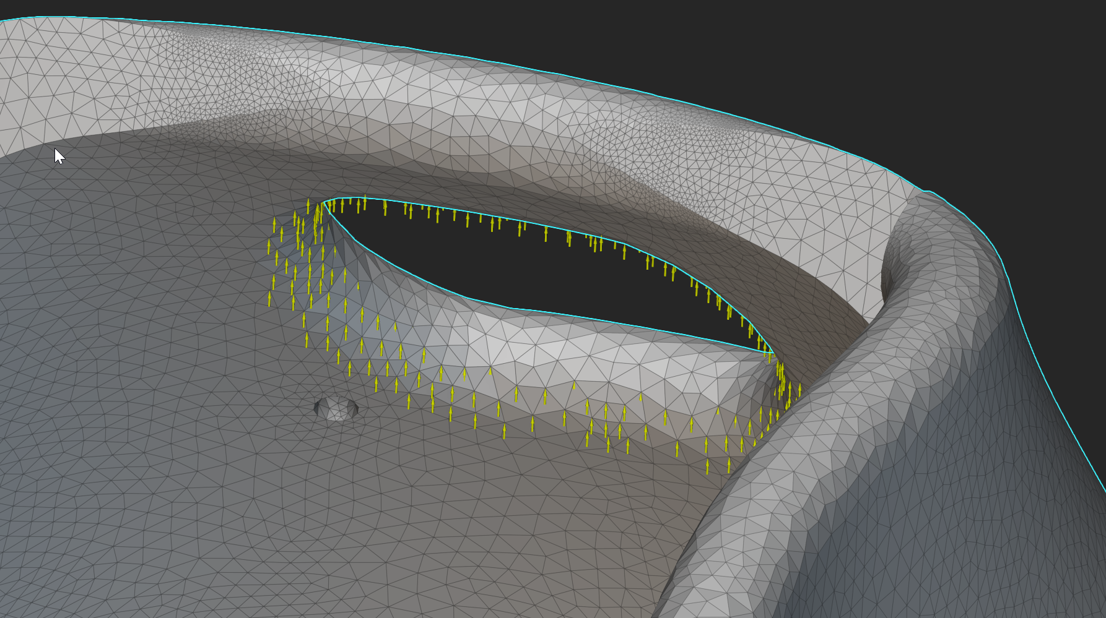 | 200 N | 0,1,0 | 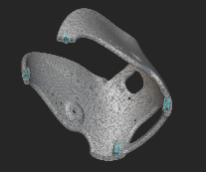
2 | 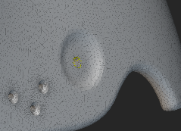 | 800 N | -1,0,0
3 | 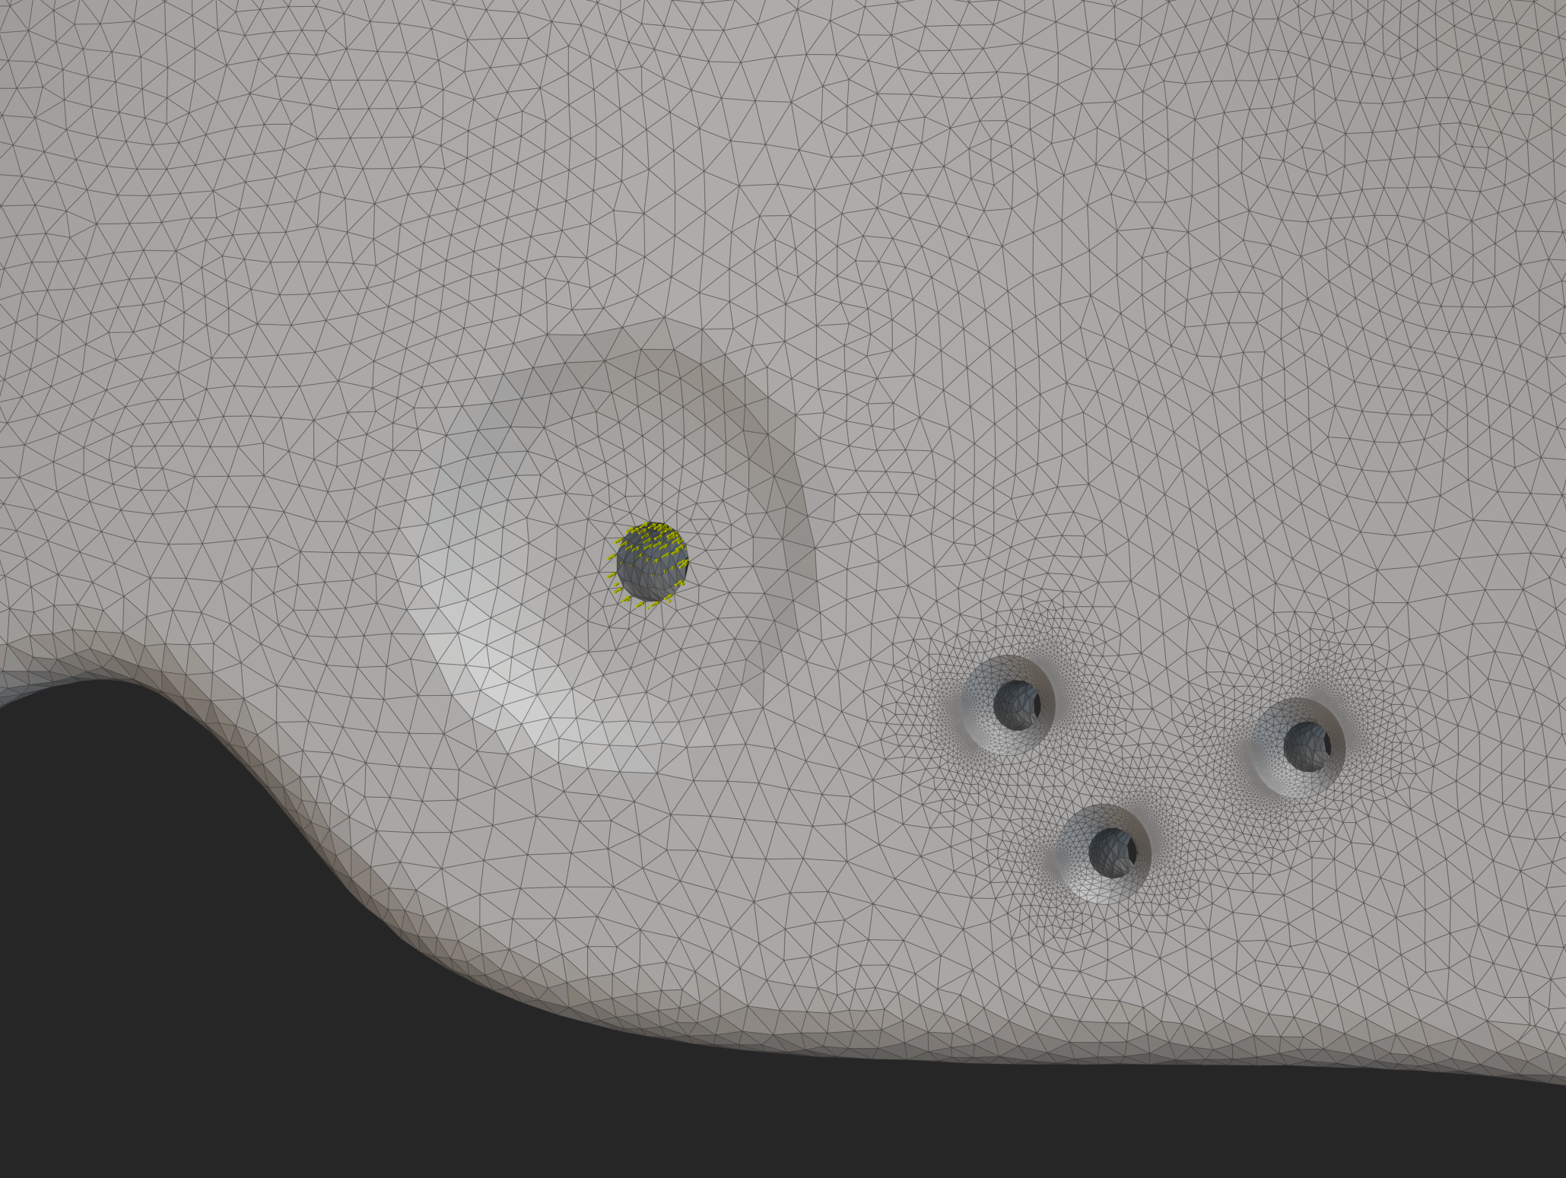 | 800 N | 1,0,0
4 | 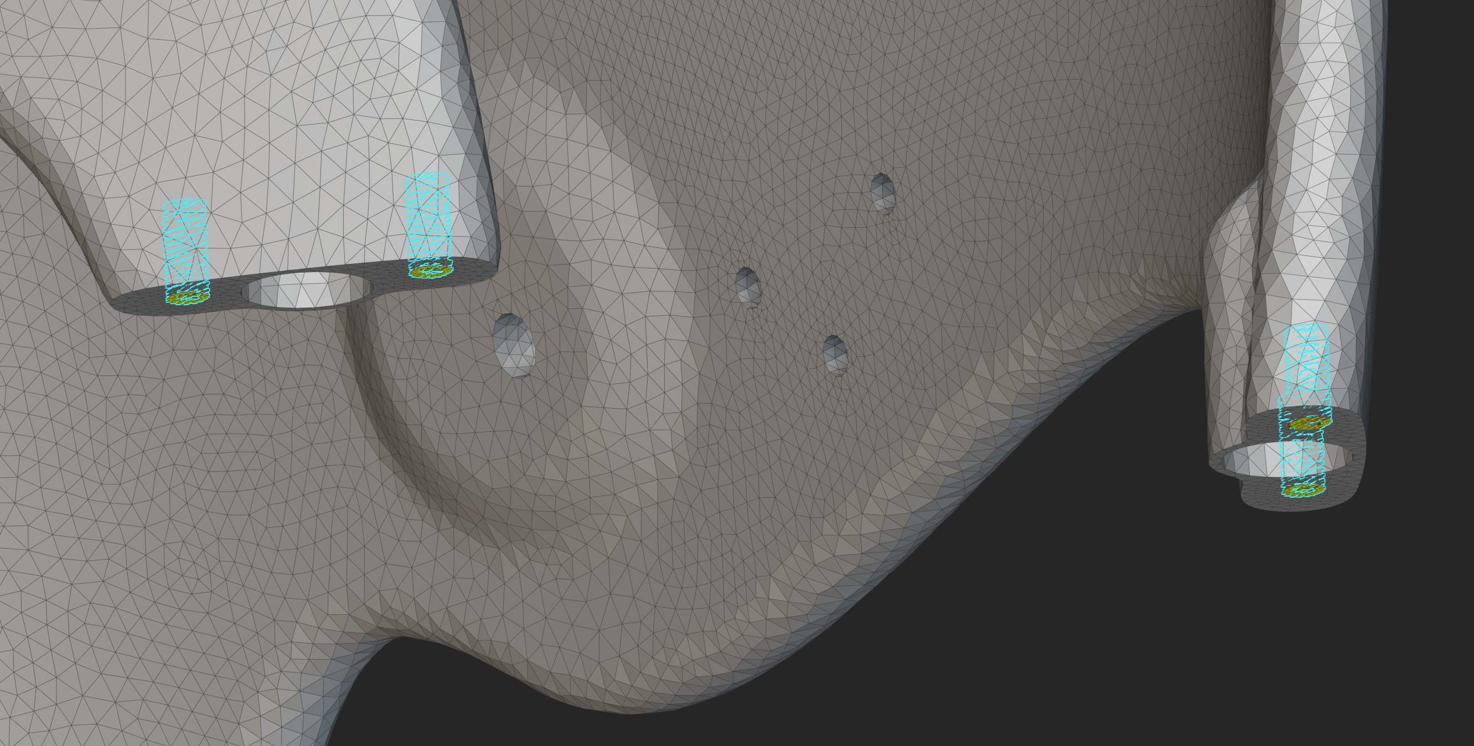 | 800 N | 0,0,-1 | 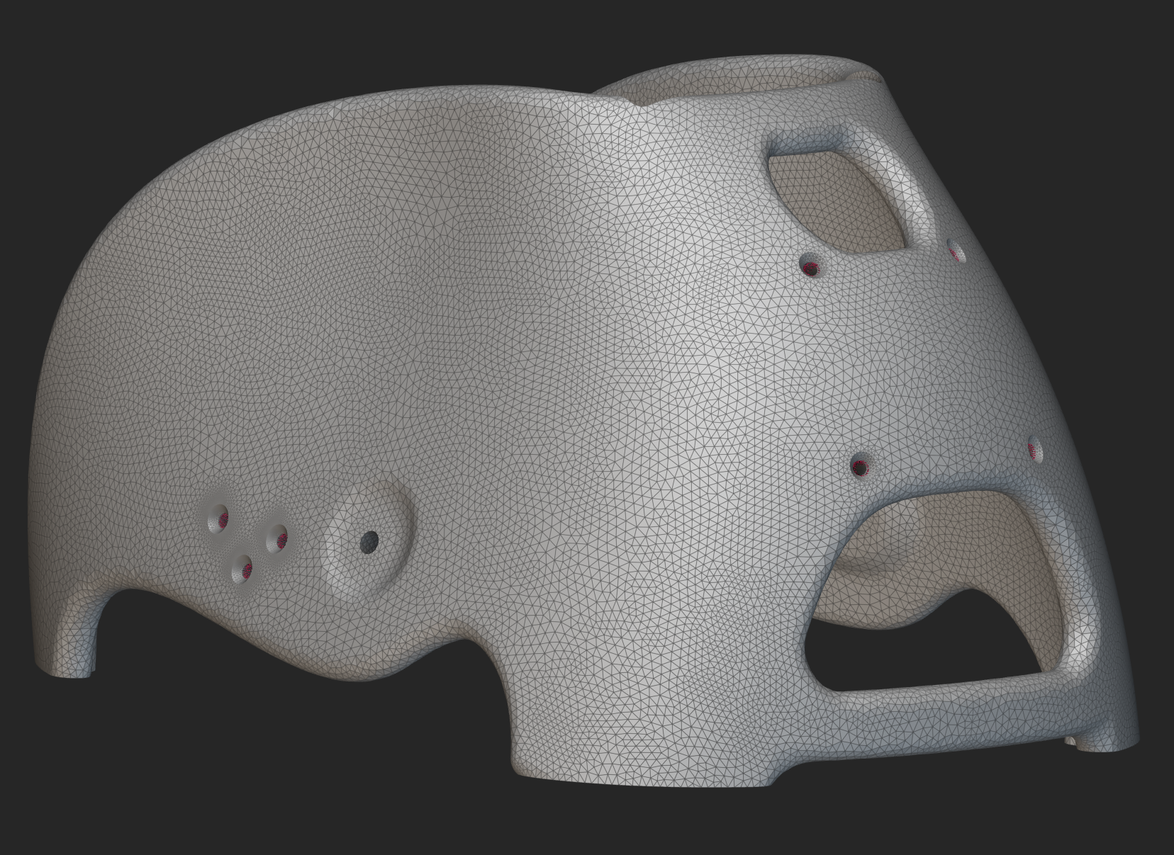
5 | 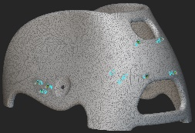 | 800 N | 0,-1,0 | 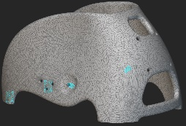
6 |  | 800 N | 0,0,-1 | 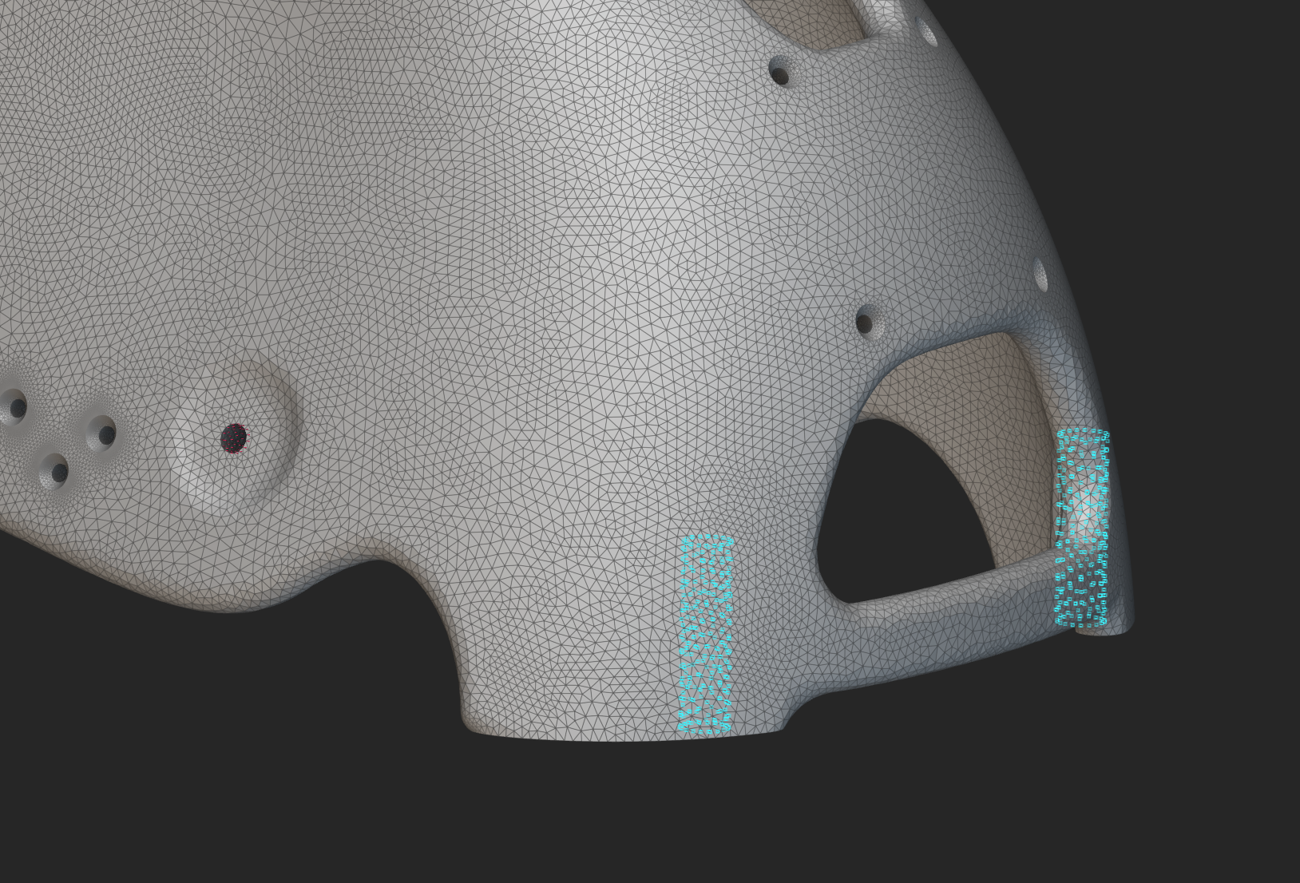

After this we identified that plastics, especially HDPE, ABS and PLA using FDM printing were not suitable for the chair. None of these materials provided enough impact resistance. We then shifted to metals, which we were confident would provide adequate impact resistance, but would be significantly more expensive for the target market.

We ran topology simulations based on the Markforged materials: 17-4 Stainless Steel, Onyx (composite), Inconel 625. These materials were chosen from a wide range of materials as it was believed they would provide the suitable strength to weight ratio based on the Markforged machine. However, due to the size of the components and the build volumes we decided to use to ARCAM Q10 and EOS M400 Additive Manufacturing machines, these are aerospace grade machines, are optimised for Scalmalloy an Aluminium alloy. This was therefore the next material tested and it was found to give the correct impact to weigh ratio. Examples of some of the topology simulations using Scalmalloy:

Axle support:

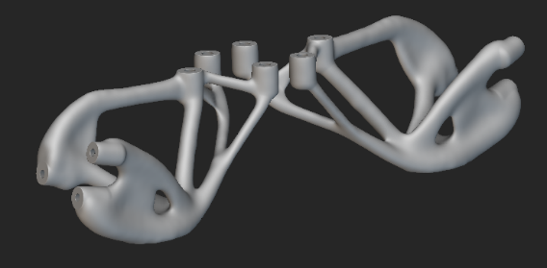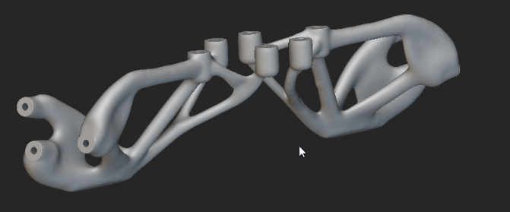

Seat Support:
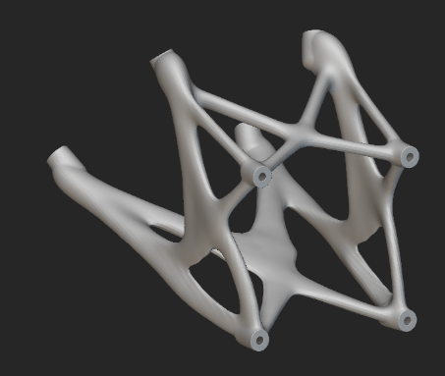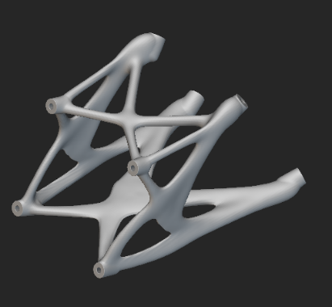
Frame:
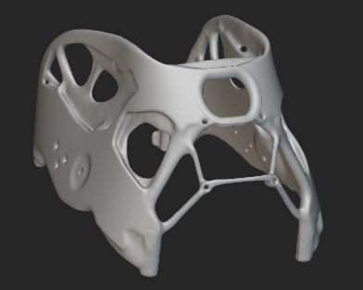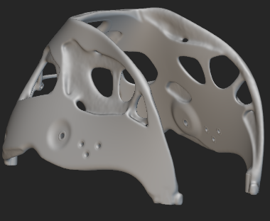
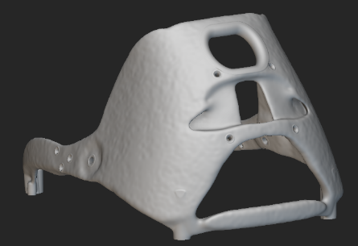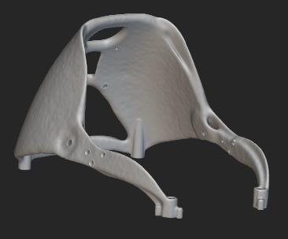
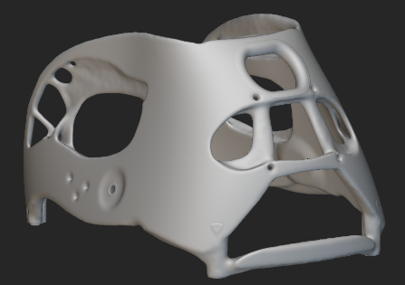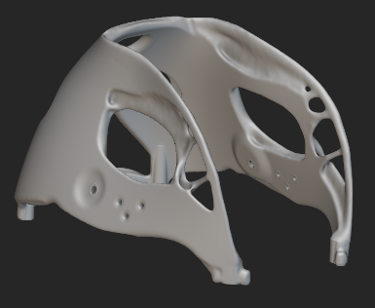

Once we had run all the simulations, we printed the main body of the wheelchair in Scalmalloy and the bumper in ABS to test the process. As the bumper would have a significant impact force we wanted to explore if this could still be shredded and then reprinted in situ.

During the printing we identified a number of challenges, such as the complexity of the assembly and the requirements for additional jigs for welding. This highlighted the challenges of manufacture and the current limitations of AM. For example even though we used a large bed, we still had to print the chair in sections which needed welding together. This created weaknesses in the overall topology design.

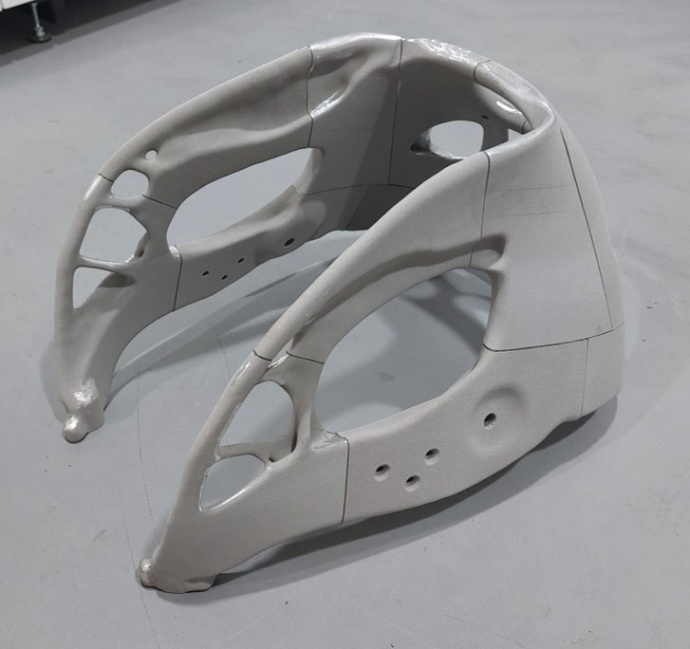

During the process of development and subsequent printing, we made several design changes, in response to the topology models and the ability to assemble the final design.

We also made a number of changes based on user feedback gained during the focus groups.

We conducted design-based workshops to understand the perspective of users we conducted workshops at:

Leicester Tigers Wheelchair Rugby Team – 10 participants. 8 athletes, 2 coaches.

Cambridge Adult Disability Multi Sport Club (CADMuS) including the Care Manager at Premier Education who works as a coach with the group. 9 participants. 7 athletes and 2 coaches.

Jaguars Wheelchair Basketball Club including Head Coach and Club Development Officer. 7 participants, 5 athletes, 2 coaches

DiSE team of youth wheelchair basketball students – 18 participants, 15 athletes, 3 coaches

Archie Eaton – Boccia Paralympic player and wheelchair user (zoom workshop)

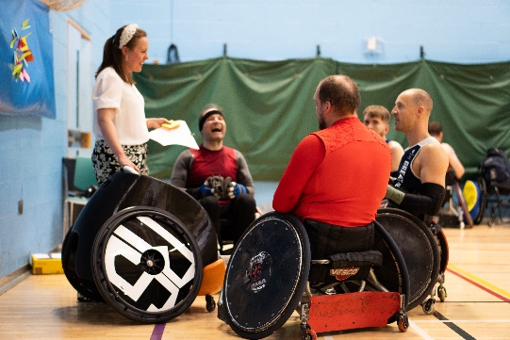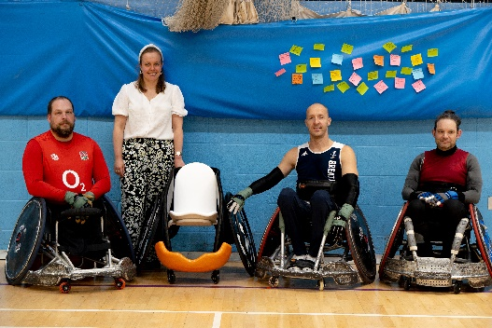
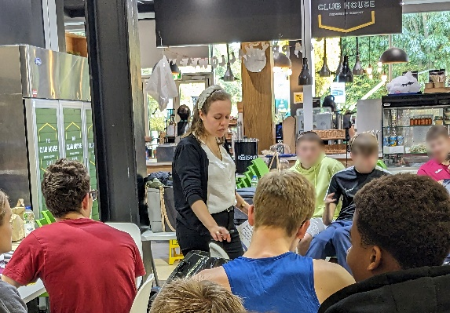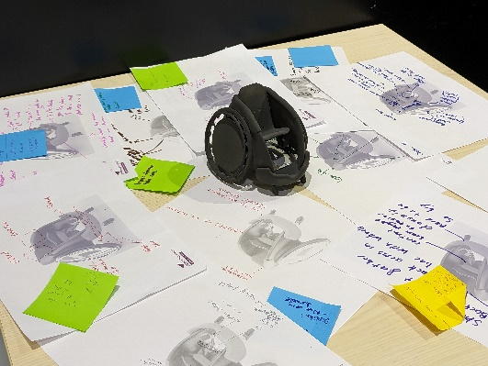

During the workshops we used both the 3D printed chair and a model, we collected data under the themes of: Customisation, Cost, Safety, Design, Topology Optimisation, and general comments about the size and fit of the design.

What we found

There have been several findings from this feasibility study.

Materials and Topology Optimisation:

Following tests with ABS, PLA and HDPE using Fused Deposition Modelling, it was quickly concluded that these would not have the impact resistance required for a chair. The design would, be suitable for a traditional manufacturing process such as rotational moulding, however, this would not allow for customisation.

An optimised topology design focusing on material reduction is suitable for the wheelchair design, it provides very good strength to weight ratio with a reduction of 38% of weight from the main body while maintaining the impact resistance required. This could not be used with any of the plastics as they are too weak.

The reduction of 38% weight was a very important factor in the user centred design workshops and was achieved through topology optimisation. Scalmalloy an Aluminium alloy was identified to be the most suitable material for the chair frame construction, it has the optimum strength to weight ratio and can be printed in large format printers.

Final Design created during this project.

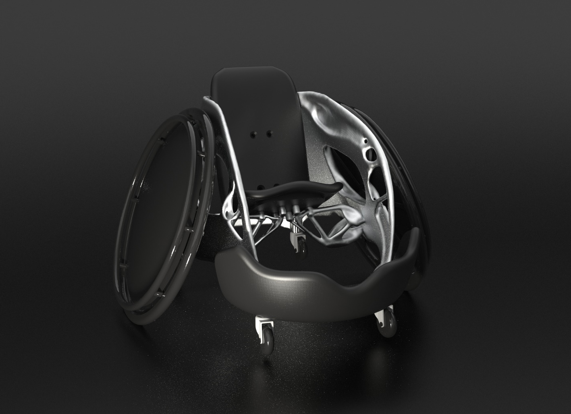

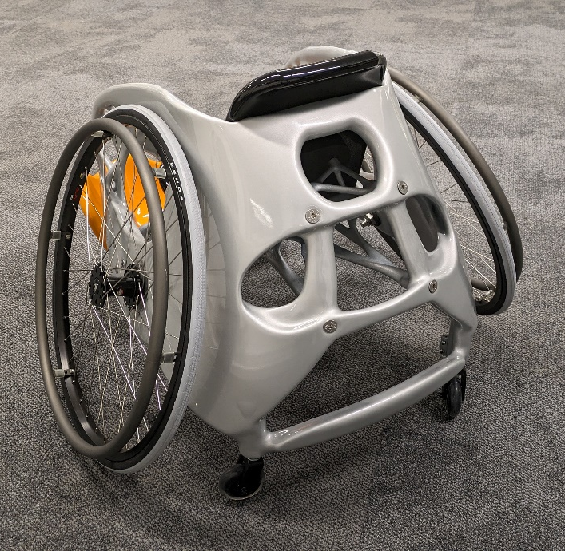
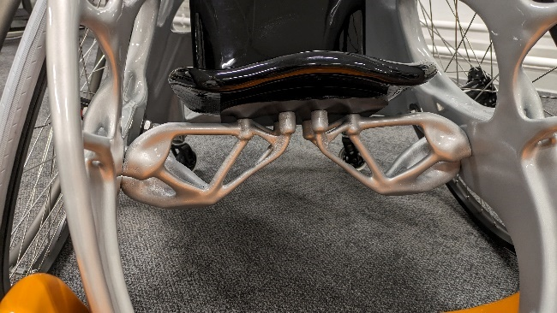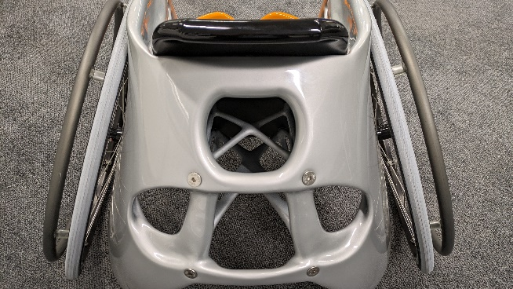

Design and Usability

86% users believed that the plastic chair would not be suitable for a contact sport and would need testing and development for strength to get it there. A 3D printed metal chair or a combination of traditional steel/aluminium with 3D Printed parts would allow for even more customisation without compromising strength.

Most participants agreed that a stronger plastic chair (not 3D printing) would make for an excellent children’s sports chair or club chair for children as a way of introducing them to disability sport and there was a lot of praise for the chair being cost effective in comparison to current chairs.

Topology optimisation will be a good first step in reducing 38% of the bulk from the chair and allow for personalisation. There were many reports of makeshift repairs to chairs. One of them had a broomstick handle up it to hold it in position as the professional repair was going to cost almost £1000 and the welding had failed. If these parts could be printed for less cost quicker then this was very desirable.

Currently to have a customised chair there is a compromise between what users want and need due to cost. Every change they make to a standard design increases the cost, sometimes disproportionately, this is due to manufacturing set up.

Current day chairs cost anywhere from £5-10,000. Specialist sports chairs with lots of customisation can be in the region of £17-20,000. The cost of a 3D metal printed chair would likely not save money, but it has the advantage of fitting better and enabling higher levels of customisation.

“If you can 3D print this in metal and reduce the bulk of it, I think you’d be onto a winner” Jaguars Wheelchair Basketball player

“I work with several clubs in Africa who are really struggling with the cost of the equipment, if you get these [Plastic chair] up and running I’d be very interested” DiSE coach

“If you get this right, it will revolutionise wheelchairs for all of us”. Leicester Tigers player

Distributed Manufacture
The aim of the project was to explore the potential for distributed manufacture through the case study of a child’s rugby wheelchair. During the project CAD data was produced, tested and printed. There were several additional components which were needed, such as wheels, axles and straps and supports. These are all common parts which can be shipped or sourced in most of the world. However, the heavy, complex part of the chair is the central frame, which normally add additional shipping and import costs. Therefore, this is a perfect use case for distributed manufacturing, where the complex parts are made in situ.

It was also found that the design of many chairs are not optimised for the users body size. “If you can make this work as a day chair, have it 3D printed to suit the person entirely, be able to print spare parts and make it cheaper, you will change the game for wheelchair users.” Leicester Tigers player.

What this means
There are several conclusions from this project. The first is that topology optimisation is suitable for reducing the material, weight, and costs of bespoke wheelchairs. However, the material used must be a metal alloy such as Scalmalloy which is expensive and may not be suitable for low-income settings however, as the cost of technology decreases there is the potential for this to become affordable in the future. It was found that 3D printed plastic chairs are not suitable for real world application, but a rotational moulded chair may be suitable for the junior division.

Users in the focus groups confirmed original knowledge that they can spend £17 - 20,000 on a custom wheelchair and so this means that additive manufacture can be a viable option for bespoke, customised chairs, which better meet user needs. The topology optimisation reduced the material by 38% in the main body section thus reducing the weight and cost.

Because the chairs can be printed anywhere in the world based on the CAD data, this data can be customised to the size and requirements of the person. Therefore, there is good potential to develop this design direction.

What next

Project next steps
Firstly, to develop a fully customisable CAD design where users are 3D scanned/measured and the subsequent CAD geometry is made to fit their profile. This would utilise the approach to distributed manufacture and could be applied around the world. User interviews reviled that often these custom chairs are focused on professional sport, but there is a need to create a design which works with ‘off-the-shelf’ wheelchairs and provides customisation or can replace standard designs so that everyone has a custom chair design.

Secondly, to develop a low cost chairs for low income areas using traditional manufacturing techniques, such as rotational moulding. This would provide the strength and rigidity needed to engage children into the sport “'This would be absolutely amazing for engaging children in accessible sports, able bodied and disabled, I can imagine my kids having a blast in one of these' Leicester Tigers player.

Publication and Dissemination
We are preparing two journal publications:

- The application of distributed manufacturing with a case study of the wheelchair. This technical paper will include all the design and topology optimisation data and results.
- Design considerations for sport wheelchair design with a focus on design for customisation and personalisation. This design-based paper will draw findings from the workshops and the impacts on

Project Website: www.distribuedmanufacture.com
Project Video: https://youtu.be/IjTz1NEt_u4

