Report on the TIDAL Network Plus Feasibility Project:

A Person Based Approach to the Development of Upper Limb Prostheses
Authors: James Male, Leen Jabban, Benjamin Metcalfe
Acknowledgements: This project was funded by the Engineering and Physical Sciences Research Council [grant number: EP/W00717/1] through TIDAL Network Plus - Transformative Innovation in the Delivery of Assisted Living Products and Services.

What We Set Out to Discover

Background and Research Context
The field of upper-limb prostheses is facing a critical challenge: up to 75% of myoelectric upper-limb prostheses are abandoned, indicating a profound disconnect between the characteristics of these devices and the actual needs of their users. This high rate of abandonment not only represents a wasteful use of resources, but more importantly has severe implications for the quality of life of upper-limb amputees. These individuals often face long-term complications due to the overreliance on their intact limb, stemming from the inadequacy of their prosthetic devices.
A key factor is the lack of effective sensory feedback. Touch is an essential component of object manipulation, and the integration of sensory feedback has the potential to enhance control, foster a greater sense of embodiment, reduce phantom limb pain, and ultimately, reduce the rate of device abandonment. Despite the recognised importance of sensory feedback, the implementation has been limited. Currently, only a select few high-end commercial prostheses incorporate a basic form of sensory feedback, many of which are based on designs from the early 1900s. This lag in technological advancement highlights a significant gap in the current approach to prosthesis development.

Research Challenge
The primary issue lies in the heavy reliance on laboratory testing, which often fails to address the practical, real-world challenges faced by prosthesis users. For instance, while much of the existing literature focuses on providing sensation through the fingertips of prosthetic limbs, our user needs assessments have indicated that this might not always be the most effective approach. In many cases, the fingertips are not in constant contact with the objects being manipulated, suggesting that sensor locations should not be limited to fingertips.
In response to these challenges, our project proposes a paradigm shift in the development of sensory feedback for upper-limb prostheses. Moving away from traditional lab-centric approaches, we are placing the users at the forefront of the development process. By employing a customisable system equipped with an Internet of Things (IoT) node, we enable users to test and modify the system within the context of their daily lives at home. This approach not only makes users active contributors to the development process but also ensures that the resulting prosthetic solutions are more aligned with their real-world needs.
This project is particularly timely and relevant given the national emphasis on digitalization and IoT-enabled healthcare. Our approach resonates with the broader movement towards user-centred care, recognising the importance of understanding and adapting to the evolving needs of users. Additionally, we are taking a novel approach by combining the design and assessment of assistive technologies within a home environment. The active involvement of users in co-creation and the subsequent quantitative and qualitative analysis of these modifications provide a comprehensive understanding of user needs. This not only aids in the development of more effective prosthetic solutions but also serves as a case study demonstrating how IoT and user-centred design approaches can lead to transformative changes in the design and provision of assistive technologies.

Aims and Objectives
Through a person-based approach (PBA), this project investigates the feasibility of using the IoT to enable true co-creation of assistive technologies that reduces device abandonment and waste. Sensory feedback will be used a vanguard case study, as it can be delivered as an add-on that does not affect the functionality of the prosthesis itself and is novel to the participants.
Objectives:
- The development and deployment to the home setting of a novel customisable vibrotactile sensory feedback “add on” that can be fitted to an existing prosthetic arm.
- The development of an Internet of Prosthetics paradigm wherein usage data is reported in near real time to the research team.
The application of the PBA throughout the project to understand the needs and behaviours of the participant in real time in the development of the sensory feedback technology.

What We Did

System Design
The system developed consists of two main subunits: the sensor control unit (SCU) and the vibration feedback device (VFD), as shown in Figure 1. The SCU is based around an M5 Stack Core2 device, which provides an ESP32 microcontroller with touchscreen and battery. This is connected to a maximum of 8 Force Sensitive Resistors (FSRs) which are attached to the participant’s prosthetic, allowing for force sensing while touching objects. The number and location of FSRs is customisable, as they are attached to the prosthesis using self-amalgamating tape to accommodate for the different types of prostheses used by the participants. The VFD consists of an Arduino Nano ESP32 microcontroller, attached to an array of 8 vibration motors via a multiplexer. The SCU and VFD communicate with each other via Bluetooth Low Energy (BLE). The ESP32 devices allow for remote over-the-air (OTA) updates through a Wi-Fi connection for both devices. This allows for code to modified and uploaded, settings to be changed, and data from the devices to be uploaded to the cloud. This is managed by an online dashboard provided by thinger.io.
A dashboard was developed through Thinger.io to enable participants to define the force values and select sensing and feedback options. The dashboard is accessible through any browser to enable participants to use it through their phones, laptops, or other smart devices.

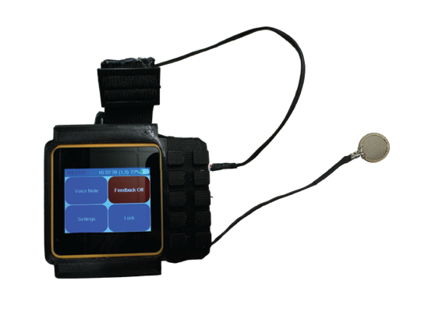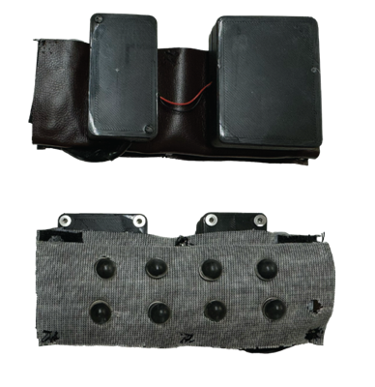
Figure 1 Sensor Control Unit (left), Vibration Feedback Device (right). The vibration feedback device shown is a version that is designed to be placed on a prosthesis harness for body-powered prostheses and high-level powered prostheses.

The Sensor Control Unit
The SCU is the main control and interaction device for the system and is designed to be worn as a “watch”. The device receives and processes the force sensor readings, sends the relevant feedback control commands to the VFD, as well as provides a touchscreen graphical user interface (GUI) for interaction with the system. The screen is used to display relevant information using programmable touchscreen buttons and a selection of menus. There are three permanent buttons along the bottom of the screen. The first is used to turn the screen on, the second allows the user to view a debug screen for the SCU, while the third button shows an FSD diagnostics screen.
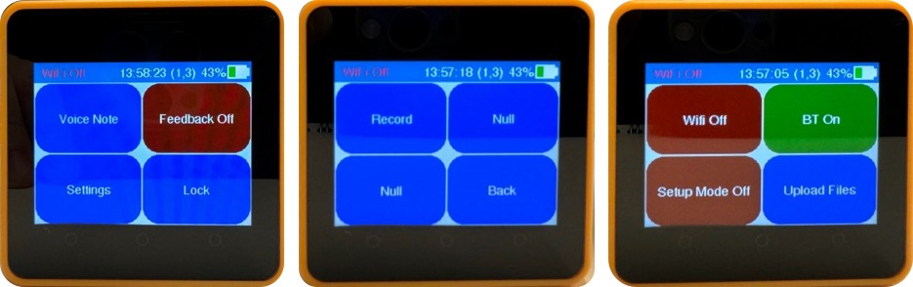
Figure 2 SCU Menus. (Left) main menu (Centre) voice recording menu (Right) settings menu.

The Vibration Feedback Device
The feedback device receives commands from the SCU over Bluetooth and controls the feedback motors appropriately. The device receives string messages from the SCU containing the 8 comma separated feedback values for the 8 feedback motors. The values correspond to the feedback waveforms available from the Adafruit_DRV2605 library. The corresponding value is written to each vibration device via a multiplexer unit to provide the feedback pattern desired.
The unit also provides diagnostic data back to the SCU. This includes a regular update message every 3 s providing the status of the Wi-Fi, Bluetooth, and vibration motor connections. Other string messages are also sent at relevant points for diagnostics.

Sensing and Feedback control
Signals are received from the pressure sensors via a 16-channel analogue multiplexer. The type of feedback can be chosen to follow one of 6 set patterns. The desired pattern can be adjusted using the dashboard interface.

Experiment Plan
Participants registered interest through an online survey that asks for their upper-limb difference background and prosthesis details, with the aim of covering a range of limb differences and patterns of prosthesis use. Participants were then invited for an onboarding call (Microsoft Teams) where the project was explained further and consent for participation is obtained. The first cohort (P1 & P2) of participants were visited at home or at a preferred location to set up the kit in person. The second cohort participant (P3) had their kit mailed, for a remote setup during a Teams call.
After the initial setup, weekly 30-minute calls would be scheduled to discuss the device use, monitored through embedded sensors, and discuss modifications that could be implemented through “over-the-air” updates to enable co-design of the optimised solution. Once the 6 weeks are over, participants were asked to return the kit in a pre-paid package and were invited to a debriefing call through a Teams call to comment on the device itself and the overall co-creation process.

Recruitment
Participants registered interest through an online survey which was advertised through limb difference charities and social media accounts of the researchers. 'Snowballing' methods were also employed, where participants shared the study within their social circles. Leaflets were placed in Open Bionics' private clinic. Interested individuals were invited to participate through a survey link. The study included adults (18+) with upper-limb differences who owned a prosthesis and lived in the UK, excluding those without access to a prosthesis, Wi-Fi, or digital devices. Participants were offered £400 in compensation for their time to help with recruitment.
N=9 participants expressing interest in participating in the project, of which N=4 completed the on-boarding call and signed the consent form. However, one of the participants had to repair their prosthesis due to a fault unrelated to the experiment. The delays in the repair process meant that they could not test the device within the project timeframe. Of the three participants that tested the device, one stopped replying to emails after the first week having previously mentioning being busy with personal matters, another had to stop participating due to a personal emergency, and one completed the 6 weeks. The profiles of the three participants who tested the device are detailed in Table 1. P2 is the participant who completed the 6 weeks.

Figure 3 Overview of the number of participants recruited. All participants who expressed interest in the project were males with acquired limb loss.
Table 1: The profiles of the participants who tested the device
 | Profile
P1 | Acquired Transumeral amputation of non-dominant hand. Uses body-powered prosthesis at least once a week.
P2 | Acquired Transumeral amputation of dominant hand. Uses body-powered or myoelectric prosthesis everyday
P3 | Acquired bilateral amputation. Uses body-powered prosthesis every day.

What we found

System level Findings
The modification of the sensory feedback system to enable remote participation required significant changes, which was challenging given the timeframe of the project. Managing reliable communications between devices, such as Bluetooth and Wi-Fi, along with ensuring the GUI worked robustly, presented considerable challenges. This complexity occasionally led to difficulties in debugging the system remotely, which detracted from our primary focus on investigating feedback types and usage patterns.
Despite the challenges faced, there were notable successes. The implementation of OTA updates and parameter setting from the dashboard worked effectively. This allowed updated code with reliability and feature improvements to be uploaded with ease, even while on a video call with participants. Feedback pattern settings could be adjusted by the user on the dashboard easily and corresponding changes made to the device.
Looking ahead, the overall system harbours significant potential for reuse in a variety of home-use studies across different fields. The integration of a touchscreen GUI device with connected peripheral devices, an interactive dashboard, and the capabilities for remote updates, settings adjustments, and data recording - including voice notes - creates a versatile system. This system could be invaluable to researchers in various domains. Given that the main engineering challenge was establishing a reliable underlying system, further development to adapt this system for diverse applications, especially in scenarios involving co-creation, home-use trials, and remote monitoring, would be highly beneficial.

Sensory feedback Findings
Given the low number of participants, the sensory feedback findings are not generalisable. However, P2 stated that even the simple implementation of sensory feedback increased their trust in the prosthesis, and while it did not affect how much they could do, it did improve their confidence in performing previously unachievable tasks and improved how they felt. Overall, they thought that sensory feedback is definitely worth it. Below is a quote from one of the interviews.
“what I found was actually … holding [my wife’s] hand was much more sort of, you know, like pleasant feedback. We felt you were holding your loved one rather than just using your prosthetic hand. I mean, it's like prodding somebody with a stick, you know, using a prosthetic arm. Whereas if you've got that sensation, it feels much more like an embodied experience.”

Test Framework Findings
Key factors influencing the success of a trial were the relationship between investigator and participant, and the participants technical background and prior experience with similar trials. P2 had a prior relationship with the research team, and significant previous technical experience and has been involved in similar trials before. In contrast, participants with less experience may have been deterred by the technical challenges, the required time commitment, and the patience needed for working with experimental technology. P2 noted the advantages of remote software updates, but also highlighted the importance of assessing participants' abilities in advance and the benefits of initial face-to-face interactions:
“Being able to update software remotely, I think that’s a great approach.. but you know you're making quite a lot of us suppose assumptions about what the abilities of the individual are .. and I think you have to assess that in advance. It's quite difficult to just start up that because having a face to face relationship initially really helps.”
P2 also appreciated the open nature of the trial, enjoying the ability to suggest modifications and see them tested promptly:
“I found the unconstrained way in which we sort of talked about these things has been really sort of useful.”
This feedback is encouraging as it supports the assumption that home-based testing frameworks can enhance co-creation. Participants like P2 could use the device at their convenience, offering valuable reflections on potential improvements. However, further research is needed to balance the open nature of such trials with the need for collecting scientific, publishable data.
Finally, it's crucial to acknowledge the substantial effort required in remote co-creation. The importance of dedicated time and a team focused on fostering relationships with participants cannot be overstated. Moreover, the necessity of quickly addressing and rectifying technical issues is a key factor in maintaining participant interest and trust. This dedication to both the interpersonal and technical aspects of the trial is essential for its success. Future work should continue to explore and refine these dynamics.

What this means
The concept of remote co-creation, while valid and appreciated by participants, requires significant fine-tuning. Creating reliable platforms to support this innovative approach is essential for its future success. The study highlighted the need for robust systems that can facilitate effective remote collaboration and co-creation.

What next
The small sample size is a barrier to publishing the results in a traditional format; however, we intend to share the lessons learnt from this trial as a “case study” paper in a suitable journal. Additionally, we are submitting a conference paper to the IEEE 2024 Engineering in Medicine and Biology Conference (EMBC) with the aim of starting a conversation about remote co-creation.
We are currently utilising the spare components from the study to develop a second iteration of the home-use system. This version will feature enhanced reliability, an easier user interface, and improved remote debugging capabilities. This upgraded system will serve as the foundation for future research, which will include an expanded recruitment effort through the NHS to increase sample size.
Furthermore, we are exploring the potential of testing other assistive devices remotely. To this end, we will circulate a survey among researchers in the field to assess their interest in applying our remote co-creation framework to their technologies. Attendance at conferences like EMBC will also provide valuable opportunities to network with researchers interested in collaborative projects in this area.

Appendix
Carbon calculations for travel undertaken as part of the project:
Transportation by car to P1 (0.08) + Transportation by train to P2 (0.01)= 0.09 tonnes of CO₂e
Attending Conferences (Singapore & Florida): 3.42+ 2.09=5.51 CO₂e
Total = 5.6 CO₂e

Open Bionics is an upper limb prosthetics company and a collaborator on the project. The collaboration was initiated to provide easier access to clinics and amputees and to provide feedback on the system design.

