Report on the TIDAL Network Plus Feasibility Project:
  - Improving the efficiency of co-designing personalised AT through digital design and manufacturing systems

Authors
Dr Jonathan Howard, Swansea Bay University Health Board
Professor Dom Eggbeer, Dr Sally Cloke, Dr Katie Beverley and Ms Emily Parker-Bilbie, PDR / Cardiff Metropolitan University
November 2023

Acknowledgements
This project was funded by the Engineering and Physical Sciences Research Council [grant number: EP/W00717/1] through TIDAL Network Plus – Transformative Innovation in the Delivery of Assisted Living Products and Services.
We wish to thank:
- All the NHS Wales staff members who participated in our workshops.
- Ms Zoë Bacon for assistance with facilitation.
- PDR’s product design team for developing product concepts and creating 3D renders, animations and GUI designs.
- All PDR staff members who contributed to the ideation stage.
- V-Trak Ltd for use of their fast 3D printer to produce the concept custom AT models.

Please note:
All research tools and outputs listed in bold in the text of this report can be found on the project website, along with updates on the progress of the team’s research: https://deggbeer.wixsite.com/co-at-design

1. What we set out to discover

Background and research context
A literature review (Howard et al., 2022, a) has pinpointed key obstacles in accessing appropriate assistive technology (AT):
- Lack of customisation to users’ health conditions and independence goals
- Limited involvement of users in the design process
- Insufficient knowledge and training among healthcare professionals
- Limited availability of local services
Prior research by the project’s lead investigator (Howard et al., 2022, b) demonstrated the benefits of integrating user-centred co-design practices, combined with affordable digital design and manufacturing (DDM), into existing healthcare services: enhanced health, wellbeing, and social outcomes, reduced barriers to AT utilisation and less AT abandonment and waste.

Engineering/research challenge and significance
However, the process was intricate, time-intensive, and expensive, with over 96% of the costs attributed to the clinician’s time. It relied on the implicit knowledge of the clinical team, hindering the sharing of solutions.
Recent work (Howard et al., 2023) has highlighted the efficiency gains offered by adjusting parameters in existing 3D computer-aided designs (parametric design).
This laid the foundation for a service model where AT could be co-designed by both modifying previous solutions or creating new devices. The challenge lies in expanding this concept through establishing mechanisms for sharing knowledge, facilitating local services, and optimising the co-design process.

Aims and objectives for the project
This project aimed to develop a blueprint for such a service. Following the Design Council’s Double Diamond research model (figure 1), we set out to:
- Discover the current landscape of AT provision through working with healthcare specialists from across the ecosystem.
- Define the challenges facing the development of co-designed DDM AT and identify areas for optimisation.
- Develop potential service models, evaluating the most promising ones, and refine these to create a proposed solution.
- Deliver a service blueprint, wireframe model and video illustrating how such a service could work, plus policy recommendations to facilitate its expansion across the NHS in Wales and the UK.
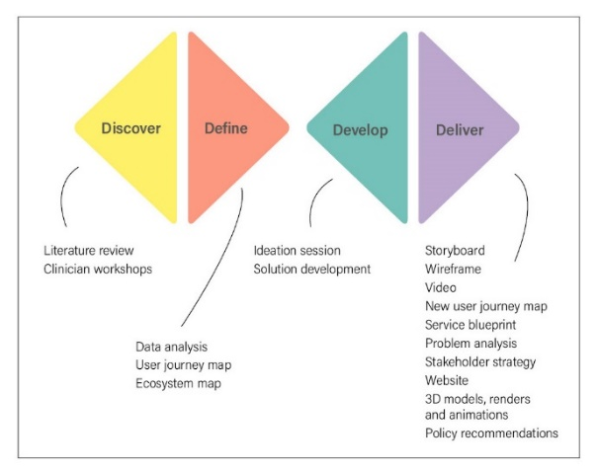
Figure 1: Key research stages and outputs mapped to the Double Diamond research model.

2. What we did

Discover: Initial workshop sessions
Five two-hour workshops were run with 21 healthcare professionals across Swansea Bay and Hywel Dda University Health Boards.
The participants represented a wide range of experiences, services and backgrounds and included rehabilitation engineers, occupational therapists (OTs), physiotherapists and physiotherapist technicians (figure 2).
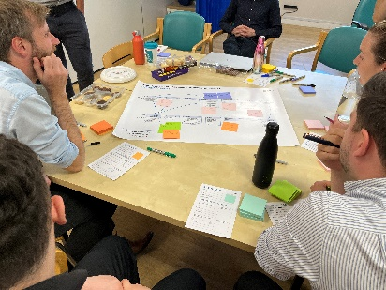
Figure 2: One of the discovery workshops with healthcare professionals in progress.
The purpose of the workshops was to:
- Find out about the experience of healthcare professionals in providing AT
- Identify their confidence and interest levels in being involved in the co-design of personalised AT.
- Co-create user journey maps to understand the current provision pathway for off-the-shelf and personalised AT.
- Identify the key stakeholders that would need to be managed within a personalised AT process, from the individual to a system level.

Define: Data analysis
The project team familiarised themselves with the qualitative data generated during the workshops (notes written by participants and researchers) and grouped it into themes. Potential barriers to scaling-up the co-design process were identified.
The current user journey maps from different healthcare services were combined to clarify the stages in the co-design AT process.
Ecosystem maps from the workshops were consolidated into a single map (see section 3 for discussion).

Develop: Ideation session
The goal of the ideation session was to generate new ideas for scaling-up and implementing a DDM enabled co-design AT process. The session involved a group of researchers and designers with varying backgrounds and experiences. Participants were briefed on the key challenges identified in the data analysis process. Ideas were brainstormed individually and then combined and discussed in the group.
The project team analysed the results, identifying commonalities and key themes. Those related to a DDM-enabled process were evaluated and scored to determine their feasibility, priority, and potential for further development.

Deliver: Concept generation and expansion
The project team, having chosen the most viable concept, developed a storyboard outlining each stage of the proposed DDM process, specifying who would be involved, where it would occur, what it would accomplish, how it would be done, and why it was necessary. This helped consolidate ideas, identify necessary innovations, and determine the involvement of various disciplines.
A low-fidelity wireframe of the process was created, illustrating key interface screens that would be visible to healthcare professionals and clients throughout the process, from initial assessment to delivery.
A new user journey map was designed, illustrating where DDM was being used to enhance and streamline the process. A proposed service blueprint was developed, showing how the user journey was supported by the activities of various healthcare professionals at different stages.
A team of product designers was briefed on the concept and brought their expertise to some of the AT prototypes previously developed by the project’s lead researcher. They enhanced the products’ aesthetic appeal and improved the modularity of the design. High quality 3D physical models as well as high-fidelity renders and animations were produced (figure 3) along with a video illustrating the new system.
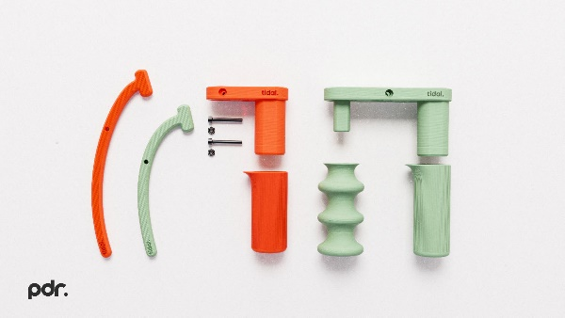
Figure 3: A high-fidelity render showing the modular construction of a concept for DDM AT.
We ran a final session with a group of rehabilitation engineers at Swansea Bay UHB to present our results and outputs.

3. What we found

Barriers to scaling-up
Nineteen potential barriers to the scaling-up of a personalised AT process were identified and grouped into four themes:
- The design of current off-the-shelf AT
- Access to current off-the-shelf AT
- Healthcare professional staffing within the current system
- Systemic pressures in the healthcare service
The full list of barriers is shown in the problem analysis diagram and will be addressed in section 4.

Stakeholder management
The analysis of the ecosystem map identified sixteen different individual stakeholders in the AT provision system and ten groups of significant organisations. A stakeholder strategy was developed to ensure that those with the most influence and interest in the provision of personalised AT will be appropriately managed.

4. What this means
Our proposed solution is an internet-based platform that will enable healthcare specialists and end-users to collaborate on the design and modification of personalised AT.
This system would facilitate the sharing of best practices and innovative ideas among peers and users, contributing to rigorously evaluated solutions that meet both regulatory requirements and user needs. It would enable custom designs to be fabricated same-day within a distributed network of manufacturing facilities close to the point of need under a common regulatory-compliant quality management system. It would incorporate a central, quality-controlled database of information on both off-the-shelf and custom AT.

How the proposed system addresses previously identified barriers:

Design of off-the-shelf AT
User involvement in the process, from self-assessment and holistic goal setting at the beginning, to trialling devices and using digital feedback mechanisms, will help devices meet an individual’s specific needs, goals and lifestyle. A device’s colour and surface finish can be tailored to individual preferences. Client expectations can be managed through providing information and examples of the type of equipment available from the start of the process.

Access to off-the-shelf AT
The system’s database will enable healthcare specialists to easily access information on off-the-shelf and custom AT. Products can be searched for by filters such as task or medical condition. Using a single system should reduce the time and paperwork required to procure AT.
The system incorporates opportunities to trial AT with end-users, where feedback is gathered, incorporated into the database, and used to inform the next step.
Barriers regarding limited budget and funding have not been able to be addressed directly by this proposed system. However, incorporating user-feedback into the system adds to the evidence base around the advantages of using quality, appropriate AT to influence funding decisions.

Healthcare professional staffing
The system is able to adapt to different levels of participation from OTs in the design process. It involves both a customisation option of previous designs using simplified DDM, and the option to design from scratch utilising the skills of rehabilitation engineers in manufacturing custom AT. By having review points prior to manufacturing, OTs and others can be sure devices are modified in a rigorous quality framework to meet regulatory standards.
Client feedback is incorporated both during the design process and after devices are issued, ensuring OTs can access and learn from this feedback for continuous improvement. Further work is required to identify how to teach those OTs interested in DDM the necessary skills and expertise to be more involved in this process.

Systemic healthcare pressures
The proposed system aims to be a centralised hub for AT, improving the integration of IT systems between different services and professionals to improve communication and consistency. It will be co-designed with the users to help it be easy to use and accessible. By providing information about the AT solutions available to end-users early on in the process, it aims to help manage expectations of clients and family. Finally, the system ensures goals captured are focused on the long-term holistic goals of patients, and not just on hospital discharge. The proposed system does not help overcome low staffing levels, but it is hoped it will make better use of staff times, e.g. reduce administrative burden, to enable them more time to be spent with clients.

How we will get there
Achieving this goal necessitates advancements in design and manufacturing technology, updated policies, and radical servicing innovations.
Key areas of focus include:

Research:
- AT user experience research to create a platform suitable for people’s confidence and ability.
- Development of a user-friendly non-CAD interface, which is accessible to both designers and non-designers, to enable the easy modification of designs.
- R&D to radically increase production speed of technologies such as 3D printing.
- Healthcare economic assessments to determine the concept’s potential value.
- Implement machine learning or other intelligent methods to enhance the database.
- Research to understand end-user needs to establish the demand for personalised AT and the level of customisation required.
- Explore the modularisation of current custom AT designs and how these can be adapted for a web-based platform.

Workforce development:
- Up-skilling health professionals in DDM processes.

Policy and procedures:
- Establishment of policies that allow physical libraries for AT solutions.
- Explore alternative business models for the hospital-supported delivery of custom AT.
- Internet platform development:
- Create a secure app/web-based platform to host and connect healthcare specialists.

Regulatory compliance:
- Implement regulatory-compliant systems that function seamlessly across health boards and any external parties in industry and the maker community.

5. What’s next

We plan to:
- Develop research proposals that address the challenges identified.
- Collaborate with academic disciplines that address the need for more rigorous and holistic healthcare economic assessment of the concept.
- Share our recommendations with relevant policy makers and decision makers.
- Continue to work across specialties in identifying opportunities for AT customisation.
- Disseminate our findings in journals and conference presentations.

References
Howard J, Fisher Z, Kemp AH, Lindsay, S., Tasker, L. & Tree, J. Exploring the barriers to using assistive technology for individuals with chronic conditions: a meta-synthesis review. Disability and Rehabilitation: Assistive Technology. 2022 2022/05/19;17(4):390-408. (Howard et al., 2022 a)
Howard, J., Tasker, L. H., Fisher, Z., & Tree, J. (2022). Assessing the use of co-design to produce bespoke assistive technology solutions within a current healthcare service: a service evaluation. Disability and rehabilitation. Assistive Technology, 1–10. https://doi.org/10.1080/17483107.2022.2060355 (Howard et al., 2022 b)
Howard, J., Bowtell, M., Fisher, Z., Tasker, L. H., & Tree, J. (2023) Can a previously co-designed device be used by others? A service evaluation of the use of the Sativex spray holder for individuals with multiple sclerosis. Disability and Rehabilitation: Assistive Technology, DOI: 10.1080/17483107.2023.2228344

Appendix
Carbon calculations for travel undertaken as part of the project.
Car miles total: 118+86+371+40 = 615. 2ltr petrol car, approx. 40mpg. Approx 0.538t CO2 (via https://co2.myclimate.org/)
Train miles: 288 (Cloke & Eggbeer) + 400 miles (Howard). Approx. 0.04t of CO2. (via https://calculator.carbonfootprint.com/calculator.aspx?tab=6)
Tram miles: approximately 10

