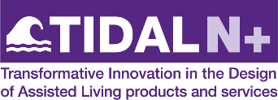 | DMS and Physical Devices Funding Call  Expression of Interest Form Part 1

- Project title

- Narrative summary (250 words max.) For use on the TIDAL N+ website if your application is successful.

- Submission and deadline
Return this form, in Word format, together with Part 2 of the Expression of Interest to TIDAL@ucl.ac.uk no later than Thursday 7th July 5pm BST

