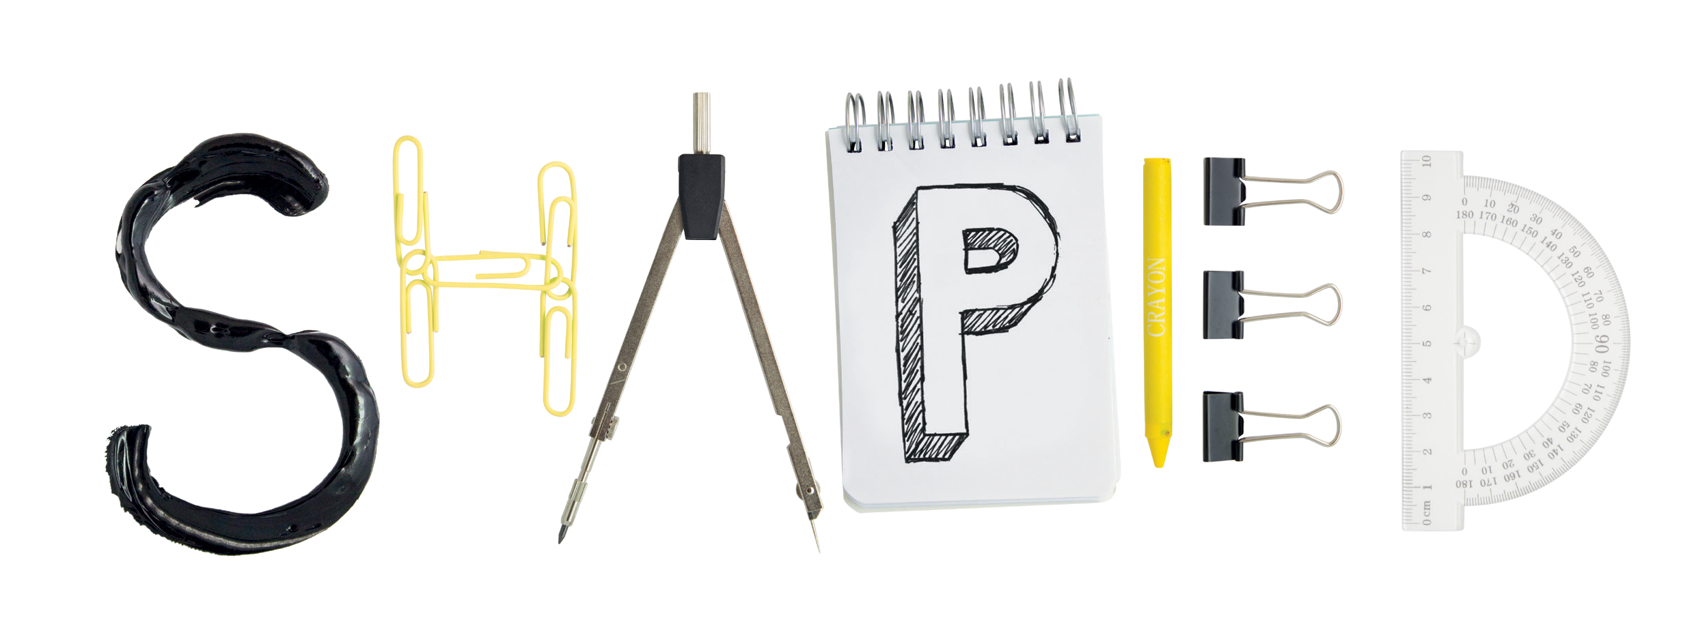

**the Department of [*xxxxxxxxxxx*]**

**STUDENT ENGAGEMENT & EXPERIENCE**

You told us [***you would like some feedback on your individual exam performance, even if you passed…*]**

Find out more at **ucl.ac.uk/[*xxxxx (or link to departmental Moodle page)]***

**You**

Together we create a better education

We have [*launched a scheme for you to view your exam papers with your personal tutor.*]