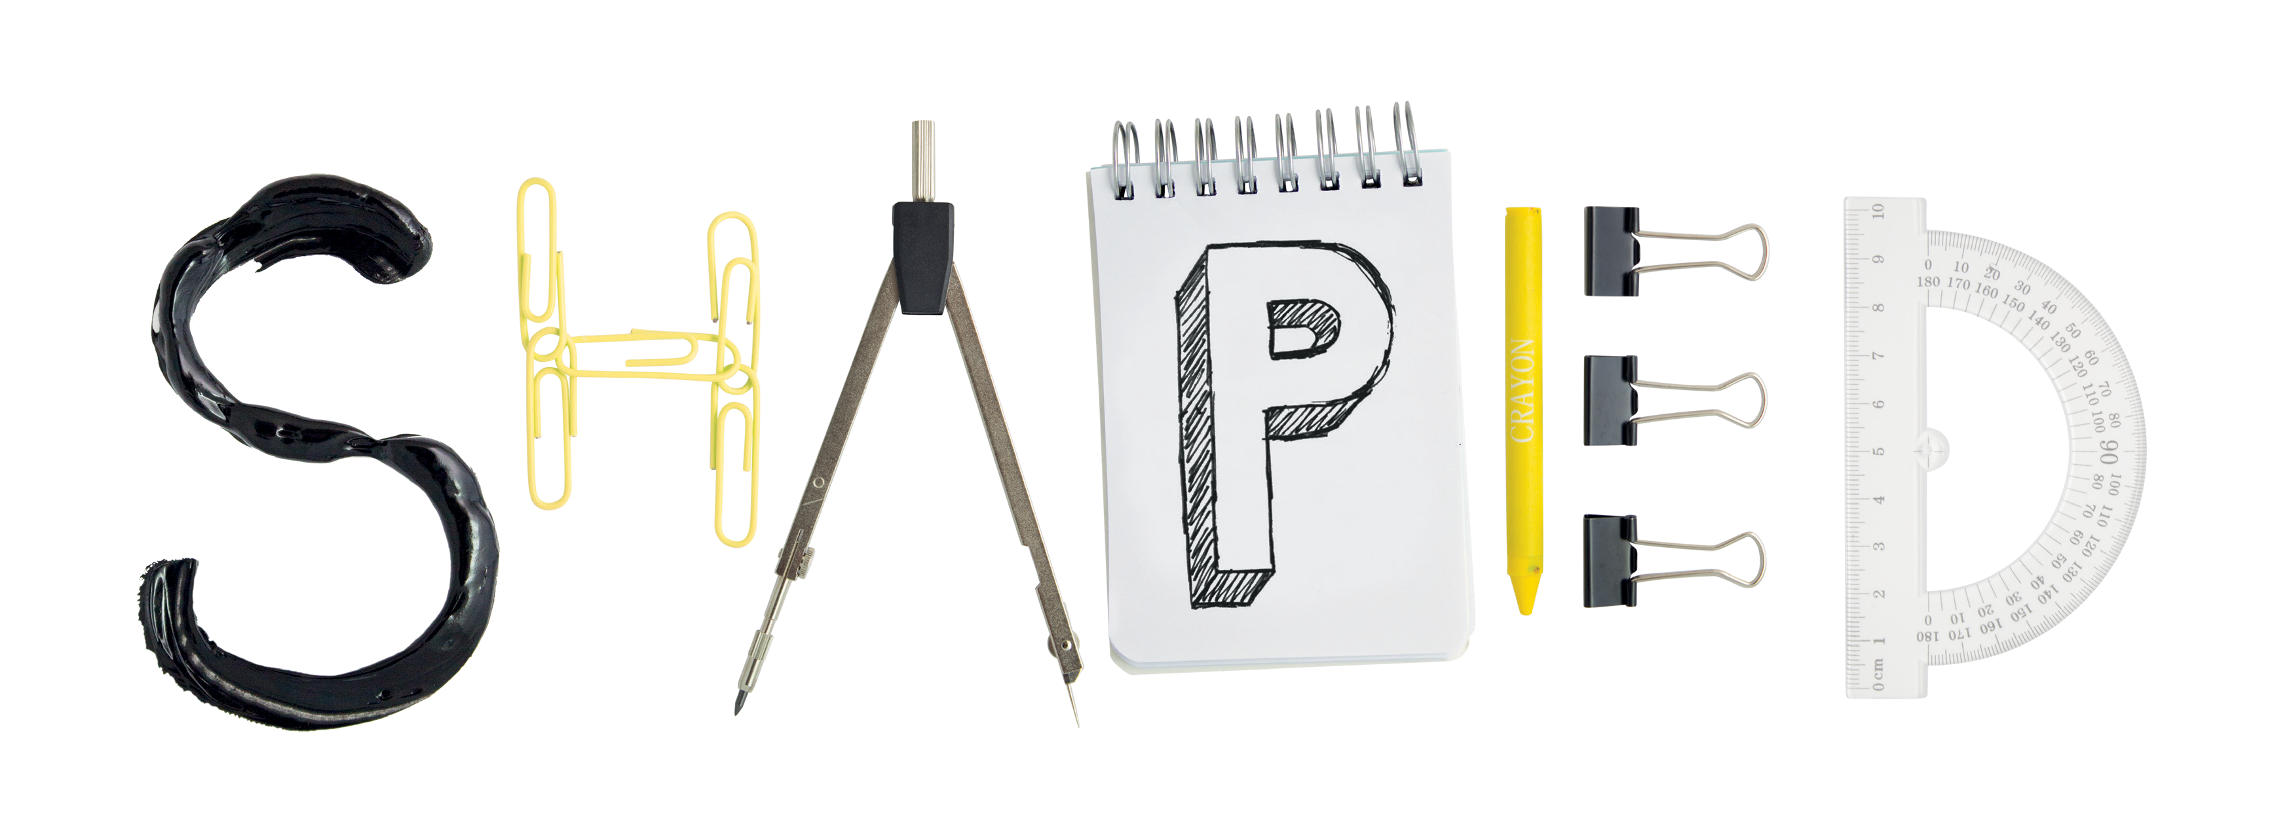

**the Department of [*xxxxxxxxxxx*]**

**Together we create a better education**

**Find out more at:**

**ucl.ac.uk/[*xxxxx (or link to Moodle page)*]**

**STUDENT ENGAGEMENT**

**You**

**We have [*launched a scheme for you to view your exam papers with your personal advisor.*]**

You told us [*you would like some feedback on your individual exam performance, even if you passed…*]