How to Add an Early Module Feedback Questionnaire (EMFQ)
- To add the EMFQ, go to your Moodle course, Turn editing on

- Then click Add an activity or resource
- Select Questionnaire which appears half way down the list and click Add
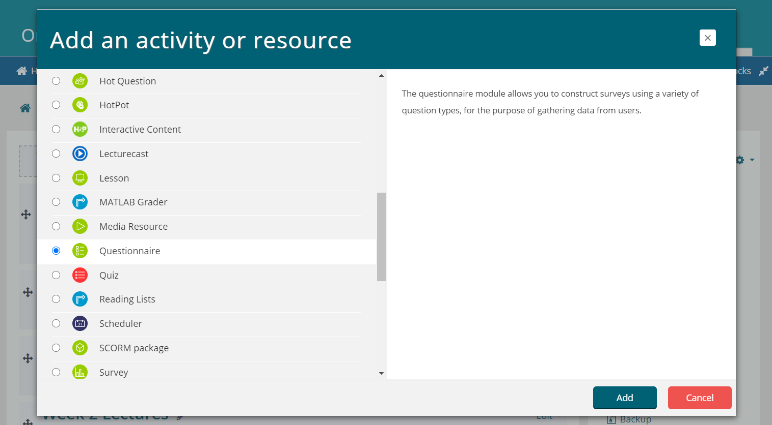
- Now follow the steps on the next page to ensure that the correct template and options are selected for the questionnaire. The next page below provides the exact options to select.

How to select the correct options and template for your EMFQ

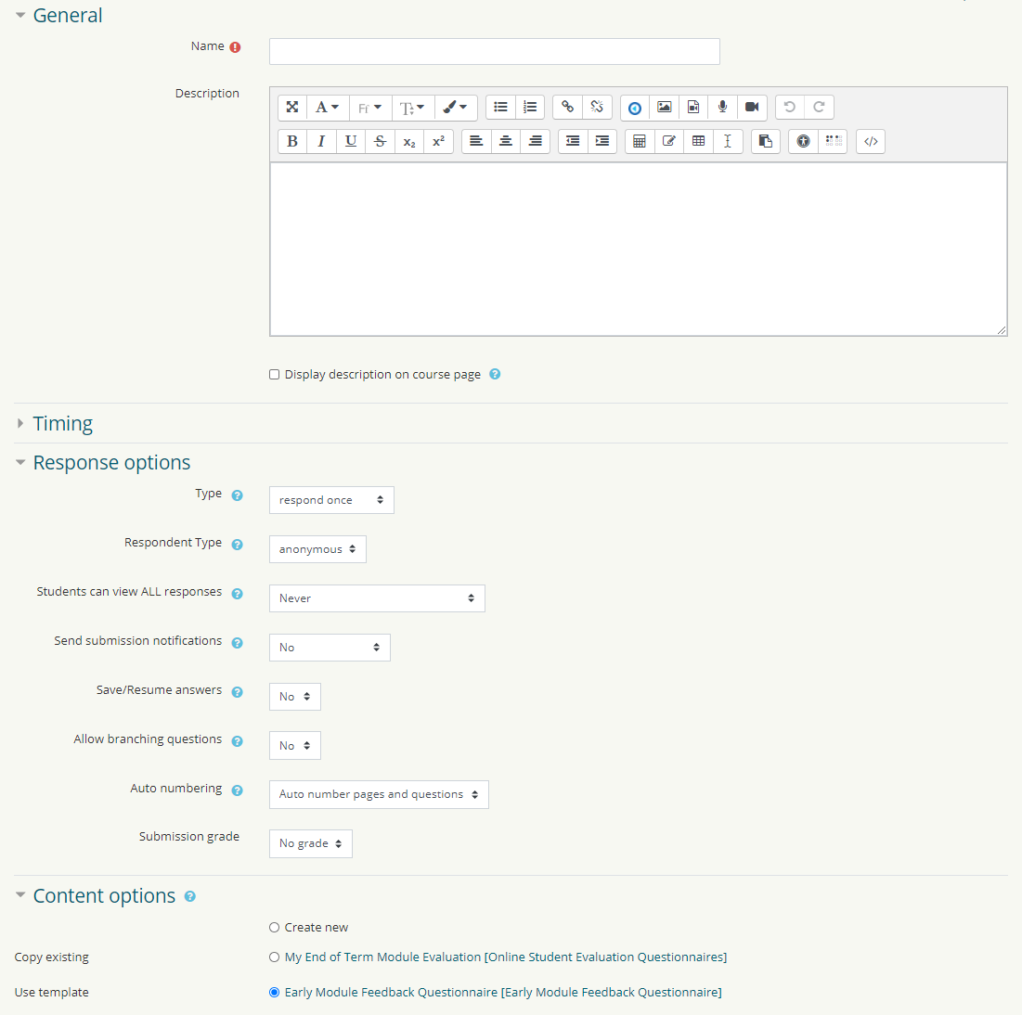
1) Name Your Evaluation e.g. Early Module Feedback Questionnaire + the module code
6) Scroll to the end of page and click Save and Return to Course
Leave the other settings as they are fine as the default
5) Click on Content options, and Use template and select:
Early Module Feedback Questionnaire
2) Set Type to Respond Once
3) Set to Anonymous
4) Set to Never
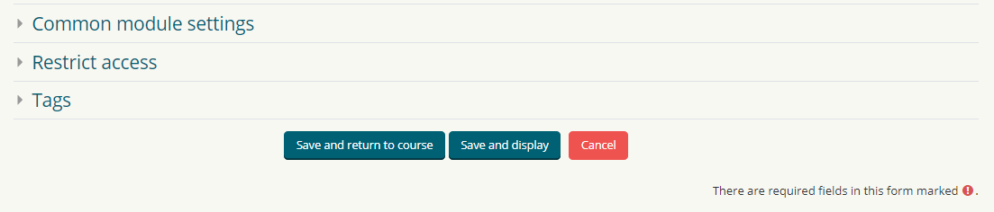
6) Then Click Save and Return to Course
5) Click on content options and a long list of templates will appear.
Scroll down and select:
UCL MODULE EVALUATION TEMPLATE COURE (DO NOT DELETE!)

How to view your EMFQ results

- Go to your Moodle course, and click on your EMFQ

- Then click on View All Responses and your questionnaire results will load up.

