Guide to using UCL Module Evaluation Questionnaire (MEQ) templates on Moodle

This document will guide you through importing one of the two UCL Module Evaluation templates, which have been developed to support staff with setting up an MEQ on Moodle.
The basis for both templates are the five core questions which were developed by the Harmonising Module Evaluation project. These support the development of a core set of institutional questions across all modules, serving as a broad diagnostic tool, and were developed to be relevant to all modules.
A larger question bank, drawing on frequently used questions from across the institution has been incorporated into the second template.
We encourage staff to consider including at least the five core questions as part of your module evaluation.

This guide covers:
- How to add an MEQ from a UCL template on Moodle
- How to select the correct options for your MEQ
- How to manage your MEQ questions
- How to add your own questions to your MEQ template
- How to rearrange the MEQ question order
- Update the title of your MEQ
- How to view your MEQ results

How to add an MEQ from a UCL template on Moodle

- To add an UCL Module Evaluation Template go to your Moodle course, Log In and Turn editing on

- Find the area of your course where you would like to add the MEQ and click Add an activity or resource

- Select Questionnaire which appears halfway down the list and click Add

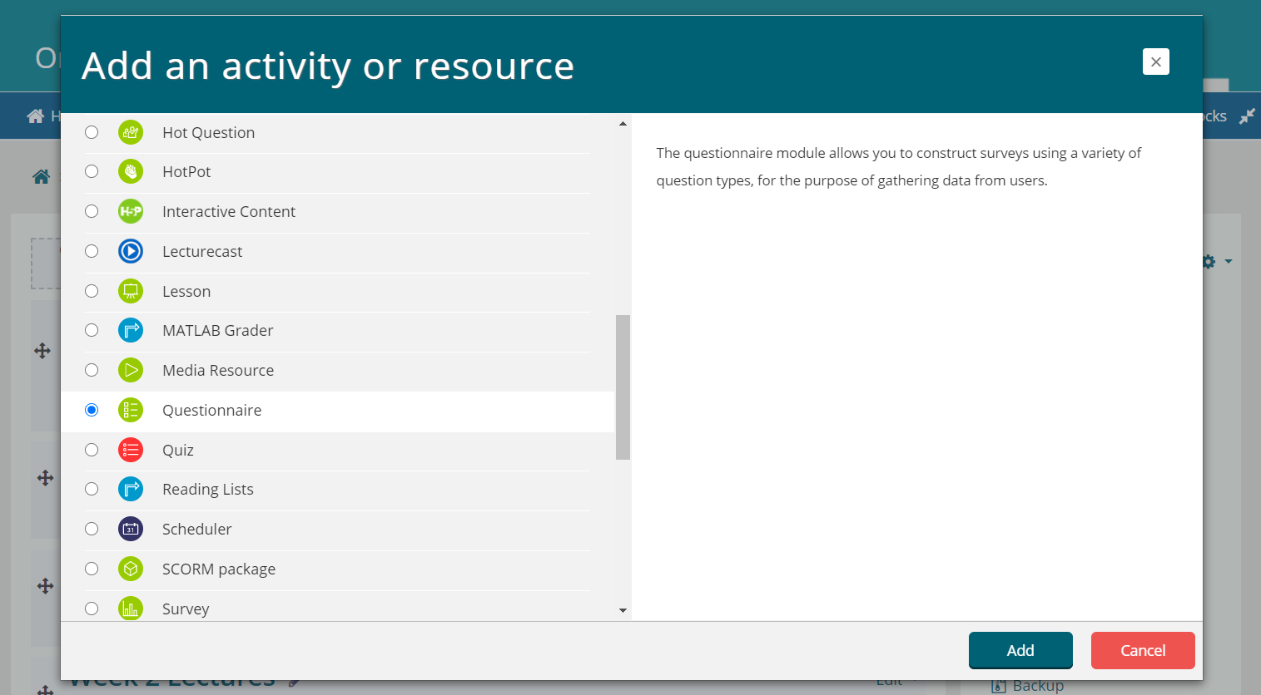
- Now follow the steps on the next page to ensure that the correct template and options are selected for the questionnaire. The next page below provides the exact options to select

How to select the correct options for your MEQ

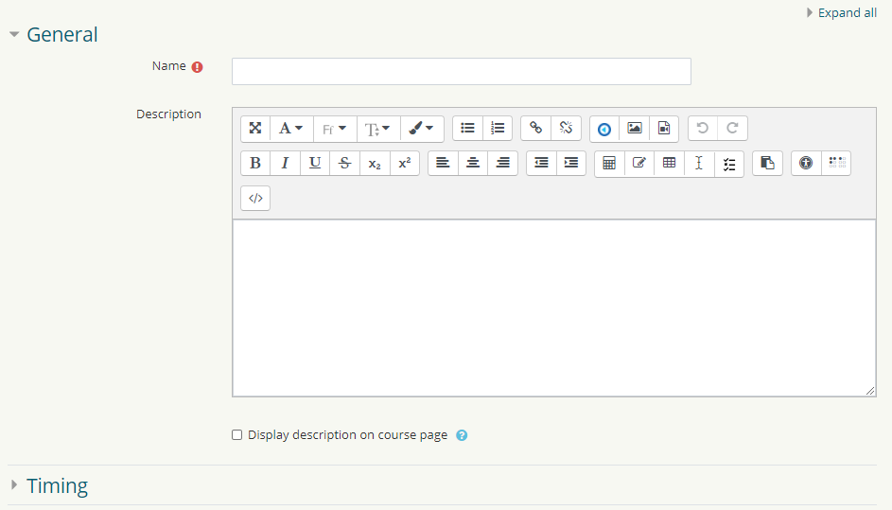
1) Name Your Evaluation e.g. MEQ + the module code

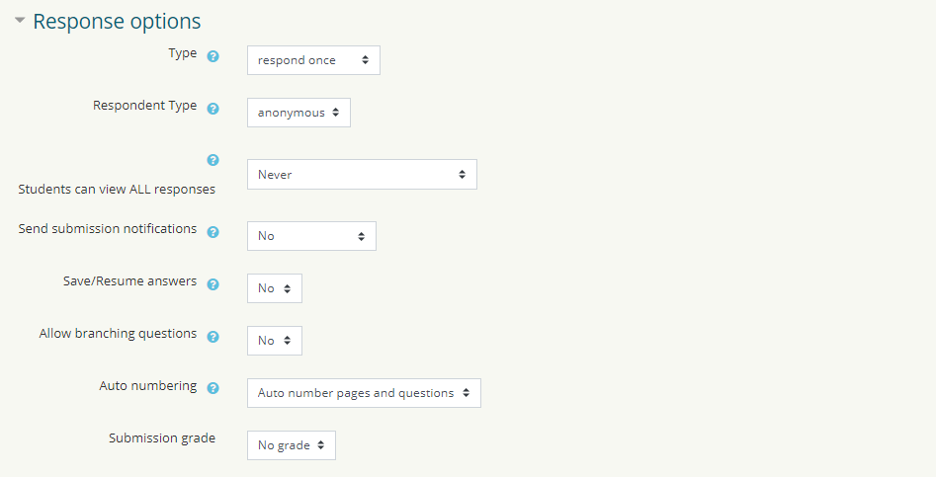
5) Click on Content options, and Use template and select from the list:
*UCL Module Evaluation (Question Bank with Core Questions)… OR
*UCL Module Evaluation (Core Questions)…
Leave the other settings as they are fine as the default
4) Set to Never
3) Set to Anonymous
2) Set Type to Respond Once
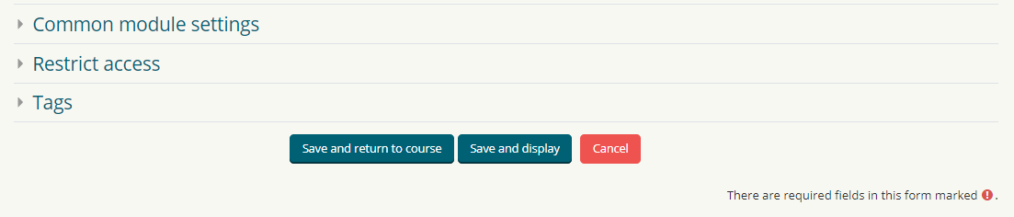
6) Close Response Options and click Save and Return to Course
6) Then Click Save and Return to Course
5) Click on content options and a long list of templates will appear.
Scroll down and select:
UCL MODULE EVALUATION TEMPLATE COURE (DO NOT DELETE!)

How to manage your MEQ questions

If you have imported the template with the question bank, there are 22 questions which you may want to refine by removing some of the questions. This can be done as follows.
- Go to your Moodle course, and click on your MEQ (ensure editing is switched on)

- On the next screen click Questions

- You will be presented with the list of questions. To delete a question click the X above the text

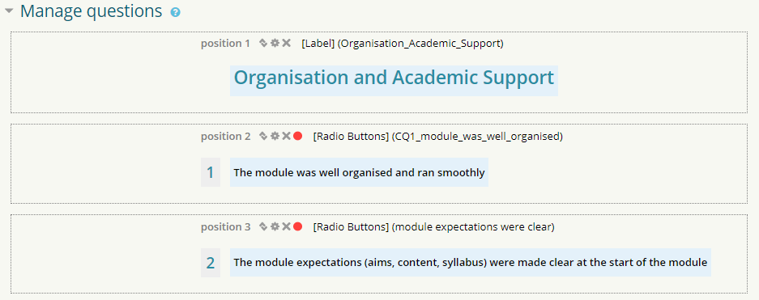

- You will be prompted to confirm and click Yes. The question will now be deleted

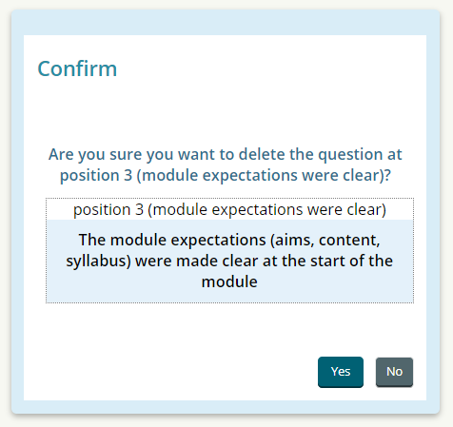

How to add your own questions to your MEQ template

If you have imported the template with just the five core questions you may want to supplement these with your own questions. This can be done as follows. Repeat stages 5 & 6 from the previous page and
- From the drop down menu select the question type you wish to add

For example to add a question with a 5 point rating scale select Radio Buttons and click Add selected question type

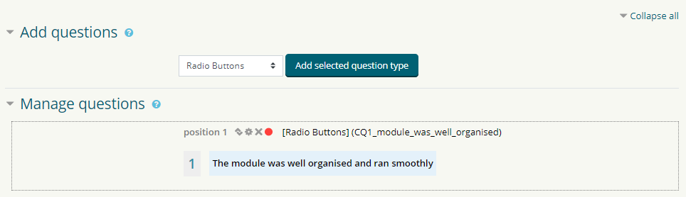

- On the next screen enter the required information noting the following

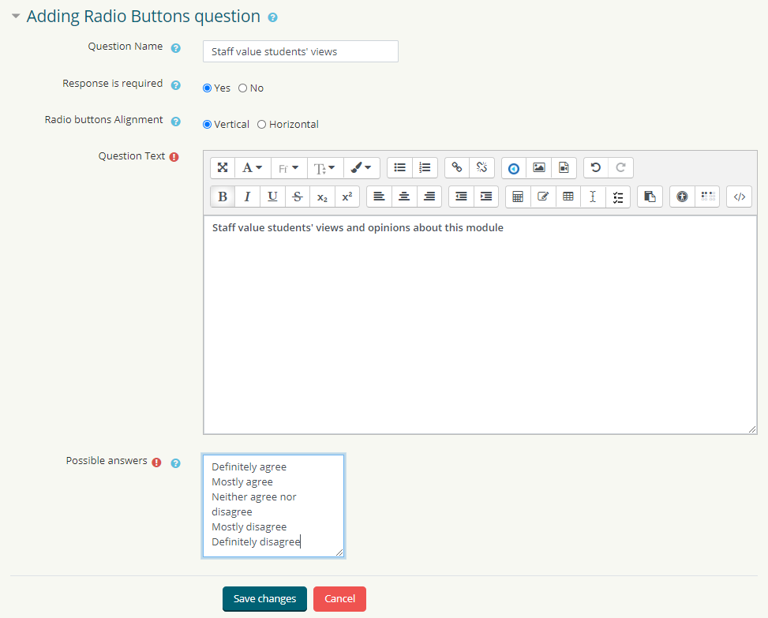
Select Yes to require a response to the question

Enter the possible answers a student can select here. Click Save changes to add your question

Enter your question text here. This is what the student will see

This is only used if you plan to export responses to Excel/CSV format

- To add a “free text” open ended question select Essay Box and click Add selected question type

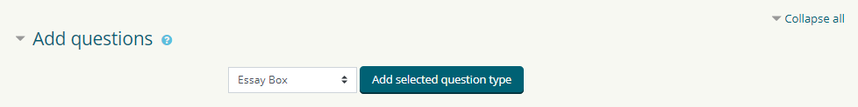

- On the next screen enter the required information noting the following

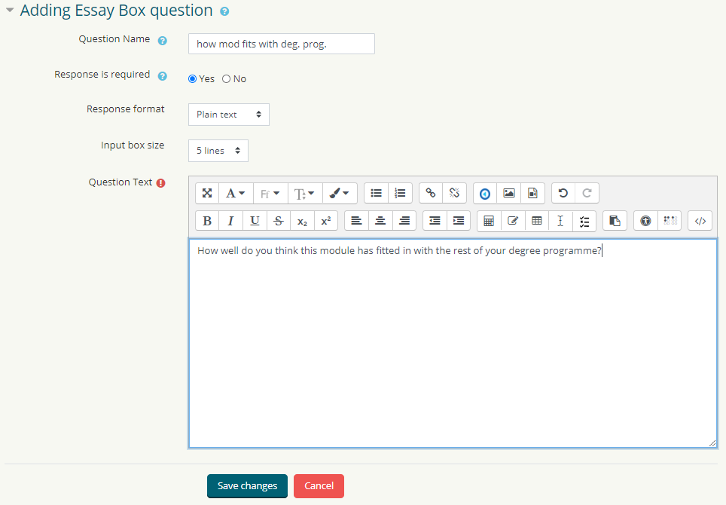
Enter your question text here. This is what the student will see. Then click Save changes

Select Plain text for a simple text box

Select Yes to require a response to the question

This is only used if you plan to export responses to Excel/CSV format

How to rearrange the MEQ question order

If after removing and creating a series of new questions, you would like to change the order the questions appear in you can do so as follows.
- Go to your Moodle course, and click on your MEQ (ensure editing is switched on)

- Click on Questions

- Find the question you wish to move and click on the Move button

- Select the new Position number you would like your question to appear in

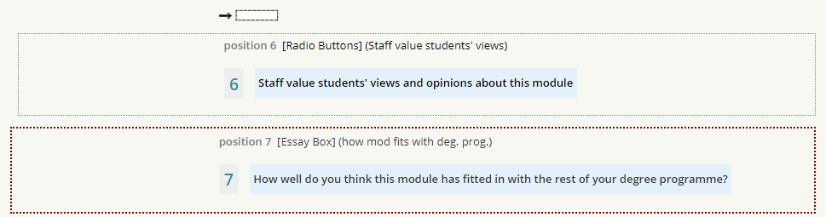

Update the title of your MEQ

After importing your MEQ template, and making any adjustments to your question set, you will need to amend the generic subtitle (which will be visible to students) to incorporate your module code. You are also able to edit the introductory text which we have provided.

- Go to your Moodle course, and click on your MEQ (ensure editing is switched on)

- On the next screen click Advanced settings

- On the next screen update the Subtitle field with the appropriate Module Code

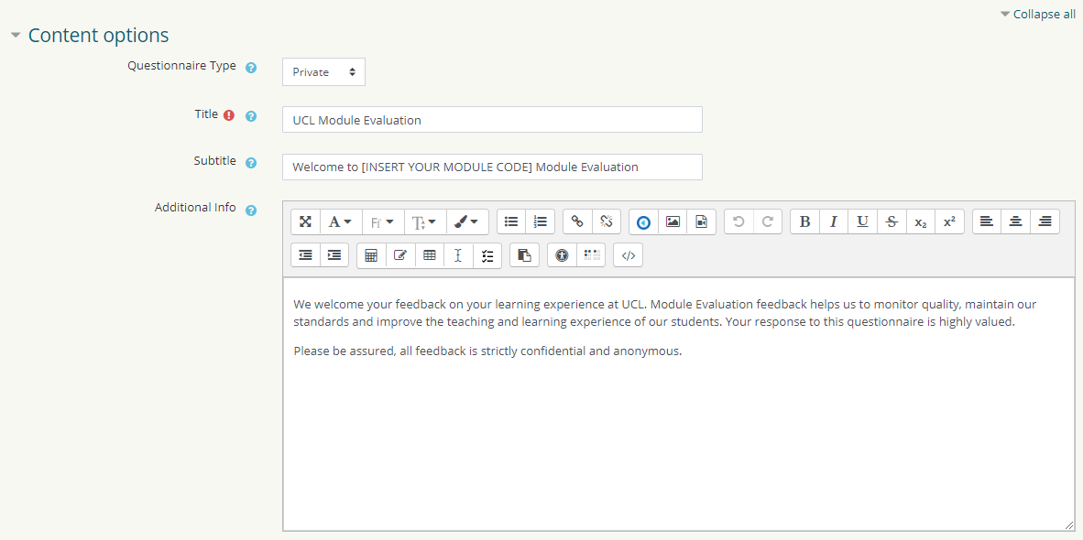
An intro to the MEQ has already been written for you. Please feel free to edit this as you see fit and click Save and return to course

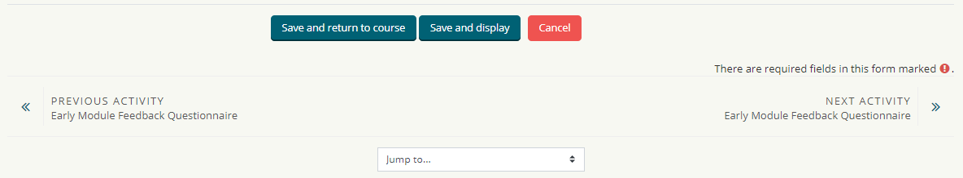

How to view your MEQ results

After several weeks, or when you have received sufficient student responses you can view the MEQ results, presented as bar charts on Moodle, or download the results as a CSV file.

- Go to your Moodle course, and click on your End of Module MEQ

- Then click on View All Responses and your questionnaire results will load up.

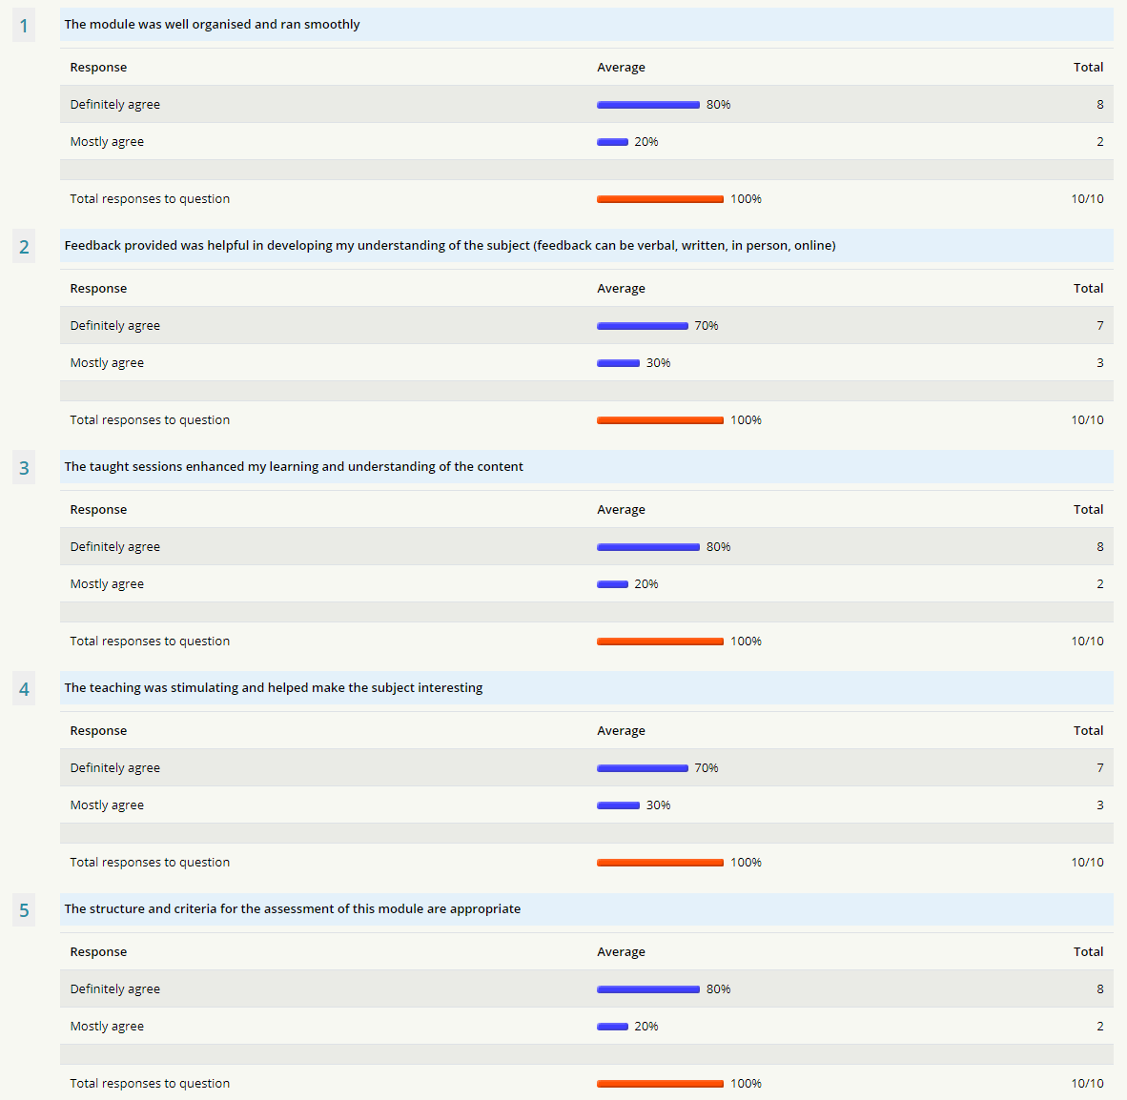

- From the Administration menu on the right, you can download the responses as a CSV file

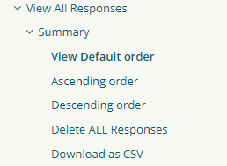

- Select your options and click download
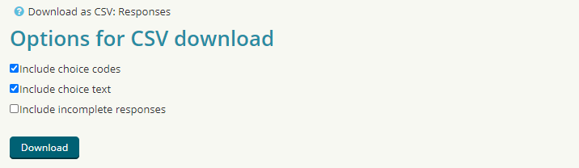
- Results for each respondent will be displayed as follows

