AssessmentUCL
2020-21 Evaluation Report
Student Experience Transformer
UCL ACADEMIC SERVICES

Table of contents

Executive summary 3
AssessmentUCL student survey detailed findings 6
Detailed student survey findings by question 8
AssessmentUCL staff survey detailed findings 33
Detailed staff survey findings by question 34
AssessmentUCL Changemakers Focus Group Discussion analysis 70
Instagram slides for communicating results to students 74

Executive summary

Context
The shift to remote teaching and assessment in March 2020 enabled UCL to accelerate its long-term aim to provide an inclusive and supportive dedicated digital assessment platform for its students and staff. Selection, procurement and testing of Wiseflow was completed in early 2021 resulting in the successful delivery of over 1000 centrally managed exams and 50 pilots for over 51,000 candidates. The platform was badged as AssessmentUCL. To increase our understanding of what went well and to identify those areas needing improvement, students and staff completed separate surveys with a response rate of 13% and 14% respectively. In addition, a small team of student changemakers undertook individual interviews and focus groups. Three student interns worked with the project team on analysing survey data culminating in this report.

Methodology and limitations
The survey collected quantitative and qualitative data. To analyse the free-text questions, overall themes were identified within the responses. Individual comments were then coded to establish the overall comment sentiment and the specific themes mentioned within each one and the sentiment towards this theme. The comment sentiment for the overall comment and the specific theme sentiment, if available, were then calculated. Within each of the themes identified, each comment was once again read and the common points lifted from each theme and summarised via tables. For each survey, keys findings have been identified as priorities to enable the AssessmentUCL project team to create a roadmap for development and enhancement. Some students sat more than one exam (the most common was two exams), and some staff marked more than others so there is variability in the levels of reported experience. Whilst these data provide some insights and can be used to improve AssessmentUCL in general, they not fully representative of the views of the entire student or staff populations.

Summary of findings
63% of students’ considered their overall experience with AssessmentUCL as positive. Most of the negative comments were very specific regarding a particular issue they faced in the platform; their positive comments were less specific and focused more on the overall experience. 42% of staff respondents chose to mark externally of the system, either via another application or offline. Of those that marked on the platform, 64% of the respondent’s comments regarding their experience of marking using AssessmentUCL compared to other systems were negative. The comments made by staff were very specific about the challenges they faced and the improvements they would like to see implemented.

Students’ priorities
- Ensure clarity with regards to the various timings of exams (including the submission hour) for all students on all of their exams.
- Practice exams should reflect the exact exam that a student is going to take, multiple practice exams will be required to ensure this.
- Provide one information page on the UCL website that provides all the information regarding AssessmentUCL, including the link to the platform, and support and all instructions and tutorials. Therefore, reducing the number of emails sent to students.
- Allow more than one submission within the time frame of the exam and allow multiple file formats, not just pdf. This will help with submission issues.
- Put in place an emergency submission pathway for students facing technical issues to avoid them having to take an LSA when they have completed the exam.

Staff priorities
- Ability to open multiple scripts at once, whether all on one question or multiple full scripts in separate tabs.
- Allow different assessors to mark separate questions, therefore allowing each question to have separate marks that are automatically totalled.
- Quick comments. Saved comments that can be quickly added to a script to save marking time.
- The sharing of marks and comments with co-assessors or reviewers should be able to be set for every paper and therefore comment within a module, instead of manually setting this for each comment, on each paper, for each student.
- The ability to upload annotated pdfs back into the system in order for reviewers/students to see the comments on the scripts if the assessor has chosen to mark offline.

Conclusion

The findings from the student and staff surveys reveal a set of positive and negative experiences. It is worth remembering that the context for taking and marking exams was characterised not only by remote working, which accentuated the stresses and strains of the exam period, but the adoption of a new technology within a short timescale. On the positive side, the platform was robust and delivered a largely consistent experience. On the negative side, there are improvements that must be made to ensure success in rolling our AssessmentUCL to more departments this year. Priorities from these two surveys are valuable in helping to inform the 21/22 Assessment Operating Model; the work of the new digital assessment advisory team; and forthcoming central and departmental communications with faculty and students. It also provides compelling evidence for the further development of the Wiseflow platform and the procurement of additional assessment platforms.

Acknowledgements

We would like to express our sincere appreciation of the UCL Student Changemakers who undertook interviews and focus groups with students, Kellynn Wee, Abigel David and Ebani Dhawan and the UCL Student Interns, Isabelle Hawley, Memta Jagtiani, and Abigel David, who undertook analysis of the survey and compiled a detailed report.

AssessmentUCL project team
23rd September 2021

AssessmentUCL student survey: detailed findings
The student questionnaire contained the following sections.
- AssessmentUCL support and training BEFORE your exams/coursework deadlines
- Support DURING exams
- Assessment communications
A summary is given for each section with details of responses provided by question.

The response rate for the student survey is slightly less than 13% (<2047/16000*100). Most students had completed at least 1 exam using the platform but there was variation in the number of exams students had sat using the platform. More than 75% of the respondents found the platform easy to use. 63% of the respondent’s comments regarding their overall experience with AssessmentUCL were positive.

Most of the negative comments were very specific regarding the issue they faced; the positive comments were less specific and focused more on the overall experience. Students who had a positive experience thought the platform was clear and easy to use: they found the practice exam, the user-guides and the videos very helpful and thought it was a great experience overall. Many of these students did suggest improvements to the platform and the topics mentioned were mirrored in the negative comments. For example, numerous comments were made about the lack of clarity regarding the submission hour and students were unsure for which exams they received the submission hour for. Some students received notifications showing that the submission was “Late”, which made them panic. There was no clear timer on the platform to show how much time was left. Students were also unclear as to the timing for their exams, for example whether they had 2 hours within a 24-hour window or 24-hours from the time stated on the portal. More clarification from the platform and from departments is needed on this issue. The full table of comments can be seen in Tables 3.1 and 3.2 below.

Support before the exams
Most frequently accessed training and support was the practice exam(s), with over 80% of respondents who used it before their first exam. Training videos and user guides accounted for 22% and 38% of respondents who used it before their first exam, respectively. Practice exams seems to be a very important and useful tool for students as it familiarises them to the online platform and online submissions. Almost 50% of those who did not use the practice exam felt like they didn’t need it; the remainder did not use it due to practical reasons.

75% of the overall sentiment towards the support that was provided before the exams took place was positive. 87% of the respondents’ comments on the practice exam suggested that it had helped students prior to taking their exam(s), however some comments stated that the exam should be more specific as many students did not feel that it reflected the exams that they took, including how the timing would work. Students also very much appreciated their department providing prior training regarding the exam platform and information as to the specific timings of their exams. The majority of negative comments were regarding the lack of support given, suggesting that students were not able to easily access the videos and user guides. Students received a high number of emails and this caused many of them to miss important information. It has been suggested that a single information page (e.g. on the UCL website accessible through an Internet search) which contained all the links and information students could need would be very welcome. Fewer emails would also be appreciated. Further comments were made and can be seen in Tables 7.1 and 7.2 below.

Support during exams
More than 70% of the respondents had positive views about exam instructions; they received sufficient guidance and knew what to do during their exam(s). The most common problems respondents faced around submitting exam(s) were Internet and connectivity issues, difficulty creating a PDF file for submission and other issues (e.g. submission process and upload process). Most of the respondents (77%-86%) did not contact anyone for support with AssessmentUCL during their exam(s).

72% of the overall experience of submitting their exams was positive. The negative comments were again very specific, however the positive comments did also suggest some improvements. The highest number of negative comments regarded the timing issues mentioned above, followed by issues with assembling the exam prior to submission. Specific comments were made on why the platform only accepted one file format, and why resubmissions within the allotted time frame were not allowed. Multiple submissions were allowed in the practice exam which caused confusion as students assumed this would be the same for the actual exam. Further comments were made on the exact issues students faced with their submissions in Tables 9.1, 9.2 and 10.1.

The support that students received during the exams was an area that received fewer comments (only 95 out of 2047 respondents) however it was also the only area where the comment sentiment was overall negative (53%). This suggests that the number of students who needed support was minimal, which is a positive, however those that required it found the experience unhelpful. Some students were unsure who to contact. This could be due to the issue students had regarding accessing the information as mentioned above. When they then contacted their departments, many found that their departments did not understand the platform and could not help. Also it was mentioned that support was not available for the entirety of the exam duration. Students were also unable to get into contact with support outside of the UK working hours, which posed an issue for overseas students. The technical issues that a minority of students faced during the exams led them to having to sit a LSA which caused further distress. Students expressed the need for an emergency backup in case they encountered issues, such as a department inbox where students who are experiencing issues could send in their paper for it to be anonymously marked.

Communications
The vast majority of respondents (96%) received information about AssessmentUCL in time to prepare for their exam(s). Most of them received information about the platform via email, either from their department or from Exams at UCL, and most of them also preferred to receive communications via email. As such, email is deemed as the most convenient method of communication for students. Students also used social media to communicate information with their peers.

Detailed student survey findings, by question

Q1. How many exams did you do on AssessmentUCL/WISE flow in April and June 2021?

Due to the question’s wording some students may have excluded exams that took place in May, only answering with respect to their experience of exams that they have taken in April and June. As this question has had 2,042 respondents it is vital to consider this potential deviation.

Figure 1.1: Bar chart summarising Q1
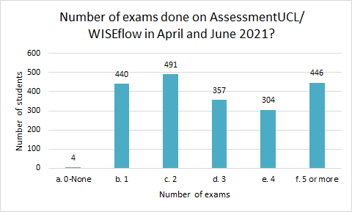

Most students did at least 1 exam on AssessmentUCL in April and June 2021, with the most common category being 2 exams. Other categories were also quite high, indicating variation in the number of exams among the respondents.

Q2. Please select your view on the following statements regarding the AssessmentUCL platform (also known as WISEflow):

Table 2.1: Total number of respondents (N) and frequency of views (%) for Q2

Items | N | Agree/strongly agree | Neutral | Disagree/strongly disagree
Using the practice exam on AssessmentUCL was helpful. | 1985 | 75.5 | 14.3 | 10.2
Accessing the AssessmentUCL platform was straight-forward. | 2035 | 85.5 | 5.8 | 8.7
Accessing my exam questions was straight-forward. | 2028 | 91.9 | 3.0 | 5.1
It was easy to submit my answers to exam questions. | 2024 | 83.2 | 6.7 | 10.2
The platform was easy to navigate. | 2022 | 84.2 | 7.5 | 8.4
I readily understood AssessmentUCL language e.g. flow, handin etc. | 2019 | 80.1 | 9.4 | 10.5

In general, all 6 items above capture the platform’s ease of use. More than 75% of the respondents either agreed or strongly agreed to all of the items listed above, suggesting that they found the platform easy to use. Less than 25% of the respondents had neutral or negative views towards the platform’s ease of use.

Q3. Please comment on your responses to the above statements, as we would like to hear more about your experience with AssessmentUCL:

Overall sentiment – 840 total comments

The overall comment sentiment was majority positive. 63% of respondent’s comments, even though they may have suggested improvements, were positive regarding their overall experience with the platform.

Figure 3.1: Comment sentiment

Comment Breakdown

Most of the negative comments were very specific regarding the issue they had with the platform; fewer negative comments were made on the overall platform experience. Conversely, the positive comments were less specific and focused more on the overall experience. The total number of specific negative comments was 448, while the total number of overall positive comments was 480.

Figure 3.2: Comment breakdown

The area which had the highest number of comments was upload & submission, with most of these comments being negative. The second area was that of the timers, again most of the comments were negative.

Example comments:

“I thought that the online examination websites were very straightforward to use and a great alternative to in person examinations during the ongoing pandemic, it was a safer and swifter process, and I would be happy to dude again for future examinations at UCL, especially with the current pandemic.”

“It was all very clear and intuitive however there was one issue. In timed exams (less than 24 hours) there is a submission time shown but then there's an additional hour window where the exam can be submitted. There was no timer for this additional hour nor was it clear on the page that the additional hour was going to happen. This ambiguity left myself and many classmates stressed and confused regarding the additional hour”

“The language and guidelines on the platform were easy to understand and made access and submission of exams straightforward. “

“Only being able to hand in documents in PDF form made it more difficult and time consuming as I had to spend several minutes changing all the documents to PDF.”

“With regards to access, I had to access Assessment UCL via a link on my email. It was not straightforward to find AssessmentUCL via a Google search or on the UCL website which I think it should be.”

“I strongly did not like only being able to submit once.”

Table 3.1: Main Themes – Negative
Timers | Upload/  Submission | Access to Platform | Overall Experience
Submission Hour timer  - No countdown visible  - Not mentioned prior to the exam  - Not included within the flow | Accept more than one file type e.g., word, jpeg etc. | More links to the website on Moodle and the UCL website. Also, clearer instructions on how to access the website. | Prefer Moodle/AssessmentUCL/  Turnitin
For each type of exam:  - Be more explicit as to the timing for the exam  - Include more instructions & examples of how the timings work | Allow the option to update the submission before deadline. | Remove browser dependency / make it more clear | Was stressful to understand a new platform as well as do the exams
Remove the late message if submitted within the submission hour | Would prefer the choice to submit question by question or as a whole exam | Website crashed when many people were accessing it which inhibited submissions
Accept submissions after the deadline but apply a late penalty - no automatic LSAs | Automatically hand in work at submission time if uploaded, to help in situations where there are issues with submission
Show the countdown timer even if the browser is minimised | Remove blank submission option

Table 3.1 continued
Interface - WISEflow | Interface – Exam & cover sheet | Practice Exam | Type of Exam
Lack of understanding of the 'Flow' terminology - seems overly complicated | Confusing cover sheets  - Module specific cover sheets  - Tick box  - More instructions | Instructions  - More accessible instructions  - More accurate instructions for each exam type  - Ensure that the exam actually reflects the type stated (e.g. some exams stated to completed by hand, whereas the practise exam specified to be completed on word) | FlowMulti  - Not useful and hard to navigate.  - Found the process of uploading separate pdfs to be time consuming  - Would have liked a way to view all questions at the end.  - Would have preferred the exam to be given in one pdf.
UI  - More professional  - Less complicated  - Important features highlighted | When required to type up answers in word on the exam paper after downloading the exam, the formatting would mess up | Would prefer if the practice exam reflected the actual exam type the student was taking | Would like more information as to the type of exam before the exam starts
 | Word count confusions (especially for handwritten submissions) | Think a video would be helpful for each exam type
 |  | Too many emails - led to people missing information/instructions

Table 3.2: Main Themes – Positive
Timers | Upload/  Submission | Access to Platform
Countdown was clear and useful | Fast upload | Easy to access
Enjoyed being able to do the exam within a 24hr window - flexible start time | Easy, stepwise, submission process

Table 3.2 continued
Interface - WISEflow | Interface – Exam & cover sheet | Practice Exam | Overall Experience
Easy and clear UI - Flows were easy to understand | Like that the cover sheets were separate | Practice exam was useful | Great experience
Great to view all exams in one page |  | Videos were helpful | Software was clear and easy to use
 |  | Clear instructions

UCL Summer school (33 respondents)

AssessmentUCL support and training BEFORE your exams/coursework deadlines

Q4. Please indicate whether you accessed any of the following AssessmentUCL training and support materials and when:

Table 4.1: Total number of respondents (N) and frequency of views (%) in Q4
Items | N | Not aware/didn’t use it | Used before first exam | Used on first exam | Used after first exam
Practice exam(s) | 2074 | 12.1 | 82.7 | 4.3 | 0.9
Training videos | 2148 | 76.3 | 22.1 | 1.2 | 0.4
User guides | 2131 | 59.3 | 37.8 | 2.4 | 0.5

From Table 4.1, it is clear that students found practice exam(s) the most useful tool as majority of the respondents (83%) used it before their first exam. In contrast, most respondents were not aware of or did not use training videos (76%) and user guides (59%), suggesting less utility in these tools.

Q5. If you did the AssessmentUCL Practice Exam, how did it help?

Table 5.1: Total number of respondents (N) and frequency of views (%) in Q5

Items | N | Agree/strongly agree | Neutral | Disagree/strongly disagree
It familiarised me with the platform, so I knew what to expect. | 1844 | 89.2 | 6.1 | 4.7
I learnt what hardware and software I'd need to prepare and submit answers. | 1812 | 76.3 | 14.7 | 9.0
I learnt how to submit my responses to exam questions. | 1840 | 88.9 | 5.7 | 5.4
Its instructions on how to use AssessmentUCL were easy to follow. | 1838 | 87.0 | 7.7 | 5.3
All important information about preparing for exams was clearly stated. | 1832 | 76.1 | 13.6 | 10.2

76% of respondents either agreed or strongly agreed to knowing what hardware and software they needed to prepare and submit their answers and to all important information about preparing for exams being clearly stated. Close to 90% of respondents agreed or strongly agreed to being familiarised with the platform and knowing what to expect, learning how to submit responses to exam questions and finding the instructions on how to use AssessmentUCL easy to follow. All in all, these suggest that the practice exam was important and useful in familiarising students with the online platform and online submissions.

Q6. If you didn't use the AssessmentUCL Practice Exam, please could you choose the relevant reason why.

Figure 6.1: Pie chart summarising Q6
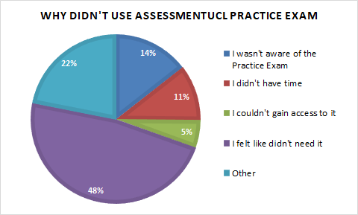
The total number of respondents for this question is 489. Almost half of those who did not use the Practice Exam felt like they didn’t need to use it, so perhaps it is not a relevant tool for them. The other half had varied reasons for not using it: not being aware of it, not having time or access, and other reasons (which made up almost 25% of the responses).

Q6a. Specify ‘Other reasons’ in Q6.
There were only 6 responses to ‘other reasons’:
- Had used WISEflow before (67%)
- During the already stressful time building up to the exams they did not have the time or the bandwidth to take the practice exam (33%)

Q7. Please comment on the support that was provided before your exam(s) took place:

Overall Sentiment - (437 total comments)
The overall sentiment towards the support that was provided before the exams took place was 75% positive. Three quarters of the comments mentioned areas where they received support from that helped them prepare for their exams.

Figure 7.1 Comment sentiment

Comment Breakdown
Across all the categories there were more positive comments than negative comments. The highest number of positive comments were those stating that the overall support they received was good. The practise exam gained the second highest number of positive comments, 87% expressed that the practise exam had helped them prior to taking their exam/s.

Unlike Q3. the highest number of negative comments were regarding the overall access to support before the exams took place, fewer negative comments were specifically aimed at the specific forms of support the student had received. This may suggest that once the support had been found the quality was a high standard, however many people could not access any support and therefore had a negative experience.

For example, a lot of comments stated that there weren’t any videos or guides to help and also many people said they received a lot of emails before the exams took place. It is likely that the number of emails contributed to people missing the links to the information. A more condensed information portal is recommended. This could take the form of one webpage that has everything on, e.g., links to the platform, links to all the support materials (videos etc) and only that link is sent to the students. Also, it would be useful if this page was accessible through an internet search of ‘AssessmentUCL’, removing the issue that many students had of having to use their emails to access the portal.

Example comments:

“I felt that there was enough support provided by UCL on how to use AssessmentUCL. There was a video and step-by-step guide on how to use the platform so that was really helpful. However, it could be improved by putting all the information on 1 website. For example, the Exam Timetable should be included on the AssessmentUCL platform rather than on a separate website. Also, the information about exams in general was spread across several webpages. There were the exam FAQs on the UCL student website and then the Confluence page on how to use AssessmentUCL. It would be easier to include them on 1 webpage.”

“The practice exam was a great way to prepare for submitting my exam answers correctly and relived any worries I had about online submission.”

“Accessing the platform was straightforward due to the regular email reminders (although I seemed to get everything in duplicate). Regarding the flow, it was initially unclear for, say, two-hour exams taken within a 24 hour period how we were to start the clock before we were actually in the 24 hour exam period. I would have appreciated an additional practice exam to show off the procedure. “

“The professor created a PowerPoint presentation with tips for taking her exam and where previous students often went wrong. THAT was helpful.”

“It would have been helpful if we were made more aware of the in-depth AssessmentUCL user guide. I had to search for it myself and only then did I discover that it existed.”

Figure 7.2: Comment breakdown

Table 7.1: Main themes – Negative
Practice Exam | Department support | User guides / Instructions / Videos | Communications (e.g. askUCL, emails, etc.)
Practice exam didn't help for timed exams | Tutors had little/no information as to how the platform would work | Step by step instructions for each type of exam | Support was not clearly advertised
Exam should have been more specific depending on the exam to be taken | Lack of understanding from tutors as to the exam format | Did not realise there was user guides & videos - missed the emails
Practice exam allowed resubmissions which wasn't allowed in the exam |  | Timing was not clear / explained well

Table 7.2: Main themes – Positive
Practice Exam | Department support | User guides / Instructions / Videos | Communications (e.g. askUCL, emails, etc.)
Practice exam was helpful | Departmental workshops & revision sessions were very helpful | User guides, videos and instructions were very helpful | Email communication re practice exam & instructions were helpful
 | Instructions from tutors on Moodle/ppts |  | Reminder emails before the exams were useful

Support DURING exams

Q8. What is your view on the following statements regarding the instructions during your exam(s)?

Table 8.1: Total number of respondents (N) and frequency of views (%) in Q8
Items | N | Agree/strongly agree | Neutral | Disagree/strongly disagree
I had all the technical guidance on using AssessmentUCL that I needed. | 1830 | 72.5 | 18.1 | 9.4
I was clear on the time I needed to set aside for submitting answers. | 2003 | 76.0 | 9.2 | 14.7
I had all the information I needed to complete my exam. | 1992 | 85.3 | 8.3 | 6.4
I knew how to create my PDF documents for submission. | 1998 | 88.8 | 5.1 | 6.1
Submitting my uploads went well. | 1999 | 84.8 | 6.4 | 8.9

Between 73% and 89% of the respondents agreed or strongly agreed to all of the above items, suggesting that most of them received sufficient guidance and knew what to do during their exam(s). Of note would be the slightly higher percentage (15%) of respondents who disagreed or strongly disagreed to being clear on the time needed to set aside for submitting answers, compared to the other items that had a response of ‘disagree’ or ‘strongly disagree’.

Q9. How was the experience of submitting your exam(s) or coursework?

Overall Sentiment - (858 total comments)
The overall sentiment towards the submission of the exam was 72% positive.

Figure 9.1: Comment sentiment

Figure 9.2: Comment breakdown

As can be seen in Figure 9.2, 69% of the respondents had a positive experience overall when submitting their exams. The negative comments again were very specific regarding the issues that the particular student faced. If a student was unable to submit their exam they were understandably unhappy with their overall experience. The highest number were comments were regarding the timing of the exams and the lack of clarity regarding the submission hour. This was then followed by issues with assembling the exam prior to submission; specific comments were made on why the platform only accepted one file format,; and why resubmissions within the allotted time frame were disallowed.

Example Comments:

“Easy and straightforward. Only issue was that the exam brief requested a .docx submission and the webpage requested a .pdf submission.”

“The one hour grace period for timed exams needed to be explicitly represented.”

“In one of my exams, I was using from the start the 1-hour submission window and using office lens to take photos to create pdfs. However, the office lens crashed leading to a very stressful rushed retaking of photos and submission and meant I missed one page of working. There needs to be more and clearer contingency for these technical problems.”

“It was a smoother experience submitting one pdf for the whole exam. Opposed to submitting a pdf per question”

Table 9.1: Main themes – Negative
Timer / Timing | Single Question / Full exam | File Format / Assembling the exam | Other
Extra upload hour was unclear | Uploading question by question was stressful | Formatting the exams & converting them to pdf was difficult. Would have preferred more instructions. | Website crash
Unsure on the timing of the exam (whether 2hr in 24hr or 24hr) |  | Allowing resubmissions | Cover sheet was complicated
 |  | More file formats required | Took a long time to upload

Table 9.2: Main themes – Positive
Timer / Timing | Single Question / Full exam | File Format / Assembling the exam | Other
Appreciated the 1hr upload | Smooth uploading one pdf | Found it easy to submit in pdf | Cover sheets was easy and convenient

Q10. If you experienced problems submitting your exam(s) please select the issues listed below that affected you:

Figure 10.1: Pie chart summarising Q10
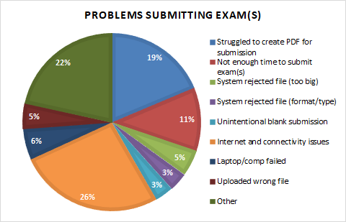
Students who encountered problems submitting their exam(s) faced a variety of technical-issues listed above. Of the more common responses were respondents who had Internet and connectivity issues, respondents who struggled to create a PDF file for submission and other issues.

Q10a. Specifying ‘other issues’ in Q10.

Figure 10.2: Comment breakdown (58 comments)

When students had an issue submitting their exams the main area they commented on was on the submission process, students who experienced any issue found it difficult to understand what had gone wrong and hence how to solve it. Many students did not fill out the cover sheet/sign the declaration of integrity and therefore could not submit their exam but could not work out what was causing this to happen. The second area where students struggled was on the upload process, browser dependency was an issue and also the time it took to upload large documents.

Example Comments:

“I thought I missed the deadline because the button was greyed out, but in fact I hadn't ticked the Declaration of Integrity”

“The count down timer was very misleading and didn't take into account the extra one hour for uploading we had been told about - it made me doubt the timings on the day of the exam and I submitted my work far too early (I could have used my time better).”

“cannot upload file in Safari browser; only Google browser can do it.”

“I didn’t have enough time to properly hand in an exam because of connectivity issues.”

Table 10.1: Main themes – Negative
Upload | Access to the platform | Submission process | Timer | Assembling exam
Browser dependency issues | Automatic time out | Took a while to understand why could not submit - would prefer it to be more obvious | Couldn't see / weren't given the 1hr submission window | Would have liked guidance on the format of the exam submission
Very long time to upload | SSO not working | File format issues | Understanding whether it was 24hr exam or a 2hr exam in 24hr window | Could not use Office Lens as recommended
 |  |  | Clarity on SORA

Q11. Who did you contact for support with AssessmentUCL DURING an exam, and how helpful were they?

Table 11.1: Total number of respondents (N) and frequency of views (%) in Q11
Items | N | Helpful/very helpful | Neutral | Unhelpful/very unhelpful | Did not contact them
Service Desk | 1539 | 10.7 | 5.7 | 3.4 | 80.3
Exam Office | 1532 | 11.0 | 4.9 | 3.0 | 81.1
My Department | 1553 | 15.1 | 4.6 | 3.1 | 77.2
My Lecturer/Tutor | 1545 | 14.1 | 5.0 | 3.2 | 77.7
My Personal tutor | 1519 | 10.5 | 4.9 | 2.1 | 82.5
Other | 1370 | 7.2 | 5.0 | 2.0 | 85.8

Most of the respondents (77%-86%) did not contact anyone for support with AssessmentUCL during their exam(s).

Q11a & Q12a. If you contacted 'Other' in the question above for support during an exam, please state who this was:

Figure 11.1: Comment sentiment

Q13. If relevant, please comment on your experience of support requirements during an exam:

Overall Sentiment - (95 total comments)
This was the only free-text question where most respondents had an overall negative sentiment to their comment. As only 95 people responded, this is a very small minority but for them the support was not up to standard for when they required it.

Figure 13.1: Comment sentiment

Figure 13.2: Comment breakdown

Example comments:

“There should be support for the entire duration that the exam is open for, to not disadvantage students with either longer, timed exams, or those overseas.”

“Maybe more support on how to deal with online exams in general. What to do when you have not been able to submit, how to create pdfs, etc.”

“Please give lecturers proper education over the system, one lecturer didn’t really understand how the system works”

“They replied quite quickly, I submitted two queries rows in the same exam and I received both responses before I finished the exam”

Table 13.1: Main themes – Negative
Contacting support | Department Support | Technical Support | Health Support
Unclear who to contact | Lecturers / departments are not clear on the platform | Little information on who to contact for technical support & contradicting information from departments & IT support | Headaches & mental health issues
Support for the entire exam duration (overseas students)
Telephone / chat support

Table 13.2: Main themes – Positive
Contacting support | Department Support | Technical Support | Health Support
Quick response | Tutors were very helpful | Updates from the IT team

Assessment communications

Q14. I received the information about the new AssessmentUCL platform:

Figure 14.1: Pie chart summarising Q14
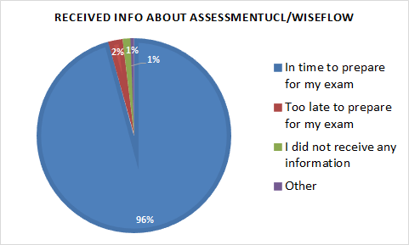

Close to all of the respondents (96%) received information about the online platform in time to prepare for their exam(s).

Q14a. Specify ‘other’ for Q14.
The main themes for this question were: (8 responses)
- Received the information too early & it got lost in all the emails
- The information was not comprehensive enough & and was not finalised so changed regularly.

Q15. Where did you find information about using AssessmentUCL? (Please select all that apply)

Figure 15.1: Bar chart summarising Q15
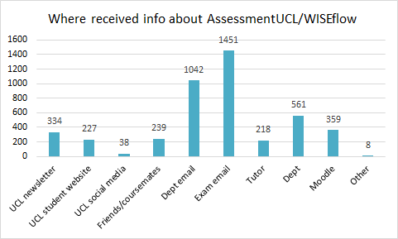

A total of 1944 students answered this question. Most of them received information about the platform via email, either from their department (N=1042) or from Exams at UCL (N=1451).

Q15a. Specify ‘other’ for Q15.
There were only 4 responses to this question:
- WISEflow website (50%)
- Used it before (50%)

Q16. How do you prefer to receive communications about exams and assessments? (Please select all that apply).

Figure 16.1: Bar chart summarising Q16
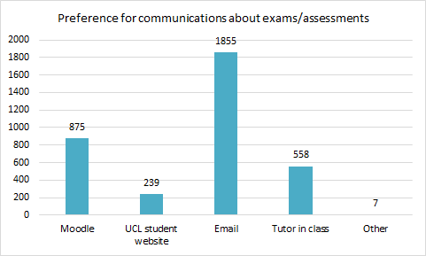

A total of 1958 students answered this question. Most of them (N=1855) preferred to receive communications via email. As such, email is deemed as the most straight-forward method of communication.

Q16a. Specify ‘other’ for Q16.
There were only 4 responses to this question:
- Everywhere – so it is unmissable (50%)
- Central platform/Assessment platform (50%)

AssessmentUCL staff survey: detailed findings

The staff questionnaire contained the following sections.

- Platform functionality
- Usability
- Issues and support
A summary is given for each section with details of responses provided by question. The response rate was 14 % (153 out of a total of 1100 staff)

Platform functionality
The most common way staff chose to mark exams submitted to the AssessmentUCL platform was on the platform. However many chose to mark outside of the system, either via another application or by marking them offline. Staff commented that they did not have enough time to learn the system which should be a consideration, as the functionality of the system may have been possible, but staff were not aware of it. There were many reasons why staff chose to mark outside of the system, the two most frequent reasons mentioned was the lack of desired functionality and secondly that the staff member just preferred to mark outside the system, which was independent of the system. The functionality that was commonly mentioned to be missing focused on the staff wanting to open and hence mark multiple scripts at once in multiple windows. This ties in with the ability to mark a single question for all students, instead of marking script by script. Also staff would like to be able to assign questions to separate markers for each question. The annotation functionality was also mentioned, with staff wanting to annotate anywhere on the scripts and the ability to insert saved comments, to save time. Many more functionalities were mentioned and can be found in Table 6.1. For the staff that preferred to download the scripts, the main reason behind this were that they preferred other software (e.g. Adobe) and marking offline on a tablet.

Usability
When commenting on the usability of the system, many staff commented on their overall experience with the system whilst also noting improvements that they would expect to be incorporated. The comments regarding the usability aligned with the comments on the functionality. The areas in which staff commented on the most were those of the annotation, the usability for multiple assessors & reviewers, followed by the ability to allocate & sum marks throughout the papers. When asked what staff want from assessment tool, the majority of comments focused on the overall system. Staff either want an easy system to use or to go back to invigilated in person exams. When asked about the specific features of a platform, the comments aligned with the previous functionality questions, for example staff want more flexible annotation, the ability to open multiple scripts at once, editable rubrics etc. All comments can be seen in Table 11.1. Offline marking was also mentioned frequently, with staff either wanting to download papers and mark offline or that the requirement for an internet connection in order to be able to mark via AssessmentUCL was not ideal.

Issues and support
The opinion towards to the support given to staff regarding AssessmentUCL was majority positive (58%). Many of the negative comments focused on the overall dislike of the system and not a specific part of the support that the staff found not up to standard. Of the specific negative comments, staff suggested that the support given was too basic and did not cover all the basic information needed. For the positive comments, the staff found the support helpful. It was suggested that workshops could be set up where assessors could demonstrate the issues that they had in person so they can be accurately corrected. With regards to academic standards, 41% of staff thought the platform made no difference to the maintenance of academic standards. Staff commented that online exams & 24hr exams in general whether on this platform or another was the main factor that affected academic standards. Turnitin scores were also mentioned, as the platform only showed a similarity score of the script on the initial page, staff then had to click through to see the Turnitin report, staff thought this was insufficient. Overall, staff had a negative experience marking on the platform (64%). With the main areas mentioned being annotation, speed, and functionality. The comment breakdown is shown in Table 17.1 & 17.2.

Staff priorities

- Ability to open multiple scripts at once, whether all on one question or multiple full scripts in separate tabs.
- Allow different assessors to mark separate questions, therefore allowing each question to have separate marks that are automatically totalled.
- Quick comments. Saved comments that can be quickly added to a script to save marking time.
- The sharing of marks and comments with co-assessors or reviewers should be able to be set for every paper and therefore comment within a module, instead of manually setting this for each comment, on each paper, for each student.
- The ability to upload annotated pdfs back into the system in order for reviewers/students to see the comments on the scripts if the assessor has chosen to mark offline.

Detailed staff survey findings, by question

Platform functionality

Q1. Were you part of the AssessmentUCL pilot?
49 staff were part of the AssessmentUCL pilot and 99 staff were not.

Q2. Did you use AssessmentUCL?
146 staff used AssessmentUCL.

Q3. What subject(s) (e.g. Chemistry, Anthropology, History, etc.) did you assess using AssessmentUCL?

Table 3.1 below shows the frequency of subjects by faculty that staff assessed using AssessmentUCL.

Table 3.1 Frequency of responses to Q3 by faculty
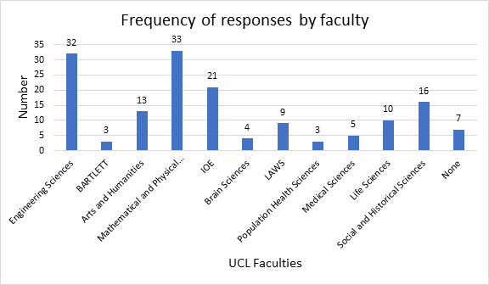
Of those that responded to this survey (N=156), the most common subjects that staff assessed on AssessmentUCL came from the Faculties of Engineering Sciences (N=32) and Mathematical and Physical Sciences (N=33), forming 42% of the total responses ((65/156)*100).

Q4. What were your roles on the platform? (Select all that apply)

Figure 4.1 Roles on the platform (numbers)

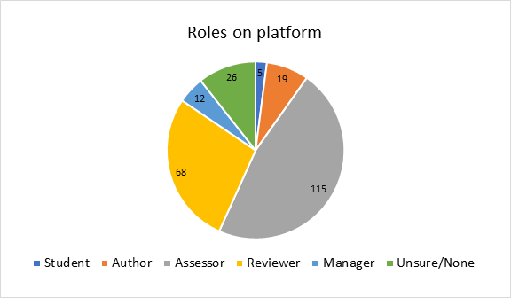

Almost half of the respondents acted (among other roles) as assessors during the main exam period on the AssessmentUCL platform, so the data below is best representative of their experiences out of all other roles possible.

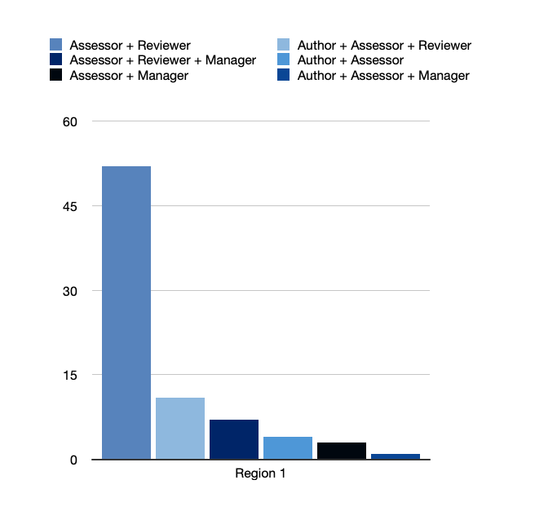

The chart above depicts the number of role-overlap combinations, i.e. staff members who have been actively working in multiple roles on the AssessmentUCL platform. Based on the 147 responses, at least 52 staff members have been both assessors as well as reviewers.

Q5. What did you use AssessmentUCL for? (Select all that apply)

Figure 5.1 Purpose of using the platform (numbers)
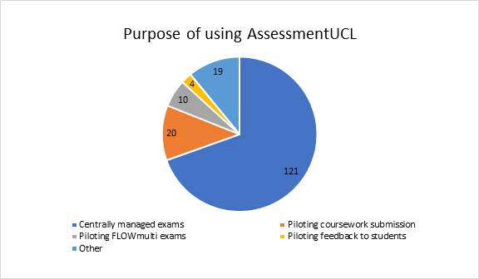

The majority of the staff who used the AssessmentUCL platform used it for centrally managed exams, the remaining users mostly used it for pilot projects. Those who selected ‘Other’, used it for assessing HEA Fellowships (Arena), or final year dissertations/extended essays and projects which included mixed media portfolios (figure 5.1).

Q5.a. If you selected Other, please specify:

Figure 5.1: Bar chart summarising Q5

Q6. How did you mark exams submitted to AssessmentUCL? (tick all that apply)

Figure 6.1 How exams were marked on the platform (numbers)
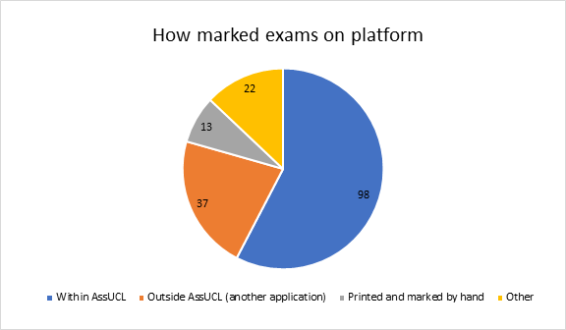

The most common way staff chose to mark exams submitted to AssessmentUCL was on the platform. However many chose to mark outside of the system, either via another application or by marking them offline.

Q6.a. If you selected Other, please specify:

Figure 6.1: Bar chart summarising Q6a

The aspect of downloading exams and marking them offline has resurfaced in the answer section of free text questions, some noting that it provides them with more control and security. This refers to the potential risks of failure of auto-save functions and/or the availability of a working internet connection. For more please see table 6.1.

Q6.b. If you marked outside AssessmentUCL please say why.

Figure 6.2: Bar chart summarising Q6b

Table 6.1 - Comment breakdown
Poor Annotation | Prefer to Download | Not suitable for multiple markers | Desired functionality not available
Need the ability to annotate anywhere on the script | Preferred marking on tablet / iPad (as have done before) | Was not possible to separate out questions for different people to mark | Want to be able to open multiple scripts at once
FLOWmulti did not have the same annotation features | Cannot upload scripts into the system with comments | Not enough time to learn the system | Want to mark question by question not script by script (& separate out marks for each question)
 |  | Could not cope with more than two markers/assessors | Was not suitable for maths & language exams

Internet constraints | Prefer other software | Reluctance / lack of understanding | Other
Not convenient to always be online to mark | Prefer Adobe Reader / Adobe acrobat | Not enough time to learn the system | System was slow
 | Prefer Moodle | Department choice not to use | It was not straightforward & UI is not user friendly

Comment Examples:

“AssessmentUCL did not seem to be able to cope with multiple assessors and multiple reviewers marking a single submission.“

“Marking mathematical work in AssessmentUCL is not feasible at the moment: it's much easier to download the pdf and mark in e.g. DrawBoard“

“This was the department's decision. Change to existing processes is VERY hard to push through in departments, there is real reluctance from academic staff.“

“The lateness of the implementation of the system meant we weren't confident in its usage and so preferred to mark offline.“

“Multiple members of staff involved in marking, not enough time to learn how to use the system.“

“I only had to read and write comments separately for my own records, no marking directly on the scripts was required. I also appreciated not having to be online for marking.“

“The assessments are quadruple marked and then undergo two rounds of internal moderation, and so it was not possible to mark with Assessment UCL. Some elements had to be downloaded.“

Usability

Q7. If you were part of the pilot, please answer this section. Otherwise please move to the next section. On AssessmentUCL it was easy to....

Table 7.1 On the platform it was easy to:
Items | N | Agree/strongly agree (N) | Neutral(N) | Disagree/strongly disagree (N)
Upload an assessment task or exam question paper | 17 | 8 | 2 | 7
Author an assessment/exam question paper | 15 | 5 | 3 | 7
Attach an assessment task/exam question paper to a flow | 13 | 4 | 4 | 5
Author a question paper | 14 | 5 | 2 | 7
Author a standard rubric | 11 | 1 | 3 | 7
Author a custom rubric | 13 | 2 | 3 | 8
Add a rubric to a flow/assessment | 14 | 4 | 4 | 6
Mark submissions | 52 | 21 | 10 | 21
Navigate from one student submission to another | 53 | 26 | 7 | 20
Access Turnitin plugins Similarity reports | 29 | 11 | 6 | 12
Use a rubric to mark students’ submissions | 31 | 9 | 5 | 17
Use a rubric to give audio feedback | 5 | 0 | 0 | 5
Add in-line annotations to students’ submissions | 32 | 8 | 2 | 22
Download exam papers | 27 | 17 | 3 | 7
Allocate and amend marks | 42 | 13 | 6 | 23
Add general comments | 47 | 24 | 4 | 19
Share rubrics/annotations/general comments with Participants and/or Co-assessors | 35 | 4 | 5 | 26
Reconcile marks submitted by different markers | 35 | 8 | 5 | 22
Access the analytics provided | 20 | 2 | 2 | 16
Moderate | 26 | 6 | 2 | 18
To release feedback and grades to students | 12 | 2 | 1 | 9
Provide marking to the external examiner for review | 18 | 5 | 2 | 11
Extending deadlines | 12 | 3 | 0 | 9
Allocate assessors/reviewers to flow | 15 | 3 | 2 | 10
Add assessors/reviewers to flow | 16 | 4 | 2 | 10

There was a general tendency towards finding specific tasks on the platform to be rather difficult. Interestingly, the ease of marking submissions (‘Mark submissions’) turned out to be most divisive answer option, with the same number of respondents finding this task easy as those who found it challenging. The largest difference is shown by the answer option detailing rubric sharing (‘Share rubrics/annotations/general comments with Participants and/or Co-assessors' with a mere 4 people finding this easy compared to the 26 staff members finding this difficult.

Q8. If you used AssessmentUCL for centrally managed exams , please answer this section. On AssessmentUCL it was easy to....

Table 8.1 On the platform it was easy to:

Items | N | Agree/strongly agree (N) | Neutral(N) | Disagree/strongly disagree (N)
Mark submissions in the way I wanted to mark them | 115 | 31 | 14 | 70
Navigate from one student submission to any other | 118 | 51 | 14 | 49
Use Turnitin’s Similarity reports | 102 | 40 | 12 | 31
Add in-line annotations to students’ submissions | 93 | 33 | 8 | 52
Allocate and amend marks | 91 | 31 | 11 | 49
Add general comments | 93 | 41 | 8 | 44
Share annotations/general comments with Participants and/or CO-assessors | 93 | 24 | 13 | 56
Read annotations/general comments shared with you | 82 | 17 | 15 | 53
Moderate Marks | 75 | 18 | 15 | 42
Provide marking to the external for review | 62 | 22 | 14 | 26
Download scripts | 83 | 61 | 10 | 12
Export/download marks (for transfer to Portico) | 47 | 11 | 12 | 24

Similarly to those staff members who have taken part in the pilot, those working during the centrally managed exams tended to find the mentioned tasks not easy. Here the question most dominantly representing one side over the other relates to the individual marking preference (‘Mark submissions in the way I wanted to mark them’), with just about 70% of respondents disagreeing with this statement. The most divisive question was the ‘Navigate[ion] from one student submission to any other’, with only two more positive responses.

Q9. Please comment on the usability and/or functionality of AssessmentUCL:

Figure 9.1: Pie chart summarising comment sentiment of Q9.

The diagram above visualizes the nature of the free-text commentary provided by staff members, categorized according to their positive, neutral, and negative sentiment. As shown, the majority of the comments included the criticism of the usability / functionality of AssessmentUCL.

Figure 9.2: Bar chart summarising comment breakdown of Q9.

Most comments were either in relation to the general evaluation of the systems and/or to the wide-ranging aspects of marking. Exporting documents has been the only topic which has been mentioned overwhelmingly in a positive regard. Annotations, speed, script comparison and mark summation received exclusively negative mentions.

Table 9.1 – Negative Comment breakdown

Annotation | Speed | Export / Import
PDF annotation features are very limited in relation to other PDF viewers and severely limit the usefulness of the platform for marking | Its clunkier and slower than other systems | It was not possible to upload the marked scripts to the system for sharing with the reviewer or external examiner
Marks associated to a comment were not visible to viewers | Very large files made the marking process quite arduous. | No quick way to upload marks which were recorded off-line.
unusable hand annotation tool (with no eraser) | Time-consuming
Lack of In-line comments
No quick comments

Multiple assessors / reviewers | Comparison between scripts | Marks / Mark summation
Marks inputted and associated to a comment were not visible to reviewers. | No easy/quick way to do comparison between different students for the same question. | Would like to note sub marks, add sub marks to question marks and then add marks to a total on the script in any remotely convenient manner.
Sharing annotations with other assessors & reviewers must be done as a separate explicit step after marking each paper, this is not optimal. | In the similarity report, it wasn't possible to flip to the next/previous student. | No way to add any kind of rubric or allocation of marks to different questions in the paper.
For marking of exams with multiple questions/multiple markers - completely unusable | Like to open exam scripts next to each other in new tabs | Too many clicks at the end to confirm rubric
Not possible to comment the paper and view co-assessor's comments simultaneously |  | It would be nice to be able to add marks by each component automatically.
Issues with submission of marks. In some cases submission had to be done twice / or only submitted by the main marker (even for the co-assessor).

Table 9.2 – Positive Comment breakdown

Export / Import
Works well for downloading a batch of scripts, with good filename convention etc. Keep this functionality.

Example comments:

“The PDF annotation features are very limited in relation to other PDF viewers and severely limit the usefulness of the platform for marking. The need to manually and individually share every annotation with other assessors is extremely frustrating and inefficient when marking large numbers of exam scripts.“

“AssessmentUCL did not seem to be able to cope with multiple assessors and multiple reviewers marking a single submission. Having downloaded the scripts to mark outside of UCLassessment, it was not possible to upload the marked scripts to the system for sharing with the reviewer or external examiner.“

“Academic Misconduct.
0 Access to the underlying text has facilitated investigation of certain kinds of academic misconduct this year (for example, ability to view changes in the original document and identify the original author of the file). We were not able to undertake investigations in the same way with the PDF submissions in AssessmentUCL and there is the possibility that this might cause some academic misconduct to be undetected.“

“We had a lot of problems with students clicking the 'hand-in blank' button and then not being able to complete their exam. This was very distressing for our students and created a volume of extra work for staff to deal with. This button should not exist or be visible to the students. Many of the students who clicked it reported that they had tried clicking the submit button on the page and nothing was happening, or the page kept freezing so they became anxious and started clicking on other buttons on the page to try and make something happen.“
“It seems generally useable, but with any new system it takes time to understand it, try it out, stall, work things out, try again. The more often we have to adapt to a new system, the more time we spend just on trying to understand it - and learning from what goes wrong. Despite a helpful intro/tutorial video - which made it look very simple - most specific functions for the marking itself still either took time to work out, or were given up on/never discovered.“

Q10. Please select the option that best represents your view of the following statements: By marking AssessmentUCL I have been able to....

Table 10.1 By marking AssessmentUCL I have been able to:

Items | N | Agree/strongly agree (N) | Neutral(N) | Disagree/strongly disagree (N)
Give students more consistent feedback | 101 | 11 | 40 | 50
Mark more consistently | 121 | 14 | 45 | 36
Spend less time marking | 127 | 18 | 23 | 86
Double-blind mark | 95 | 39 | 26 | 30
Work more effectively with co-assessors aided by the ability to share comments with them | 113 | 25 | 21 | 67
View or edit relevant content to mark/moderate effectively | 105 | 24 | 19 | 62
Give more precise, detailed or nuanced feedback | 111 | 6 | 34 | 71
Identify academic misconduct more easily | 105 | 18 | 35 | 52

The majority of respondents felt like their abilities regarding the activities mentioned above were limited. Except for double-blind marking, all other option choices received a significantly larger number of disapproving answers.

Q11. Please comment on what you want from an assessment tool/ platform:

Figure 11.1: Bar chart summarising comment breakdown of Q11.

Rather than pointing out specifics of a desired platform, most respondents have opted to comment on wanting a platform that is intuitive, easy to implement and ‘feels’ fit for purpose. In other words, they expect an overall improvement of the functionality in AssessmentUCL.

Table 11.1 - Comment breakdown

Download / Upload | Annotation | Comparison of scripts | Access / Move between scripts
Easy to batch download | Pen based annotation | Ability to open and mark more than one script at once | Slow loading times
Mark offline and upload scripts back into the system | Place comments anywhere on the paper | Mark 1 question for all students | Difficult to access different sections of the system
 | Save comments to be used again |  | Ease of opening scripts and navigating between scripts
 | Make all comments (for 1 paper and full all submissions) viewable in 1 click
 | Annotation of section by section

Table 11.1 – Continued

Multiple assessors / reviewers | Offline / Internet | Marks | Rubric
For different assessors and reviewers to be allocated to individual questions/sub-questions that form part of an assessment & to be able to assign marks per question | If chosen to mark offline, an easy way of uploading marks to the system | Forwarding of marks / sharing marks between assessors | Link comments to rubric
Exchange pdf docs between students/assessors/external examiners | To mark offline (without internet connection) | Remove the mistakes when adding up the marks | To be able to mark using a rubric that automatically allocates a certain number of points through ticking the various corresponding rubric, and automatically sums it up
Second markers comments to be added in the same way as first markers |  | Finer granularity of marking & ability to mark section by section | Editable marking rubrics & ability to upload own rubrics
View all comments from all markers & assessors easily

Example comments:

“Make first marker comments visible to second markers automatically “

“Something that replicates the experience of marking paper scripts as closely as possible.“

“In the case of assessing fine art: a reliable, clear and straightforward uploading system for the students and a clear, logical access system for staff, with folders specific to each student. File size limitation is good to prevent unnecessarily large files being uploaded.“

“To be integrated to Moodle and PORTICO. To be able using current Moodle interface.“

“I would like to be able to share the feedback with all internal markers on my programme to ensure consistency. AssessmentUCL seems to keep the marking to a small group of people.“

“I believe being able to set up a bank of feedback comments would be a significant bonus to using a digital assessment tool/platform - supporting consistency and staff workload. “
„I think it's a good tool, just need some refinement to allow us to mark like before, should be relatively easy to fix “

“Reduced opportunity for student academic misconduct; ease of marking for multiple markers, good integration with Portico.“

“Somewhere you can add marks, overall comments and in line comments, tick a matrix/criterion, and quickly visualise/check for plagiarism. The latter two were the main problems with the preliminary system which I hope the piloted version resolves.“

“An easy-to-use method to allow students to submit answers and academic staff to mark them, that allows for multiple answers per paper, and papers that combine MCQ and written answer questions, with similarity reports from Turnitin. Use for other marking, not just centrally managed exams, would be good, e.g., student projects.“

Issues and support

Q12. Please select the option that best represents your view of the following statements: I found these AssessmentUCL resources helpful:

Table 12.1 I found these AssessmentUCL resources helpful:
Items | N | Agree/strongly agree (N) | Neutral(N) | Disagree/strongly disagree (N)
UCL’s written user guides | 114 | 51 | 37 | 26
UCL’s video user guides | 110 | 53 | 30 | 27
WISEflow’s user guides on their website | 90 | 19 | 38 | 33
AssessmentUCL training sessions | 110 | 49 | 39 | 22
Recordings of AssessmentUCL training sessions | 100 | 39 | 40 | 21
Ad-hoc informal support from your colleagues | 124 | 86 | 27 | 11
Drop-in sessions | 87 | 26 | 51 | 10
Support via formal channels (e.g. emailing ISD AssessmentUCL, Digital Education, ISD Service Desk) | 97 | 33 | 51 | 13

While the functionality of AssessmentUCL received criticism, the support that was provided was overall received as very positive. Apart from WISEflow’s user guides, every other help source listed was deemed helpful. The largest difference between two agree/disagree values was posed by the ‘Ad-hoc informal support from your colleagues’, which has been positively rated by significantly more respondents.

Q12.a. other (please state)

Figure 12.1: Bar chart summarising comment breakdown of Q12.

Q13. Please comment on the support for AssessmentUCL and/or on your support needs.

Figure 13.1: Pie chart summarising comment sentiment of Q13.

Figure 13.2: Comment breakdown of Qu.13.

Table 13.1 – Negative Comment breakdown

Written instructions & Videos | Training sessions | Communications | Platform opinion
Need simple guides not written by specialists in the software | Too basic, did not cover all the information needed | People who emailed for support did not know the system | Should be no need for users guides and videos
Support was hard to access | Training sessions were poor, with issues occurring with the system within the sessions
 | System should not require training

Table 13.1 – Positive Comment breakdown

Written instructions & Videos | Training sessions | Communications | Platform opinion
Drop-in sessions were helpful | In person training is the most helpful | Replies to emails were prompt and helpful | Very easy system to use
Written guidance & videos were clear and helpful

Comment Examples:
“Written guidance was clear and sufficient.“

“Support was good, but it is more a case of knowing how assessments are done and helping working out the Wiseflow equivalent beforehand.“
“The support was useful. I think internal markers will require more proactive training if they are going to be prepared to work with the system when there is a full rollout in 2021-22.“

“The written guides and video provided a useful introduction. Our department also gave staff some guidance.“

“The drop in sessions were very helpful, as were one on one sessions. The generic training was much less useful.“

“It was quite hard to get your head around at first and there is so much documentation, it was hard to find what you need, but I accept this is just a bit of a learning curve and once you know it, it will be fine.“

“Good training was offered to UCL Summer School tutors. Thank you.“
“Replies to emails were prompt and helpful.“

Q14. Did you encounter any problems with the marking process? (Please tick all that apply)

Figure 14.1 Bar chart summarizing the number of users encountering the individual problems

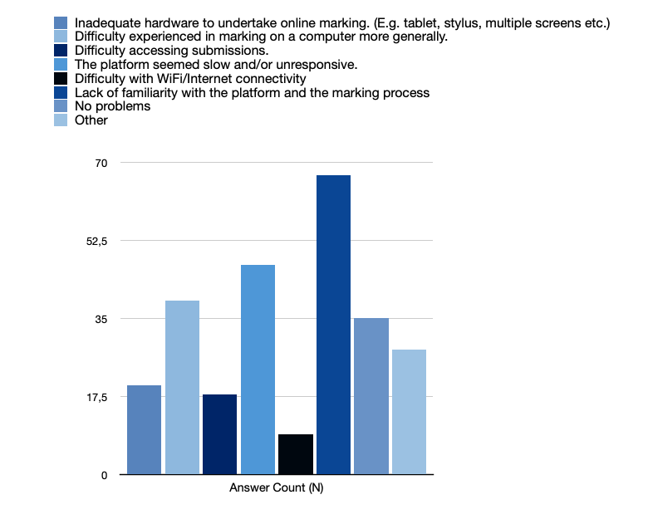

Q14.a. If you selected Other, please specify:

Figure 14.1: Bar chart summarising comment breakdown of Q14.

Table 14.1 - Comment breakdown

Slow process | Functionality | Overall | Upload / Download | User Interface
Takes at least 5x longer to mark via the platform | Issues with annotation. E.g. not being able to see comments/being able to view comments when not wanted, not being able to annotate on any part of the page | Did not like the system at all | Unable to upload scripts that had been marked offline | Scripts not rendered properly
 | Marks adding up wrong / using the lowest mark of the range

Comment Examples:

“my comments were visible to the reviewer despite me specifying that they should only be visible to me myself“
“Co-assessors could not see my marks and I could not see their comments (despite we making sure to have those visible to co-assesors)“
“During the marking process I discovered that I could not give a numerical mark for individual parts of the rubric. Instead we had to adjust the 'ratings' on the individual parts of the rubric in a 'trial-and-error' process in order to arrive at the desired mark. This is not an efficient way to organise things. Also the gradings seemed to be set up to use the bottom of a grade range, not the middle. Very confusing as the overall mark then ends up being lower than expected.“

Q15. Please select the option that best represents you experience of the following statements:

Table 15.1 Best representations of experiences:

Items | N | Agree/strongly agree (N) | Neutral(N) | Disagree/strongly disagree (N)
I found AssessmentUCL easy to navigate | 144 | 53 | 31 | 60
I could access AssessmentUCL easily | 144 | 94 | 23 | 27
I readily understood AssessmentUCL language | 141 | 49 | 38 | 54
I fully understood my role on AssessmentUCL | 143 | 76 | 28 | 39

Q16. To what extent do you think this platform enabled UCL to maintain academic standards?

Figure 16.1 Pie chart showing the proportion of responses

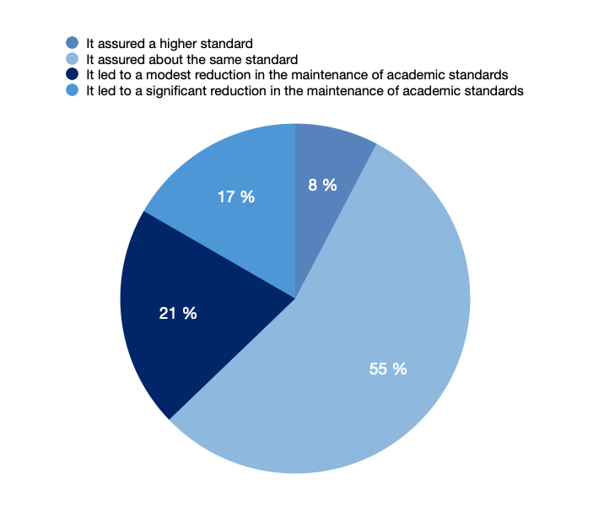

Q16.a. Please explain why you selected the option above regarding academic standards:

41% thought that the platform made no change in the ability to maintain academic standards.

Table 16.1 – Negative Comment breakdown

Change but not due to platform | Platform had an effect | Platform opinion | Turnitin
Online exams & lack of invigilated exams | Consistency of marking is drastically reduced | Added more time to the process of marking | Students have no opportunity to see a Turnitin score before submission
24hr exams allow more collusion | No ability to distribute a scatter of marks throughout the paper and create sub totals and totals on the paper | Confusion about how the 'grade scales' of the individual components of the rubric translate into the final mark. | Handwritten scripts were not subject to Turnitin checks
 | Unable to check for cheating. Unable to access underlying MS Word documents. | Spend a lot more time figuring out the platform than focusing on the exams. | Assessors cannot see the Turnitin report unless they navigate to a separate page. They can see a similarity score, but that is not sufficient.
 | Could not compare scripts | PDF meta data exposed - possible lack of anonymity
 | Harder to give detailed feedback and annotation of assessments

Table 16.2 – Positive Comment breakdown

Platform had an effect | Platform opinion | Turnitin
It allowed for blind marking within the system which is a big bonus | Allowed timed exams in a remote learning environment, it was clearly a step up and very helpful. | it helped more than other platforms to review the Turnitin scores
Mark typed scripts more accurately and more quickly than the old handwritten scripts. | It is so much easier to deal with large modules for centrally managed exams with this system compared to the old paper exams

Comment examples:
“The same standards were maintained albeit hindered by the inefficiencies of the platform.“

“The implementation this year was rushed, different times not handled well. it will be better next year. standards are not a function of the tool.“

“It didn't do anything concerning academic standards; it was just harder than Turnitin or paper scripts to mark.“

“I do not believe it is the software but people that maintain or change standards.“

“It has the potential to increase standards, if they were not already high, but I found I was writing less comments than I used to... because of the fiddle of not being able to see the rubric whilst writing comments.“

“It takes away human error, so much more efficient.“

“The 'normal' system of marking paper copy of exam scripts assures high standards so I see no real improvement.“

“Maintaining the academic standards is responsibility of the staff members no matter the assessment platform used.“

Q17. Please comment on your experience of marking online using AssessmentUCL in comparison to other platforms/tools you’ve used:

Figure 17.1: Pie chart summarising comment sentiment of Q17.

Table 17.2 – Negative Comment breakdown

Annotation | Overall | Speed | Rubric | Functionality
Leaving annotations and comments was extremely difficult, requiring multiple steps. | Worse than Moodle, including the Turnitin functionality | Online marking generally seems to take longer than marking paper scripts. | Personalised rubrics couldn't be used and difficulties around this | Second marking is much better although samples need to be smaller than 100% of students
Could not see the comments of other assessors | Prefer to download |  |  | Turnitin allows to view scripts side by side, a functionality not on Assessment UCL.
Unable to amend in-line annotations compared with pdf software | Crowdmark is better
 | Worse than in person exams

Table 17.2 – Positive Comment breakdown

Annotation | Overall | Rubric | Functionality
Typing comments much easier than writing them, which is a plus for digital marking. | Better for double blind marking | With the rubric present it is better than Moodle | The moderating process was more efficient
 | Better than Moodle for navigation |  | The automated marking to Portico is a massive plus
 |  |  | Much better for second marking - nothing else has worked eg Moodle.

Comment examples:
“It took me longer to mark using AssessmentUCL than using Box/Acrobat. Online marking generally seems to take longer than marking paper scripts.“

“With the rubric present it is better than moodle.“
“I have not used another platform, but I have downloaded scripts and marked offline using a tablet and xournal, entering marks into a spreadsheet. marking offline was far simpler and more reliable.“
“Comparable to Turnitin in terms of annotation. Not as easy to navigate between submissions. Fewer issues with identifying submissions than Turnitin. No adequate alternative to the marking form ("rubric") in Turnitin - though neither platform allows all marks to be downloaded.

“Turnitin is easier to use and staff have greater familiarity with it.“
“A big improvement on Moodle (which is slow and inconsistent).“
“I believe that once criteria and rubrics are set up, the management of marking and feedback will be somewhat easier (require less administration) than Moodle Assignments.“

18. Not all functionalities could be supported in time for 2021 exams and UCL is investigating various enhancements to the platform. Out of the following, which would make the biggest improvement to marking? Please Rank in order of the most to least important...

Figure 18.1 Bar chart depicting improvements from most to least important
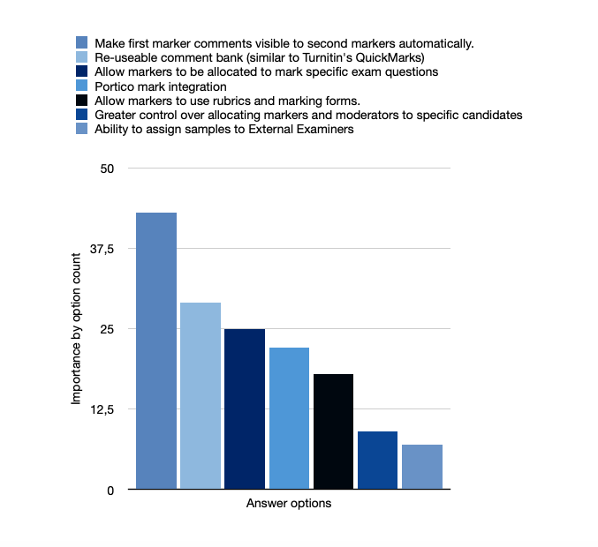

18.a. If you have another improvement that isn't mentioned above please state here and why.

Figure 18.1a: Bar chart summarising comment breakdown of Q18.

Table 18.1 - Comment breakdown

Multiple markers / assessors | Annotation | Marks / Mark summation
Co-assessors comments available by default / when they are set to visible not being able to see them | Pen annotation / improve stylus function | Ability to scatter sub marks throughout a question, ability to have each questions sub marks totalled and then each questions totalled
Should not assume blind marking | Ability to view other markers' comments at the side of the assessment, not only at the top, and when writing one's own comment. | Sanity checks for marks given, to make sure they are not exceeding the max
The ability to allocate markers to specific questions, and even parts of questions. | Make it possible to write comments to specific positions in a script (as in Acrobat Reader). | Allow integer marks not a range

Table 18.1 - Continued

Question type / format | UI | Upload / download | Other
MCQs | Better user interface, with fewer clicks to perform basic tasks. | upload script with comments back | Inadequate training
Being able to annotate FLOWmulti essay answers. | Fix the lexicon - The language should be per UCL process and regulation, not as defined by the platform. | No way of bulk exporting annotated scripts. | Moodle integration
Be able to set an exam where the students are asked to answer X of Y number of questions. |  | Re-ingestion If work can be exported and marked offline, then this should be re-importable. | Accessibility on small screens please

Comment examples:
“No improvements are needed - I have only ticked the above boxes because it wouldn't let me submit the survey otherwise. Please focus on making the basic functionality work as well as possible -- it was pretty much fine this year.“

“Make all comments/marks visible to all assessors by default.
Switch easily between student submissions to easily Mark question by question rather than all questions per student.“

“Spreadsheet functionality to automatically total the mark and also sanity check per question marks, as, for instance, ensuring the mark does not exceed the maximum for question, etc.“
“The rubric needs enough visible columns to allow a fine grain, i.e. 5 mark intervals from a possible 100. At present this results in a very illegible layout.“
“The ability to allocate markers to specific questions, and even parts of questions, is essential for much of UCL.“

UCL summer school staff survey

There were 12 respondents to this survey.

What improvements to AssessmentUCL would you like to see?
- More training & greater instructions
- More clarity with regards to the roles and permissions
- Not user friendly

What benefits might you derive from marking in AssessmentUCL?
- Everything on one platform
- Great for students in different time zones

Overall, how would you rate AssessmentUCL?
- Overly complicated system
- The way that it is used by UCL needs to clearly match the Wiseflow features.
- It took lot of time and admin effort to share feedback with students

18.b. Overall, would you like to provide any further comment on your experience using AssessmentUCL?

Table 18.b – Negative Comment breakdown

Usability | Implementation | Improvement | Other
Overcomplication of otherwise simple tasks | More time required for familiarisation than given | separate Identification of questions via WIseFlow | Should not be implemented as a complete replacement for invigilated exams
Submission too shortly before the deadline | Help needed to prepare staff for using the platform | Word count should be made easier | Academic misconduct a major issue that can’t be solved with online examination
No submission allowed past deadline | Encouragement and training needed for staff to learn the usage of the platform | Mark release to students to be made easier | More freedom to be given to module coordinators for marker allocation
No clear procedure for technical failures | General resistance to change of systems within departments | Mark downloads and amendments not possible
Time-consuming | Too many new adaptations for staff already, AssessmentUCL was too much and too late | No rubrics
Moderators couldn’t directly comment on/provide marks, the extra use of the spreadsheet is unnecessary | Module coordinators require access | Blank hand-ins
 | Pilot testing needed before system implementation | Link to Portico

Table 18.b – Positive Comment breakdown

Problem solving | General Satisfaction | Other
Rapid response to dysfunctionalities of the platform | With implemented enhancements happy to use the software | Positive outlook on improved software
Reliable | Satisfaction with the visible effort that has gone into the making of the platform
 | Easy usage for fine art students

Table 18.b – Comparative Comment breakdown

WiseFlow | Crowdmark | Moodle
Seen potential but poor experience overall | More time required for familiarisation than given | via Turnitin late submissions allowed but flagged
No relevant benefit of using WiseFlow | Help needed to prepare staff for using the platform | AssessmentUCL needs to make examinations easier than on moodle to make it worth using
Significant improvement to moodle | Better for maths assessments | Preferred platform for coursework
ELOs need manager access |  | Good idea to remove the assessment aspect of moodle
Should not be used for coursework

Comment examples:
“Wiseflow was a HUGE improvement to using Moodle but would be useful for ELOs to have manager access. There needs to be a significant push in training and encouragement for academic staff to use the system though or UCL will never move forward. There is massive resistance to any change within departments and this is hugely frustrating.“
“Students leaving submission until minutes before the deadline was an enormous issue. It wasn't initially clear that submission would become impossible after the deadline (Turnitin allowed but flagged late submissions the previous year) or what the process would be for dealing with technical failures.“

“It is important to resolve access for module coordinators who need a manager role to set dayes etc. in case of last minute changes. Late submissions, mark release to students and LSA submissions need to be given proper thought.“

“I don't think it is (yet) the right tool for language exams and some tutors struggled to understand how to move within it. The interface needs to be simpler.“

“A big improvement on what UCL previously had, with potential to be better.“

“My experience using AssessmentUCL was okay. It was reliable and my co- assessors and I were able to work out how to use it.“

“There were so many clicks to get to wherever I needed to be on the system, and the terminology is not intuitive. I'd like to be able to have feedback to students separated out from markers comments - a bit like comments to authors and comments to editors when reviewing a paper.“

AssessmentUCL Changemakers Focus Group: Discussion analysis

Eight students agreed to be interviewed online through Zoom and MS Teams. Interviews were conducted using the set of standard questions below. Key theme emerged from the data. These have been captured using Instagram images. The intention will be to publish these through the students union.

- What was it like taking the exams?
- How did you feel about the process overall?
- How did you first learn about the platform?
- If you had any questions about AssessmentUCL, who or where did you go to for help?
- What sort of tests, quizzes or assessments did you experience this academic year?
- What, in your opinion, were some of the most effective assessments? Why?
- What changes would you like to see in terms of how your education is currently assessed?
- What is your opinion of how UCL handled centrally managed exams during the pandemic?

24-hour exams vs exams within a timed window

The spectrum of feelings towards the open book 24-hour exam was very broad. Even though departments had provided recommended times for completion which were less than 24 hours, many felt obliged to keep returning to improve their work. This created considerable anxiety for some students who make comments such as:

“I get that it’s hard to work around when people are in different time zones, but I think the idea of having a three-hour exam to do in 24 hours was not the best. I don’t know if other people were able to do it in three hours and leave it at that, but I personally was not able to do that” (second year student)

“24 hour exam windows do account for high levels of stress and feeling like one has to use all of the available hours to produce the best result, potentially leading to a large window of constant stress” (first year student)

Other students preferred the 24 hour window, stating:

“The [24 hour] exam taking process was very smooth, simple and easy to navigate. It reduced exam stress significantly. Having to attend a two-hour exam in person … causes extreme amounts of stress and isn’t representative of real-life situations.

Some students were confused by short duration exams (1-2 hours) that could be started at any time within a given 24-hour window and open book exams that stayed open for the whole 24-hour window. This added to levels of anxiety. The word ‘stress’ was mentioned ~20 times in the focus groups. 56% used this in in a negative context (e.g: clustered deadlines), 19% in a neutral context, and 25% in a positive context (e.g: 24h reduced pressure)
This suggests that stress underscores examination periods, but this is experienced differently by individuals: some students said that they work better under short-term high level pressure and some said the exact opposite and were happy to have 24-hour exams.

AssessmentUCL communications

The majority of interviewees learned about AssessmentUCL via email, although the content appeared to vary depending on whether it was sent out by central exams or their department. Some students found personal tutors to be their first port of call for clarifications, but this was very dependent on the individual relationships students had with their tutors. Many students consulted their peers via internal messaging group chats.

Assessment variation

All the interviewees had experienced a wide variety of assessments. They expressed appreciation for module leaders who had amended their exams to suit a year of remote learning:

“…when my tutors took that [remote learning] into account that was 10 times better. In those cases, I really felt … what I’d learned, were being assessed properly. (year 2 student)

Interviewees liked the timed quizzes as they thought they not only tested comprehension accurately, but they were also fair, and students were familiar with the assessment type. Students expressed mixed opinions about group work. When they were well-designed, they brought back some the interactive elements missing from more remote learning. Some students mentioned that it was helpful when tutors set aside time via breakout groups during weekly seminars for groups to work together.

“Group projects added an element of interactivity that was missing from the year. Presentations were good as well since learning how to present online is a good skill to have in the digital world.” (2nd year student)

Essays were also appreciated as it was a continuation of what was normal. Students found that essays were representative of their knowledge acquisition. Sometimes departments were able to coordinate to ensure that deadlines were spread out. Where they were not, students had to actively advocate for deadlines to be moved around:
Students also wanted rubrics that were better tailored to their assignments, rather than the usage of a standard rubric:

“There was no proper marking rubric, just the standard departmental rubric which had nothing to do with the module. It was quite disappointing.” (Year 2 student)

Mitigation

Students appreciated extenuating circumstances. Comments included :
“I don’t think I could have made it without ECs - I am in Beijing and distance learning is difficult for me to manage my time.” (Year 2 student)

“The ECs this year were a godsend. When you are distance learning, you can’t just talk to anyone in the corridor. Office hours were also really short. I had to schedule 20-minute slots for time with tutors, but that’s not really enough to help plan an essay.” (Year 2 student)

Whilst the interviewees represent only a small sample of students across UCL, their comments on what they would like chime with similar comments found in formal surveys such as SU priorities.

Remote learning means that we should have more spread out weightings of assignments - it was “terrible” when modules were graded 100% based on one assessment.

“Any assessment that counts [towards]100% of module grade is terrible especially when there is no formative practice run of the assessment. This doesn’t encourage learning from feedback throughout the module and is also quite un-engaging, especially if it’s a solo assessment. It’s also far too much pressure hinging on one assessment in an already difficult year.” (2nd year student)

Feedback should be given on time so that it can be incorporated for the next assignment and also should be relevant and transferable.

There is a really big issue re feedback. When we hand in our first assessment, we should have our feedback before the second assessment. But that was not the case. We handed in our second assessment, and we had no idea how we did in the first assessment. We didn’t know the assessment criteria.” (Year 2 student)

Instagram slides for communicating results to students
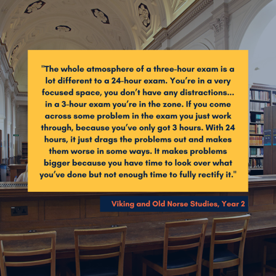 | 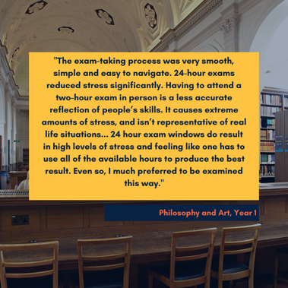
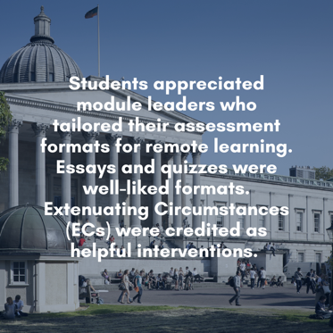 | 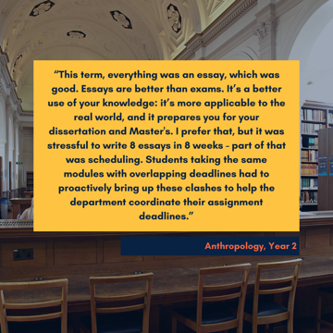
 | 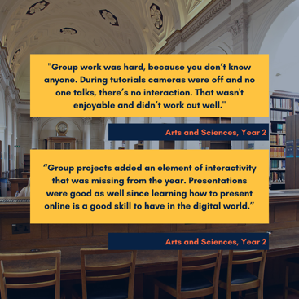
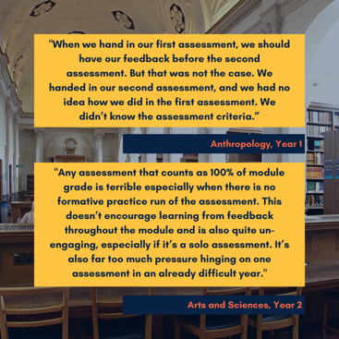

COVER PHOTO: Matt Clayton
ucl.ac.uk/teaching-learning/AssessmentUCL

