UCL Teaching Toolkit: Basic hybrid teaching
A basic approach for how staff can teach in-person and online students in the same class.

About this topic
There is no one single definition of ‘hybrid teaching’ but generally it means having both a local (in-person) and a remote (online) audience for the same class. This can vary a lot in sophistication, from using lavish custom-built classrooms to adding some new technology into existing spaces.
UCL has a hybrid lecture theatre but given the large size of UCL’s teaching estate, we need a broad approach to hybrid teaching that can be applied in hundreds of different teaching spaces. We are making additions across the teaching estate to support basic hybrid teaching, and providing opportunities for UCL staff to become familiar with what is available and works best for you.
In many cases the best approach is likely to be:
- Use Zoom or Teams during the live teaching session to connect to a remote audience as well as your in-person audience. We will facilitate this with by adding new audio and video facilities into teaching spaces.
- Record the teaching event using Lecturecast, Zoom or Teams so that it is available to those that could not attend, e.g. due to time zone differences.
This Toolkit aims to guide education staff through how they might make ‘basic’ hybrid teaching manageable for them and a satisfactory experience for their students.

Why it matters
Whilst the majority of students will be on campus from the start of the 2021-22 academic year, where possible, UCL is supporting overseas students who need to be remote for a period of time, with the expectation that they will be able to come to campus by Term 2. UCL staff may therefore be teaching in some programmes with a mix of physically present and remote students in the same teaching event. We are calling this approach ‘basic hybrid’.
This will not provide a seamless experience for local and remote audiences to learn, interact, work in groups and so on. But it should be sufficient for remote students to keep in touch with classes, remain connected with their teaching and meet the learning outcomes.

On this page
- About 'basic' hybrid teaching
- Managing learners
- Technology for ‘basic’ hybrid teaching
- Key takeaways
- Further help
- References and further reading
- Related content
- Download this toolkit

About 'basic' hybrid teaching
Hybrid teaching where a local and remote audience interact is difficult and tiring, especially if you are doing this on your own. Mor et al (2021) notes that:
“However, many of the [institutional] newcomers [to hybrid teaching] appear to be disillusioned, realising that if not implemented properly, synchronous hybrid learning is “the worst of both worlds” – synergising the limitations of both online and onsite teaching; On one hand, the teacher is constrained in utilising collaborative and active learning approaches that utilise the affordances of physical (or virtual) interaction. On the other, the need to be present simultaneously in the classroom and in a virtual environment creates a challenging cognitive load for the teacher.”
There is no expectation that hybrid teaching will form a new pedagogy or delivery mode at UCL. We are supporting basic hybrid teaching as part of our ongoing COVID-19 response. It will have limitations, and not all the teaching methods currently in use at UCL will translate well to this basic hybrid format. We recognise the load this puts on teachers in thinking through how best to support their students, and themselves, when basic hybrid teaching is being used.
For each teaching event, we should consider whether online, face-to-face, or basic hybrid offers the best approach. And perhaps engage our students to understand what works best for them; there are certainly some who yearn for face-to-face teaching to resume, but also others for whom learning online has worked very well. There may be teaching events that work well in basic hybrid, others that are best being fully online, and others where teaching separate face-to-face and online groups is the best option.
Return to the top of the page

Managing learners

Managing simultaneous local and remote audiences
Face-to-face and remote audiences can struggle with being able to see the teacher and view the content, but not really able to engage with their peers. This separation of audiences may feel contrary to the inclusive, lively way you traditionally teach in a room, or even fully online.
A teaching assistant, or co-pilot, can be very helpful for fielding questions from the remote audience, particularly if there is a lively – but not so relevant – chat, where the important questions and comments fly by. By joining in with the remote audience, the co-teacher can support their questions and discussions, reducing the cognitive load on the primary teacher and act as the bridge between them and the face-to-face group.
Return to the top of the page

Structuring classes
Structuring time is important: time for content, time for questions, and time for discussion. Incorporating both audiences into your teaching by explicitly giving time for both audiences to digest and discuss is likely to mean you cover less content in a single session.
Although it should still be just a few minutes, the sessions will also take slightly longer to set up using the in-room technology. Please respect the UCL hour (classes being 5 past to 5 to the hour, to allow for changeover and setup for the next group).
The Centre for Teaching and Learning at The University of Oxford have produced a useful guide for planning hybrid teaching.
Return to the top of the page

Managing discussion
If you are having a group discussion, it’s important to regulate and orchestrate it so that only one person is speaking at once.
A lively class discussion is a wonderful thing to enjoy. Humans are very good at listening, and can zone-in on who they want to listen to and filter out background noises or distractions, even in a busy, noisy room. Microphones are not as good at dealing with multiple sources of noise, so when multiple people speak at the same time, the result is a cacophony. If you’ve ever watched a TV news programme or political debate where panellists speak over each, you will understand the problem.
A good discussion in basic hybrid teaching is more like the experience of being at a well-chaired committee meeting, than sitting ‘round having a chat.
Return to the top of the page

Time zones and recording
If you have remote audiences based outside the UK, they may be in a variety of different time zones. Recording, either with Lecturecast or by recording in Zoom/Teams can make a huge difference for students overseas.
You might also vary the time of teaching events so that at least some are in more social hours depending on students’ time zones. Even when using Zoom or Teams in space, you can still schedule a Lecturecast recording for those that cannot make the live session to catch up later, in fact having both is a good ‘belt and braces’ approach.
See guidance on recording lectures in Lecturecast, Zoom or Teams.
Return to the top of the page

Keep it simple
Teaching practices have changed at a rapid pace during the pandemic. At least when starting with basic hybrid teaching, we encourage colleagues to try to keep things as simple as possible and grow from there.
Return to the top of the page

Technology for ‘basic’ hybrid teaching

Sharing content
Many of us have had the experience of sharing our desktop to show slides or do a demo, and then not being able to see the other remote participants. An alternative to sharing the whole screen is just to show one window, which is your application of choice.
PowerPoint doesn’t have to use your whole screen; it can run a slide show in a single window. To do this:
- Go to Slide Show
- Set up Slide Show
- Choose the ‘Presented by an individual (window)’ option.
Now the slideshow will be in a single window, and you can position this so that you can see the remote participants, and any hands raised at the same time – making things a bit more personable.
Alternatively, you might share slides in advance via Moodle, and allow remote participants to use them at their own pace.
Return to the top of the page

Using the microphone
Lecture theatres are often not the best acoustic environments, with lots of hard surfaces, and noisy fans and ventilation systems. Most rooms have wearable microphones, and these will make a big difference to the sound quality for the remote audience. It’s good practice to use the microphones when available, as they can be helpful for members of the local audience, but will be particularly useful for remote participants.
Please remember to put the microphone back on charge after use. Where there are no wearable microphones but instead fixed microphones about the teacher, you may need to ask for quiet within the room when you are speaking.
Return to the top of the page

Using a visualiser
Many teaching spaces have a built in visualiser, also known as a document camera.
Portable visualisers have also been issued to many staff who have been teaching remotely from home during the pandemic. These can be used in your basic hybrid teaching by swapping the feed from the camera trained on the speaker to the visualiser feed instead. When using the in-room visualiser, this is a little fiddly, but is demonstrated in the video below (this video has captions).
https://mediacentral.ucl.ac.uk/Play/68596#!
Important: when you are using the in-room visualiser, you will need to use the control panel to show the visualiser on screen for the local audience. However, when you do this, you will no longer be able to hear the remote audience through the room system, although they can still hear you. You might wish to ensure you have a co-pilot to field questions in the chat, or take regular breaks from using the visualiser to connect again with your remote audience.
Return to the top of the page

UCL teaching spaces for hybrid teaching
Many of our teaching spaces already include a range of technology, with a standard teaching station at the front of classrooms and lecture theatres. We are adding equipment to these in various ways depending on the size and existing facilities of the spaces.
Read more about how technology in UCL teaching spaces can support hybrid teaching.
Return to the top of the page

Bring your own hybrid
Some teaching spaces will not be receiving additional equipment. This will usually be for one of three reasons:
- They are very small spaces, typically for 10 students or fewer, and normally used for parallel/break-out/tutorial style sessions rather than larger teaching events.
- They are departmentally managed spaces where the equipment is not managed by ISD.
- They are other ‘ad-hoc’ spaces, such as staff offices, in which teaching activities (e.g. supporting research students) might take place, but are not designated as teaching spaces.
For teaching spaces that don’t have existing technology, we suggest a ‘bring your own hybrid’ approach to using portable technology to produce a workable experience for face-to-face and remote students.
Return to the top of the page
Bringing technology for smaller group teaching
ISD will supply each department with:
- two Jabra Speak 510 units which are combined speakers and microphones that provide good audio in smaller spaces.
- two Logitech Brio webcams.
Once connected, the devices you need to use in Zoom or Teams are:
- Camera: Logitech Brio
- Microphone: Jabra Speak 510 Speakers: Jabra Speak 510
Both of these connect via USB Type A sockets to a desktop or laptop. The Brio ideally would use a USB 3 connection, although a USB 23 connection will work for non-4k video. The Jabra Speak 510 uses USB 2.
Together, these would provide an acceptable level of video, audio and content sharing for a remote audience. For a small group, these can facilitate a natural discussion. For larger groups, they can enable to the teacher to be seen and heard by a remote audience, but won’t be sensitive enough to pick up audio across a room.
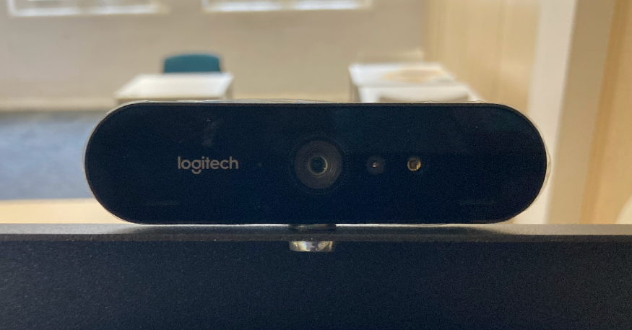
Figure 1 Logitech Brio webcam mounted on a monitor
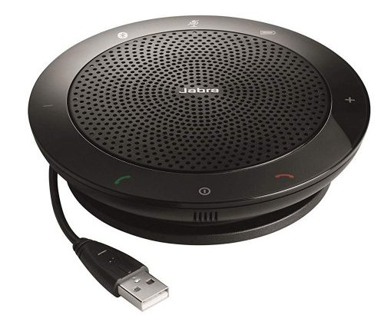
Figure 2 Jabra Speak 510 hands-free speaker/microphone conferencing unit
Bringing technology for larger group teaching
If you have larger groups, there are other Jabra units available; as a rule of thumb, the larger the unit, the larger the audience it can accommodate.
You can view the full Jabra Speak range; note that all of the units except the Speak 810 are powered by USB or internal batteries. The Speak 810 requires mains power when in use.

Key takeaways
- Practice your set-up and test your technology in advance, including connecting any of your own devices to UCL systems and using a visualiser if needed.
- Structure your sessions to enable interaction with both audiences. Keep the ‘UCL hour’ in mind; the amount of content you can realistically cover may be less for hybrid teaching than a traditional face-to-face or online class.
- Engage a teaching assistant or co-teacher to help monitor and facilitate discussion amongst the remote participants.
- Share slides in advance and/or open your presentation in a minimised window so you can still see your remote participants whilst you present.
- Use wearable microphones where they are available in teaching spaces
- Keep it simple! 'Basic' hybrid teaching is to enable some students who cannot join in person to follow along remotely for a set period of time. Start with small adjustments and build up to more complex approaches as you get more comfortable.

Further help
- A greater number of AV technicians will be available during teaching so that help is readily available.
- Specific information about what technical capability is available in that room will be added to each space.
- People’s approaches to basic hybrid teaching will vary. Digital Education is working closely with Faculty Learning Technology Leads, who are the best first point of contact for advice.
Return to the top of the page

Click to view references and further reading
Raes, A., Detienne, L., Windey, I., & Depaepe, F. (2019). A systematic literature review on synchronous hybrid learning: Gaps identified. Learning Environments Research. Gil E., Mor Y., Dimitriadis Y. & Köppe C. (ed.), (forthcoming) Hybrid Learning Spaces . Springer
City University Teaching Here and There podcast series (listen out for a future appearance from UCL’s Steve Rowett)
Oxford (2021), Planning and Presenting a Hybrid Teaching Session, University of Oxford Centre for Teaching and Learning, https://www.ctl.ox.ac.uk/hybrid-teaching#/ [accessed 19 August 2021]

