STUDENT ENGAGEMENT

YOU
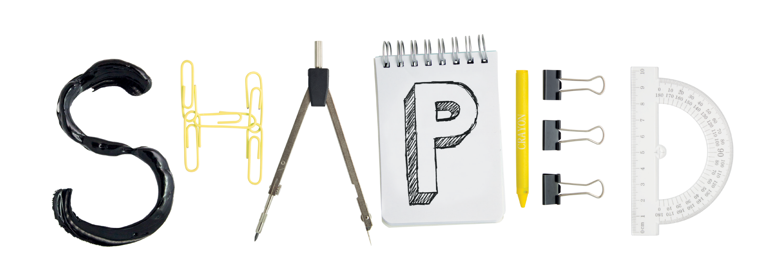
You told us [you would like more feedback on your individual exam performance]

You can now [view your exam papers with your personal advisor]
Find out more at:
ucl.ac.uk/[department]
the Department of [xxxxxxxxxxxx]

Together we create a better education

