This is to certify that the Environmental Management System of:

University College London
Gower Street, London , WC1E 6BT, United Kingdom

applicable to:

The provision of further and higher education, research and support services for the university
has been assessed and registered by NQA against the provisions of:

ISO 14001:2015

This registration is subject to the company maintaining an environmental management system, to the above standard, which will be monitored by NQA

F
Managing Director

Certificate No. 69850

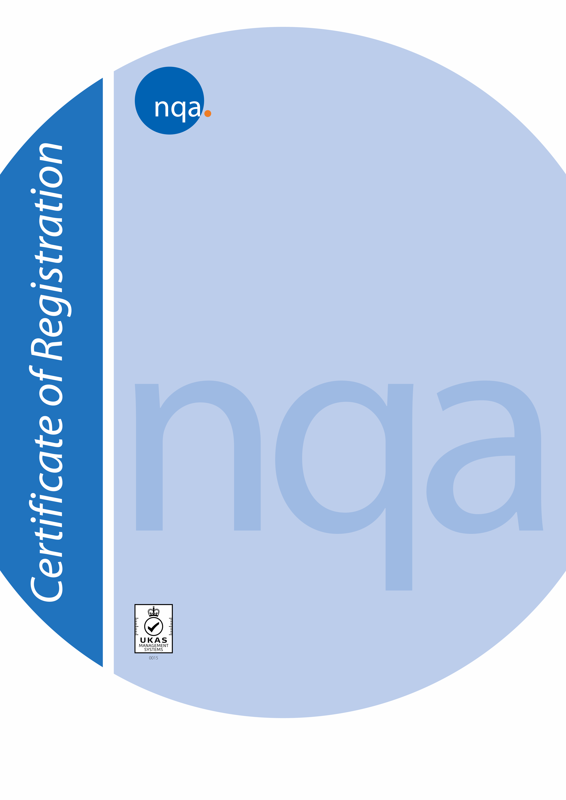
ISO Approval Date: 26 July 2017
Reissued: 5 July 2021
Valid Until: 2 July 2024 Prior Cycle Exp Date: 3 July 2021 EAC Code: 37

Page 1 of 1
The use of the UKAS Accreditation Mark indicates accreditation in respect of those activities covered by the accreditation certificate number 015 held by NQA. NQA is a trading name of NQA Certification Limited, Registration No. 09351758. Registered Office: Warwick House, Houghton Hall Park, Houghton Regis, Dunstable Bedfordshire LU5 5ZX, United Kingdom. This certificate is the property of NQA and must be returned on request.

