UCL Sustainability Policy 2022

Our Vision
As climate change, resource depletion and biodiversity loss become critical, the world faces an uncertain future. UCL knows that to change the future, we have to show that change is possible. Our vision is to create a local campus and wider community that know a sustainable future is possible.

To deliver our vision, UCL has developed a Sustainability Strategy which seeks to embed the principles of sustainability throughout its core activities and operations and in doing so, contribute to the Institutional Strategy, UCL 2034.

Our Foundations
The foundations of the Sustainability Strategy are the building blocks for embedding sustainability across our institution:

Foundation 1: UCL inspires action Foundation 2: UCL is run sustainably Foundation 3: UCL shapes the debate

UCL Sustainability Strategy sets our plan for delivering our foundations, which recognises both our local and global impacts, and sets priority actions against each of our foundations.

Our Commitments

UCL is committed to fulfil our compliance obligations and protect the environment from any adverse impacts, including pollution that arise from the use of our estate or during our research, teaching and enterprise activities.

UCL will seek to deliver a set of headline goals which demonstrate our dedication to a sustainable future by 2024:

- Every student will have the opportunity to study and be involved in sustainability
- We will increase our sustainability research, with increased focus on the Sustainable Development Goals
- Our buildings will, collectively, be net zero carbon, and by 2030 our institution will be net zero carbon
- Be a non-essential¹ single-use-plastic free campus
- Reduce waste per person by 20%
- We will create 10,000m² of more biodiverse greenspace on campus

This Policy will be reviewed annually and managed through the development, delivery, and continuous improvement of the UCL Environmental Sustainability Management System (ESMS), which is certified under ISO14001.
Signature: 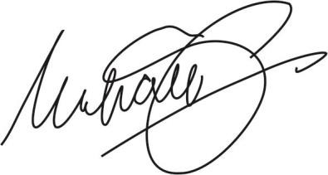 Date: 10 June 2022
UCL President and Provost, Dr Michael Spence AC

1 Considered essential where there is currently no accessible, safe, or sustainable alternative

