UCL Energy Audit Checklist
Introduction
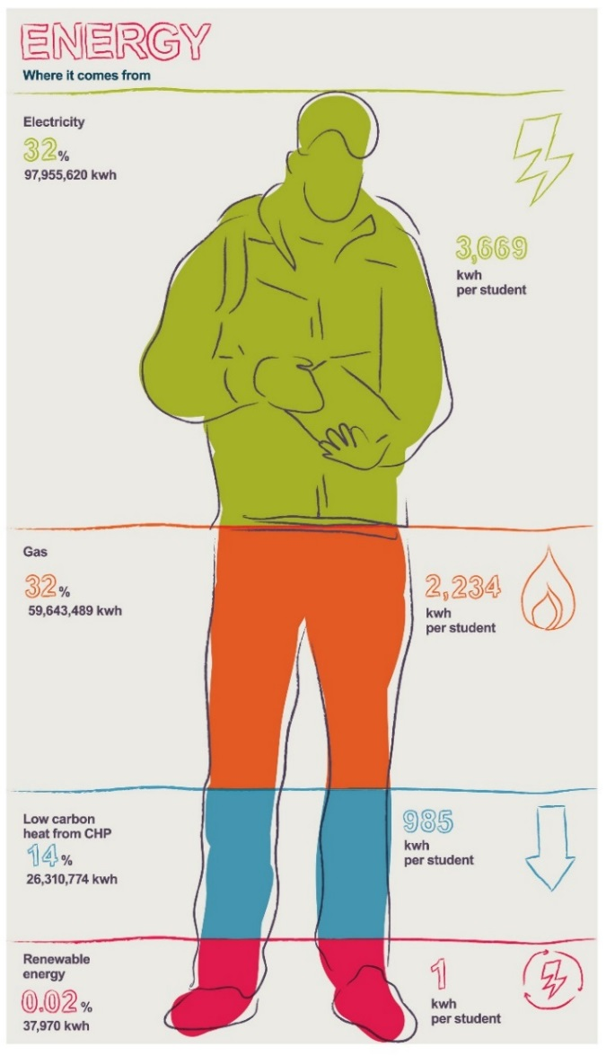
Conducting energy audits on a regular basis helps identify energy waste and identify opportunities for improving energy practices. This aids carbon emission reductions, can make working environments more comfortable, ensures Health and Safety guidelines are met and helps improve communications between the estates department and the people that work and study in your building.

On the following pages is an audit checklist. It is designed to stimulate questions about energy practices. Not all questions will be applicable to every department, but we’ve tried to make them as relevant to as many people as we can. Some questions may be difficult to answer without external help (e.g. is there roof insulation?) However, these questions are still worth asking as issues may have been overlooked.

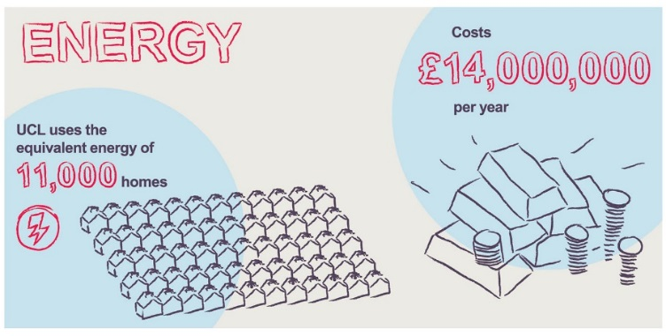
Most of the measures are simple good housekeeping measures which can be implemented immediately. Other measures are low cost (e.g. fitting timers, pipe insulation or draught proofing) and will involve some expenditure and/or contacting Estates.

RAG rating
While going through your audit, it’s essential to rate the severity of any issues that you identify. UCL uses a standard red/amber/green ranking to structure this activity.
Rating | What it means
Red | A real problem. This must be dealt with immediately.
Amber | Some issues have been identified that should be addressed, but nothing needs to be done immediately.
Green | There may be some scope to improve, but generally things are excellent.

- Basic Information
Key
Visual inspection needed: | Interview with staff needed:

Date of energy audit:

Area covered (fill in each box): | Department | Building | Floor / area
Person(s) conducting audit:
Normal occupancy hours of building (fill in each box): | Monday-Friday | Saturday-Sunday | Holidays
Building cleaning times:

- Analysing energy use data
To effectively manage our impacts, it’s essential to measure them. This data may be able to be used to identify any actions, failings or anomalies that you may be able to address in the following sections.  Use UCL’s Carbon Culture platform to get energy data for the building. This platform can be accessed here: www.platform.carbonculture.net/communities/ucl/ Please note: this is only available for some UCL buildings.  Factors to look out for include the baseload energy usage of the building (the minimum level of demand – usually during the night or weekend). If this baseload makes up a large proportion of the maximum load, there is likely lighting or equipment being left on when the building is not in use. | Write any findings or insights that you’ve gained from looking at the building’s energy data below. | RAG rating

- Walk around and inspection
Lighting
Criteria | Inspection / interview | Evidence | RAG rating
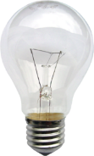
Are any incandescent (not low-energy) lights present?
If so, how many?
If there are several light switches grouped together, could they be labelled to make it more obvious which switches relate to which appliances?

Are light being left on unnecessarily?
I.e. could lights be switched off to make more use of daylight? (e.g. lights parallel to windows or in corridors)
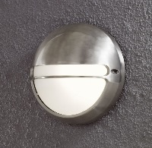
Are any external lights on the building left on during daylight hours?

Are there any light fittings, windows or skylights in the department that need cleaning?
If so, what are they and where?

Heating
Criteria | Inspection / interview | Evidence | RAG rating
Are radiators effective and giving consistent heat? They may need bleeding of air or maintenance to remove dust and sediment.

Are radiators blocked by boxes and furniture restricting air circulation?

Are any window panes cracked or broken? Is there evidence of problems with double glazing (e.g. moisture between panes).
If so, where is this happening?

Awareness
Are there posters/stickers/guidance displayed to remind people of good practice?
If so, please briefly list the materials you have seen.

Is equipment clearly labelled so that staff know how to activate energy saving features or switch it off?
Are there any appliances or pieces of equipment that would benefit from labelling or signage?

- Interview
Heating
Criteria | Inspection / interview | Evidence | RAG rating
Does the temperature of the department / space vary much during the day, or does it remain constant?

Do occupants often complain it is either too hot or too cold in the department?

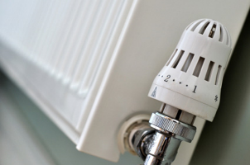
If there are Thermostatic Radiator Valves (TRVs) in the department, do they work or are they faulty?

If there is a room thermostat, is it correctly set? (in winter, it should be set between 19-20 degrees centigrade, and in summer, 22 degrees or above)

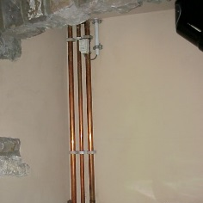
If the room tends to overheat, could this be caused by any bare pipework for hot water that could be insulated?

Are portable electric heaters in use? If so, why is the heating system not adequate
If there is a roof space, is it insulated?

Cooling and ventilation
If there is air conditioning with local controls, is this on only when necessary?
Is it obvious how to control it? What temperature is it set to?

Does air conditioning ever run at the same time as heating?

Does the department make the most of natural ventilation?
Opening windows overnight in the summer, where it doesn’t present a security risk, will help cool the building down and reduce the need for air conditioning.

Reporting and maintenance
Are any aspects of the department’s operations not covered in the previous questions faulty or broken?
If so, have these been reported – and what was the outcome of this report?

Other impacts
Feel free to add in any other impacts or activities that may be specific to your department or division that you’d like to audit.

Tip sheet produced by the UCL Sustainability Team, Green UCL.
Email: green-ucl@ucl.ac.uk
Twitter: www.twitter.com/greenucl
Facebook: www.facebook.com/greenucl

