GREEN UCL

UCL Waste Audit Checklist
Introduction
Conducting audits on a regular basis helps identify opportunities for improving practices, reducing unnecessary waste and increasing recycling and reuse. On the following pages is an audit checklist. It is designed to stimulate questions about waste and recycling practices. Not all questions may be applicable to all departments, but we’ve tried to make them as relevant to as many as we can.
Feel free to edit and adapt the checklist to suit your needs.

Some of the measures that this checklist will help you identify are simple good housekeeping that can be implemented almost immediately. Others may need help from UCL Estates. If you’re unsure about any aspect of this, just contact the Sustainability Team.

How waste and recycling works at UCL

Before conducting your audit, it might be useful to find out more about how waste is handled at UCL.

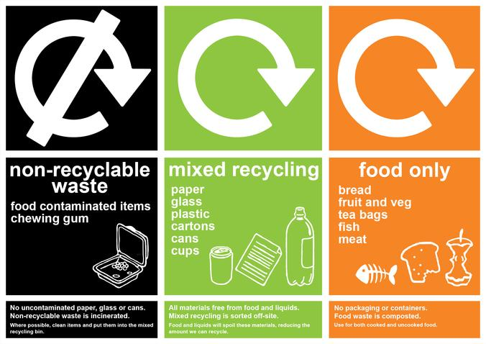
There a three main waste streams
Most buildings at UCL operate with three main waste streams:

- Mixed recycling: all recyclable items go in the bins marked 'mixed recycling'. These materials just have to be dry and largely food-free. They're taken away and sorted off-site to ensure the highest amount of recyclable materials are collected.
- Food only: all food remains should go in the bins marked 'food only' in orange. It is important that these items only comprise food, and not packaging, as they are taken off-site and broken down using anaerobic digestion or composting.
- Non-recyclable waste: All those items that are left, items like food-contaminated containers, polystyrene packaging that cannot be returned to the supplier, used tissues and other litter, go in the bins marked 'non-recyclable waste' in black. These items are incinerated and the heat they produce is used to generate energy.

You can find out more about what types of material can go in each bin here:
https://www.ucl.ac.uk/greenucl/resources/materials-and-recycling/which-bin-should-i-use.

Use of WARPit
For unwanted but usable equipment, furniture or resources, staff are requested to use WARPit. This is an easy to use online portal which allows staff at UCL to give, loan or share resources within UCL and beyond. You can sign up and use the service here: https://www.warp-it.co.uk/UCL.

RAG rating
While going through your audit, it’s essential to rate the severity of any issues that you identify. UCL uses a standard red/amber/green ranking to structure this activity.
Rating | What it means
Red | A real problem. This must be dealt with immediately.
Amber | Some issues have been identified that should be addressed, but nothing needs to be done immediately.
Green | There may be some scope to improve, but generally things are excellent.

1. Basic Information
Key
Visual inspection needed:   |   Interview with staff needed:

Date of waste audit:
Area covered (fill in each box): | Department | Building | Floor / area
Persons conducting audit
Building cleaning times (am, pm, during the working day?):

2. Waste data for the building
To effectively manage our impacts, it’s useful to measure them. This data may be able to be used to identify any actions, failings or anomalies that you may be able to address in the following sections.  In particular, if this data identifies that your building is producing a large amount of a certain material (e.g. glass) this might be a good indicator that a new process could be explored to tackle this (e.g. a supplier take-back scheme).  At the moment, waste data is usually collected for groups of buildings, rather than individual ones. You can request this data from the Sustainability Team. | Write any findings or insights that you’ve gained from looking at the building’s waste data below.

- Visual inspection
Bins
Criteria |  | Evidence |  |  |  | RAG rating
Does the department have bins covering the three streams of mixed recycling, non-recyclable waste and food? |  | Yes (tick) |  | No (tick)
What are the approximate numbers of each of these bins in the department?

Does the department use under-desk bins, or a more centralised system? |  | All under-desk bins (tick) | Mix of central and under-desk (tick) |  | Only centralised bins (tick)
Does the department provide dedicated recycling bins for batteries and toner cartridges?

Awareness and communications
Criteria |  | Evidence | RAG rating
Is UCL’s standardised bin signage in use across the department / space?

Have any posters or other materials been used to remind building users of good practice?

4. Visual inspection of bin contents
Type of bin | Contaminants to be avoided | Any contaminants? If so, what are these materials and what proportion do they make up of the waste? (feel free to add or remove bins from this list, depending on the size of the department)
Type of bin | Contaminants to be avoided | Bin 1 | Bin 2 | Bin 3 | Bin 4 | Bin 5 | Bin 6 | Overall  RAG rating
Mixed recycling bins | Wet or food covered materials. Please note that small amounts (i.e. 5% of total) of contamination is acceptable.  Batteries and toner cartridges (these should be recycled in dedicated bins).  Electrical items (service requests should be raised with the Customer Services Centre for collection)
Food bins | Non-biodegradable materials like packaging or plastic wrappers.
Non-recyclable waste bins | Any largely food or liquid-free recyclable materials (these should be recycled).  Batteries, toner cartridges and electrical items (these should be recycled in dedicated bins).
Other bins (battery, toner cartridge, etc.) | Anything other than the items stated on the bin.

5. Interview
Bins
If the department does not have bins for the three main waste streams, what is the reason for this? |  | Reason | Please tick
 |  | Don’t want to change established procedures
 |  | Cannot afford changes to bins at this time
 |  | Didn’t know about the three bin system
 |  | Doesn’t have space for the three bin system
 |  | Other (please specify)
Approximately how many people use these bins in total (approx. how many staff and students use the department?)
Removal of under-desk bins improves recycling and reduces waste.

If the department has not already reduced the number of under-desk bins, have any steps already been taken to remove under-desk bins?

Awareness and communications
Criteria |  | Evidence | RAG rating
Have email updates or similar communications been sent to members of the department, to ensure that they’re familiar with the best way to dispose of waste and recycle?

Sharing and waste reuse
Criteria |  | Evidence | RAG rating
Is the department aware that they can use WARPit to share unwanted items, resources and equipment with other members of UCL?

Have one or several members of the department signed up to WARPit?
https://www.warp-it.co.uk/UCL.

If not, are there any barriers to them doing this?

Are there any unused items being stored in the building (lab bottles, furniture, folders, etc.) that could be reused via WARPit, or another scheme? (e.g. chemical bottle supplier take-back scheme).

Other impacts
Feel free to add in any other impacts, activities or comments that may be specific to the department or division you’re auditing.

Tip sheet produced by the UCL Sustainability Team, Green UCL.
Email: green-ucl@ucl.ac.uk
Twitter: www.twitter.com/greenucl
Facebook: www.facebook.com/greenucl

