SUSTAINABLE UCL

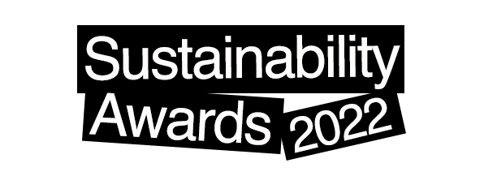

Meet the Highly Commended Nominees and Winners of the UCL Sustainability Special Awards 2022

As part of the Annual UCL Sustainability Awards, we like to shine a light on individuals and teams who have gone the extra mile to achieve greater levels of sustainability in teaching, research and operations at UCL and beyond.

Contents

Staff Award for Outstanding Commitment to Sustainability 2
Student Award for Outstanding Commitment to Sustainability 4
Sustainability Impact Award 7
Sustainability Research Award 9
Sustainability Education Award 11
Special Award for Outstanding Sustainability Plan 13

Staff Award for Outstanding Commitment to Sustainability
This award is given to the member of staff who most clearly exemplifies an outstanding commitment to driving, encouraging or creating environmental and/or social change at UCL.

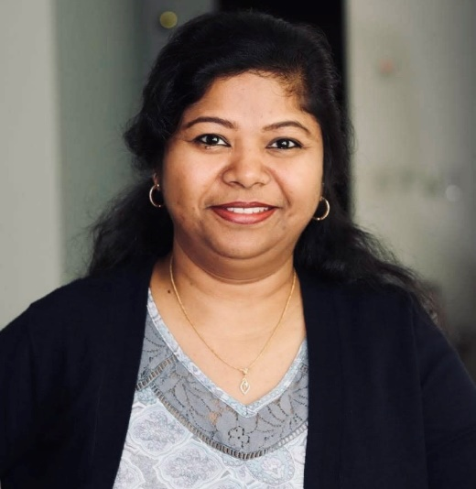
Highly Commended
Dr. Zareena Gani
Lecturer, Department of Mechanical Engineering

Zareena is promoting sustainability within the Mechanical Engineering Teaching Labs and has enrolled the lab with the UCL LEAF program to make laboratories more sustainable.
Zareena has also been focusing on integrating “Sustainability” as the core of her undergraduate and postgraduate research projects.
These include: Sustainability in the Production Sectors of Manufacturing Industries; a project on identifying and resolving the crisis around charging electric vehicles in the UK; a project on the impacts of the pandemic on the supply chain of the electric vehicle production sector in the UK; and a 3rd Year capstone project on Business Model for Sustainability in Textiles Industries.

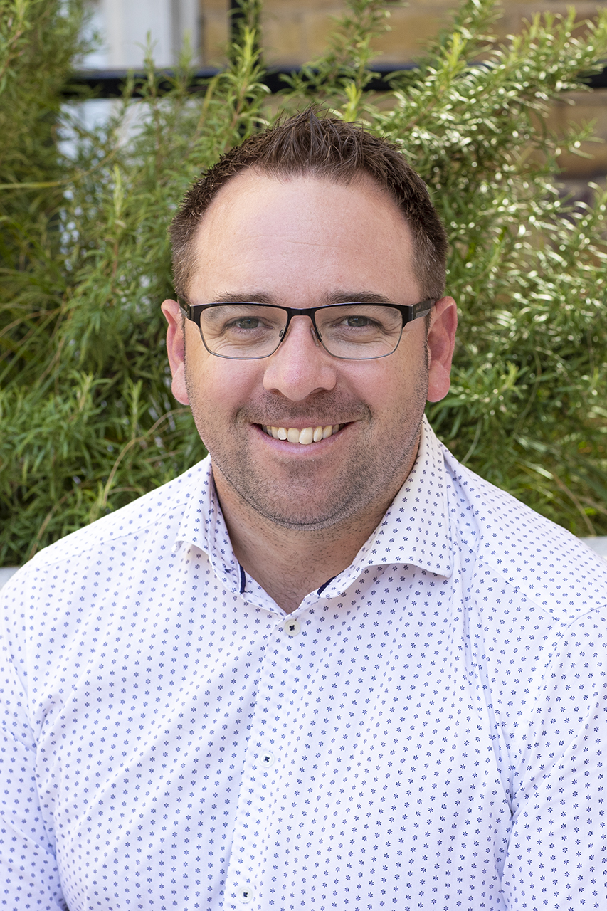Winner
Wesley Knapp
Decants and Moves Manager, Estates Development

Wesley has significantly progressed the agenda around maximising the reuse of furniture across a wide variety of projects by using tools such as Warpit and Reyooz as well as day-to-day activities working with project teams and UCL logistics colleagues.
Wes is also carrying out audits of UCL spaces prior to strip out to see where and how things can be reused. This has prompted a new partnership with 'Brightsparks' a company which will come in before clearances and take away what we don't need, repurposing it for use in social housing, and for families who are struggling to furnish their homes within the community.

Student Award for Outstanding Commitment to Sustainability
This award is given to the students who most clearly exemplify an outstanding commitment to driving, encouraging or creating environmental or social change at UCL.
Highly Commended
Trizzha Feliciano
MBBS Medicine, UCL Medical School

Trizzha has helped transform the Medical School’s activity and culture on sustainability. She has led the Planetary Health Report Card (PHRC) application for the last two years, working with students, staff and NHS colleagues to complete the in-depth metrics and improve planetary health content in health professional schools.
Trizzha provides live induction talks to first and second-year students, introducing them to sustainability at UCL and the effects of climate change on health.

Highly Commended
Vaania Kapoor Achuthan
BSc Politics and International Relations, Department of Political Science

Vaania is the founder and 2-term President of the Animal Rights Society at UCL - the second biggest society related to sustainability at UCL.
Vaania has founded a Plant-based University Campaign run in over 20 universities and mobilized 300+ students, with the ultimate objective of having universities transition to 100% just and sustainable plant based catering.

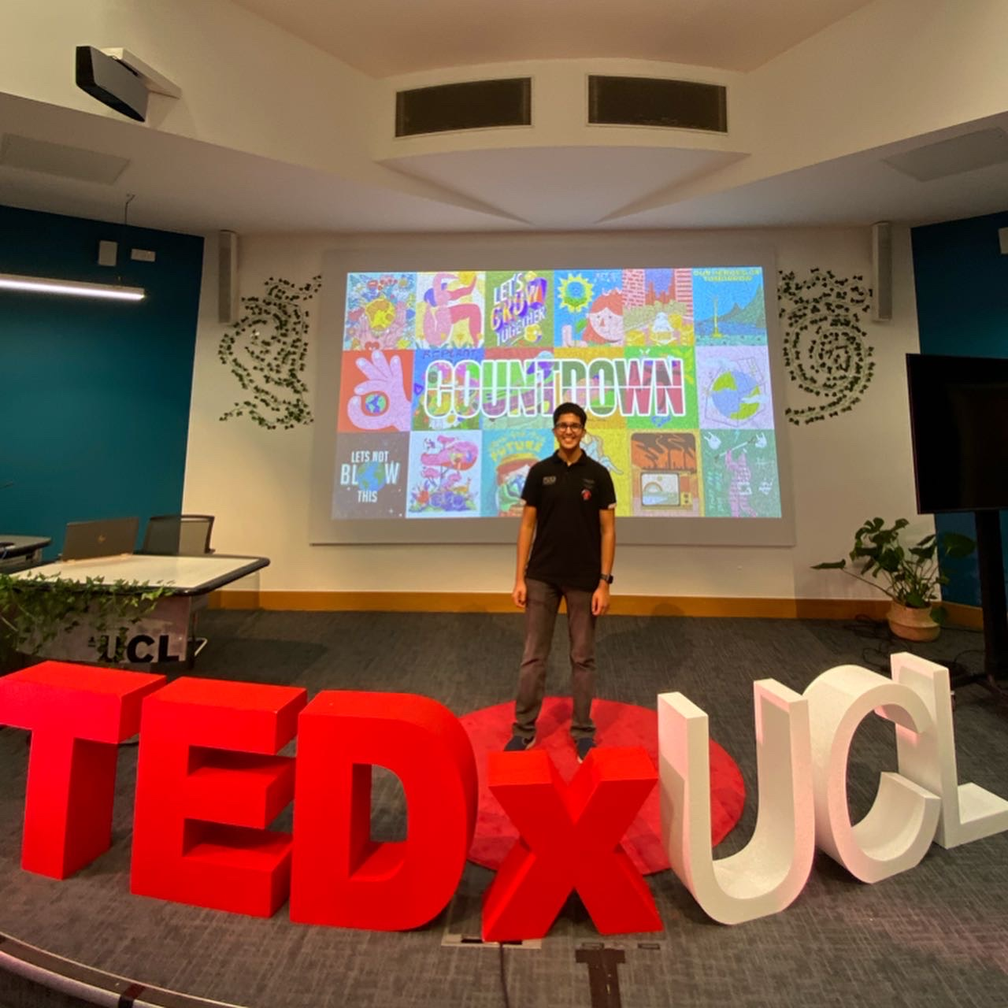Winner
Mukund Hari Nathany
BSc Economics, Department of Economics

Mukund is the President of UCL TEDx Society and has brought TEDx back to the
UCL campus after 6 years. Mukund chose to license TEDxUCL under TED’s Countdown initiative to demonstrate and amplify solutions to the climate crisis.
Under Mukund’s leadership, UCL TEDx Society made sustainability the focus of its activities in 2021/22 including the flagship TEDxUCL conference on climate, which became one of the largest conferences of its kind in the United Kingdom.
The live audience exceeded 500 people and the talks delivered on stage have been uploaded to the official TEDx Talks YouTube channel with 34.9 million international subscribers.

Sustainability Impact Award
This category focuses on the work of teams or societies at UCL, who have undertaken an environmental or social initiative, which contributes to the Signature Campaigns in UCL’s Sustainability Strategy: Change Possible.

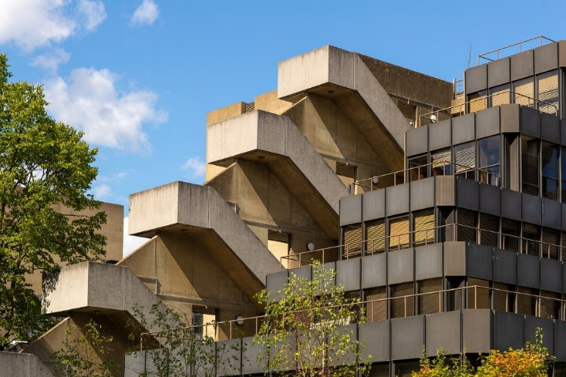
Highly Commended
IOE Student Support Team
Academic Programmes Office, IOE

The IOE student support team ran several projects for staff and students during this academic year to draw attention to sustainability and make a positive impact on students' experience during their studies at IOE.

The team recruited a sustainability officer who worked with the team on a ChangeMaker application and secured funding to run a student campaign at the IOE to encourage students to make small changes for sustainability.

The also ran the 'Grow together' campaign through which they created a student 'plant buddies' community. They facilitated check-ins and meetings for participants to talk about plants, gardening and mental health and wellbeing - connecting around 500 students, staff and plants.

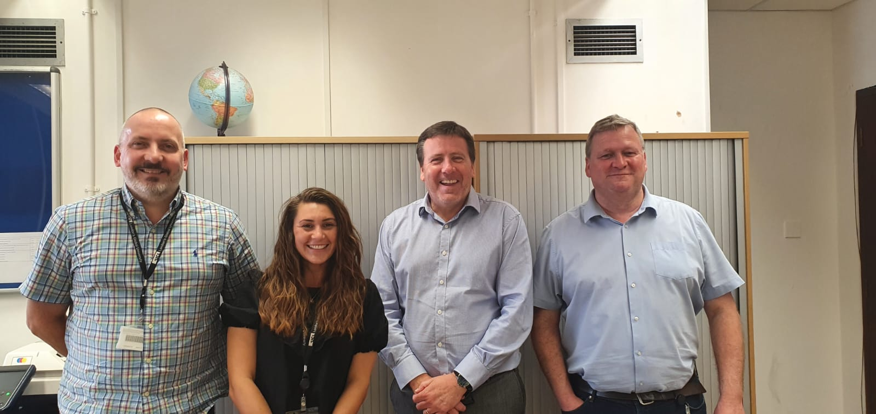
Winner
The Logistics Team
Campus Experience and Infrastructure

The UCL Logistics Team has been working on a number of sustainability initiatives. They have managed to reduce 90% of vehicle access on UCL’s main campus during core hours by working with university departments to bulk buy orders and have them delivered to the Logistics Hub.
In addition, they have partnered with Camden City Council and introduced a ‘no-idling campaign’ for vehicles entering Bedford Way helping to reduce vehicle emissions and local air pollution. Last, but not least, The Logistics Team has purchased cargo bikes to ensure that the final leg of deliveries to UCL is done in a more environmentally friendly way.

Sustainability Research Award
This award is given to the researcher/s whose contribution to the environment and/or society at UCL, or beyond, has the greatest positive impact.

Highly Commended
Dr Jing Meng
Associate Professor in Ecological Economics, The Bartlett School of Sustainable Construction

Dr Jing Meng provides academic leadership in innovative interdisciplinary research, which applies quantitative approaches to link economic growth to environmental sustainability. Since 2016, Jing has been committed to producing transparent and robust data for the Carbon Emission Accounts & Datasets (CEADs).
CEADs provide up-to-date CO₂ emissions and socioeconomic variables, which reflect the global supply chain for emerging economies, which is often neglected. Building on the dataset, Jing delivers high impact research that targets multiple sustainable development goals and their interaction, particularly targeting SDGs 7 (Affordable and Clean Energy), 10 (Reduced Inequalities), 11 (Sustainable Cities and Communities) and 13 (Climate Action).
Jing’s research articles have provided scientific evidence for the policy documents for the World Bank, the Asian Development Bank and the International Panel for Climate Change reports.

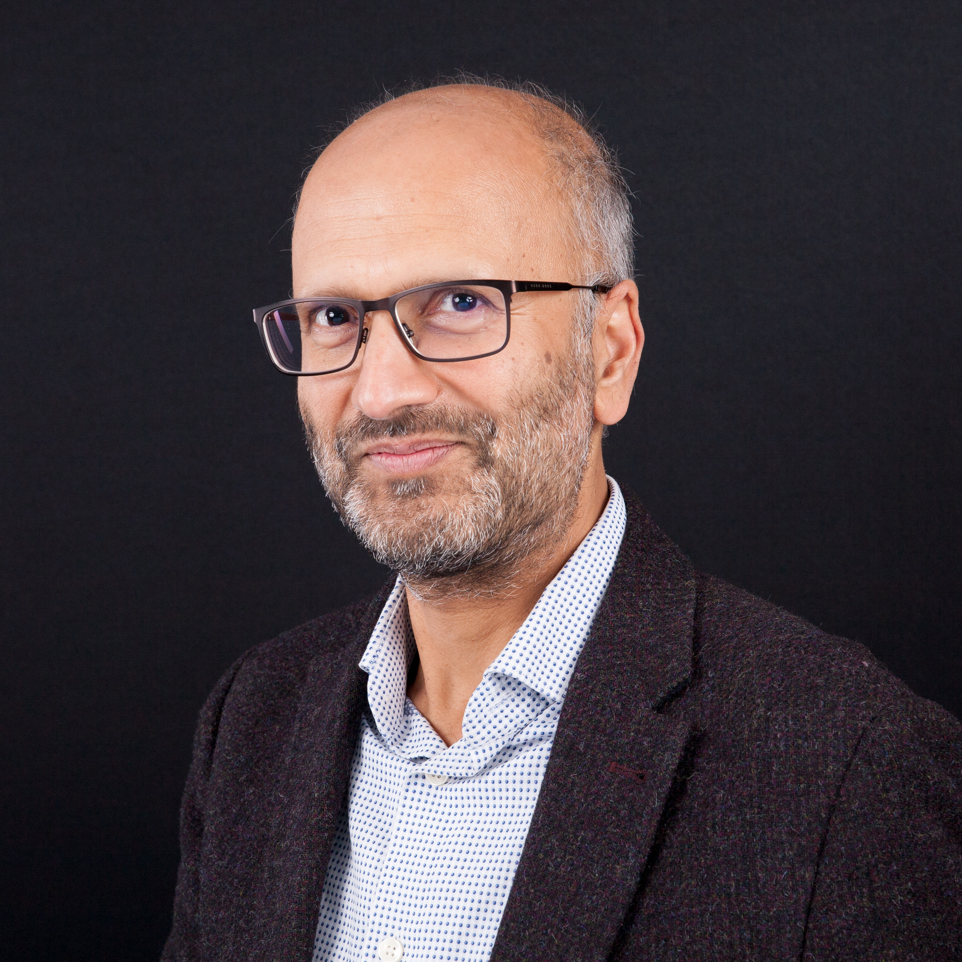Winner
Professor Sanjay Sisodiya
Professor of Neurology, UCL Queen Square Institute of Neurology

Professor Sanjay Sisodiya established a global consortium, called Epilepsy Climate Change (EpiCC), of neurologists, scientists, nurses, representatives from industry and charities supporting people with epilepsy as a global initiative to foster research, raise awareness and share knowledge. He has since established the UCL NeuroClimate Consortium, a cross-Faculty initiative at UCL, including climatologists, neuroscientists, neurologists, pharmacists and architects, aiming to develop and undertake research on climate change impacts across neurological diseases.
Through EpilepsyClimateChange (EpiCC), Sanjay has promoted research internationally, raised awareness and inspired others to take action. EpilepsyClimateChange also won PR Week’s ‘Favourite Campaign of COP26’ – with the distribution during COP26 (2021) of a special-edition newspaper, highlighting the impact of climate change on neurological health.

Sanjay has given 18 national and international climate neurology talks since 2018, and EpiCC was noted at Prime Minister’s Questions (2021).

Sustainability Education Award
This award is given to the member/s of staff and or postgraduate student/s who have integrated a comprehensive sustainability education plan into the formal or informal curriculum.
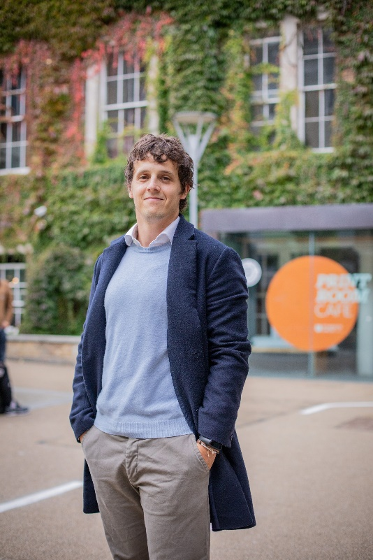
Highly Commended
Dr Lorenzo Lotti
Associate Professor in Economics of Energy and the Environment, Bartlett School Environment, Energy & Resources

Dr Lorenzo Lotti has encouraged students to think about and get involved with sustainable practices through the module ‘Behavioural Economics and Game Theory’.
Within the module, Lorenzo organised a “Behavioural Marathon” where students help an NGO or charity focusing on sustainability to tackle issues with the help of nudges and behavioural economics.

This year, the event was scaled up: teams from UCL and the University of Warwick competed in designing interventions on "sustainable fashion" or "reducing meat consumption among young males football supporters", to help the London-based charity Hubbub. The event was live-streamed, and the winning groups went to Hubbub in Somerset House to present their projects.

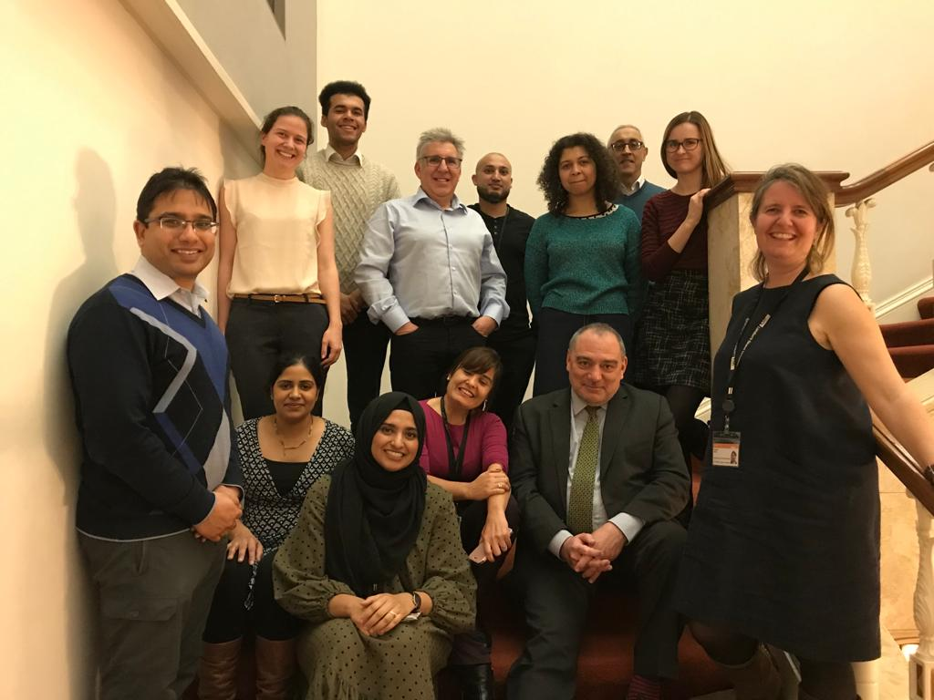Winner
PCPH Primary Care Medical Education Team
Primary Care and Population Health, IEHC

The PCPH Primary Care Medical Education Team re-designed their Year 5 GP course for students to incorporate sustainability into formal teaching and educate future practitioners and leaders that can:
- Advocate for planetary health measures on a population level
- Create health and practise medicine in ways that are environmentally responsible
- Lead systems change through quality improvement and innovation to achieve a NetZero NHS.
The sustainability elements of the course were developed in collaboration with students, academics, GPs, experts, and patient experts. Through lectures the course highlights and discusses the doctor’s and students’ role in a sustainable healthcare system and engages students in discussions of sustainability issues.

Special Award for Outstanding Sustainability Plan

The Sustainability Plan is a bespoke plan, which focuses on the unique sustainability opportunities and challenges that are connected to a division or faculty’s area of work.
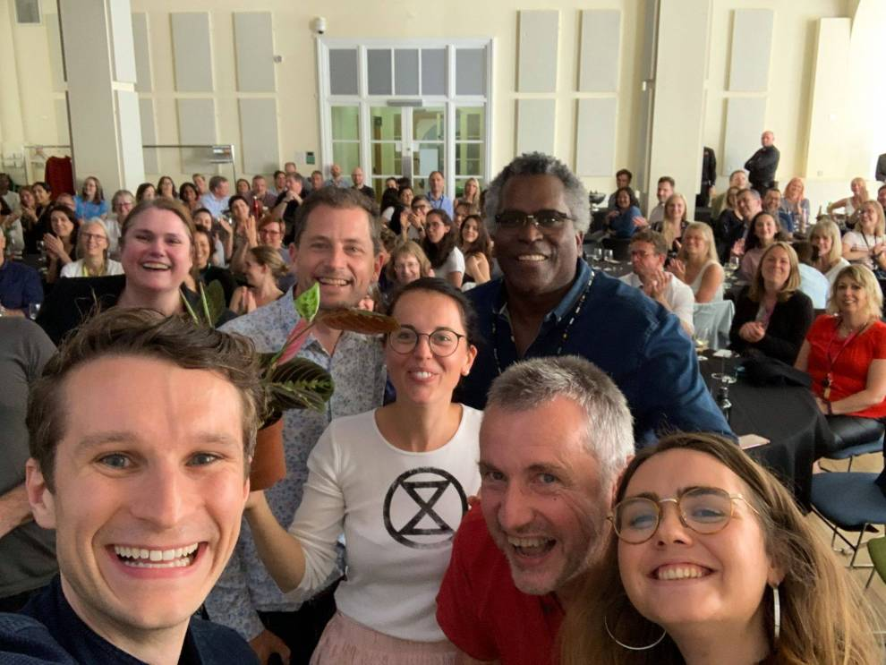
UCL Divison of Psychology and Language Sciences (PALS) Green Team

From the ‘Powered by Plants’ initiative to their zero flying pledge, the PALS Green Team inspire other departments and faculties at UCL and beyond. They have been instrumental in developing UCL’s first Faculty Sustainability Committee in Brain Sciences – a model that is now being adopted across UCL – and continue to lead the way on sustainability at this University.

Accommodation

This year the Accommodation Team have kick-started their sustainability campaign. They have a large new team of green champions and support from senior staff who will increase the sustainability of their buildings and practices through sustainability audits, ramping up recycling and by looking into creating a circular waste stream within halls so that students buy
and waste less.

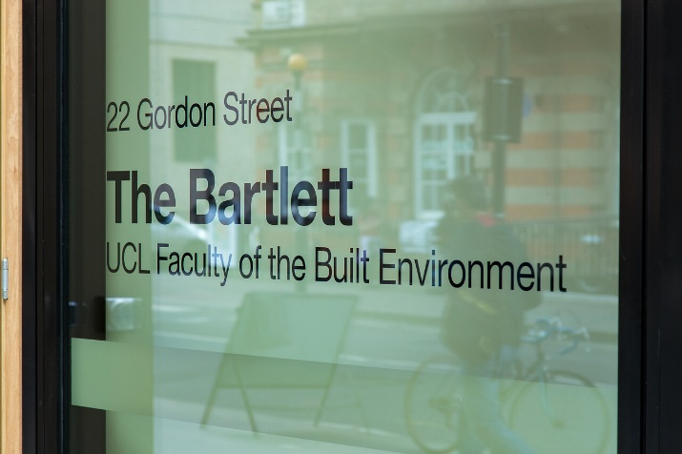
The Bartlett

The Bartlett have taken the initiative to set up their own Net Zero Advisory Group.
This follows a clear decision by the faculty to focus on UCL’s path to net zero with particular attention on driving down operational emissions; whilst also drawing on the research, teaching and wider experience of the Bartlett community.
They have a programme of subject areas they are tackling and will develop plans to understand baseline emissions associated with each one; and put together measures to reduce them.

The Students’ Union UCL
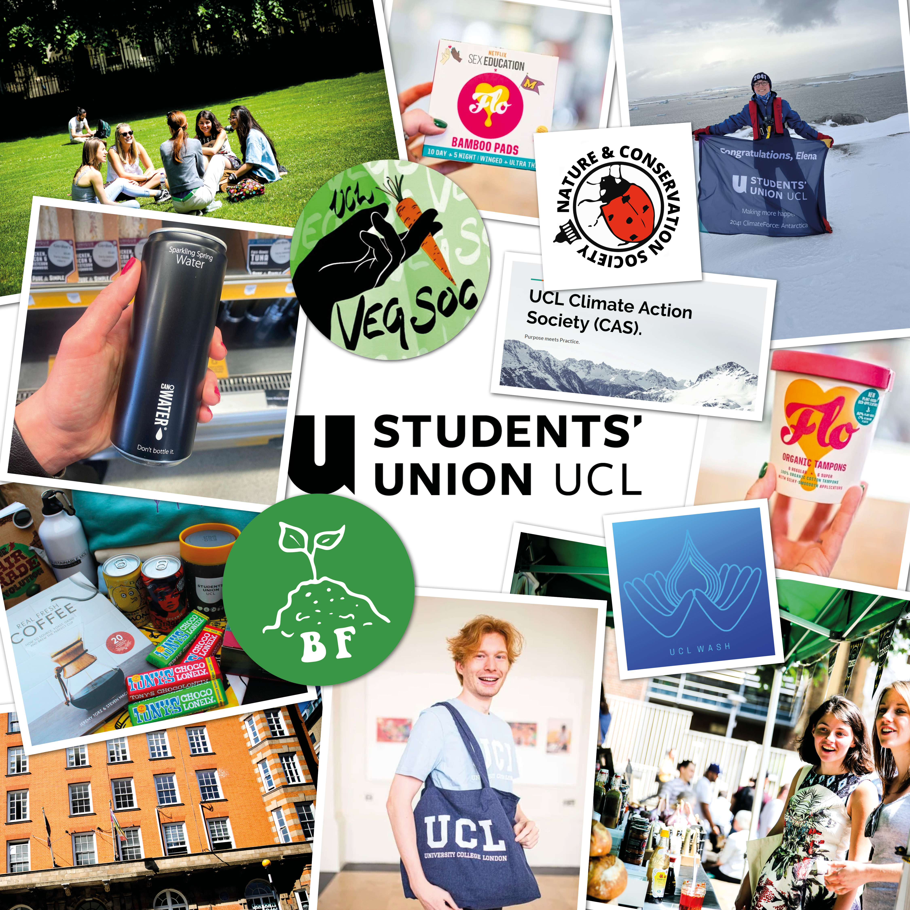

The Student’s Union UCL has implemented an environmental management system on their journey to becoming the UK’s most sustainable Students’ Union
With student engagement being the SU’s biggest opportunity, they have put their power to good use, by engaging students in sustainability through the joint initiatives: the Student Sustainability Ambassador Programme, the Student Sustainability Council, 28 Days of Sustainability (UCL’s Sustainability Month), and organising Sustainability Fairs and Bike-Powered cinemas

