# Sustainability at UCL

Sustainability is at the heart of Estates’ work and what we do at UCL.

For us, it’s all about creating a cleaner, greener, healthier university, which can continue its work into the future. Creating a sustainable estate is a key enabler of UCL’s 2034 strategy for the whole institution.

UCL has some key aims; to create a sustainable campus; to help staff and students improve our impacts; to improve learning and research; and to create a positive impact locally, nationally and internationally.

As UCL President and Provost Michael Arthur sets out:

Whatever your role at UCL, you’re part of a community that’s producing ground-breaking research, delivering world-class teaching, and helping to shape a better world. UCL has a large environmental impact, which as a truly global university, we know we have a responsibility to improve. This is an exciting time for sustainability at UCL.

We have an ambitious vision for the future, but this can only be achieved if all of us; students and staff, play our part. Whether it’s through our research, the way we use energy or the things we buy, there are things we can all do to help create a cleaner, greener, more sustainable UCL. Let’s create a UCL fit for the future.

While helping to improve UCL’s impact really is part of everyone’s role, there are some specific actions that every staff member can take to get more involved and make a positive impact.

How you can get involved

Throughout the year, there are sustainability competitions, programmes and training events.

Make sure you stay up-to-date by following the Sustainability Team on Twitter and ‘liking us’ on Facebook. You can also sign up to the monthly newsletter on the Green UCL website.

www.ucl.ac.uk/greenucl

www.twitter.com/sustainableucl

www.facebook.com/sustainableucl

**www.instagram.com/sustainableucl**

Become a Sustainability Champion

Green Champions are a network of staff and student volunteers.

They work together to make UCL a more sustainable place to work and study. The role is flexible and designed to suit your interests, priorities and schedule.

At its core, it’s all about being enthusiastic about sustainability issues and working to help improve UCL’s environmental impact.

If you’d like to become a sustainability champion, get involved or find out more contact the Sustainability Team or visit-https://www.ucl.ac.uk/greenucl/get-involved

Take part in Green Impact

Green Impact is all about staff and students working together to improve the environmental impact of their departments.

It’s an environmental accreditation and award scheme that recognises achievement, provides rewards, builds sustainability literacy and breaks down the challenge of making environmental improvements into simple steps.

If you’d like to get involved or find out more, just email [green-ucl@ucl.ac.uk](mailto:green-ucl@ucl.ac.uk)

**Help increase recycling rates**

Recycling at UCL is simple, we have a target to increase recycling rates to 85% - we need your help to make this happen.

Almost everything can go in the bins marked ‘mixed recycling’. Materials in our recycling bins are sorted off-site and over 90% goes on to be recycled.

Food and food-contaminated materials should go into other bins. You will find recycling bins in all our offices – please use them!

**UCL has a simple 3 slot bin system across our buildings:**

* Mixed recycling: all recyclable items go in the bins marked ‘mixed recycling’. These materials just have to be dry and largely food-free. They’re taken away and sorted off-site to ensure the highest amount of recyclable materials are collected.
* Food only: all food waste should go in the bins marked ‘food only’ in orange. This is taken off-site and broken down using anaerobic digestion.
* Non-recyclable waste: All those items that are left, items like food-contaminated containers including biodegradable packaging, coffee cups and contaminated wet tissues go in the bins marked ‘non-recyclable waste’ in black. These items are incinerated and the heat they produce is used to generate energy.

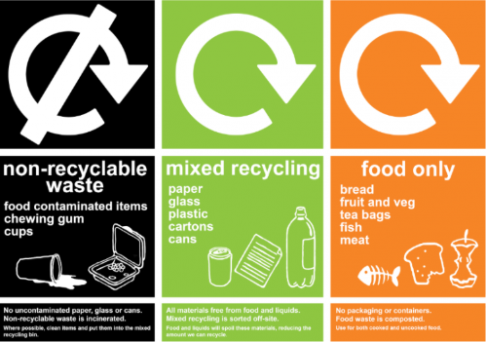

**www.ucl.ac.uk/greenucl/what-we-do/waste-and-recycling/use-right-bin**

**Share unwanted items with WARPit**

WARPit is an easy to use online portal which allows staff at UCL to conveniently share unwanted furniture, stationery, equipment and other resources within UCL. The tool makes it easy for staff to find others with spare equipment and resources. It’s all about reducing purchasing costs and waste disposal costs, as well as avoiding landfill and carbon emissions.

Find out more about using WARPit by going to **www.warp-it.co.uk/ucl**



**Be a Responsible Buyer**

When buying at UCL please consider the long term cost of your decision – does it help UCL to reduce our running costs and have a more positive environmental impact? Were the people who made it treated fairly? We all have a role to play in cutting carbon emissions, ensuring fair employment and eradicating Modern Day Slavery through our purchasing decisions.

UCL has a range of product buying guides, including stationery, electrical goods and furniture, please consult these to ensure you are meeting UCL’s policies: **www.ucl.ac.uk/greenucl/procurment**

**Help save energy – make sure you switch off**

Help save energy, carbon and money by switching off all unnecessary lights and appliances.

Especially at the end of the day, make sure your computer, charger, lights, etc. are all off.