Downloading your Digital Award Certificate to share with CSCSE

Follow the steps below to download your Digital Award Certificate to share with CSCSE.
- Log in to your Gradintelligence account and click My Documents.
- Your Award Certificate (and any other Digital Documents if you have them) will show on this page. Click the View button on your Award Certificate tile.

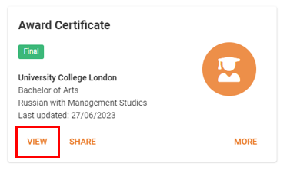
- Click the download icon (top right hand side of your screen – it is an underlined arrow symbol).
- Save your Digital Award Certificate.
You can now upload this Digital Award Certificate when completing the CSCSE application process.

