Request for A New Mobile Phone / Sim Card

Recipient’s Details:
UPI Number: ….……..…….. First Name:…………………………… Last Name:…………………………

Email address: ………………………………………………

Department: ………………………………………………….

Budget Code:
Project: ………………………………. Task: ………………………………. Award: ……………………………

Mobile:
New starter ☐ Lost ☐ Broken ☐

Handset: iPhone SE (128GB) £399.16 (ex VAT) ☐ Samsung A54 £374.17 (ex VAT) ☐

If you have lost your mobile phone, you must contact the Information Security Group (ISG) on the following link:
www.ucl.ac.uk/staff/task/report-data-breach-including-near-misses

SIM:

New ☐ Transferred ☐ Mobile number if transferred ………………….....................

Please provide justification for requiring a new mobile phone now all staff have access to Teams calling:

Application made by:

Name: Signature: Date:

Line manager approval:

Name: Signature: Date:

Once completed and signed by all approvers, please send to: businessops@ucl.ac.uk

If you are requesting on behalf of a new starter, please ensure you make them aware of the
UCL Mobile phone policy once they have received their phone.
Mobile phone use:

Staff issued with mobile phones purchased by UCL for use in the course of their work, must always ensure the security of the phone (and any allied equipment). As with the use of other UCL telephones, personal (non-business) calls should be avoided; and where necessary should be kept to a minimum.

The ISD Telecoms Team can provide guidance to mobile phone users regarding health and safety in relation to their use, and these must be observed at all times. Under no circumstances should mobile phones be used while driving or while using machinery.

The full mobile telephony policy is available here,
https://www.ucl.ac.uk/isd/sites/isd/files/isd-telephony-services-mobile-policy-v2.pdf

Managed Mobile Service from Fluid One

As part of the Fluid One contract, UCL has a data pool that is sufficient for its user base based on the previous 12 months data use.
Although you may have had an individual data allowance previously this is no longer required.
Usage alerts initially were set at 2GB per connection, as of today these have been removed and we will analyse the average data connection usage every quarter to ensure these are meaningful going forward.
The Unified Voice team will be alerted if the data pool is utilised by 80% and will take the necessary action to ensure that no user is impacted with excess data charges.
Mobile Phone Connections (5G)
NB. Subject to mobile device being compatible with 5G, alternatively the data will downgrade to 4G.
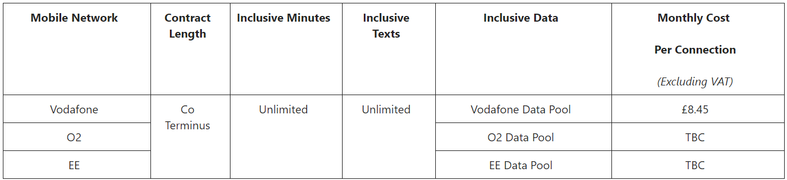

Mobile Broadband Connections (5G)
NB. Subject to mobile device being compatible with 5G, alternatively the data will downgrade to 4G.
