Supplementary Questionnaire

NOTE: If you are applying online, the completed form must be uploaded under ‘Research proposal’ or ‘Statement’ on the online application system.

NB: While filling out the form, be precise, do not repeat yourself and do not exceed the word limit. Every section must be filled out!

Name:
[first name, last name]

- Indicate which (a) study track and (b) partner university you would like to enrol on.

Please indicate below a study track and your first (1) and second (2) preference for year 2 university.
Prior to filling in your preferences, please consult the table on page 2 for study track availability in each partner university. Please see the IMESS website for more details on each of the year 2 universities, including the degree titles awarded by each partner.

Study track (indicate ONE study track only)

Economics & Business
Politics and the International Economy
Politics & Security
History & Society

NOTE: Applications indicating the choice of more than one track will not be considered.

Year 2 university preference (indicate first AND second choice – track availability is shown on page 2).

Year 2 university: | First preference  (1) – please pick ONE | Second preference  (2) – please pick ONE
University of Belgrade, Serbia
Corvinus University of Budapest, Hungary
Jagiellonian University, Cracow, Poland
Helsinki University, Finland
Higher School of Economics, Moscow, Russia
Higher School of Economics, St Petersburg, Russia
Charles University, Prague, Czech Republic
University of Tartu, Estonia

NOTE: While we make all possible effort to accommodate your first preference of Year 2 destination, it is not possible to guarantee places. Students will be notified about Year 2 university allocation by the end of UCL enrolment week.

TRACK AVAILABILITY IN 2021/23:

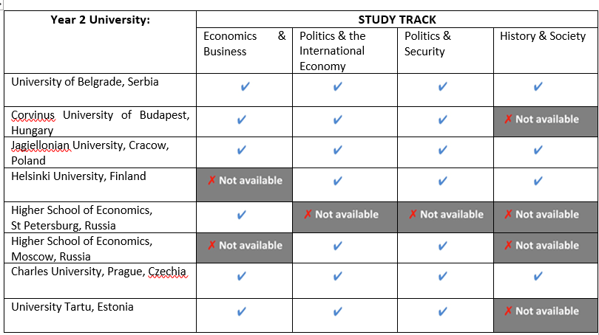

2. Which IMESS language would you like to study?
Please indicate first (1) and second (2) preference.
Note: you can study one of the IMESS languages either in both years or only in year 1 or 2.
You can study any IMESS language in year 1; in year 2, you can normally only study the titular language in year 2 as a rule, except for Tartu, where either Estonian or Russian can be studied.
Czech
Estonian
Finnish
Hungarian
Polish
Russian
Serbo-Croatian (=Bosnian/Montenegrin)

I would like to study the language (tick only one of the options):
in both years
only in year 1 (at UCL).
only in year 2.
Level (please explain in full:

3. Please explain the reasons for your language and year 2 university choice selected above.

(100 words max)

4. Motivation and suitability.
Outline your motivation for choosing the IMESS programme and explain why you think you are a good candidate for the programme: i.e. how IMESS complements and develops your previous studies; how it relates to your future career path; how the programme and the courses offered on both years relate to your personal and academic interests. State why you have chosen the study track indicated in (1) above.

(300 words max)

5. Research interests.
Briefly outline the provisional topic of your IMESS dissertation (this can change later): explain how it relates to the programme theme (‘Economy, State and Society’) and to your choice of year 2 country of study and language (if applicable). Indicate 1 or 2 IMESS electives that you consider might be helpful in preparing for your research (here we will be looking for evidence that you have studied the programme websites).

(500 words max)

If you have already submitted your application, please send the form (including the scan of the information page of your passport) to imess@ssees.ucl.ac.uk with the subject header ‘IMESS Scholarship Application’

