Redefining the Russian Literary Diaspora (1918-2018):
National Tradition and Postnational Contexts

FRINGE Research Centre Annual Conference

May 30-31, 2018
UCL

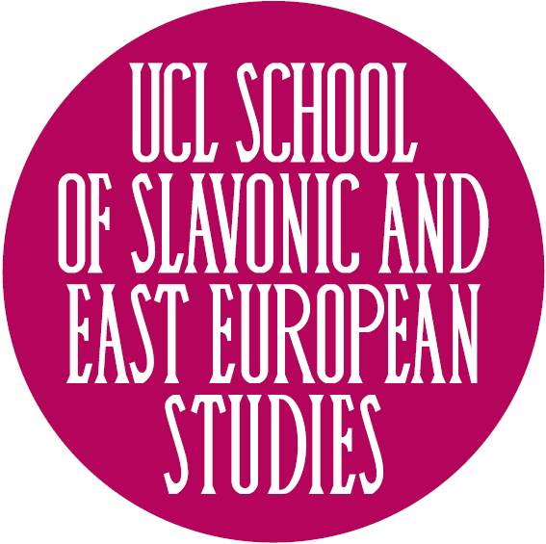
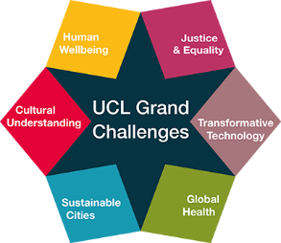
Programme
Venue: UCL Institute of Advanced Studies (Common ground (G11), ground floor, South Wing)
Wednesday, May 30

09:45-10:00 Registration. Coffee/tea.
10:00-10:15 Welcome from Director of SSEES Diane P. Koenker and Director of the FRINGE Research Centre Peter Zusi (UCL SSEES)
10:15–10:45 Maria Rubins (UCL SSEES)
“Modes of Writing and Reading Diasporic Literature: The Russian Case.”
10:45-11:45 Andreas Schönle (Queen Mary University of London)
“Exile as Emotional, Moral, and Ideological Hybridity: The Case of N.I. Turgenev”
Discussant 1: Mark Lipovetsky (University of Colorado)
Discussant 2: Alexander Zholkovsky (University of Southern California)
11:45-12:45 David Bethea (University of Wisconsin Madison)
“‘Nothing in Diasporic Culture Makes Sense Except in Light of Biology’
(Pierre Teilhard de Chardin, Theodosius Dobzhansky, Vladimir Nabokov)”
Discussant 1: Kevin Platt (University of Pennsylvania)
Discussant 2: Lada Panova (University of Southern California)
12:45-13:00 Coffee Break
13:00-14:00 Alexander Zholkovsky (University of Southern California)
“Experimenting with Experimental Writing:
Ivan Bunin's Dark Alleys with Special Reference to ‘Visiting Cards’”
Discussant 1: Mark Lipovetsky (University of Southern California)
Discussant 2: Katharine Hodgson (University of Exeter)
14:00-15:00 Lunch Break (Catered)
15:00-16:00 Pamela Davidson (UCL SSEES)
“The Impact of Exile on the Russian Literary Tradition of Prophecy: the Case of Viacheslav Ivanov”
Discussant 1: Adrian Wanner (Pennsylvania State University)
Discussant 2: Lada Panova (University of Southern California)
16:00-17:00 Adrian Wanner (Pennsylvania State University)
“Translingual Poetry and Diasporic Identity: The Self-Translations of Marina Tsvetaeva, Vladimir Nabokov, and Joseph Brodsky”
Discussant 1: Maria Rubins (UCL SSEES)
Discussant 2: David Bethea (University of Wisconsin Madison)
17:00-17:15 Coffee Break
17:15-17:45 General Discussion
19:00 Dinner (L’etoile restaurant, see back page for map & Directions)

Thursday, May 31

10:00-11:00 Lada Panova (University of Southern California)
“Aristocratic Writing in Emigration on the Verge of Extinction: A Survival Kit, a Suicidal Kit”
Discussant 1: Andreas Schönle (Queen Mary University of London)
Discussant 2: David Bethea (University of Wisconsin Madison)
11:00-11:45 Galin Tihanov (Queen Mary University of London)
“Exile and the Making of ‘World Literature’”
11:45-12:00 Coffee Break
12:00-13:00 Katharine Hodgson (University of Exeter)
“The Role of the Poetry Anthology in the Construction of a Diasporic Canon and the Repatriation of Diasporic Literature”
Discussant 1: Pamela Davidson (UCL SSEES)
Discussant 2: Kevin Platt (University of Pennsylvania)
13:00-14:00 Lunch Break (Catered)
14:00-15:00 Mark Lipovetsky (University of Colorado)
“Is There Room for Diaspora Literature in the Internet Age?”
Discussant 1: Alexander Zholkovsky (University of Southern California)
Discussant 2: Maria Rubins (UCL SSEES)
15:00-16:00 Kevin Platt (University of Pennsylvania)
“The Benefits of Distance: Extraterritoriality as Cultural Capital in the Literary Marketplace”
Discussant 1: Adrian Wanner (Pennsylvania State University)
Discussant 2: Galin Tihanov (Queen Mary University of London)
16:00-16:15 Coffee Break
16:15-17:15 Discussion with writer and BBC journalist Zinovy Zinik
“Author’s Observation Point and Identity Politics”
17:15-19:00 Conclusion and Wine Reception

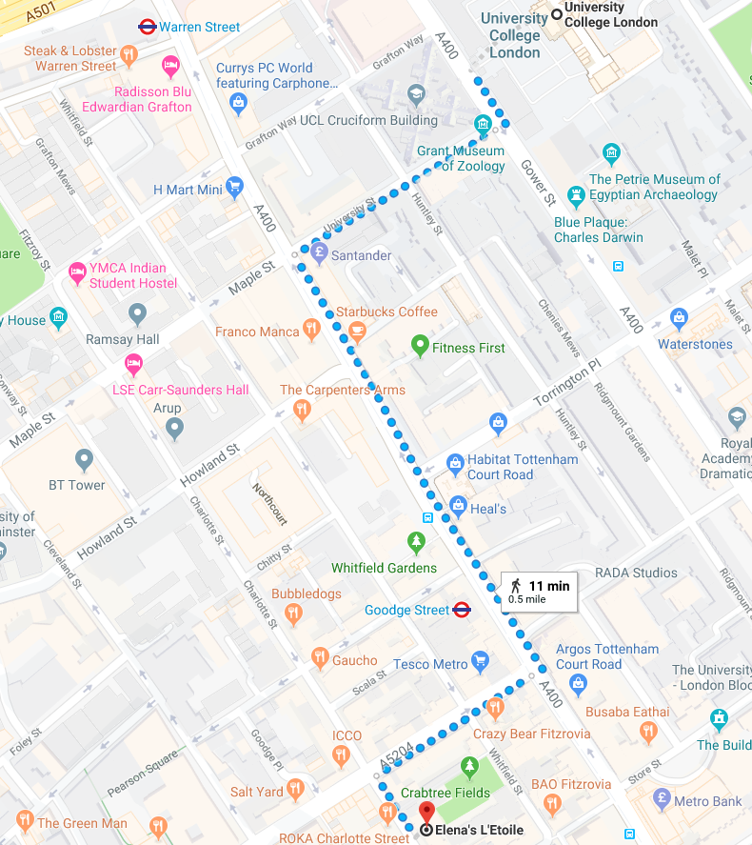
Directions to L’etoile Restaurant from UCL:

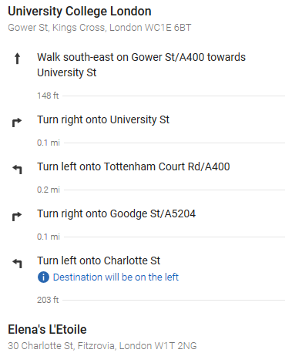

Guest WI-FI
Connect to (join) the UCLGuest Wireless Network.
Open a web browser and navigate to a page outside of UCL. The browser will automatically redirect to the UCLGuest Welcome page. The UCL Welcome page will look like this:
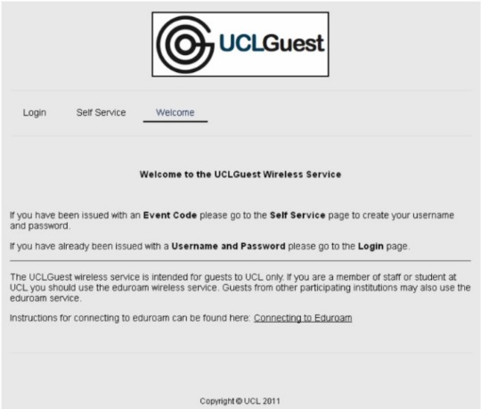
Click on the link to the Self Service page; enter your information in the fields provided (name, surname, email, WI-FI event code: Diaspora)
Click Generate Account.
Your username and password will be displayed on the screen; these details will also be sent to your e-mail address. Make a note of your username and password as you will need them each time you log into UCLGuest (the system will not remember your login details).
Click on the link to the Login page and enter your details. (Please be aware it may take up 60 seconds for your account to become active after it has been generated, if you cannot log in please wait a short while and try again)

