Return to UCL – Covid-19 Precautionary Measures
This template provides a structure for Departments preparing local arrangements for returning to work. The use of this template is not mandatory. A thank you to the Institute of Neurology who prepared a document for their pilot of which ideas are incorporated here.
These arrangements are not required to outline good habits and hygiene advice which is already covered in the ‘Return to UCL briefing’ but detail the department and building specific arrangements such as building routes and shift times.
Any italic text in the body of this document is for guidance to those preparing these arrangements and should be deleted before publishing.

Introduction
This Staff Guidance document summarises all necessary control measures put in place at <INSERT BUILDING> by <INSERT DEPARTMENT>, Estates and UCL to ensure social distancing, personal hygiene and most importantly the safety of returning staff.
This document is specific to <INSERT DEPARTMENT AND BUILDING> and serves as an easy to follow supplement to the Department specific Covid-19 risk assessment (<INSERT REFERENCE NUMBER>). All regulations must be strictly followed by all returning staff and students.
Principal Investigators, Managers and Supervisors are directly responsible for their personnel adhering to these rules.
Please note that guidance and policies are subject to change as and when UK Government, Public Health England and UCL advice is updated and lessons are learnt from the pilot phase.

Use of this document
The purpose of this document is to outline how social distancing measures will be achieved and what rules staff must understand before they return to work.
Before reading this document, staff must have completed the following e-learning courses:
- Return to UCL Induction
- Fire Safety (unless this has been completed within the last 2 years)

Who can return
This section should detail which staff members are eligible to return. Example points are listed below.
- If staff and students are able to work from home, they should continue to do so.
- Only essential and urgent lab work should be carried out on site.
- Complete laboratory work in minimum time and defer desk-based activities to home.
- Staff must not come on site for office-based work.
- The return to work is on a voluntary basis at this stage and staff must be consulted beforehand.
- Staff classed as vulnerable or in care of the vulnerable must not travel at all and stay at home.

Access and egress
This section should detail which doors can be used to enter and exit the premises. Theoretical example below for Bidborough House.
- Entrance: The main entrance on Bidborough Street must be used at all times.
- Exit: The side entrance on Mabledon Place must be used and operates between 7am – 9pm on weekdays only. At other times and weekends the main entrance on Bidborough Street must be used and social distancing maintained.

Occupancy
This section should detail the maximum occupancy that will be allowed in the building at any one time. Examples below.
- Occupancy will be at 10% of staff for the first part of the return.
- This will increase to 10% staff and 5% students when approved.
- This will increase to 25% staff and 5% students when approved.
- This will increase to 25% staff and 15% students when approved.

Shift arrangements
This section should detail the shift times that the Department will be operating. Examples below.
- Shifts are from Monday to Friday, no lab work will take place on weekends.
- Shift 1: 07:00 – 13:00 (staff must exit by 13:30)
- Shift 2: 14:00 – 20:00 (staff must not enter before 13:30)

One-way systems
This section should include floor plans showing the one-way systems and describe any rules to follow. Examples below.
- All floors will operate an anti-clockwise route.
- The stairs on the east end of the building are for ascending only.
- The stairs on the west end of the building are for descending only.
- The passenger lift by the main entrance may be used by those who require a lift. This must be used one at a time.
- The passenger lift at the west end of the building is for deliveries and labour staff use only.
1st floor:
<Insert floor plan>
2nd floor:
<Insert floor plan>
3rd floor:
<Insert floor plan>

4th floor:
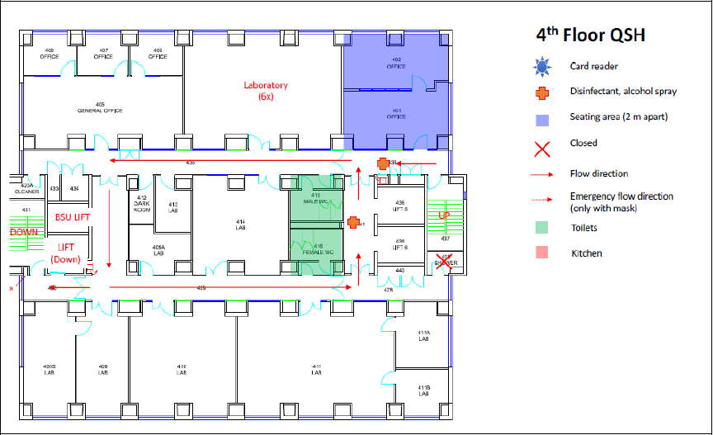

Labs and workshops
This section should detail working arrangements that must be adhered to in labs and workshops, especially where 2m distances are not practical. Examples below.
- When indicated, the maximum number of staff in each lab must never exceed the number displayed on the door.
- Bench space and shared equipment must be bookable where possible and must be cleaned after each use.
- Nitrile or other protective gloves are not required and not recommended for use unless necessary under a task specific Risk Assessment. Hand washing/sanitising remains the best personal hygiene measure.
- In every lab, maintain a 2 metre (6'6") distance between people wherever possible.
- If a 2 metre distance cannot be maintained, work side by side or work facing away from other people, rather than face to face. The specific risk assessment will outline any PPE requirements in this case.
- Lab coats must be stored separately from others.

Example plan for a lab:
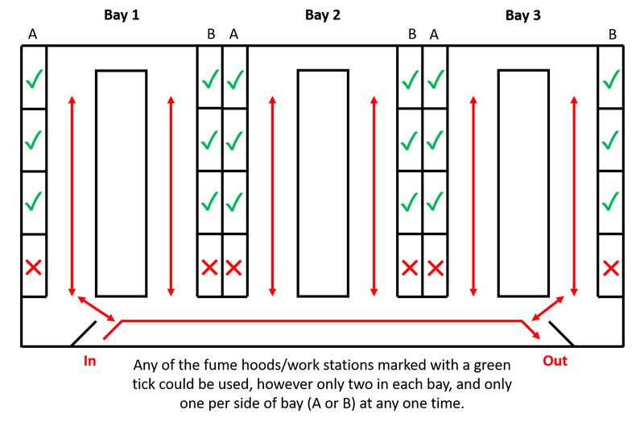
Example plan for a workshop:
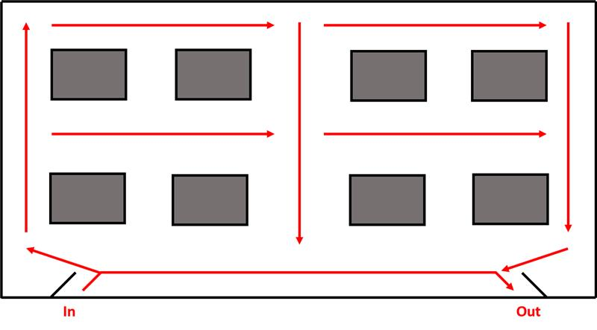

Offices
This section should detail working arrangements in open-plan offices, this would be for short duration desk tasks as full-office workers should not be returning at this stage. Examples below.
- Agile working is suspended, certain desks are marked for use and others as out of use.
- Maintain a 2 metre (6'6") distance between every desk workstation.
- Staff should work at desks on the same side or facing away from each other, never face to face.
- Office equipment should not be shared. Printers and photocopiers should be wiped down after each use.

Welfare facilities
This section should detail what controls are in place for using kitchens, tea points and toilets. Examples below.
- Use of communal kitchens or tea points is single-use only. Queue markings will be in place outside the entrances to these areas.
- Communal cutlery and mugs etc. should not be used, and personal ones be taken home to be washed, not left in communal areas.
- Fridge, kettle and microwave handles should be wiped after use.
- Where toilets have multiple cubicles in the same room, the room is restricted to use by one person at a time only. Queue markings will be in place outside the entrances to these areas.
Example for using tea points:
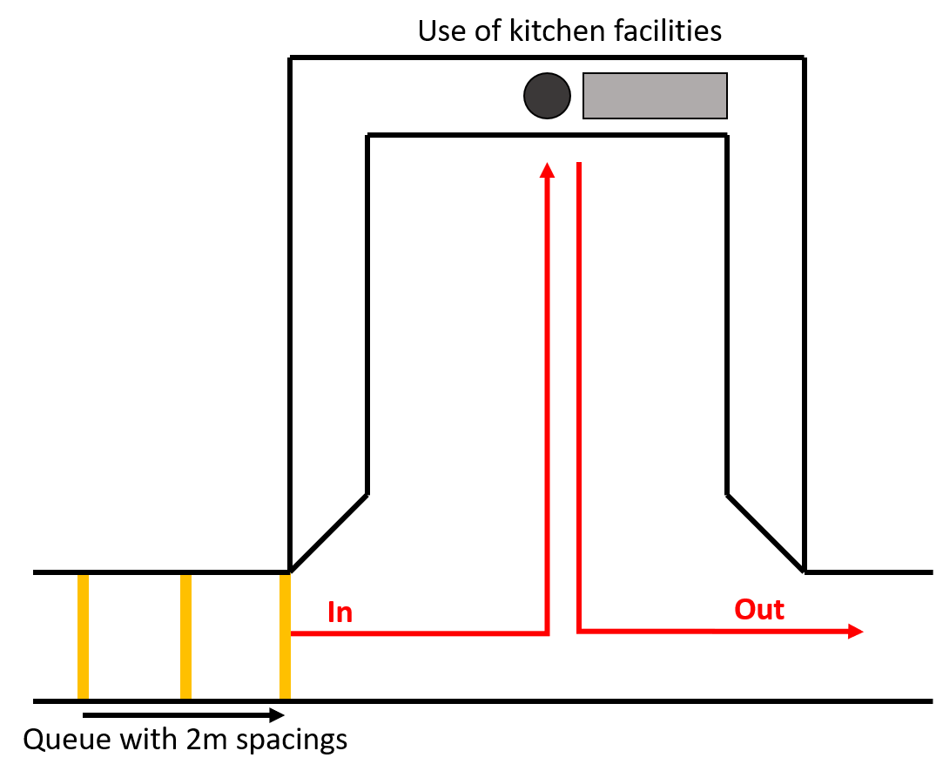

Example for using kitchens:
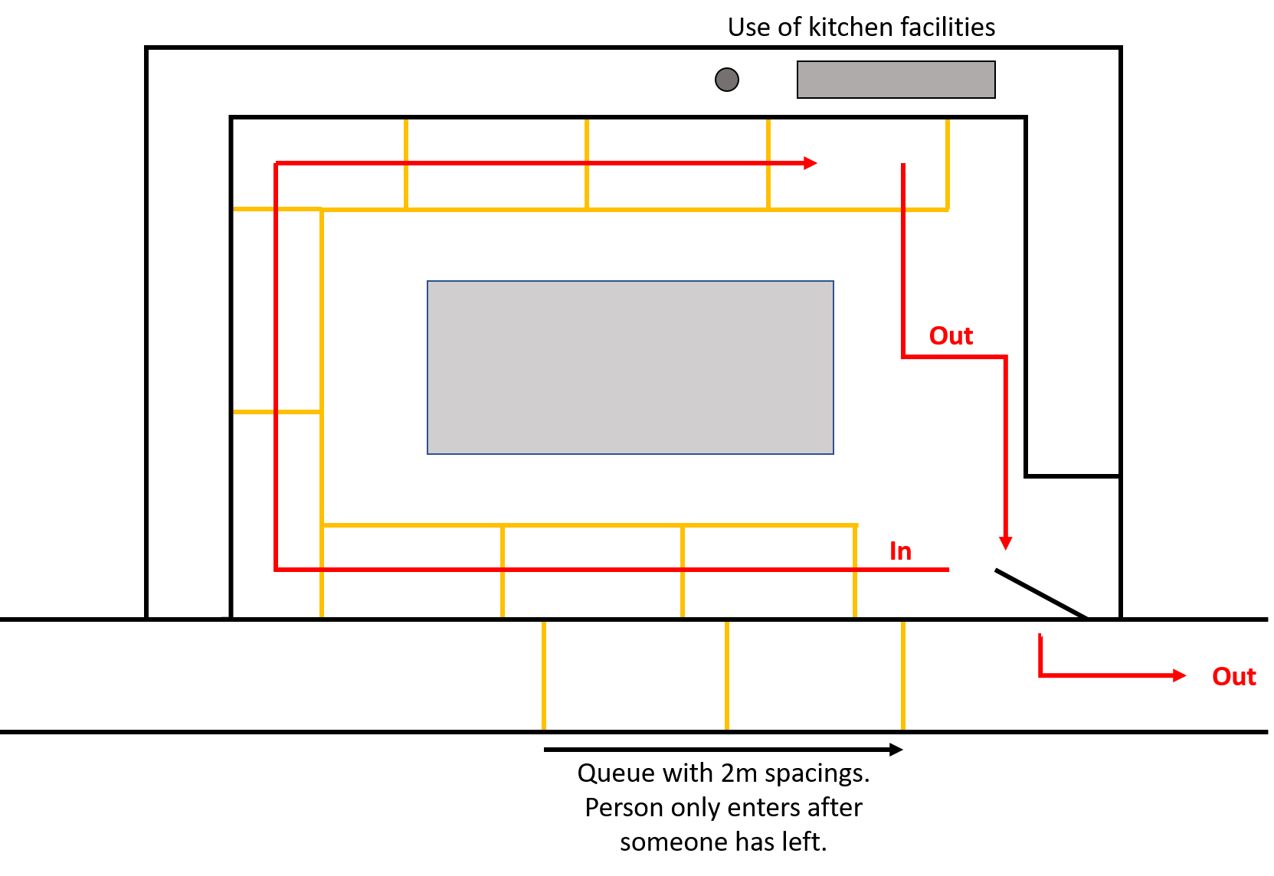

Emergency arrangements
This section should detail first aid and fire marshal coverage and tackling spills in labs etc. Examples below.
- In emergencies such as supporting a seriously injured colleague or responding to a chemical spill, people do not have to stay 2 metres apart if it would be unsafe to do so.
- If you need to provide assistance to others, you must pay particular attention to sanitation measures immediately afterwards including washing hands.
- In an emergency - call UCL security on 020 7679 2222 or extension 222, before calling 999.
- High risk activities must not take place if there is reduced or no first aid cover in your building.
- Line managers should review PEEPs in place to ensure they can still be followed.
- First aiders must report to reception when they are present so first aid presence is monitored.
- The fire assembly point is the same as usual, staff should socially distance wherever possible if required to evacuate and muster.

Contractors and visitors
This section should detail how to manage contractors and visitors. Examples below.
- No visitors will be allowed in the buildings for the foreseeable future.
- All non-essential contractor or maintenance visits must be cancelled or postponed.
- Laboratory / Facilities / Operations managers should contact the Estates Area Facilities Manager (AFM) to discuss essential maintenance visits.
- Limit the number of contractors visiting at any one time and limit visit times to a specific time window.
- Contractor and staff works should not overlap, if essential maintenance must take place in a work area no staff should attend UCL who work in that area until the contractors work is completed.

Deliveries
This section should detail how deliveries will be accepted. Examples below.
- Deliveries must be minimised, for lab items order larger quantities less often where possible.
- Personal deliveries (e.g. Amazon) are prohibited.
- Deliveries will be accepted by reception and stored in room G01.
- Staff will be emailed to collect their delivery during a time-slot.

Communications
This section should detail how the Department will keep staff up to date as guidance and rules are updated. Examples below.
- Staff should ensure they read the UCL daily coronavirus (Covid-19) update.
- Staff should ensure they read the Departmental newsletter which will highlight updates to these arrangements.

Quiet and multi-faith rooms
This section should detail use of quiet and multi-faith rooms. If these are to remain closed staff should be made aware.

Wellbeing
This section should include details on support and wellbeing resources. Examples below.
- For staff; Care First can be contacted 24/7 for confidential, impartial support. Call for free on 0800 197 4510.
- For students, support is provided by Student Psychological and Counselling Services (SPCS) during 'office hours'. Care First can be contacted outside office hours (5pm to 9am) by calling for free on 0800 197 4510.
- Care First also offer support through a one-to-one online messaging service, in which you can speak to a counsellor in real time.
- Where appropriate, adjustments to working times or hours should be made, to account for staff or students experiencing poor mental health. If confidential advice and assessment would be helpful, please contact Workplace Health using the management referral process.
- A wide range of other resources and guidance is available via the 'Remote not distant' website, Student Support and Wellbeing website and UCL Health and Wellbeing website.

Once you have read and understood these arrangements, please email your line manager to confirm you have read and understood them prior to returning to work.
If there is anything you are unsure about, please ask your line manager before confirming you understand these arrangements.

Document Control
Author (name and position) | Author name, Job title
Date published | Month Year Version

