Guidance for Interim Staff to Undertake the ‘Return to UCL’ Induction

Introduction
This guidance applies to any UCL staff, students or visitors who cannot access the ‘Return to UCL Induction’ on MyLearning.
This does not apply to those who can access the course through MyLearning or who are only temporarily unable to access it through MyLearning. This should not be viewed as a shortcut method to inducting staff who can access it via the official method.

Roles and responsibilities
Managers / Supervisors / Principal Investigators
Managers are responsible for ensuring their personnel undertake the ‘Return to UCL Induction’ by the appropriate means and only view the PowerPoint version if they do not have access to MyLearning.
Managers are responsible for ensuring no changes are made to the induction by their personnel and local records are retained of completed inductions by PowerPoint. See appendix 1 for guidance.
Staff / Student / Visitors
Staff, students and visitors are responsible for only undertaking the induction by PowerPoint if they do not have access to MyLearning. It is their responsibility to view the entire course and understand the contents before confirming their completion to their line manager or other responsible person. They are responsible for not making any changes to the document.

How to undertake the induction
- Eligible staff, students and visitors will be given a copy of the file ‘Return to UCL induction final’ by their line manager or other responsible person.
- This has been marked as final to restrict editing access. Do not make copies or attempt to make any changes.
- The induction is set to autoplay, no clicks or slide turnovers are necessary from the viewer. Simply press the ‘F5’ key or click on the ‘From Beginning’ button (see screenshot below) to begin the induction.
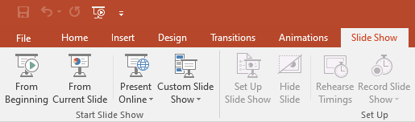
- Once you have completed the induction, confirm to your line manager or other responsible person that you have completed the course. You may be asked to record this on a record form.

Appendix 1: Induction Record Sheet

Return to UCL Induction Attendance Record

Content
The ‘Return to UCL Induction’ covered the following criteria:
- General information  - Travel  - Welcome stations  - Social distancing  - Good habits |  |  |  | - Cleaning  - Face coverings  - Welfare  - Emergency arrangements  - Where to find further information

Declaration
I confirm I have viewed in full the ‘Return to UCL Induction’ and I have understood the contents.
# | Name | Date Inducted | Job Title |  | Sign

