UCL Collaborative Social Science Domain
Social Science Plus
Pilot Project Outcomes Report

Project Title
Children and unsolicited sexual images on Social Media Apps: Developing Better Digital Defences and Literacy (£11,000)

Amount
£11,000

Academic Year
2019-20

Social Science Principal Investigator
Professor Jessica Ringrose, Professor Sociology of Gender and Education, Education, Society and Practice, Institute of Education

Co-Investigator(s)
Non-Social Scientist Co-Investigator:
Dr. Enrico Mariconti, Lecturer, Department of Security and Crime Science, Engineering Sciences, BEAMS

Additional Collaborators (include academic and non-academic partners both UK and international)

School of Sexuality Education

Project outline (about 150-200 words)
Purpose/Aims:
Adapting to the context of COVID 19 in March 2020 we changed our project to an online method, given we could no longer work in schools and carry out our original project to explore young people’s snapchat profiles and download their data (with ethical permission) with them in school sites. The project couldn’t be adapted online for ethical reasons. We decided to pool our skills to design an online survey. Rethinking issues of sexual image sharing at the start of the pandemic in March 2020 we found that increased screen-time during quarantine for COVID-19 was worsening gender and sexual risks online, with the scope for bullying and harassment increasing significantly, particularly for girls (Plan International UK, 2020) (1). Plan International UK found in May 2020, that since lockdown began, ‘25% of girls have experienced at least one form of abuse, bullying or sexual harassment online’ (Plan International 2020). And the Internet Watch Foundation saw a 50% increase in public reports of child sexual abuse during the first lockdown (Internet Watch Foundation, 2020). Responding to these issues we designed a survey ‘Staying Safe Online’ to learn more about young people’s image sharing practices, which we launched in May 2020, running till September 2020. The survey brought together 4 areas of inquiry together into a unique instrument to ask13-18 year olds about their experiences of: 1. Wanted/Unwanted sexual imagery received; 2. solicitation for sexual imagery; 3. youth self-produced sexual imagery; and 4. non-consensual sharing of sexual images. The survey’s aim was to find out the prevalence and nature of consensual and non-consensual sharing practices, enable understanding of the content shared, the platforms used, and feelings experienced when imagery is shared or received. Specifically, the survey was designed to find out the gendered nature of the sexual content of imagery (is it male or female genitals) which has been neglected in surveys on youth sexting to date (Van Ouystel, 2019). We also wanted to find out the incidence of non-consensual content on which specific platforms, which helps us see which apps are higher risk, and to gauge young people’s responses and understandings of blocking and reporting options. We struggled with recruiting participants in the pandemic context but by October 2020 we had gotten useable responses from 336 young people across the UK.

Main findings (about 150-200 words)

Age of participants
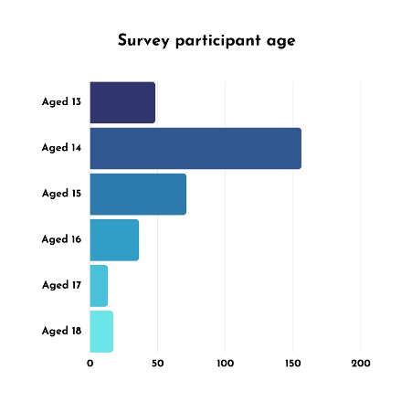
Gender of Participants

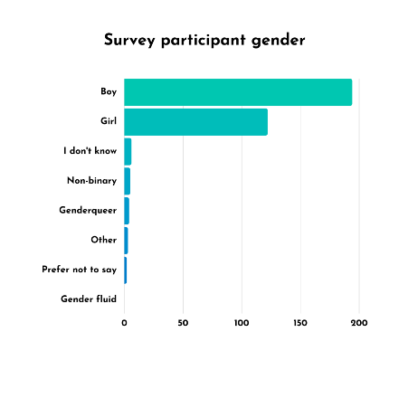
Looking at both descriptive statistics and tests of significance we found:

Solicited to send nudes:

41% of girls said they had been asked to send nudes, 45% of gender diverse young people said they had been asked to send nudes, 17% boys told us they had been asked to send nudes. Girls and gender diverse young people are significantly more likely to be asked to send nudes than boys.

Unwanted solicitation who the requests were from
Bot account (e.g. porn bot) | 3
Friend | 14
Friend of a friend | 3
I didn’t know them | 17
Knew them online only | 16
Met in real life at least once | 8
Not sure | 2
Other | 1
Romantic or sexual partner | 26

The majority of requests for nudes (which is a form of online sexual harassment) is from unkown and only known online contacts.

Sending Nudes
15% of girls, 6.7% of boys and 33% of other genders have sent nude images of themselves to others. Girls are significantly more likely to send self-produced nude images compared to boys. Students of other genders are significantly more likely to send self-produced nude images compared to boys.

Being sent unwanted sexual content (non-consensual sexual content):

Platforms where unwanted content was sent on

62% said it took place via Snapchat, 21% via Instagram, 8% via Whatsapp, 3% on Tiktok, 1% via Facebook or Video Platform, 4% said other.

Snapchat is the platform where most unwanted content is received.

Gender

37% of girls said they had been sent unwanted sexual images online, and 44.4% of gender diverse young people; compared to 20% of boys. Girls and gender diverse young people were significantly more likely to be sent unwanted sexual content online

32% of girls and 17% of gender diverse young people have been sent dick pics compared to only 5% of boys. Girls were significantly more likely to be sent an unwanted dick pic. A large majority of girls said they felt disgusted by these images.

Graph of levels of disgust 35% agreed or strongly agreed that images were disgusting
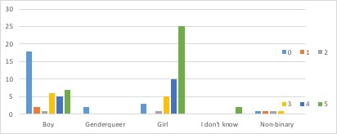

These findings are similar to those of a YouGov Dick Pic survey which found 53% of millennial aged women (18-24 had been sent an unsolicited penis image, with nearly ¾ saying they found it ‘gross’.

Characteristics of senders

WHO SENT Unsolicited sexual images

Bot account (e.g. porn bot) | 19
Friend | 10
Friend of a friend | 5
I didn’t know them | 38
Knew them online only | 8
Met in real life at least once | 5
Not sure | 3
Other | 3
Romantic or sexual partner | 1

41% who received an unwanted sexual image or message say the sender was a stranger. 12% say it was someone they know (friend or romantic partner); 5% say it was a friend of a friend.

Age:
25% who received unwanted sexual messages say the sender was an adult and 33% said it was from a peer, 66% who received unwanted sexual messages were not sure of the age of the sender.

Reporting
In spite of the negative feelings associated with receiving unwanted sexual content, the numbers of young people who reported their experiences were staggeringly low with only 6% reporting it to the social media platform; 3% telling parents and a mere 1% reporting it to their school. Reporting rates had been similarly low in our qualitative findings from the year before; girls typically said they didn’t feel they could report to anyone or anywhere and lacked knowledge of (or faith in) the reporting functions on the platforms themselves.

Receiving Consensual Sexual Content

44% of gender diverse young people, 17% of boys and 12% of girls received images they did want. The rates of receiving wanted sexual images are low for both boys and girls

Especially for girls the rates of unwanted vs. wanted dick pics was notable: 32% of girls had received unwanted dick pics while only 7% said they had received dick pics they wanted.

Non-consensual sharing of Images: Image based sexual abuse

There were very low rates of experiences of image based sexual abuse reported in this survey, which found 3.6% of boys, 2.5% of girls and 16.7% of gender diverse young people had had their images shared without their consent. Together this was only 11 young people in our dataset, unfortunately such a small sample does not allow to draw any statistical conclusion, we think this is because young people understood sharing to mean publicly posted images rather than other modes of sharing discussed in our qualitative research and are aiming to investigate this further.

Summary of Key Findings

Key Platform for abuse is Snapchat:

Snapchat is platform where most of the unwanted sexual content/contact is received 62% with instagram only 21%. Snapchat is a platform whose affordances of ephemerality and inability to report abuse make it ideal for online sexual harassment such as sending dick pics. Cyberflashing. From our qualitative research, we found young people lack awareness of privacy settings or ignore them for the streak, game features of Snapchat leaving them vulnerable.

Perpetrators use affordances of snapchat:

41% of young people reported the content is sent to them by strangers and 25% of content is from an adult and 33% from a peer their age. A significant amount of content is easily sent to young people from strangers on snapchat.

Significant gender differences in receiving unwanted nudes:

37%, of girls received images they did not want on social media apps. Dick pics was the large majority of this content (cyberflashing) 32%. Girls were significantly more likely to receive unwanted sexual content and dick pics than boys.

Significant gender differences in being solicited for unwanted nudes:

High rates of girls 41% and gender diverse young people 45% being solicited to send nudes (sexual harassment) Girls are significantly more likely to be asked to send sexual content than boys.

Extremely low rates of reporting

There were extremely low rates of reporting: only 6% of young people reporting it to the social media platform; 3% telling parents and a mere 1% reporting it to their school.

Key achievements and impacts (academic and non-academic), media coverage, etc (about 150-200 words)

Informing Policy

Report Launch (6 December 2021)
Understanding and combatting youth experiences of image-based sexual harassment & abuse
This report, authored by Professor Jessica Ringrose (UCL Institute of Education), Dr Kaitlyn Regehr (University of Kent) and Betsy Milne (University of Leicester), in collaboration with the School of Sexuality Education and the Association of School and College Leaders, directly addressed the online dimensions of sexual violence amongst young people, drawing on the experiences of 480 young people aged 12-18 years from across the UK. The launch event outlined recommendations and advice to help parents, schools and policymakers identify and respond to image-based sexual harassment and abuse.

The survey findings informed new Online Sexual Harassment Guidance for schools developed with School of Sexuality Education and launched in October 2020.
https://static1.squarespace.com/static/57dbe276f7e0abec416bc9bb/t/5f86b3b1117dd72a57c88d48/1602663347896/School+of+Sex+Ed+OSH+School+Policy.pdf

In December 2020 the guidance was recommended in the new Department for Education guidance “Sharing nudes and semi-nudes: advice for education settings working with children and young people”https://www.gov.uk/government/publications/sharing-nudes-and-semi-nudes-advice-for-education-settings-working-with-children-and-young-people/sharing-nudes-and-semi-nudes-advice-for-education-settings-working-with-children-and-young-people

Media Coverage
The survey was reported in Times Educational Supplement: https://www.tes.com/news/there-hidden-sexual-abuse-going-your-school

and The New Statesman https://www.newstatesman.com/science-tech/social-media/2020/07/snapchat-streaks-and-revenge-porn-what-its-be-teen-online

Public Report
We are working with our charitable partner on this project, School of Sexuality Education using the survey stats to inform a popular report to industry and stakeholders on Young People and Online Sexual Harassment, to be completed by May 2021.

Research Report Launch
6 December 2021
Understanding and combatting youth experiences of image based sexual harassment & abuse
The report is informed by the survey conducted as part of the award.

Lesson Plans
Working with our external partner the sex education charity School of Sexuality Education on this project, we have developed lesson plan content to respond to and combat online sexual harassment, which we will be shortly piloting in schools.
Academic Article
We are working on at least one academic output in the form of a journal article to be submitted to a mixed methodology social science journal.

Detail your plans for external funding application(s) (funder, scheme, date of application, amount, outcome (if known) etc)

Building on our collaboration we submitted a joint proposal to the ESPRC Council in Summer of 2020 ‘Mitigating Image Based Sexual Abuse’; Unfortunately, this funding proposal was unsuccessful.

Professor Ringrose was successful in COVID 19 Fast Response AHRC funding to look further at gender risk and harm online. The ‘Staying Safe Online’ survey is being added to and adapted

University of Leicester led on the AHRC Rapid Response bid:
" Combatting gendered, sexual risks and harms online during Covid-19: Developing resources for young people, parents and
schools."
Whole grant is for £214,524.27. My portion is 1 day a week: £16,841
Next steps

Prof Ringrose and Dr Mariconti are currently working on a new variation of the project above; which will be broadly on mitigating online harassment, cyberflashing, and IBSA through machine learning and educational interventions. We are in planning sessions to develop a funding application for ESRC funding with partners from Queen Mary University (Computer Science) and University of Kent (Digital Arts).

Expenditure summary. You may forward a separate spreadsheet summary if you have the details in that form

We have spent the budget for this project. Thank you.

