Adding a new student to Je-S

Je-S provides a Helpdesk service (details on website) ALL ENQUIRES regarding completing Je-S forms should be directed to the Je-S Helpdesk in the first instance and NOT Research Studentships.

- Go to the Je-S home page http://je-s.rcuk.ac.uk
- Login to Je-s with your username and password
- Select Documents from the Account menu on the left hand side of the screen.

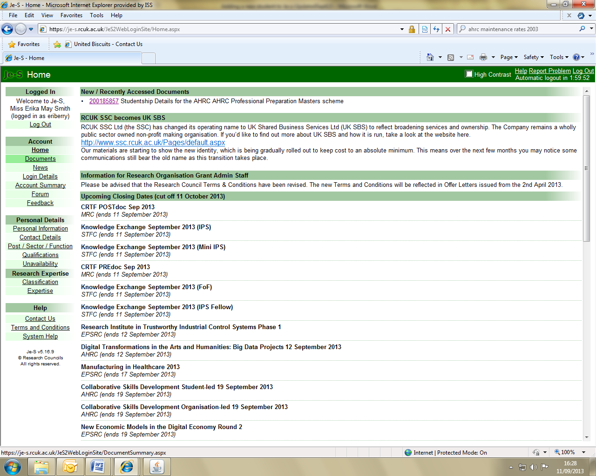

On the next screen click select New Document under the Functions menu.
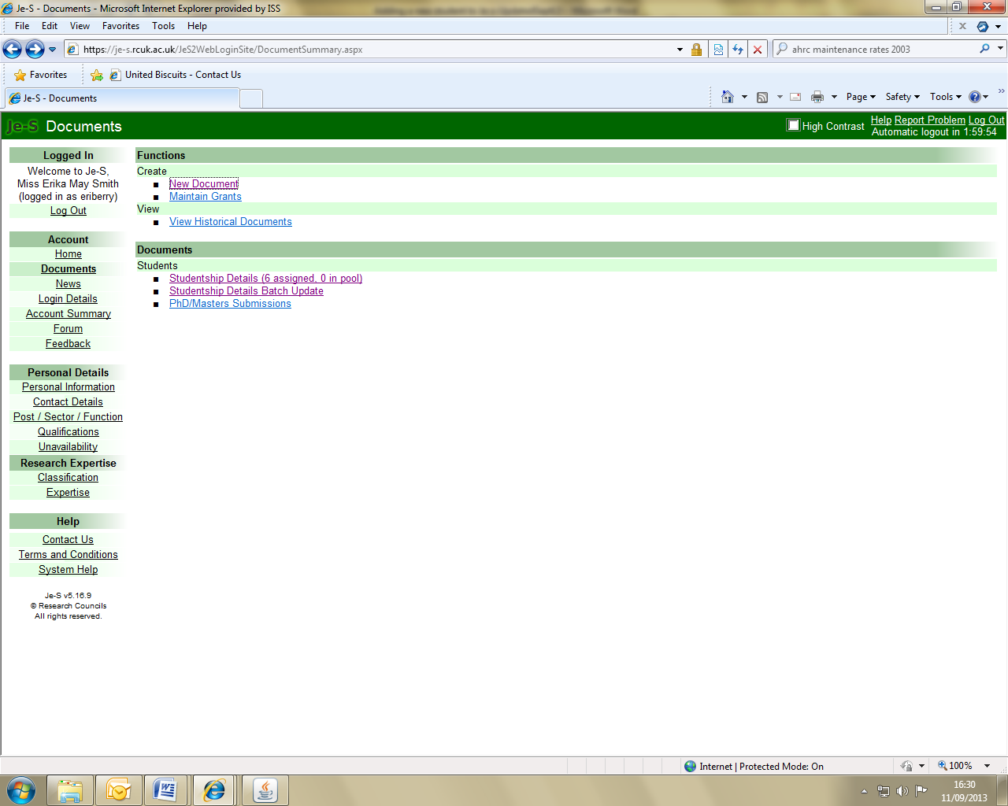

You will then be taken to the Add New Document Screen. Use the Select Council drop down menu to select the appropriate Research Council .

From the Document Type list select Studentship Details.

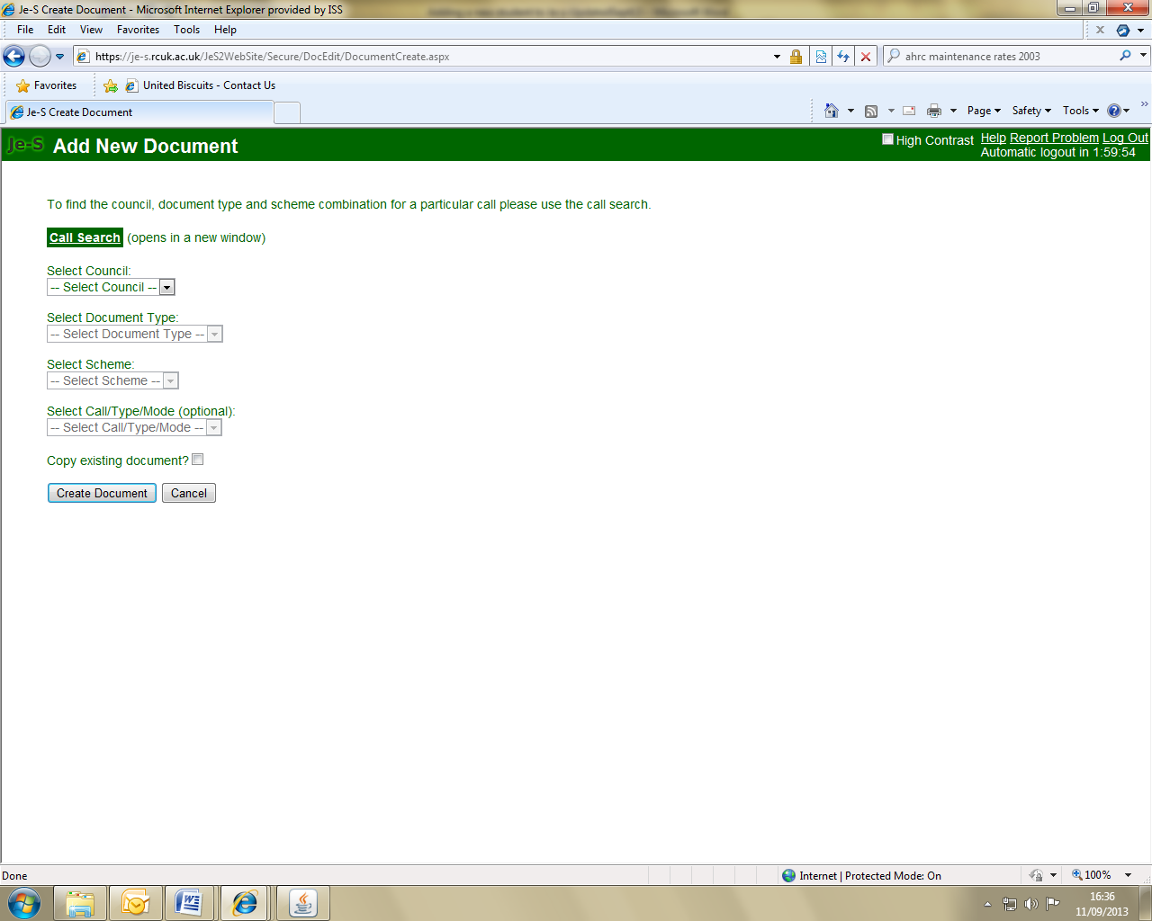

Select the appropriate Scheme from the the Select Scheme list.

For EPSRC International students receiving a full award under the 10% conversion rule select EPSRC International Doctoral Scholars – IDS grant. Where this is an Industrial Case studentship – select category Industrial Case in the first instance so that the Voucher Number and the grant reference can be entered. Once all completed then ‘Change Scheme’ to EPSRC IDS, save and submit.

ESPRC CDTs – infomation on adding students and ‘Incorporated Studentships’.

For the majority of student records, you will not need to select a Call/Type/Mode and this drop down box will not be available.

Click on Create Document to take you into the newly created student record.

Work through the document menu on the left hand side of the screen to complete each section of the student record.

Please note that Research Councils display sections of the record e.g. Ethical Information, Classification etc. in different orders and some sections may be required for certain Research Councils which are not required for others.

(Click on the Instructions option for an explanation of the icons displayed next to each section of the student record.)

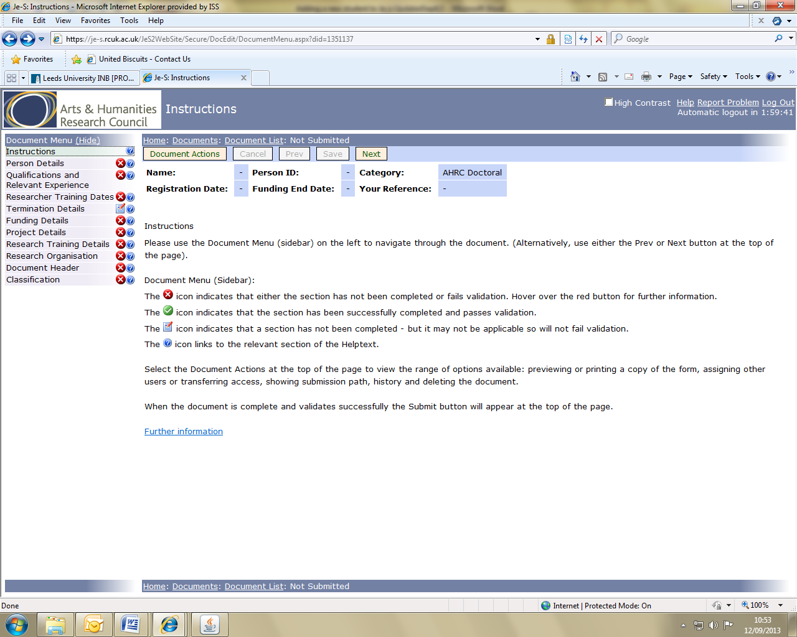

Person Details – You must click on the Select Person button to start completing this section.
In the pop up window that appears enter the student’s surname and click Search.

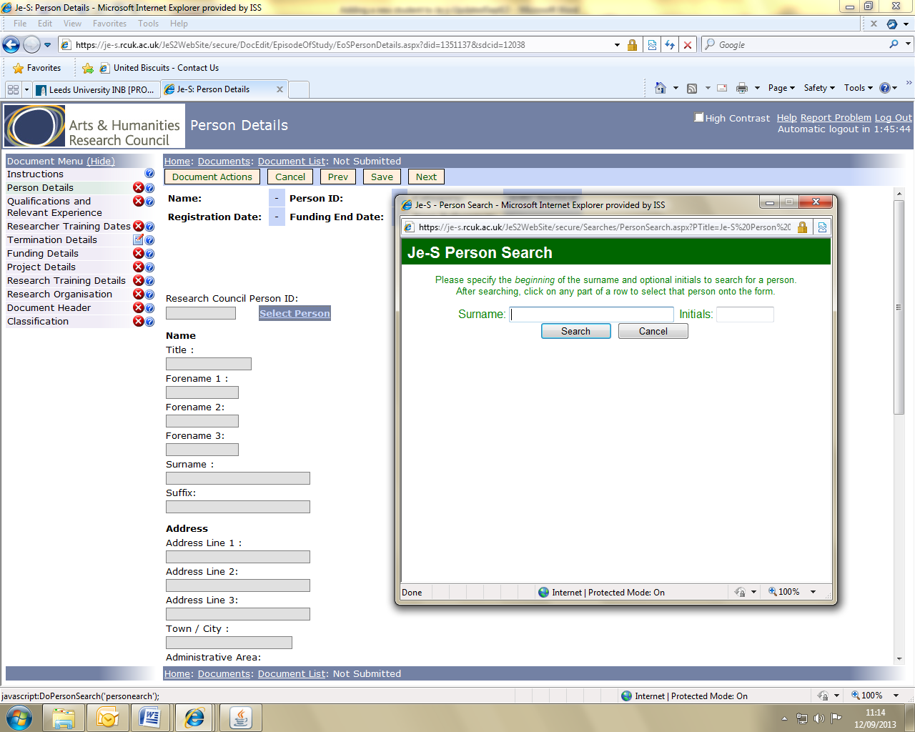

A list of people will appear – ignore the list and click on Add New Person. Complete the mandatory information.

It is very important that you enter the student’s email address.

Note: If this is a personal email then once they have a UCL email – update through ‘Student batch update’ , save and submit once all components have been completed.

Click on Save at the bottom of the screen. The details will be retained and you will be returned to the main Person Details page.

On the Person Details page, date of birth, email address, gender, ethnic origin, country of nationality and disability indicator are required fields.

Gender & Ethnic Origin, Country of Nationality and Disability.

At UCL the preference is for university e-mail address to be used, however, there must be an email entered into the record and as stated above a personal one can be used in the first instant.

Once the details have been entered, click Save at the top of the page to retain the details and return to the document menu.

Cancel returns to the document menu without saving any changes made since the last save.

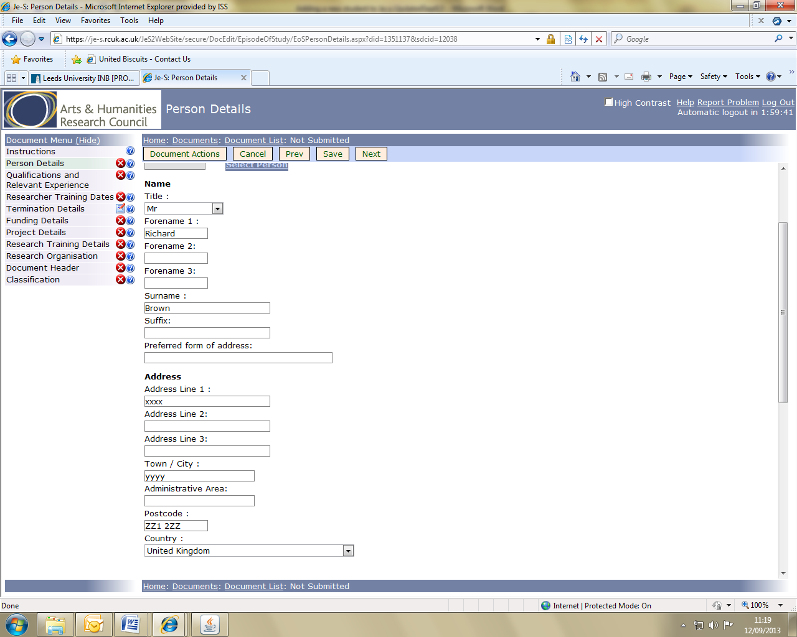

Degrees/Relevant Experience or Qualifications and Relevant Experience
To add a qualification to a student record, select Edit Qualifications.

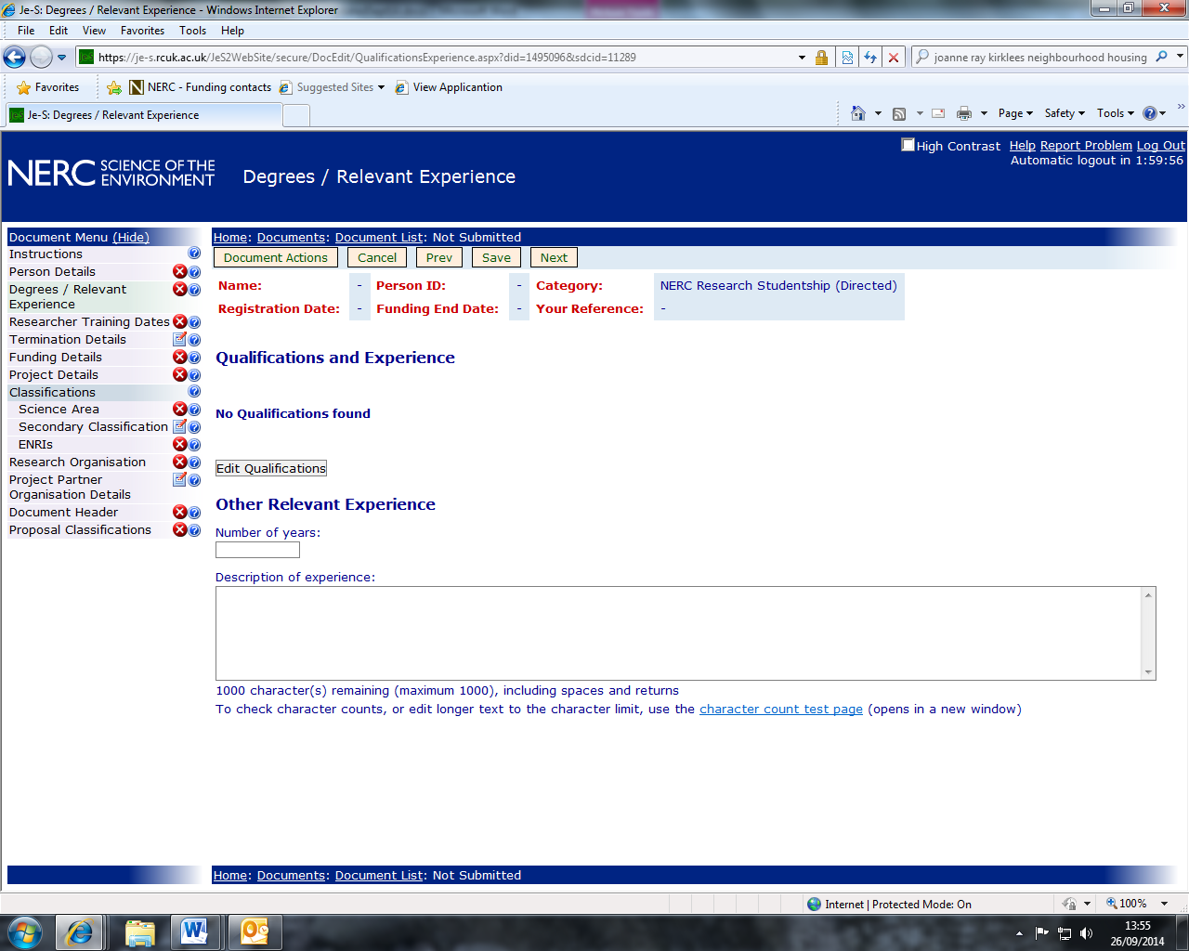

On the next screen click on Add Qualifications which will then take you to the Add new qualifications screen.

Click on Select Organisation to search for the higher education institution that awarded the qualification. Enter the organisation name in the box within the pop up screen that appears and click on search. Select the relevant organisation.

Select the year the qualification was awarded from the drop down box.
Use the radio buttons to select the qualification level (Undergraduate, Postgraduate/Masters or Higher/Doctorate). N.B. If the qualification is a 4 year integrated masters course e.g. MChem select ‘Undergraduate’.

The qualification type can be selected from the drop down boxes.

Type the subject of the qualification into the Qualification subject box then click on Search and select the relevant subject from the list.

The two drop down boxes underneath the Qualification subject box will automatically populate. If required, use the drop down arrows to change the subject information.

Add a description if necessary then click on Save to retain the details and return to the document menu.

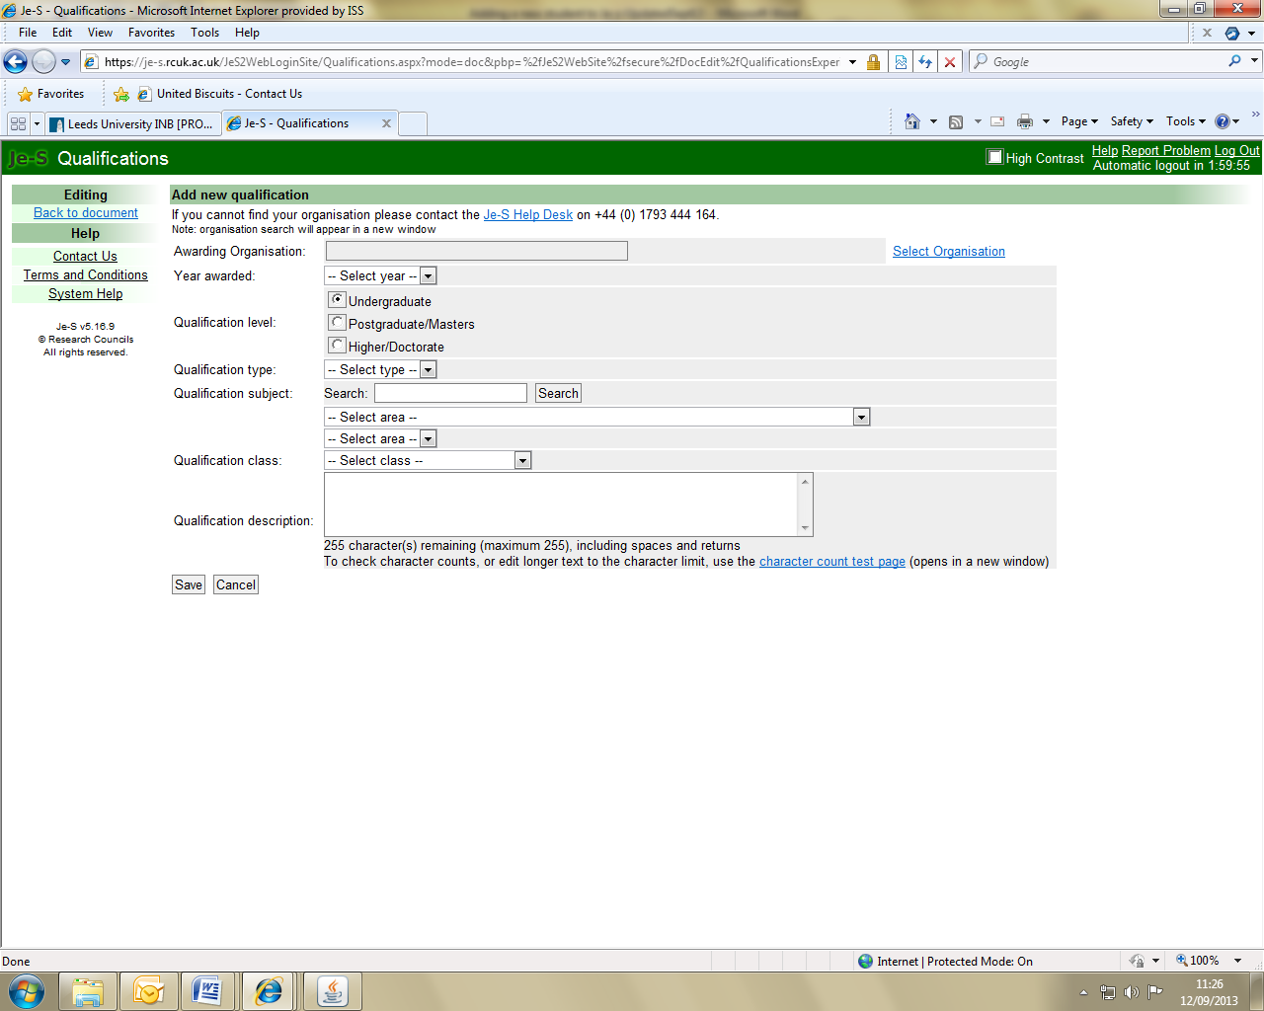

Repeat this step for all of the student’s qualifications then click on Back to document under the Editing menu on the left hand side.

Other relevant experience may be added if applicable (e.g. research or research-related experience of relevance to the student's suitability to undertake the project).

Researcher Training Dates - The dates on this page can be added or amended using the toggle calendars, or by typing directly into the date boxes.

The Registration/Appointment Date is the date on which the student started their studies.

The Funding Start Date is the date from which the student started to receive Research Council funding. This will generally be the same as the Registration/Appointment Date, but may differ if, for example, a student began to receive Research Council funding part-way through their studies. The Funding End Date is when the student’s funding from the Research Council funding will cease (generally 36, 42 or 48 training months duration).

The Expected Submission Date is the date by which the thesis is due to have been submitted.

BBSRC, NERC and STFC expect submission within the funded period. MRC expect submission no later than 6 months from funding end date. The AHRC, EPSRC and ESRC expect submission within a year of funding end date.

Part-time students have double the time period normally expected by that council for the submission of thesis.

Once all details have been entered, click Save at the top of the page to retain the details and return to the document menu.

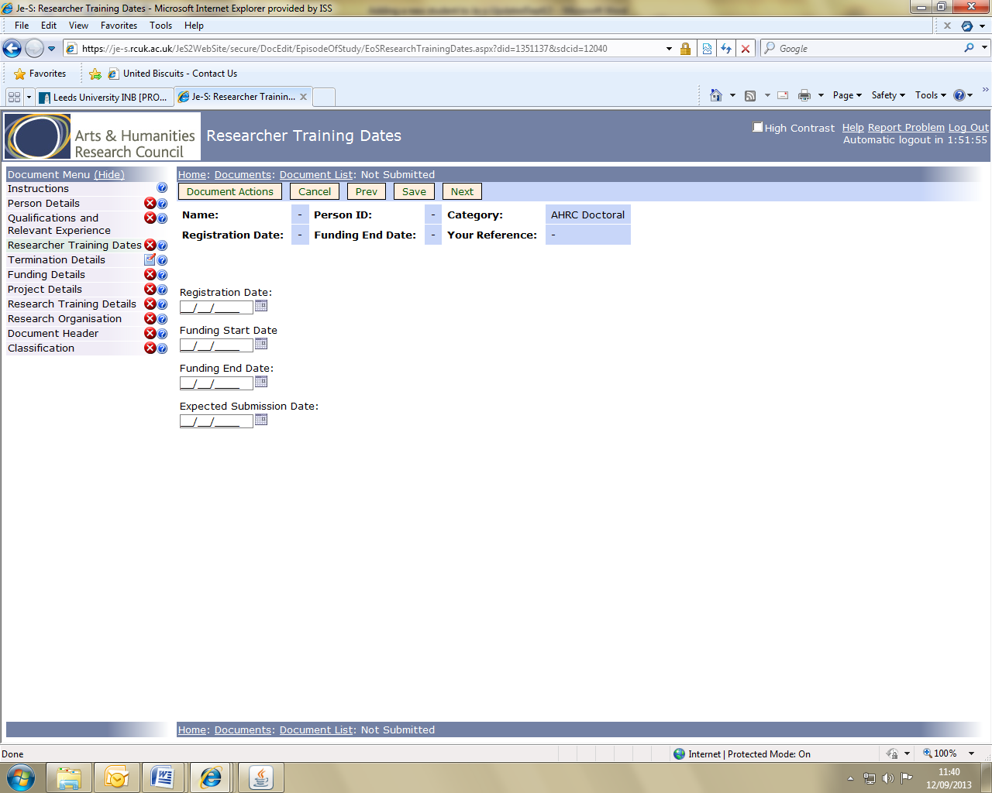

Funding Details – Click on Add Funding Details

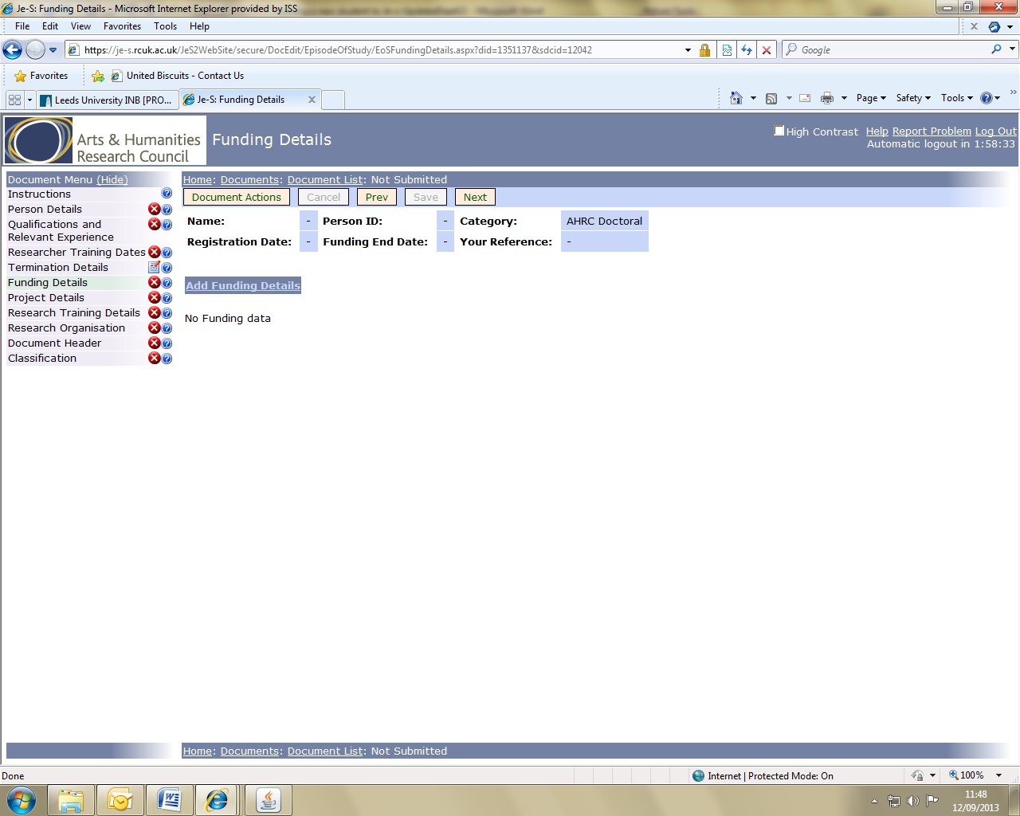

The next screen will allow you to enter the funding details for one year.
You must repeat the process for all years the student will receive funding.

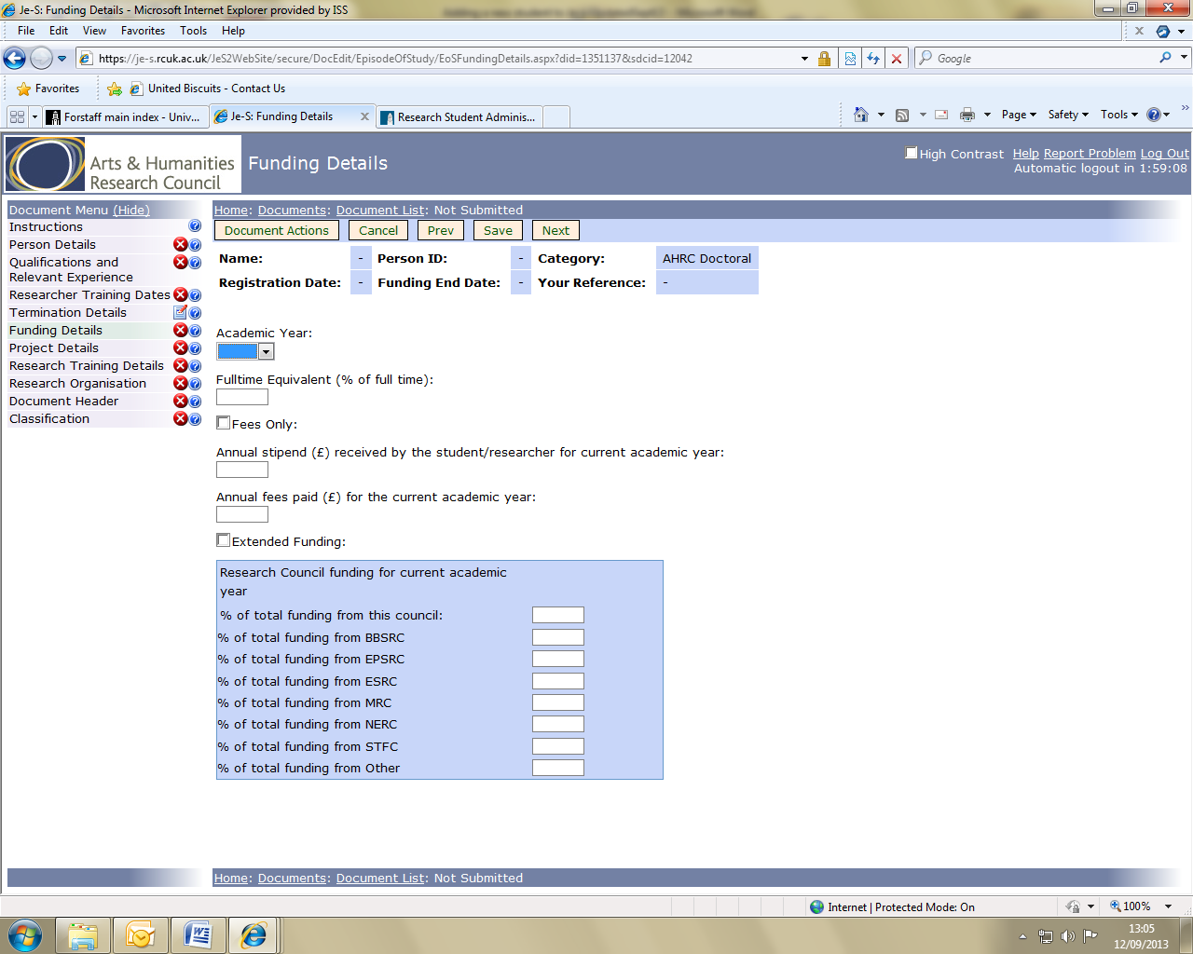

The funding information must include:
- The percentage of full time, which should be entered into the Fulltime Equivalent box. For full time students this will be 100% and for part time students this will be a minimum of 50%
- Annual Stipend paid to the student from all sources (unless the Fees Only box has been ticked)
- Annual Fees paid (enter the University’s rate, not the RCUK nominal fee)
- % Research Council funding for the current academic year

Complete the funding details for each year of the studentship even if the maintenance amounts are estimates.

Notes on funding details
The stipend should be the full annual rate paid to the student from all RC Studentship Grants during the current academic year, plus any funding from other sources (departmental, industry etc).

Increased funding (ESRC only) - This should be ticked for students in receipt of an enhanced stipend for Economics or Advanced Quantitative Methods (AQM).

Project Details - add a project/course title and a project summary for the student’s project. The project title field is optional, but this should be completed as soon as the title is confirmed. Plain text may be pasted from documents or emails, but there is a character limit of 150 for the title and 4,000 for the summary.

IMPORTANT FOR ALL COUNCILS Funded students - the project abstract needs to describe the domain or domains that the project covers relevant to the council(s) supporting the studentship. If the project abstract does not adequately describe how the project falls within the Councils remit, the studentship record will be returned to the University to amend until it satisfies their requirements or the council refuses the studentship.

To help detail how the novel research fits under Councils remit refer to the research areas which can be found on the council web pages: e.g. the EPSRC :
http://www.epsrc.ac.uk/research/ourportfolio/researchareas/ and describe how the research fits into one (or more) of those research areas.

Students who are undertaking a four year integrated masters and PhD course complete their first year of study before deciding on their specific research project, for these students, you should enter a provisional ‘Project Title’ such as MRes and type ‘Project to be confirmed.’ in the summary box. It is suggested that supervisors receive this information and provide the project description.

The student’s specific research project details must be submitted to Council within one month of the student commencing their second year of study. This information is updated on the student’s Je-S record by staff in the Departments/Faculty or Centres. Supervisory staff must provide the administrative support with a word document providing the confirmed ‘Project Title’ and ‘Summary’ for each student within one month of the student commencing their second year of study. This is subsequently published via ResearchFish during a student’s 3rd year of funding.

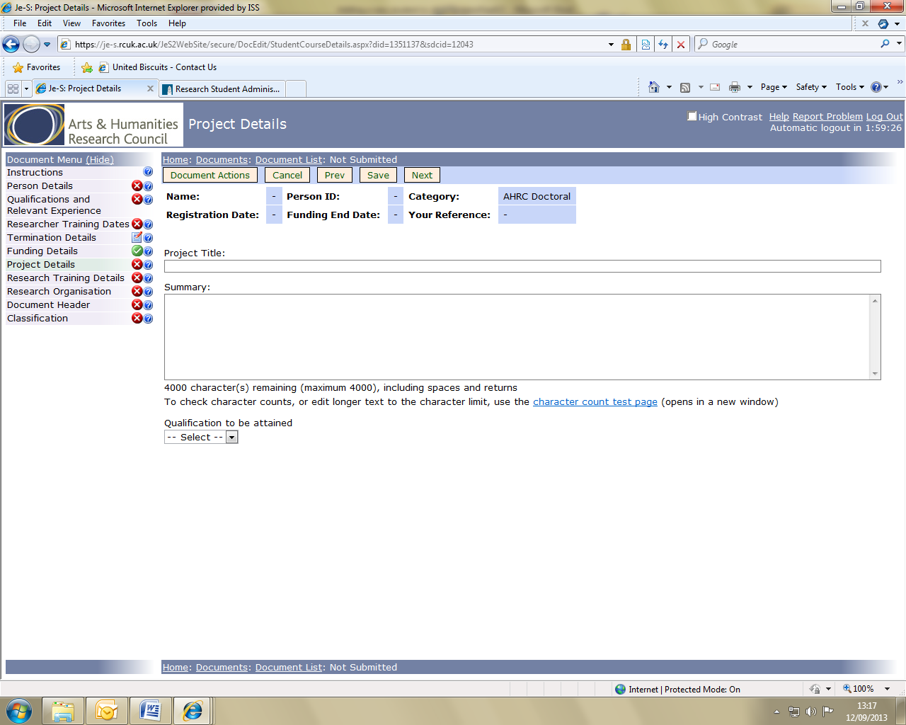

Qualification to be attained – AHRC only. Please select the qualification that will be awarded at the completion of the programme of study.

Research Organisation – click on Add New Organisation to begin this step.

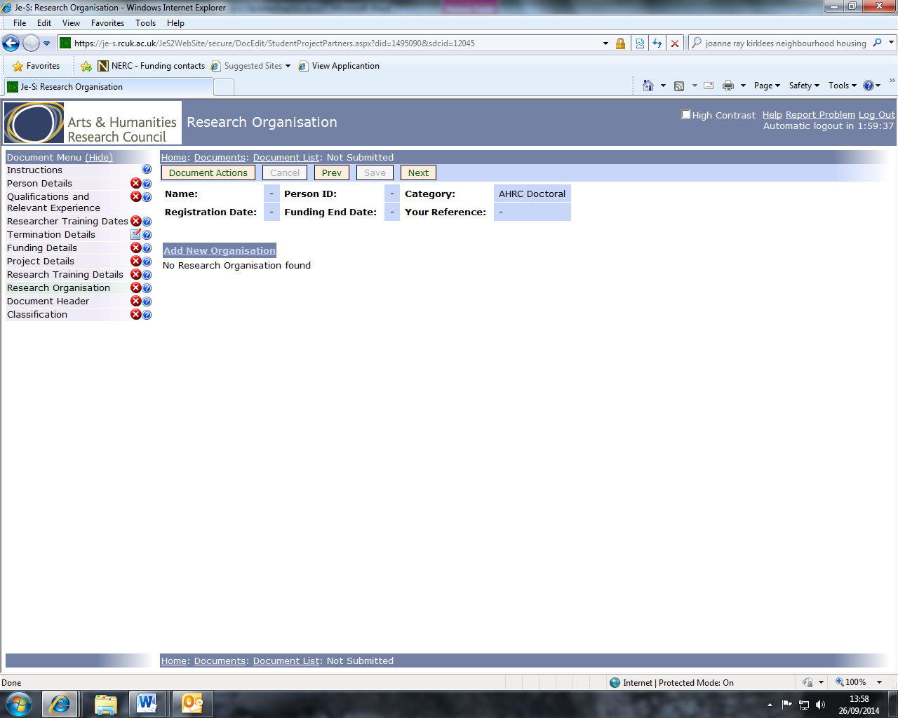

On the next screen click on Select Organisation. In the pop up screen that appears enter University College London into the search box then click Search. Select University College London to populate the Organisation box.

Click on Select Department then either use the search facility or scroll through the options to select the relevant department. Note: You MUST select the name of the registration unit from the list (e.g. Civil Engineering).

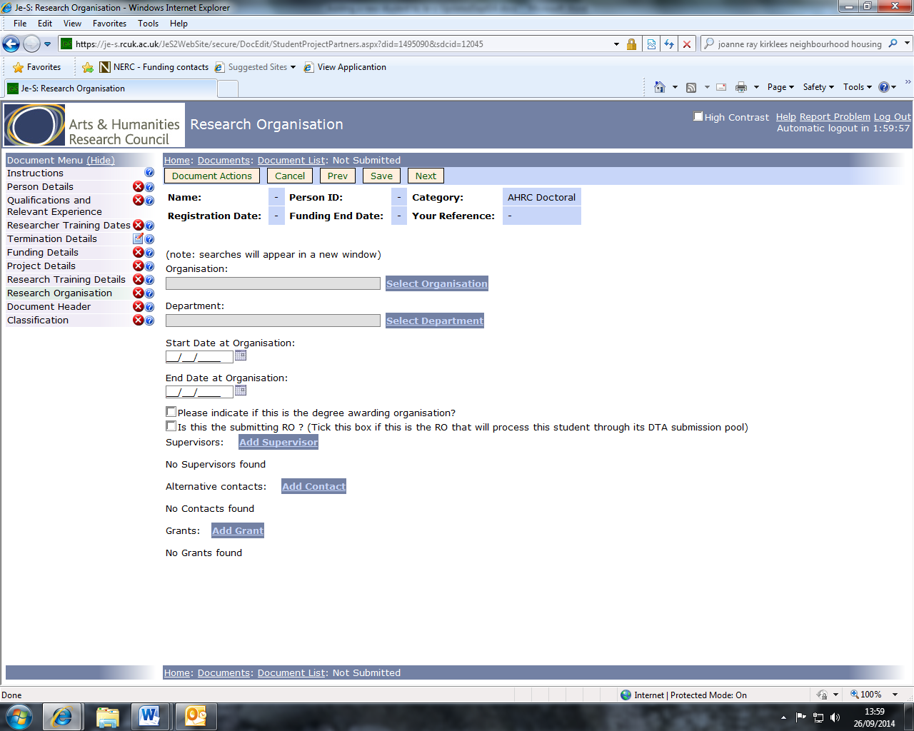

The student’s Start and End dates at the Organisation must also be entered on this screen. The End Date is taken to mean the funding end date.
There must be a tick in the boxes to indicate that UCL is the degree awarding organisation and to indicate that UCL is the submitting RO.

Click on Add Supervisor to search for and select from a list of staff at the research organisation. If the supervisor does not appear in the search results click on Add New User to add his/her details to the student record. There is a tick box for recording if the supervisor is the student’s main supervisor, and all student records must have one main supervisor identified.

Note: For the AHRC Collaborative Doctoral, NERC Open CASE and the STFC CASE and CASE-Plus schemes, the supervisor from the non-academic organisation should be entered in the Project Partner Organisation section.
Alternative contacts can be added by selecting Add Contact.

Select Add Grant to record the grant from which the student is funded. Ensure the correct Research Council is selected from the drop down list, followed by the Category to ensure that the correct grant details are available within Select Grant.

Use Start Date of Funding from Grant and End Date of Funding from Grant boxes to allocate funding to each training grant. If a student is funded from more than one grant then this information can be added by returning to the main Research Organisation page, and selecting Add Grant again. The details of the additional grant can now be added.
Project Partner Organisation Details – this is only necessary when the student is receiving funding from an Industrial Sponsor (eg. CASE, iCASE, Collaborative, CDA/CDP,).

The contributions from industrial partners (£ value in cash and/or kind) should be the proposed totals for the duration of the partnership, NOT annual figures.

Note: EPSRC iCASE students – the company contribution must be a minimum of one-third of the funding provided by EPSRC.

To add a project partner, click on Add New Project Partner and use Select Organisation to search for and select the relevant body.

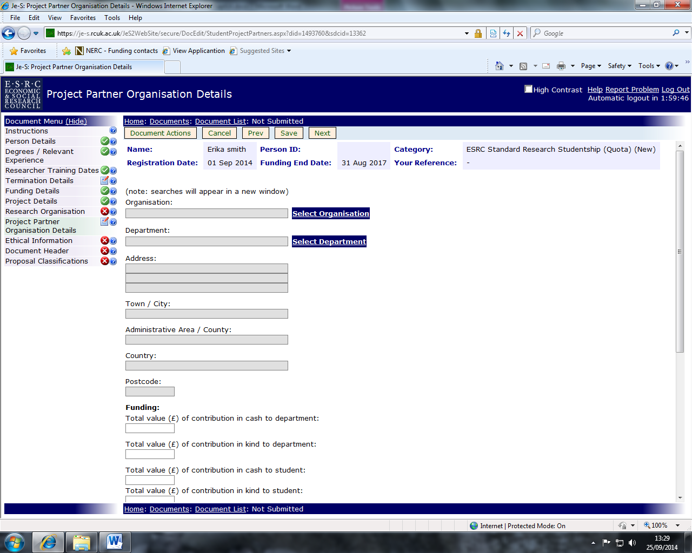

Use Select Department to select the relevant department within the project partner organisation.

Complete the dates on which the project partner became involved in the project and the end date.

A named supervisor must be selected if the project partner is providing supervision for the student (for iCASE, CASE, CDA/CDP the company is required to provide co-supervision and a placement for the student, so the supervisor should always be named).

Click on Add Supervisor then use Select Supervisor to search for and select the correct person. If the supervisor cannot be found use the Add New Person process to add them to the system and assign to the student’s record.

Unless you have been specifically advised that the project partner supervisor is the student’s main supervisor do not check the box on this page.

Ethical or Ethical Information

Select Yes or No from the options after the text ‘Has any consideration been given to any ethics issues arising from the proposed research?’

If Yes is selected an explanation must be provided in the text box to outline what the process was for considering ethics issues, what the issues are and how they will be dealt with.

If No is selected an explanation must be provided in the text box outlining the process that will be undertaken to identify whether there are ethics issues and how they will be addressed.

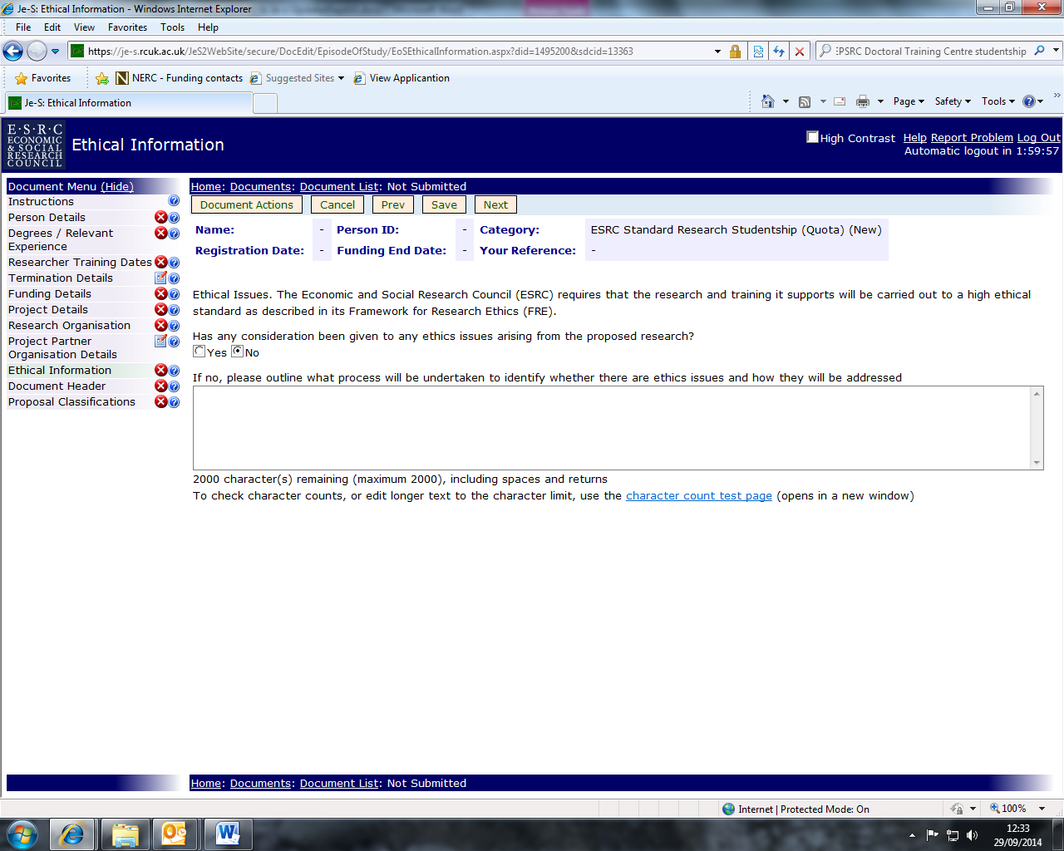

Please see the table below for details of ethical information required by specific research councils.

Research Council | Ethical Information  to be provided if the Student’s project involves any or all of the following: | Notes:
BBSRC | - Vertebrate animals  - Other organisms covered by the Animals (Scientific Procedures) Act | The provisions of the Animals (Scientific Procedures) Act 1986 must be observed. Institutions and award holders are responsible for ensuring that all appropriate personal and project licences required under the Act have been granted by the Home Office. All BBSRC awards are made on the absolute condition that no work that is controlled by the Act will begin until the necessary licences have been obtained.
ESRC | If ethical considerations have been considered, please select ‘YES’ and describe what the process was for considering these issues, what they are (if any) and how they will be dealt with.  Where an ethics review is yet to be undertaken, please select ‘NO’ along with a statement explaining how any issues will be addressed. | It is the responsibility of Research Organisations to ensure that the appropriate ethical mechanisms are in place. The ESRC has its own Framework for Research Ethics which should be consulted by Research Organisations. Research Organisations should ensure that proper consideration has been given to any ethical issues that the research project may raise.
MRC | - Animals  - Human participants  - Human fetal material  - Human tissue  - Radioactive substances  - Neutron irradiation in humans  - Dangerous pathogens  - Controlled drugs | Section 8 "Specific Conditions and Considerations" of the MRC Postgraduate Studentships Handbook sets out ethical guidelines which must be followed by MRC award holders.
NERC | - Animals  - Human participants  - Human fetal material  - Human tissue  - Radioactive substances  - Neutron irradiation in humans  - Dangerous pathogens  - Controlled drugs | Terms and Conditions of NC3rs Studentships" and "Responsibility in the use of Animals in Bioscience Research" set out ethical guidelines which must be followed by NC3Rs award holders.

Document Header – All fields in this section must be completed.

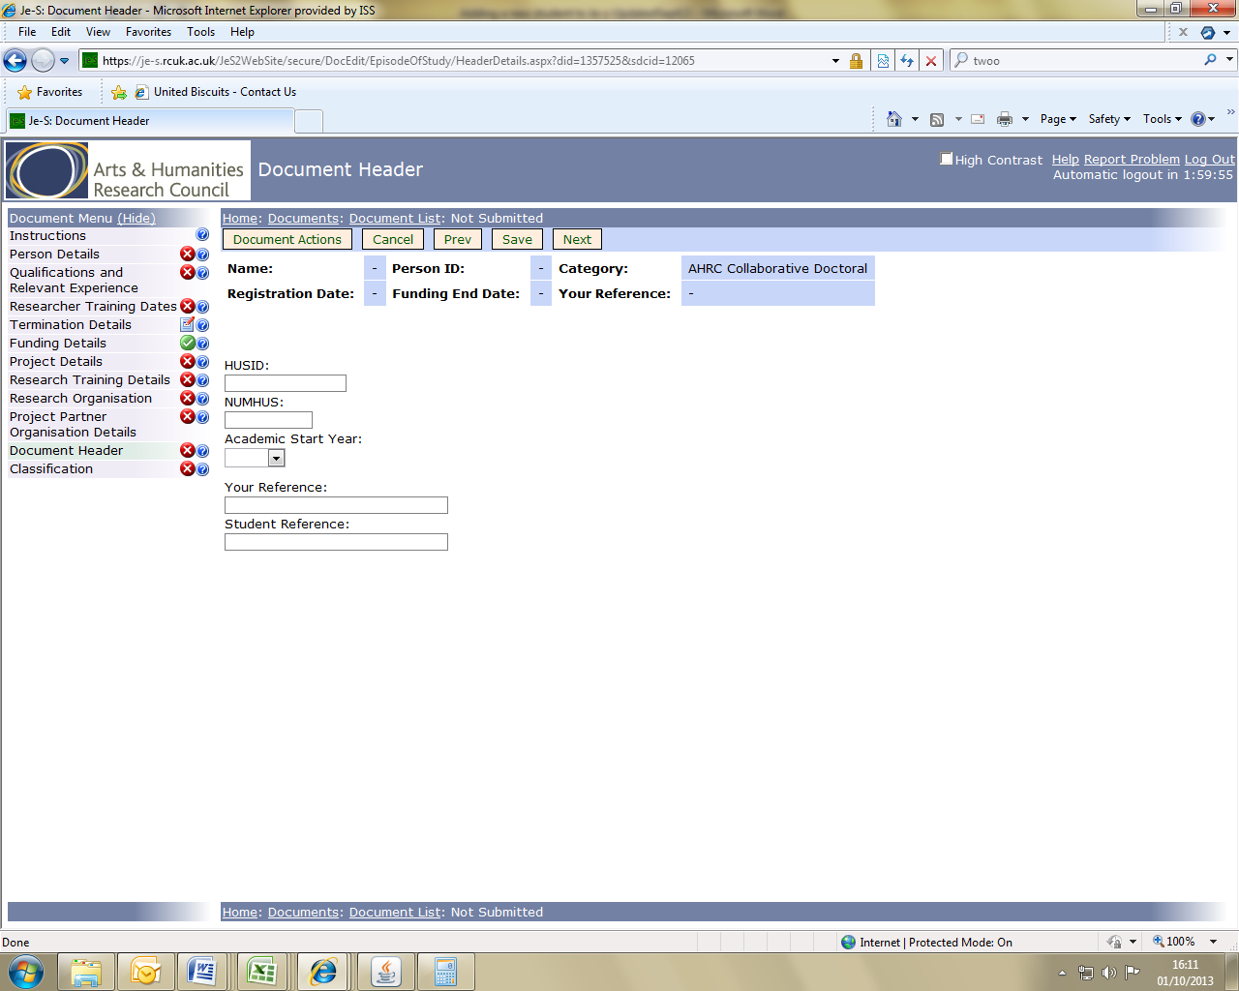

HUSID – This can be found in the UCL Portico System or by contacting Student Data Management in the Registry.

NUMHUS – This is the student’s University identification number (SID)

Academic Star Year – The year the student began their course

Your Reference - The UCL Account Codes (e.g. 555666) supporting the studentship should be entered.

Student Reference - The student’s University identification number (SID)

Proposal Classifications/Research Classification/Classifications

Note for STFC and BBSRC NERC you will just need to select from the classifications automatically displayed on the section/sub-sections, entering a percentage if appropriate.

For NERC and STFC: You will need to complete the Classifications section as above and the follow the instructions below for the Proposal Classification/Research Classification as below.

Note for ESRC: It is essential that the primary classification for the studentship reflects one of the ESRC core disciplines. Please see the following website for further guidance:

http://www.esrc.ac.uk/funding-and-guidance/applicants/proposal-classifications-esrc-disciplines.aspx

Click Add New Research Areas

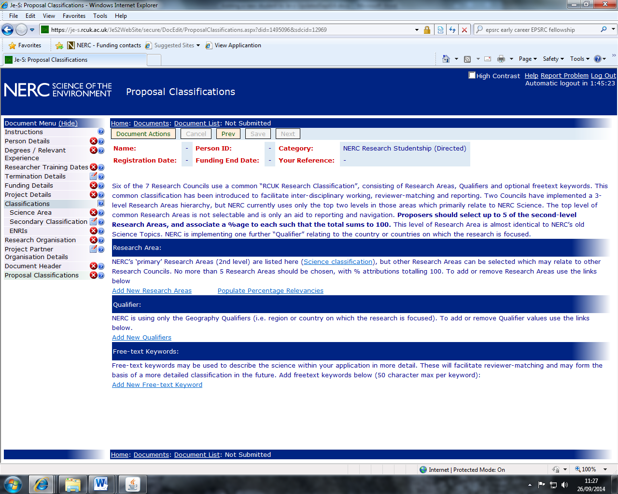

Click on the cross next to each classification to expand the menu and select the relevant research area. Place a tick in the relevant classification/s then click SAVE at the top of the page.
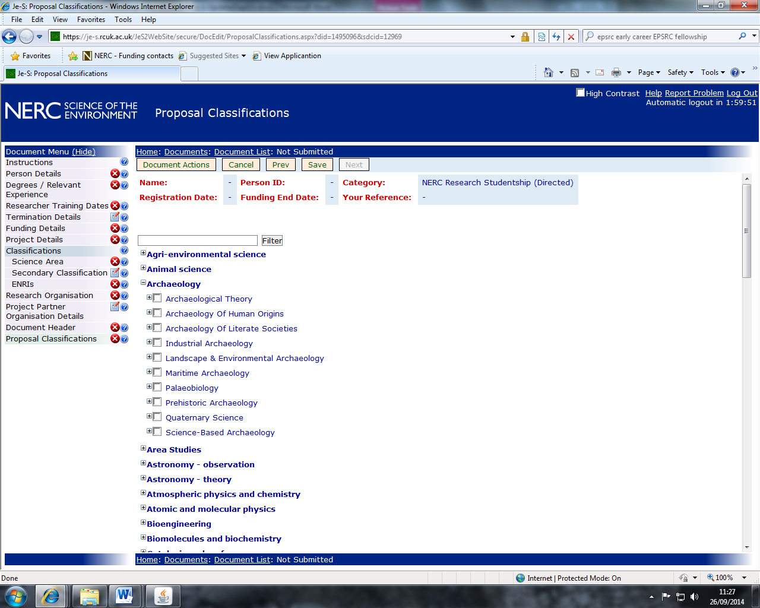

For some Research Councils you will then be prompted to select a Primary Research Area. This can be done by placing a tick in the box next to the relevant research area then clicking on Set Primary Area.

Qualifiers must also be selected. Click Add New Qualifiers to display a list of the types of qualifiers available. Click on the cross next to the qualifier type to show the options available, then place a tick in the box next to the relevant qualifier/s to select them.
Click on Save at the top of the page.

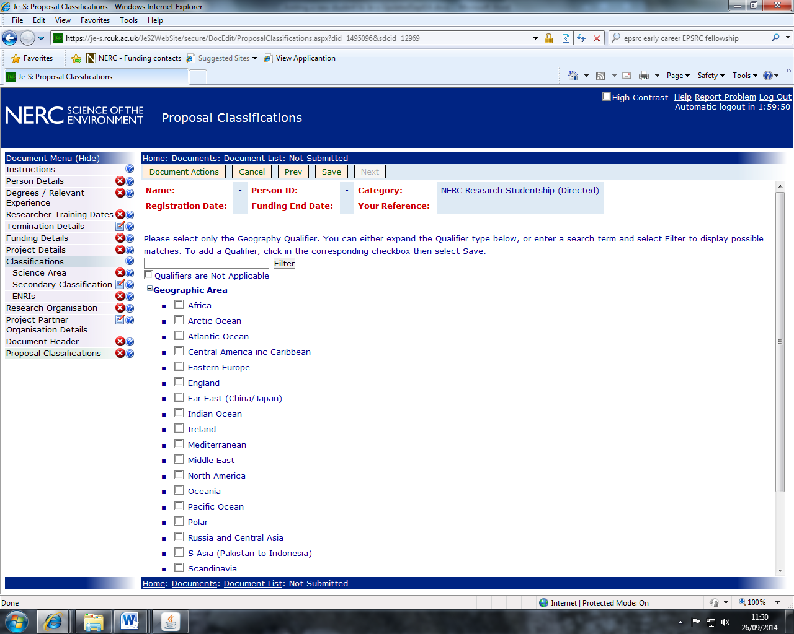

Free-text Keywords can be used to describe the proposal in more detail, they are not compulsory. To add a new Free-text keyword, click on the Add New Free-text Keyword link.

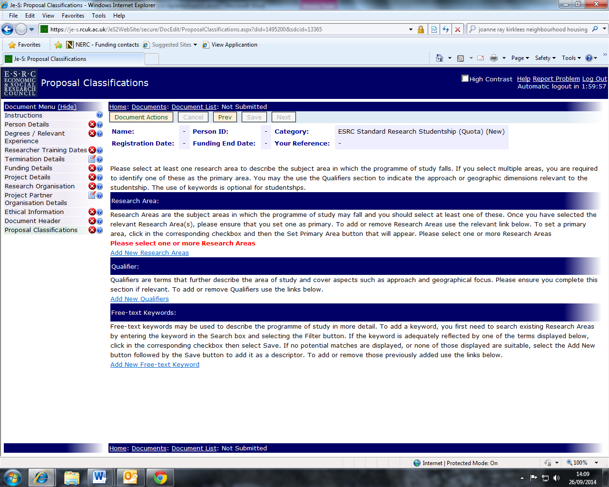
When all sections of the student record have been completed and checked you will need to validate the record to ensure it meets Je-S requirements. To validate the record hover your mouse over the Document Actions button at the top of the page to display an options menu. Select Check Document Validity.

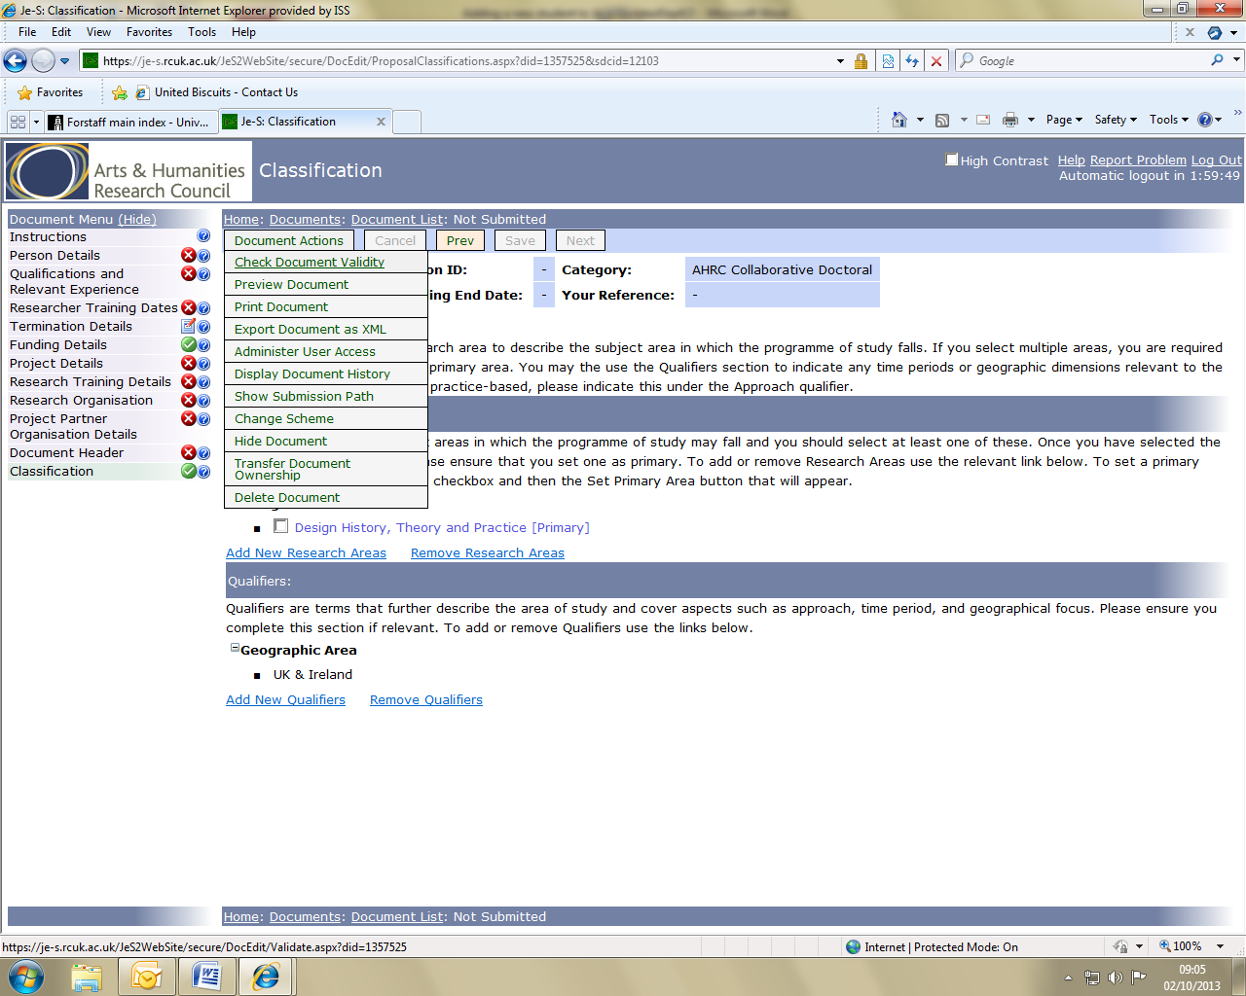

If any sections of the record do not meet Je-S requirements a warning page will display instructing you which sections are not complete.

When your document has successfully been validated you will need to view the entire record as a whole document and CHECK ALL THE DETAILS that have been entered. (Note: A student record may still validate with incomplete or incorrect information).

To view the record as whole document hover the cursor over the Document Actions option in the menu at the top of the page. A list of available actions will display in a submenu. Click Print Document.
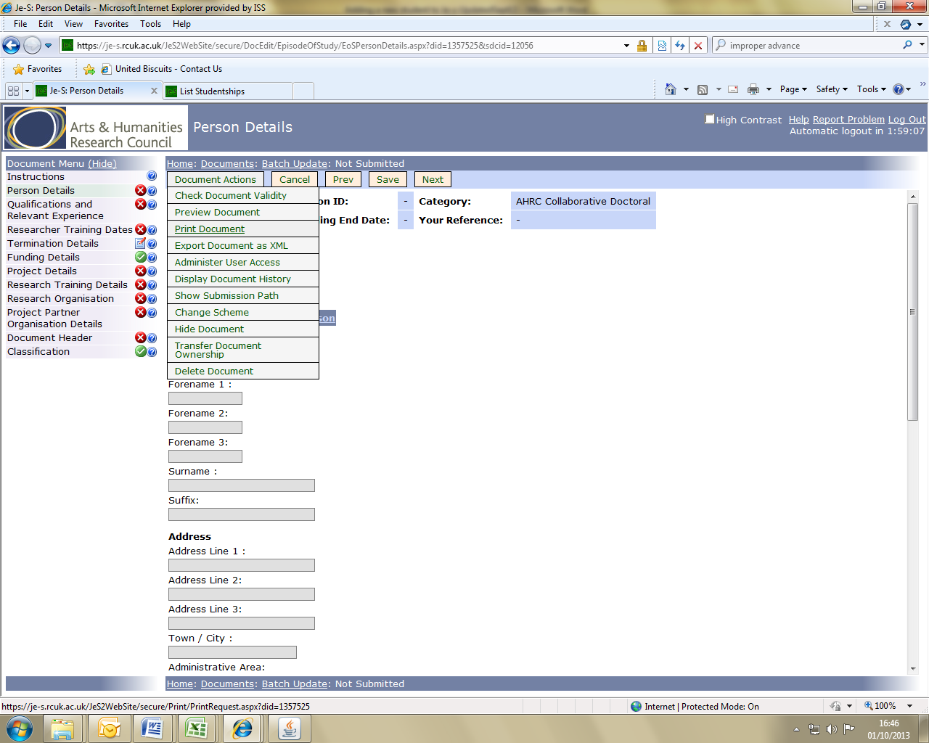

Select one of the document formats in the drop down menu then click Download the Document or have the document emailed to you. You can check the document on screen or in print form.

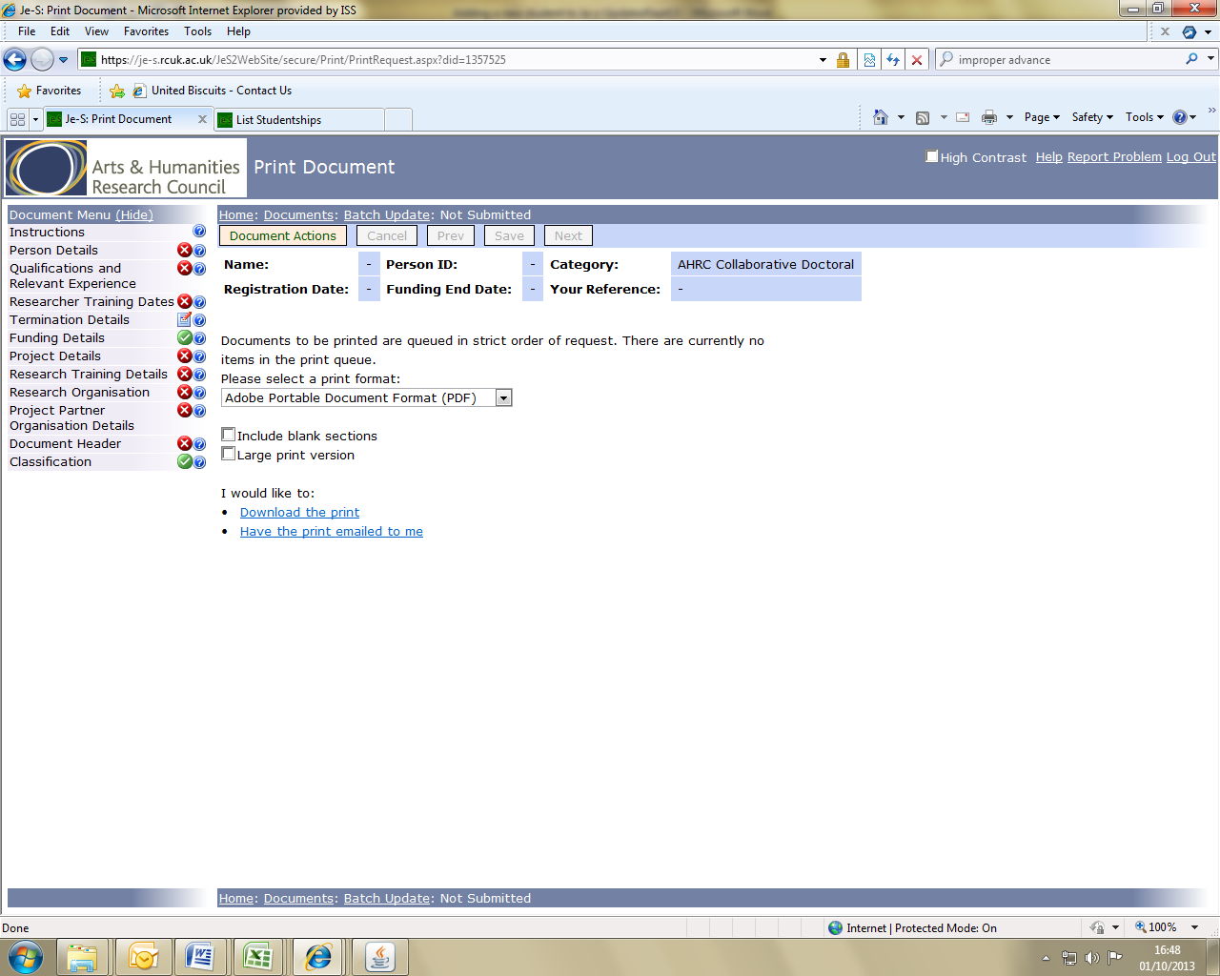

It is highly recommended that Administrators save a copy of each student’s Je-S record as it is not possible for them to view the record once it has been submitted to the Universities Submitter Poll.

Once the record has been checked for accuracy it can be submitted to the approver pool (Research Services). To submit the record hover the cursor over Document Actions at the top of the page and select Check Validity/Submit Document from the submenu. Answer Yes when asked ‘Are you sure you wish to submit these student/research details?’

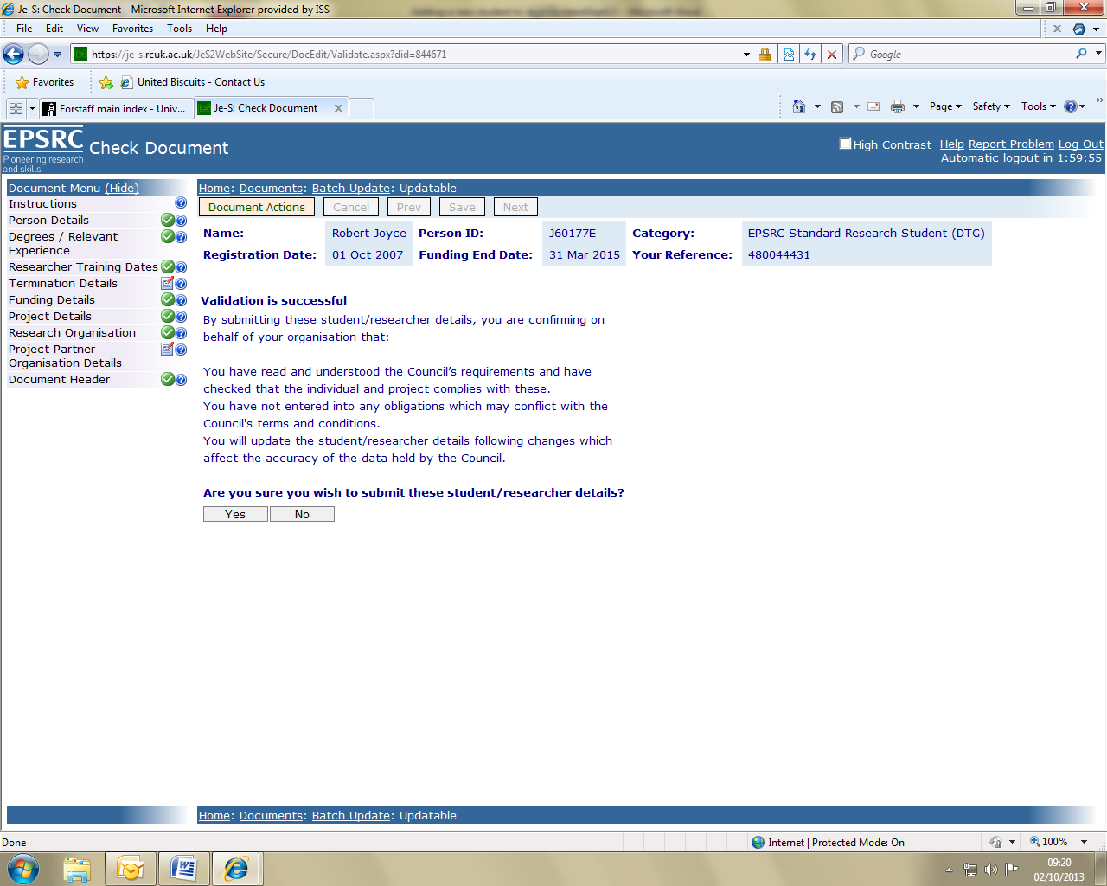

NEW
UPDATING STUDENT FUNDING DETAILS ON Je-S

The record has to be maintained during the lifetime of the funding. This is undertaken at UCL by the relevant administrative staff in the department/faculty or centre offices as appropriate.

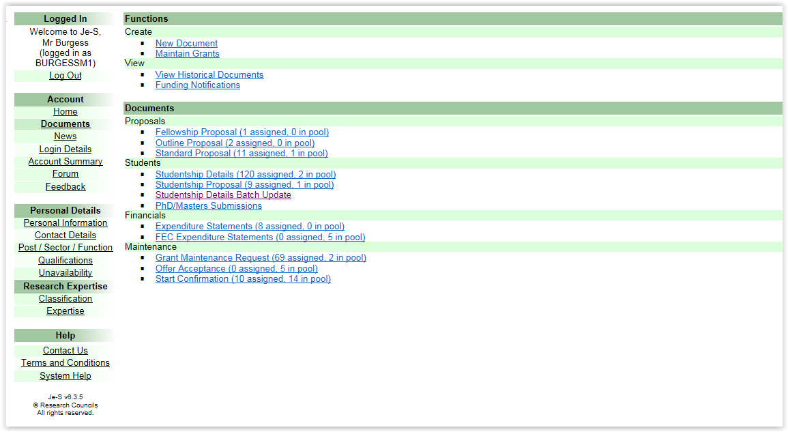

To enable you to view and make changes you should logon onto the RCUK Je-S web Portal, select Student Batch Update – List Students

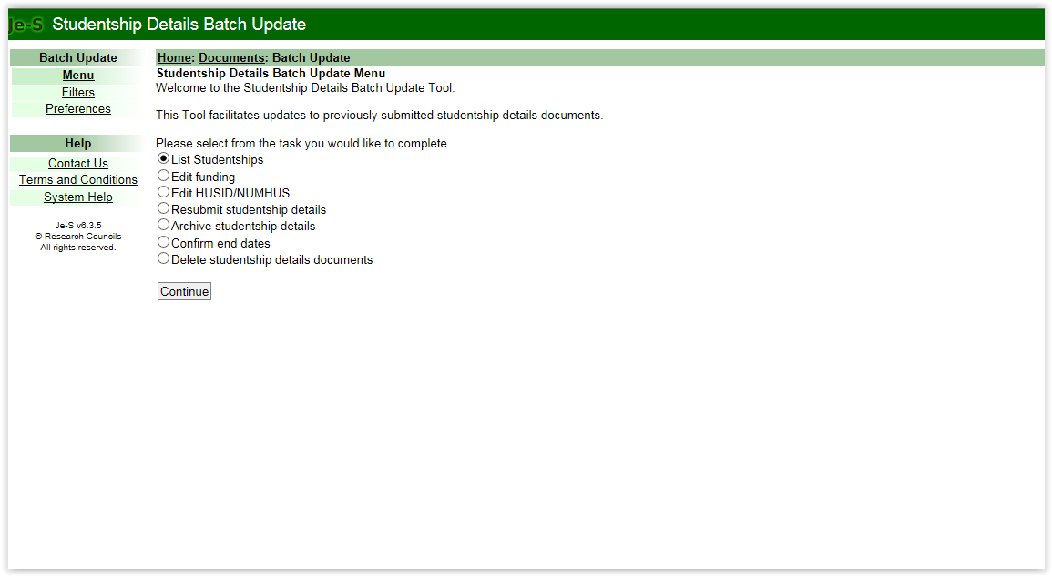

– within the filters I would advise selecting ‘additional filter’ dropdown – Student surname – enter surname and then Apply filter.

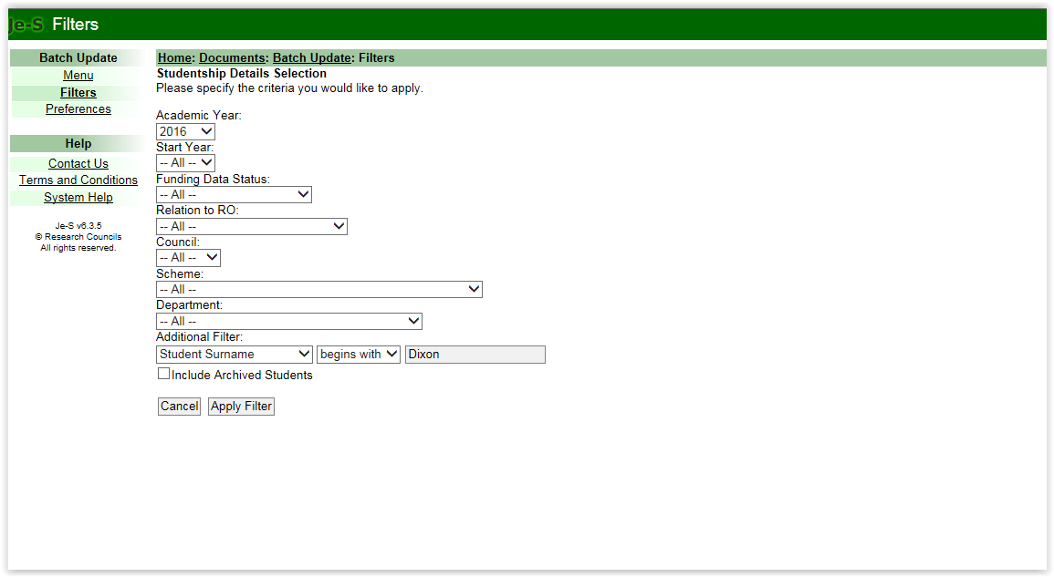

This gives you one or more students – select the one within your area

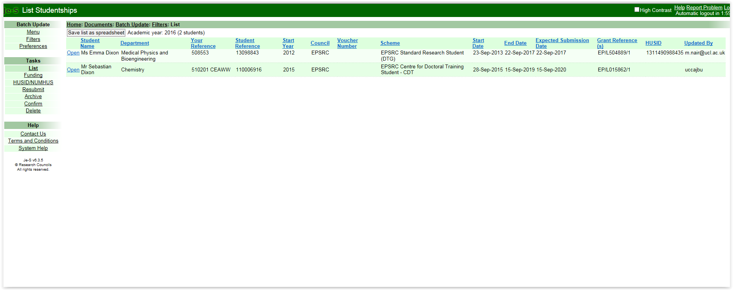

– select the one within your area

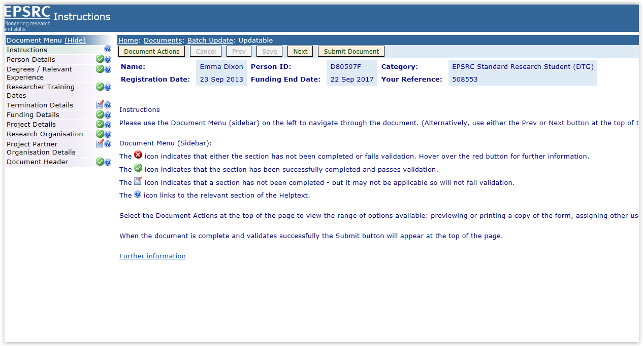

Go into the record and make the adjustments required, save and submit.

