Newsletter Issue 4 September 2020  Clinical and cost evaluation of Intensive support teams (IST) for adults with intellectual disabilities and challenging behaviour |  | 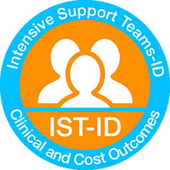
Prof Angela Hassiotis-Chief Investigator

Welcome to the fourth IST-ID newsletter. We are a national study funded to evaluate if different models of intensive support teams produce comparable outcomes for people with intellectual disabilities and challenging behaviour.

Recruitment
We are grateful to all carers and individuals with Intellectual Disability for their commitment to the study. In May 2020, we completed recruitment. We consented 226 participants with intellectual disabilities who have received input from 21 Intensive Support Teams. We are now carrying out 9 month follow-up assessments; 137 participants and 3 sites (Nottingham, Ealing and South West Yorkshire) have now completed the study. We look forward to seeing you all again for the follow-up appointments in the coming months. We expect all follow-up assessements to finish by January 2021.

To remind you
We have identified two models of IST provision: (a) enhanced and (b) independent provision based around a community intellectual disability service. ISTs aspire to adopt person-centred care, mostly using the framework of positive behaviour support and report concerns about organisational and wider context issues. The paper explaining the work leading up to the classification of the ISTs in England is now published and can be accessed via this link: https://doi.org/10.1192/bjo.2020.2

Other work

We looked at 16 operational policies that cover 19 Intensive Support Teams. The main domains identified are: Aims of the IST – prevent placement breakdown; reduce hospital admmissions; optimise behaviour; and ensure community integration; National guidelines – The guidelines referenced are: Transforming Care; Winterbourne View; Building the Right Support; the Care Programme Approach; and the Valuing People (DOH, 2001); Working hours – Although policies mention that Intensive Support Team staff may work out of hours, when needed, they usually deliver services during working hours; while only 1 team being available 24/7.

We have analysed 26 interviews conducted with service managers, IST staff, family and paid carers. The themes identified regarding the stakeholders’ experiences of ISTs are: the organisation of IST care and the content of IST care. They told us the following:
“I think sometimes we do more than actually our job role is. Because we’re person-centred and, unfortunately Social Care is on its knees and so we do try and pick up the pieces as we go.” (Service manager)
“Well I would always say, formal outcome measures. We’ve never yet been able to find robust outcome measures. That can accurately capture and reflect our outcomes.” (IST staff)
“I learnt actually about a hospital communication passport and the fact that there are nurses or there’s a team up at the hospital if she needs to stay in or if she needs to, you know do anything different up there. That there’s somebody up there that will support us. Absolutely, phenomenal.” (Family carer)
“I can’t complain at all because I’ve had people come having a look in the morning, an incident has happened the night before and somebody’s been out that afternoon. I would say that the standard is you’ve got somebody else you can share your concerns with, they’re not just listening, they’re going to come back with try this, try that.” (Paid carer)

Patient and Public Involvement  The Challenging Behaviour Foundation has supported us to recruit family carer representatives (Jan, Lorna and Narender) who have been providing valuable input and advice on study related issues such as study materials and topic guides. We would also like to shout out to our service-user representatives, Moussa, Maureen and Stuart from Camden Disability Action who also support the study. | 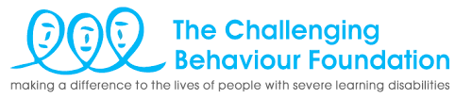
The Research Team
We would like to wish best of luck to Peiyao Tang, Research Assistant, who has moved on to a PhD at King’s College London. We welcome Leila Hamza, UCL MSc alumna, who will join us for the last stage of the study.

Co-applicants

Dr Elisabeth Victoria Crossey – NHS Lothian
Dr Ken Courtenay – BEH Mental health NHS trust
Dr Brynmor Loyd Evans – University College London
Dr Renee Romeo – King’s College London
Dr Vincent Kirchner- Camden and Islington Foundation Trust
Dr Ian Hall – East London Foundation Trust
Dr Nicola Morant – Independent Research Consultant
Prof Peter Langdon – University of Kent
Dr Laurence Taggart – Ulster University
Miss Rebecca Jones – University College London

Research Staff
Nancy Kouroupa – Project Manager, athanasia.kouroupa.12@ucl.ac.uk
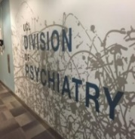
Contact Details
University College London, Division of Psychiatry, 6th Floor, Maple House, 149 Tottenham Court Road, London, W1T 7DN

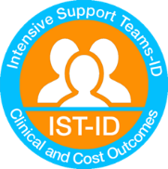
Website
https://www.ucl.ac.uk/psychiatry/research/epidemiology/pis/hassiotis-research-portfolio/intensive-support-teams

