Newsletter Issue 2 September 2019  Clinical and cost evaluation of Intensive support teams (IST) for adults with intellectual disabilities and challenging behaviour |  | 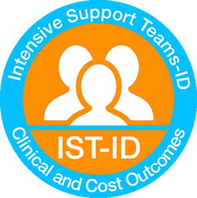
Prof Angela Hassiotis-Chief Investigator  Welcome to the second IST-ID newsletter. We are a national study funded to evaluate if different models of intensive support teams produce comparable outcomes for people with intellectual disabilities and challenging behaviour.  Recruitment  We are in Phase 2 of our project and so far we have recruited 116 participants with intellectual disabilities who have received input from intensive support teams. We have also started seeing participants for follow-up assessments and have completed 14.  We would like to thank all the participants and their carers for their co-operation and putting aside some time to help with the study. We look forward to seeing you all again for the follow-up appointments in the coming months.  We still need to recruit 100 participants! |  | Contents  - Recruitment  - Teams  - The views of services  - Patient and Public Involvement  - UCL Research team and contact details
Teams
We are currently recruiting from sixteen Intensive Support Teams, three of which (Enfield, Haringey and Ealing) are based in London and the rest from various parts of England.
We thank the Intensive Support Teams for referring participants to us and allowing us to conduct our research!

The views of services
We sought the views of managers and staff working in ISTs and we found that priorities included 1. the implementation of a more flexible approach to providing intensive support outside of working hours; 2. The development of reliable liaison with other local agencies in order to improve communication and referral procedures. The main challenges faced by ISTs were lack of resources, staff turnover, varying expectations from service providers and quality of residential provider care. Expanding the IST function to work with service users across the lifespan, or patients with autism and other population groups such as those with borderline intellectual functioning were identified as potential future additions to ISTs.

Patient and Public Involvement
The Challenging Behaviour Foundation has supported us to recruit family carer representatives (Jan, Lorna and Narender) that have been involved in the IST-ID study, providing valuable input and advice on study related issues such as study materials and topic guides. We would also like to welcome to our PPI group, service-user representatives, Moussa, Desmond, Maureen and Stuart from Camden Disability Action who will also be providing input and feedback to the study.
The Research Team

Chief Investigator

Prof Angela Hassiotis -Professor in intellectual disability in the Division of Psychiatry at UCL and honorary consultant Psychiatrist at the Camden Learning Disability Service

Co-applicants

Dr Elisabeth Victoria Crossey – NHS Lothian
Dr Ken Courtenay – BEH Mental health NHS trust
Dr Brynmor Loyd Evans – University College London
Dr Renee Romeo – King’s College London
Dr Vincent Kirchner- Camden and Islington Foundation Trust
Dr Ian Hall – East London Foundation Trust
Dr Nicola Morant – Independent Research Consultant
Prof Peter Langdon – University of Kent
Dr Laurence Taggart – Ulster University
Miss Rebecca Jones – University College London

Research Staff

Project Manager: Dr Victoria Ratti v.ratti.11@ucl.ac.uk
Research Assistant: Jessica Budgett j.budgett@ucl.ac.uk

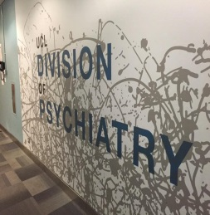
Contact Details
University College London, Division of Psychiatry, 6th Floor, Maple House, 149 Tottenham Court Road, London, W1T 7DN
Phone: 020 7679 9311
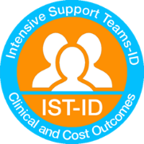
Website
https://www.ucl.ac.uk/psychiatry/research/epidemiology/pis/hassiotis-research-portfolio/intensive-support-teams

