Newsletter Issue 1 March 2019  IST-ID  Clinical and cost evaluation of Intensive support teams (IST) for adults with intellectual disabilities and challenging behaviour | 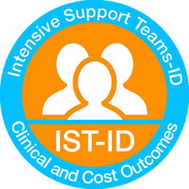
Prof Angela Hassiotis-Chief Investigator  Welcome to the first IST-ID newsletter. We are a national study funded to evaluate if different models of intensive support teams produce comparable outcomes for people with intellectual disabilities and challenging behaviour.  Background to the study  About 17% of people with learning disabilities (LD) living in the community display challenging behaviour such as aggression to others or property, self-injury or hyperactivity. There are concerns that adults with LD and challenging behaviour over-use medication, spend large periods of time in hospital, and miss out on living in the community. Hospital care is expensive, and costs are increasing.  NHS England has produced guidance about Intensive Support Teams (ISTs) proposing that they should be part of all community ID services in England.  ISTs are specialist services for adults with LD and challenging behaviour, which aim to support individuals through interventions such as positive behaviour support and other psychosocial approaches, to promote recovery, leading to reduction in severity and frequency of challenging behaviour and preventing restrictions of liberties such as inpatient admissions.  However, there is currently very little evidence about how effective ISTs are. The people who pay for Health and Social Care services (commissioners) would like more information about outcomes, and this project aims to provide this. | Contents  - Introduction  - Background to the study  - The project  - Recruitment update  - Our Co-applicants  - UCL Research team and contact details  - Patient and Public Involvement
The project
We propose to do a project over 36 months. It will be in two parts.
Stage 1: First we will find out about how many, and what type of ISTs exist in England, by asking service managers about their service, their staff, and the work they do. With this information, we will identify different models of ISTs
Stage 2: We will look at various services in each model to compare how they work with people with ID and other local services. We will collect data twice over 9 months to see which model(s) work best. We will also carry out interviews with people who use ISTs, family and paid carers, and referrers to ISTs to find out about their experiences of these services, and how happy they are with them.
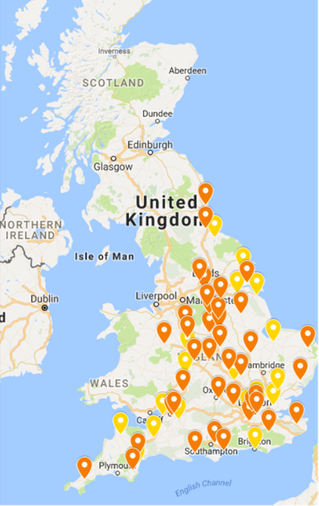
Recruitment update
Stage 1 of the study has been completed and we are currently in Stage 2. We have identified two models of ITSs in England and we have calculated that we need to collect information from eight sites per model. 15 out of 16 sites have given approval to recruit participants and so far we have recruited 49 out of our target of 226
.
We are actively looking for more participants!

IST-ID Team

Chief Investigator

Prof Angela Hassiotis -Professor in intellectual disability in the Division of Psychiatry at UCL and honorary consultant Psychiatrist at the Camden Learning Disability Service

Co-applicants

Dr Elisabeth Victoria Crossey – NHS Lothian
Dr Ken Courtenay – BEH Mental health NHS trust
Dr Brynmor Loyd Evans – University College London
Dr Renee Romeo – King’s College London
Dr Vincent Kirchner- Camden and Islington Foundation Trust
Dr Ian Hall – East London Foundation Trust
Dr Nicola Morant – Independent Research Consultant
Dr Peter Langdon – University of Kent
Dr Laurence Taggart – Ulster University
Miss Rebecca Jones – University College London

Research Staff

IST-ID Project Manager Dr Victoria Ratti v.ratti.11@ucl.ac.uk
Research Assistant Jessica Budgett j.budgett@ucl.ac.uk

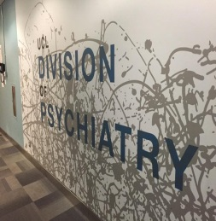
Contact Details
University College London, Division of Psychiatry, 6th Floor, Maple House, 149 Tottenham Court Road, London, W1T 7DN
Phone: 020 7679 9311
Website
https://www.ucl.ac.uk/psychiatry/research/epidemiology/pis/hassiotis-research-portfolio/intensive-support-teams
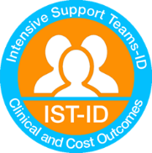

Patient and Public Involvement
What is public involvement in research?
The NIHR INVOLVE defines patient and public involvement in research as research being carried out ‘with’ or ‘by’ members of the public rather than ‘to’, ‘about’ or ‘for’ them. This includes, for example, participating in study steering groups and offering advice to researchers, supporting researchers to develop study materials, providing feedback and interviewing participants.
The term ‘public’ refers to patients, potential patients, carers and people who use health and social care services as well as people from organisations that represent people who use services. Their role is distinct to that of professionals in health and social care services.
Exemplars of public involvement in our study are family carers and persons with intellectual disabilities.
Family carer group
The Challenging Behaviour Foundation has supported us to recruit family carer representatives (Jan, Lorna and Narender) that have been involved in our research study, providing valuable input and advice on study related issues and topics. Their contribution through regular meetings is highly valuable and we look forward to continue working together for the duration of the study.

