
[INSERT TRUST LOGO HERE]

University College London
Division of Psychiatry
Maple House
6th Floor Wing B
London, W1T 7BN
Tel: 0207 549 5867

Easy read EEG information sheet

DREAMS START
Dementia related manual for sleep: Strategies for relatives

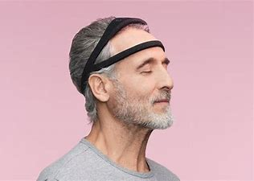

Why have I got this leaflet?
 | We are inviting you to take part in an additional project as part of the DREAMS START study.
 | You can talk with your family, friends, carers, doctor and me to help to decide whether to take part.
If you have any questions about this leaflet, please contact [name] [telephone number] [email] for further information.

Why are we doing this study?
 | We currently don’t know the best way to measure sleep problems in people living with dementia.  One new way to measure sleep is by wearing a special headband. This headband directly measures sleep.  It is safe to use. However, it has not yet been used with people living with dementia.  We want to test this headband to see if people living with dementia like wearing it.  We also want to see if the information we get from this headband is useful.

What will we do?
 |  | We will ask 10 people with dementia who have taken part in DREAMS START, to take part in an extra project.  These 10 people will also be living with another long-term condition, as well as dementia. Some examples of long-term conditions include diabetes and arthritis.
We will ask all of these people to wear the special headband that measures sleep.

We will see if people have any problems wearing it and if they like it.
Do I have to take part?
 | No, you do not need to take part.  If you say no, you do not have to say why. It will not change the care you get.
 | If you say yes, I will ask you to sign a consent form or will record you agreeing to take part.
What if I do not want to carry on with the study?
 |  |  |  | You can stop the study at any time, without giving a reason.
 |  |  |  | We will keep information about you that we have already, but we will not collect any new information.
What will happen if I take part?
  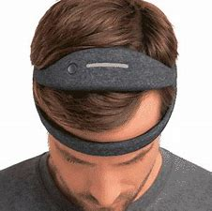 |  |  | We will arrange to meet you and your relative/friend.
 |  |  | We will ask you to sign a consent form or we will record you saying that you agree.
 |  |  | We will give you a special headband to wear for 2-4 nights. The headband measures sleep. We will ask your carer to support you and complete a diary when you wear the headband.
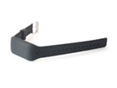 |  |  | You will be asked to tell us about how you found it. You can also tell us what you liked, and what you didn’t like.  We will give you a special watch to wear for the same nights, like the one you would have worn previously.
 |  |  | We will ask your relative/friend questions about how you sleep, and your health.
Will I get paid?
 |  |  |  |  | You and your carer will each be paid a £25 voucher as a thank you for taking part.
What if I feel upset taking part?
 |  |  |  |  |  |  | We hope that taking part will not make you feel worse, but it may be upsetting talking about sleep difficulties.
 |  |  |  |  |  |  | If you do feel upset, you can ask us to stop or take a break or speak to one of the research team.
 |  |  |  |  |  |  | You can also call the Alzheimer’s Society helpline on 0300 222 11 22
What happens after the research stops?
 |  |  |  |  |  | The researcher will stop contacting you, unless you have agreed that we can contact you again in future about other research projects.
 |  |  |  |  |  | We will publish results in papers and talk about results at conferences.
Will my taking part be kept private?
 |  |  |  |  |  | Yes, the information you and your relative/friend give will be confidential (private).
 |  |  |  |  |  | We will not talk to anyone else about you unless we are worried about your safety.

How will we use your information?
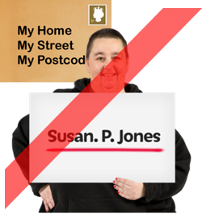 |  | Personal information like your name, address, phone number or date of birth will be kept safely and separately from the other information we collect.
 |  | We will give you a code which we will use when we are looking at the findings so no one will know it is you.
 |  | We will keep any information you give safely and securely.
If you have any questions about the information you give us, you can speak to study manager:
Dr Sarah Amador
Tel: 020 549 5867
Email: s.amador@ucl.ac.uk

You can find out more about how we use your information at:
www.hra.nhs.uk/information-about-patients/

What if there is a problem?
   | If you are worried about any aspect of this study, you can speak to Dr Sarah Amador (Study manager):  Tel: 020 549 5867  Email: s.amador@ucl.ac.uk
If you remain unhappy, or wish to make a complaint you can contact Dr Penny Rapaport (Chief Investigator):
Tel: 020 7679 9647
Email: p.rapaport@ucl.ac.uk
Address: UCL Division of Psychiatry
6th Floor, Maple House
149 Tottenham Court Road
London, W1T 7NF

 | She will send the complaint to the Research Sponsor: Camden and Islington NHS Foundation Trust.
 | Or you can contact your local hospital Patient Advice and Liaison Service (PALS). You can find you nearest PALS office on:  https://www.nhs.uk/Service-Search/Patient-advice-and-liaison-services-(PALS)/LocationSearch/363

If you would like any further information, please contact:
 | [name] on [telephone number] or [email]
Sarah Amador (Trial manager):
Tel: 020 549 5867
Email: s.amador@ucl.ac.uk

Thank you for reading this leaflet

