Process to Carry Over Annual Leave in to the 2020/2021 Leave Year

At the end of the 2019/2020 leave year there will be no automatic carry-over of outstanding annual leave. Any leave to be carried over will need to be requested using the guidance in this document.

Creating a Request to Carry Over Additional Annual Leave

From the MyHR main menu, navigate to UCL Employee Self Service > My Absence > Carry Forward Annual Leave.

Carry Forward Annual Leave

Click on ‘Create Request’

Figure 1: Carry Forward Annual Leave: Create Request

Compensation Details

- In the ‘Type’ field select ‘UCL PTO Accrual Carried Over’

Figure 2: Carry Forward Annual Leave: Compensation Details: Type

Details

Figure 3: Carry Forward Annual Leave: Compensation Details: Details

Complete the following details:

- Entry effective date: Enter 01 October 2020.

- Expiration Date: Enter 30 September 2021.

- Plan Hours: Enter the total number of hours that are to be carried over.
As there will be no automatic carry-over of any outstanding annual leave at the end of the 2019/2020 leave year, please remember to enter the total number of hours to be carried over, including the standard UCL carry over.

- Notes: Enter any notes to support the request.

- Workflow Transaction ID: This field does not need to be completed.

- Cost Allocation: This field does not need to be completed.

- Effective Date: This can be left on the date pre-populated.

Click on ‘Apply’ in the top right hand corner

Future and Ongoing Transactions

This page will show any transactions that are currently in progress, including the one being completed, or any that have been approved for the future.

- Review the details and select one of the following options:

- Where the request needs amending click on ‘Back’ in the top right hand corner

- Where the request is to be cancelled click on ‘Cancel’

- Where the request is ready to be submitted click on ‘Next’ in the top right hand corner

Please note: Where ‘Save for Later’ is selected, the request will be saved in a pending status until this is re-opened and submitted or cancelled.

Carry Forward Annual Leave Review

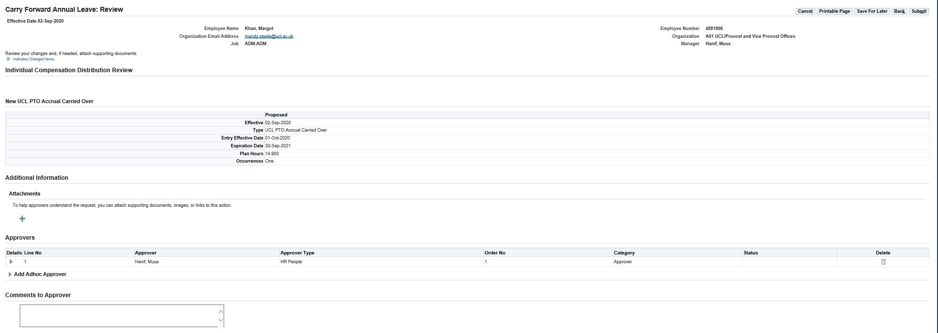
Figure 4: Carry Forward Annual Leave: Review

This page allows for a final review of the request which is to be submitted, including the name of the approver who will receive the request.

- Comments to Approver: Enter any comments to support the request for the approvers.

- Review the details and select one of the following options:

- Where the request needs amending click on ‘Back’ in the top right hand corner

- Where the request is to be cancelled click on ‘Cancel’

- Where the request is ready to be submitted click on ‘Submit’ in the top right hand corner

Please note: Where ‘Save for Later’ is selected, the request will be saved in a pending status until this is re-opened and submitted or cancelled.

The request has now been submitted for approval.

