Department of Space and Climate Physics

Code of Conduct for Meetings

and On-line Etiquette

Table of Contents
Key Principles 3
Good Meetings Etiquette, for On-line and In-person Meetings 4
Good Email Etiquette 5
Unacceptable Behaviour 6
Reporting Unacceptable Behaviour 7
1. Informal resolution 7
2. Procedure of UCL-level formal complaint 7
3. Outcome of a formal complaint 7

Key Principles

Our Department welcomes staff and students from a variety of different backgrounds and cultures.
This document describes standards of behaviour expected of everyone in our Department, which are designed to ensure a safe and inclusive environment for work and study, for all students and staff in our Department.
We uphold the UCL-wide “Prevention of Bullying, Harassment and Sexual Misconduct” policy, which, together with support available, protects staff and students from unacceptable behaviour, whether by a member of the UCL community, or by a third party such as a supplier or visitor to the University.
All employees and students are entitled to:
- a workplace free from bullying, intimidation, harassment or victimisation
- be treated with dignity, respect and courtesy
- experience no form of unlawful discrimination
- be valued for their skills and abilities
All staff and students are responsible for ensuring that they behave in an appropriate manner, showing respect for each other and anyone working alongside or engaged with the UCL community.
Inappropriate behaviour may be verbal or written, intentional or unintentional. Comments or actions made outside the standard workplace, such as on work related social events or via social media, that impact on work can be subject to UCL disciplinary procedures.
Managers have particular responsibility for setting standards and ensuring appropriate workplace behaviours are maintained. They should set a good example and ensure concerns raised are acted upon.
All staff are responsible for appropriately challenging inappropriate behaviours and raising concerns with managers so these can be dealt with. Students are encouraged to do the same.

Good Meetings Etiquette, for On-line and In-person Meetings

Guidance on good practice; to help us to be a welcoming and respectful community

No participant of any meeting or event hosted by the Department of Space & Climate Physics is expected to tolerate unacceptable behaviour, whether by a member of the UCL community, or by a third party such as a visitor to the University.

The opportunity to present your ideas and debate with peers is an important part of the ethos of UCL. Good etiquette means that in these debates or discussions, your comments remain respectful and constructive – they are offered in the spirit of helping to improve or build on someone’s work, not in order to target an individual or group with personal criticism.
We expect all participants in our online and in-person events to observe the following good practices:
- Thanking, acknowledging, and supporting people – especially in on-line meetings where people may not be able to see you nod, smile or frown as you read their messages. So, if they get no acknowledgement, they may feel ignored and be discouraged from contributing further. It is a good habit to respond constructively to comments in the chat, acknowledging the other person’s perspective and moving the conversation forward.

- Acknowledging before differing - before you disagree with someone, try to summarise the other person’s point in your own words. Then they know you are trying to understand them and will be more likely to take your view seriously.

- Making your perspective clear - try to avoid speaking in a dogmatic and an impersonal way, so avoid phrases like ‘It is a fact that …’ as they leave no room for anyone else’s viewpoint. So, why not start with ‘I think …’? You may want to present someone else’s views; if so, say whose they are, perhaps by a quote and acknowledgement.

- Emotions can be easily misunderstood when you cannot see faces or body language. Be mindful that people may not realise when you are joking, and one person’s joke may not seem amusing to someone else. You should always be aware of the receiver(s) of your message, particularly as people from widely differing cultures and backgrounds may be offended by something that you find funny.

- Disagree with the comment, not with the person - disagreement is expected but remember to focus on the matter under discussion and avoid negative comments about other people.

- Respect difference – respect others’ cultural, religious, professional, academic and economic backgrounds, skills, abilities and contributions.

Good Email Etiquette

Guidance on good practice; how to use email effectively, to avoid misunderstandings and to avoid unintentionally causing offence. Print and keep by your computer!
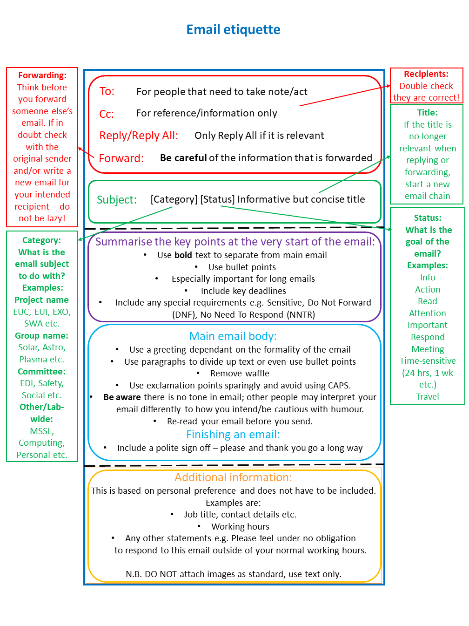
Your UCL Email Account is provided by UCL for work purposes only
You should not use personal email addresses (e.g. gmail account) for UCL business

Unacceptable Behaviour

Please see below some examples of behaviour considered unacceptable at UCL. The list is not comprehensive. If you are unsure whether some behaviour is inappropriate or unacceptable, ask yourself whether you would want members of your family to witness or to be the subject of the behaviour?
- Shouting at, being sarcastic towards, ridiculing or demeaning others
- Deliberately excluding someone from meetings, communications or a social activity without a good reason;
- Repeatedly or deliberately ignoring people who are waiting to make a contribution to a meeting; continuously cutting people off whilst they are speaking; persistent aggressive questioning; wilfully being dismissive of someone and their suggestions;
- Deliberately creating an environment where an individual is side-lined or has their responsibilities limited or narrowed;
- Abuse of power by blaming someone else if something has gone wrong, rather than taking personal responsibility;
- Physical or psychological threats
- Overbearing and intimidating levels of supervision;
- Allocating staff unreasonable workloads with unreasonable deadlines that require an individual to work excessive hours for sustained periods.
- Inappropriate and/or derogatory remarks about someone’s performance
- Unwanted physical contact, including touching, pinching, pushing, grabbing, invading their personal space and more serious forms of physical or sexual assault.
- “Grooming” behaviour, for example making someone feel special by befriending them, for example, then gradually manipulating them to carry out duties outside of their normal remit, or to do things which are in breach of UCL policy or with which they are not comfortable;
- Making offensive jokes or derogatory or stereotypical remarks, or mocking, mimicking or belittling a person’s protected characteristic
- Outing or threatening to out someone as gay, lesbian, bisexual or trans
- Speculating or gossiping about someone's perceived sexuality or gender identity, refusing to use someone's preferred gendered pronoun (e.g. using 'he' to refer to a trans woman) or continuing to use their former name ('dead naming').
- Practices which are potentially discriminatory and have the effect of excluding certain people. Examples may include regularly holding a meeting at a time or on a day that a part-time worker cannot make or arranging an away day with a physical activity which a wheelchair-user cannot access.
- Not providing equal development opportunities or promotional prospects to those in a team.
- Being discriminatory in recruitment practices or appointing staff in a non-transparent way.
- Sexual harassment, which can include (but is not limited to) unwanted sexual advances, sexual comments or comments about someone’s body or appearance; innuendos; wolf whistling; groping; tugging or lifting someone’s clothing, or stalking.
- Racist behaviour, which can include (but is not limited to) making racist jokes, name calling, making assumptions about someone based on their race or religion, racial harassment (for example, anti-Semitism or islamophobia) or racialised micro-aggressions.
- Not giving due consideration and/or an explanation of a refusal to a reasonable request covered by UCL policy, such as flexible working, or requests for annual leave.
- Overtly or covertly recording colleagues in order to gather evidence that may be used against them.

Reporting Unacceptable Behaviour

The UCL Prevention of Bullying, Harrassment and Sexual Misconduct Policy may be found on the UCL website. Here we briefly highlight some key points from the Policy.

Informal resolution
A person affected by bullying, harassment or sexual misconduct under the UCL policy may wish to resolve the behaviour informally if it is a one-off occurrence or is not considered serious.
Staff and students are encouraged to speak to their line manager or supervisor in the first instance. If that is not appropriate, please report to the Chair of the EDI Committee, Prof. Sarah Mathews; the Departmental Manager, Dr Dimitra Stamogiannou, and/or the Head of Department, Prof. Andrew Fazakerley. Further options are listed in the UCL website mentioned above.
UCL recognises it is for the person affected to determine the preferred pathway for resolution, and that engaging in informal resolution is not a barrier to bringing a formal complaint at a later time.

Procedure of UCL-level formal complaint
  - Students who feel they have experienced or witnessed bullying, harassment or sexual misconduct by another student may make a formal report to the Student Casework Team by emailing them on casework@ucl.ac.uk . This process may also be initiated through Report + Support. Students who feel they have experienced or witnessed bullying, harassment or sexual misconduct by a member of staff may make a formal report to HR through Report + Support.
  - The student may contact the UCL Student Mediator who will support them through either formal reporting process.
  - Members of staff who feel they have experienced or witnessed bullying, harassment or sexual misconduct may make a formal complaint against a staff member by using the Staff Grievance Policy or they may make a formal complaint against a student by contacting the Student Casework Team by emailing them on casework@ucl.ac.uk . Either process may also be initiated through Report + Support.

Outcome of a formal complaint
The Reporting Party will be told whether their complaint has been upheld or not; and whether the Reported Party has been dismissed or expelled.
If the complaint is not upheld or the Reported Party is not dismissed or expelled, information will be shared with the Reporting Party to minimise any adverse effects in accessing their work or study environment, or the UCL activity, where possible, but there may be limits to the information about the consequences to the Reported Party that can be shared with the Reporting Party.
Where the Reporting Party is told the outcome they will be asked to respect confidentiality with regards to the outcome.

