Management Systems

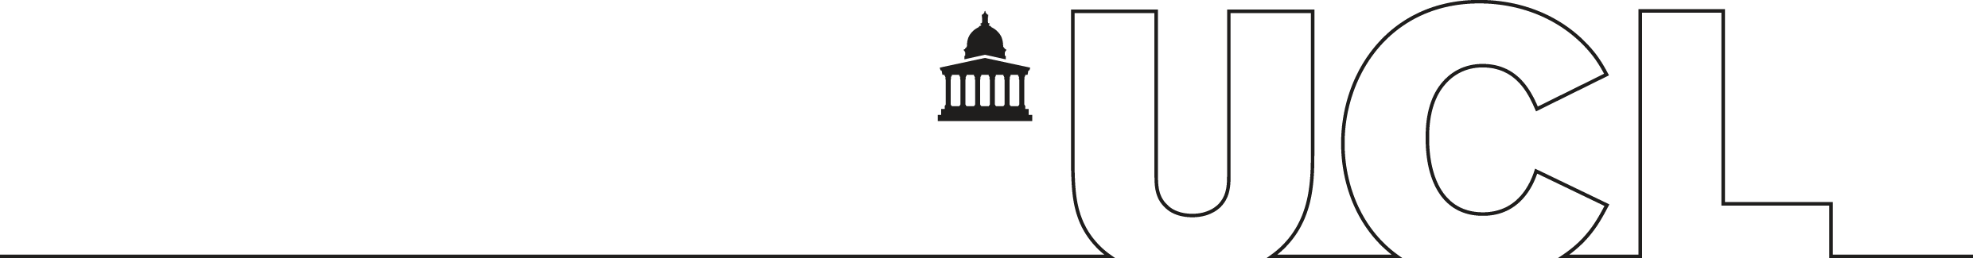

Human Resources
Professorial Appraisal Review
(PAR)
System:

Introduction and Navigation

Authors: MS
Reference: PAR-UG-1
Date: 7th November 2013
Version: 1.1.2

Abstract

This document provides an introduction to the UCL Professorial Appraisal Review (PAR) system and is suitable for anyone using this system. The document covers basic navigation of the system and how to perform basic tasks such saving and deleting information. It also looks at the approval process.

Contents

1. Introduction 1
2. Getting Started 2
2.1 Screen Settings 2
2.2 PAR Web Page 2
2.3 Logging on 2
2.4 Access to PAR 3
2.5 PAR Help 3
3. Navigating the PAR System 4
3.1 Moving Between Fields 4
3.2 Moving Between Tabs 4
3.3 Moving Between Parts 4
3.4 Moving Between Appraisals 4
4. Creating and Approving an Appraisal 5
4.1 Creating an Appraisal 5
4.2 Approving an Appraisal 6
4.3 Entering data 7
4.4 Entering PAR specific data 8
4.5 Changing External Data 8
4.6 Deleting Data 9
5. The Appraisal Process 10
6. Using the PAR System 11
6.1 Part A 11
6.1.1 Objectives Tab 11
6.1.2 Research Tab 13
6.1.3 Grants Tab 14
6.1.4 Publications Tab 16
6.1.5 Research Students Tab 17
6.1.6 Teaching Tab 18
6.1.7 Knowledge Transfer & Enabling Tab 19
6.1.8 Honours & Esteem Tab 20
6.1.9 Learning Tab 22
6.1.10 Personal Circumstances Tab 23
6.1.11 Sign Off Tab 24
6.2 Part B 26
6.2.1 Progress Tab 27
6.2.2 Impact Factors Tab 28
6.2.3 Objectives Tab 29
6.2.4 Support Tab 31
6.2.5 Training Tab 32
6.2.6 Part B Sign Off Tab 34
6.3 Part C 38
7. Printing an Appraisal 40

8. Changing data in External System 41
8.1 Principal Grants 41
8.2 Publications 41
8.3 Research Students 41
8.4 Honours 42
8.5 Learning 42
9. Exiting PAR 43
10. Appendix maximum field lengths 44

Figures

Figure 1: PAR Web Page 2
Figure 2: UCL Logon Box 3
Figure 3: Tab Change Confirmation Message 4
Figure 4: Professor Appraisal List 5
Figure 5: PAR Appraisal List 6
Figure 6: Part A Front Page 6
Figure 7: PAR HoD/Dean Front Page 7
Figure 8: Delete confirmation message 9
Figure 9: Part A – Objectives tab. 11
Figure 10: Objectives tab with new Objective 12
Figure 11: Part A – Research tab 13
Figure 12: Part A – Grants tab 14
Figure 13: Grants tab with new Co-Investigator Grant 15
Figure 14: Part A – Publications tab 16
Figure 15: Part A – Research Students tab 17
Figure 16: Part A – Teaching tab 18
Figure 17: Part A – Knowledge Transfer & Enabling tab 19
Figure 18: Part A – Honours and Esteem tab 20
Figure 19: Honours & Esteem tab with new Indicator of Esteem 21
Figure 20: Part A – Learning tab 22
Figure 21: Part A – Personal Circumstances tab 23
Figure 22: Part A – Sign Off tab 24
Figure 23: Part A – Sign Off confirmation 24
Figure 24: Part A – Sign Off message 24
Figure 25: Part A – Appraisal Signed Off 25
Figure 26: Part B Menu 26
Figure 27: Part B – Progress tab 27
Figure 28: Part B – Impact Factors tab 28
Figure 29: Part B – Appraisal Objectives tab. 29
Figure 30: Objectives tab with New Objective 30
Figure 31: Part B – Support tab 31
Figure 32: Part B – Training tab 32
Figure 33: Training tab with new Training Requirement 32
Figure 34: Part B –Sign Off as viewed by a Professor 34
Figure 35: Professor Part B Sign Off confirmation message 34
Figure 36: Part B –Sign Off as viewed by a HoD 35
Figure 37: HoD Part A Re-Activation confirmation message 35
Figure 38: Part B Sign Off ready message 36
Figure 39: HoD Part B Sign Off confirmation message 36
Figure 40: Part B –Signed Off by HoD 36
Figure 41: Part C –Dean Sign Off 38
Figure 42: Dean Part C Sign Off confirmation message 38
Figure 43: Dean Part C Sign Off dialogue box 39
Figure 44: Print Appraisal Button 40
Figure 45: Print Appraisal File Download Message 40

Tables

Table 1: PAR Status Progression 10
Table 2: Maximum Field Lengths in PAR 44

Introduction
This document provides an introduction to the new UCL Professorial Appraisal Review (PAR) system.

The aim of this document is to introduce you to the PAR system. It focuses on navigation, entering data. It gives step-by-step procedures and selected examples for using PAR. This document is not designed to be used as a comprehensive manual, explaining every function of PAR system. Rather, it presents an overview and introduction for the basics in using the screens and does not cover UCL procedures related to entering PAR requests.

The workbooks also assume that users have the following skills before using PAR:

- An understanding of the concepts of a PC including managing files and directories.
- Knowledge of Microsoft Windows and basic knowledge of a browser.
- Some familiarity with the UCL Appraisal Process.
- You have the appropriate preconditions to use PAR.

An understanding of the concepts of databases is highly desirable but not strictly necessary.

Getting Started

Screen Settings
It is recommended that your screen resolution is set to a minimum of 800x600 with at least 256 colours.

PAR Web Page
PAR is accessed through the following url and selecting the appropriate Live System link:
http://www.ucl.ac.uk/management-systems/msapps/par/

Logging on
PAR is a web based application so in order to access the system you need to take the following steps:

1. Start your Internet Explorer web browser and then access the following URL:
http://www.ucl.ac.uk/management-systems/msapps/par/

A web page similar to Figure 1 will appear:
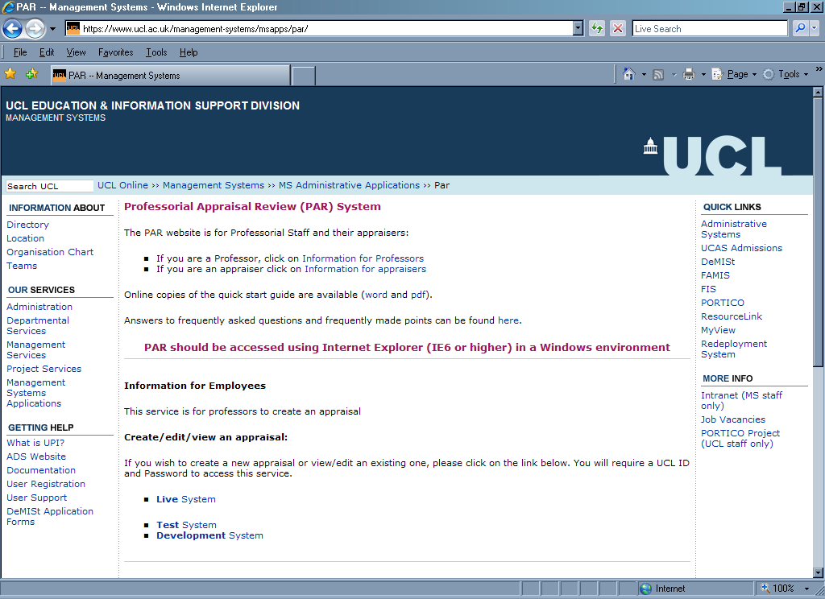
Figure 1: PAR Web Page

2 When you click on the appropriate “LIVE System” link, you will be asked to enter your UCL username and password (see Figure 2):

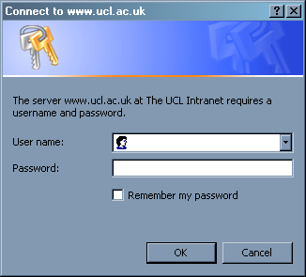
Figure 2: UCL Logon Box

3. Enter your user name and password into the correct fields then click on the OK button.

4. If successful you will see either the Professor Appraisal List (see Figure 4) or the HoD/Dean Appraisal List (see Figure 7) depending on which link is clicked on..

Access to PAR
Access to PAR is granted automatically, assuming that the user has the correct preconditions and a valid UCL username and password.

For Professors, they need to have the appropriate Professorial Staff Category within the HR/Payroll system.

For Heads of Departments (HoDs) and Deans, they must have the appropriate managerial role in the UCL roles system.

PAR Help
If you are unable to access PAR or have any issues when using it, please contact the PAR Help Desk by email (hr_helpdesk@adm.ucl.ac.uk) or by this webpage:
https://www.ucl.ac.uk/hr/helpdesk/helpdesk_web_form.php

Navigating the PAR System
This section describes some of the basic methods for navigating within and between appraisals in PAR.

Moving Between Fields
The [tab] button can be used to move between fields on a specific PAR tab. If there is a row of fields, then the [tab] button will move along the row. Otherwise, using [tab] will move the cursor to the next enterable field.

Moving Between Tabs
Navigation is only within a tab, to move between them requires the specific tab to be clicked using the mouse.

Please note, if a tab is left before saving it then the following message will appear asking whether you wish to save the changes made or not:

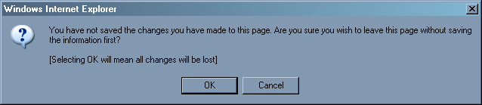
Figure 3: Tab Change Confirmation Message

If Cancel is selected then the tab is not exited, so allowing the user to save their changes. If OK is selected, then the new tab is opened and all changes in the previous one are lost.

Moving Between Parts
Navigation between Parts of an appraisal is achieved via the menu on the left-hand side of the PAR screen. Which Parts can be seen is dependent on the stage of the appraisal. Thus, the Part B menu option only appears once Part A is signed off by the Professor. Similarly, the Part C menu option appears when Part B has been signed off by the HoD.

Moving Between Appraisals
To move between appraisals, the user should use the Appraisals button of the menu on the left-hand side of the PAR screen. This will take you back to the Appraisal List they go to when they initially log in (see Figure 5: PAR Appraisal List).

Creating and Approving an Appraisal
This section covers the process of creating and approving an appraisal. Each will be covered in turn, before discussing how to enter and delete data.

Creating an Appraisal
This section goes through the process of a Professor creating a new Appraisal. After logging onto PAR, the user sees their list of Appraisals. If none exists, then the user can create one using the appropriate button (see Figure 4). A member of staff with multiple professorial posts is given a list from which to select the appropriate one.

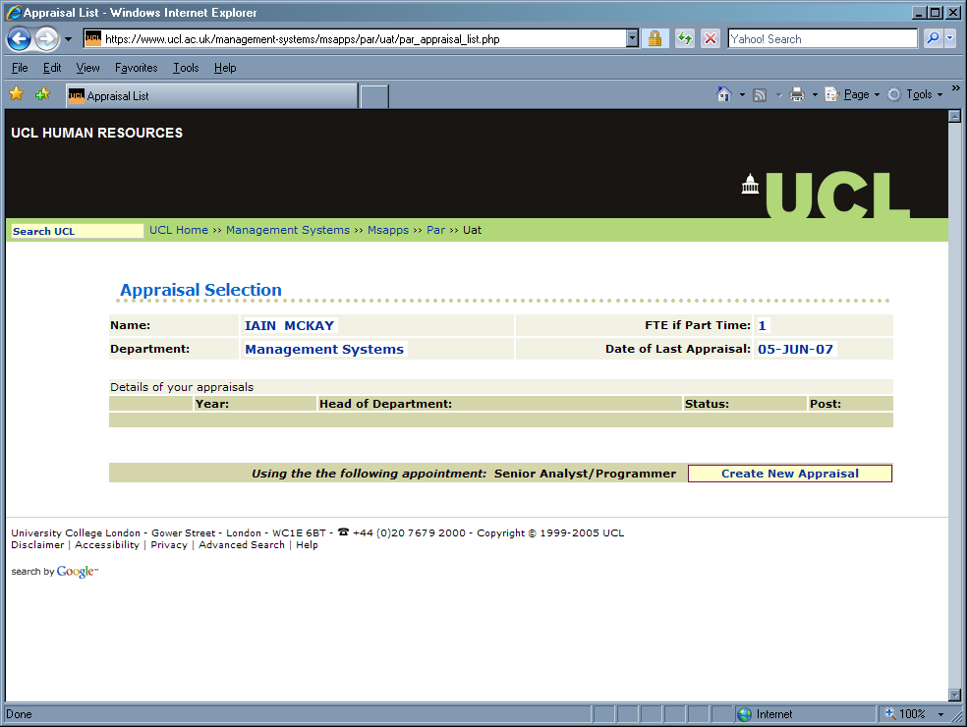
Figure 4: Professor Appraisal List

Staff with multiple professorial posts will see a drop-down-list of their posts next to the “Create New Appraisal” button, from which they should select the post they wish to be appraised for. This should be selected before the “Create New Appraisal” button is pressed.

When a new appraisal is created, then it will appear in the window and added to the list of appraisals and can now be picked by clicking on the Select button (see Figure 5).

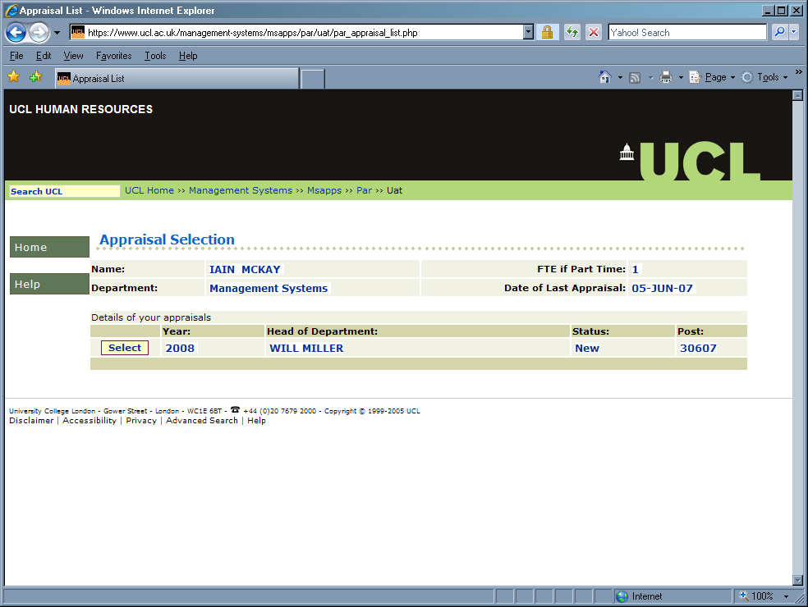
Figure 5: PAR Appraisal List

This will take the user to Part A of the specified Appraisal (see Figure 6).

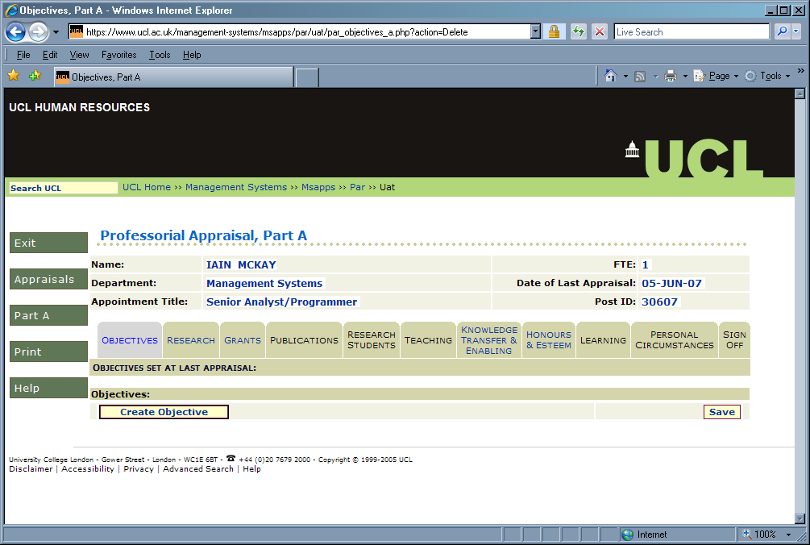
Figure 6: Part A Front Page

Approving an Appraisal
This section goes through the process of a HoD or Dean approving an Appraisal. After logging onto PAR, the user sees their list of Appraisals:

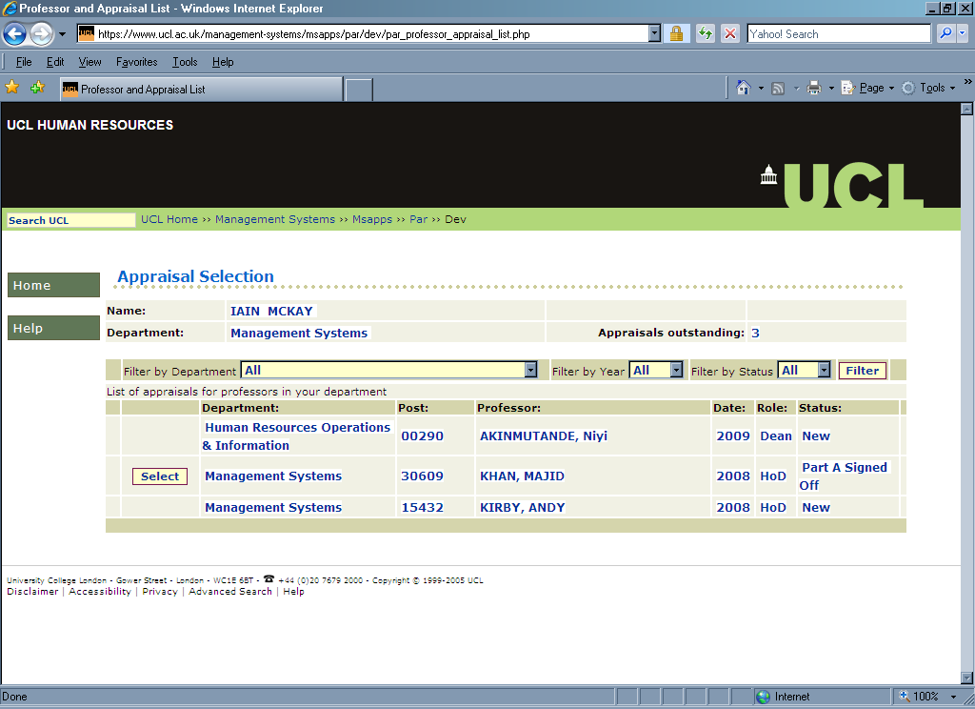
Figure 7: PAR HoD/Dean Front Page

The Approver front screen shows the appraisals and their status for the HoD/Dean. They can be filtered by department, year and status. Once an individual appraisal has been selected (by pressing the appropriate “select” button) then Part A of the Appraisal is displayed (see Figure 6). Part B can be accessed by clicking on the appropriate button on the menu.

Please note: An Appraiser cannot view an appraisal until the Appraisee has signed off Part A. In other words, Appraiser’s cannot select appraisals of status “New.” New status appraisals do not have a “Select” button associated with them (as shown in Figure 7). In addition, this summary screen only displays appraisals which exist in PAR (so if an Appraisee is not listed then that means they have not created an appraisal in PAR yet).

Entering data
For new appraisals, most tabs can be used to enter appraisal specific information. Some display data from external systems (for example, Research Students and Publications), a few combine both (for example, the Grants tab). However, both can be changed as long as the Part A of the appraisal has not been signed off. How this is done is discussed in turn.

Entering PAR specific data
To enter data, simply type it into the appropriate fields. All fields have a maximum character count, which is displayed directly beneath them.

When text is entered the character count decreases appropriately. If data is already in the field then the character count will, initially, display the maximum allowed. Once the field is selected and new data entered, the character count adjusts and takes into account the data on the field. No data in excess of the maximum character value can be added. In addition, you can “cut and paste” text from other applications, such as word processers. However, if the text being copied is larger than the maximum character length then it is automatically truncated to that length.

Certain fields can only take certain forms of data. For example, date fields take their data in the form DD/MM/YYYY. Again, if a date is entered in an incorrect format (say as MMDDYYYY or DD-MON-YYYY) an error will be raised.

Data is saved in PAR by pressing the Save button at the bottom-right of every tab which has text fields. For tabs where you need to press a button to create a new row of data, any changes you have made before pressing the button to create a new row will be automatically saved.

Changing External Data
PAR utilised data from various external systems. These are FIS (for Principal Grants), PORTICO (for Research Students), UCL Research Publications Service (RPS) (for Publications), Resourcelink (Personal, Post and UCL Learning data), Learning Event Record System (for non-UCL learning data) and the Achievements Application (for Prizes and Honours data). They are linked to on the appropriate tab (via a hyperlink named after the appropriate external system).

If data which you expect to see from any of these systems does not appear, you need to enter the appropriate data into the appropriate data. PAR will reflect any new data once the tab has been refreshed for all system except RPS (where the new data will appear in PAR the following day).

Once Part A of an appraisal is signed off, the system stores the external data within PAR. This is, in effect, a “snapshot” of the external data associated forever with the specific appraisal. When this is done, changes in the external system will not reflect on the data displayed on PAR for that appraisal.

For more details see section 8 Changing data in External System.

Deleting Data
PAR system allows users to delete data in specific Parts before they are signed off. To do this, you simply remove all the data from the field you wish to delete and than press the Save button. This will produce a warning message (see Figure 8)

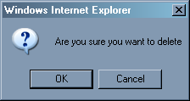
Figure 8: Delete confirmation message

To delete, press OK. Cancel will return you to the tab you were working on, as it was before you pressed Save.

For data which is stored in rows of fields (such as the Co-Investigator Grants), all you need to do is delete the data in the first field only.

The Appraisal Process
PAR system appraisal process is as follows:

STATUS | Description
New | Professor creates a new appraisal.
Part A Signed Off | Professor has submitted the appraisal by signing off Part A.
Part B Signed Off | Professor has signed off Part B of the appraisal.
HoD Part B Signed Off | HoD has signed off Part B of the appraisal.
Closed | Dean has signed off Part C.
Table 1: PAR Status Progression

Using the PAR System
This section describes each of the three Parts of the PAR system.

Part A
This is section is either entered by the Professor or drawn from external systems.

Objectives Tab
How this tab functions depends on whether this is the first appraisal created in PAR from the users. If there is no previous appraisal, then the professor will be able to enter any previously agreed objectives into this tab. If there is a previous appraisal in PAR, then this is tab is read-only and displays the objectives agreed in the Professor’s last appraisal.

Figure 9: Part A – Objectives tab.

To enter a new Objective, click on the “Create Objective” button and a new objective box will appear, as in the following screen:

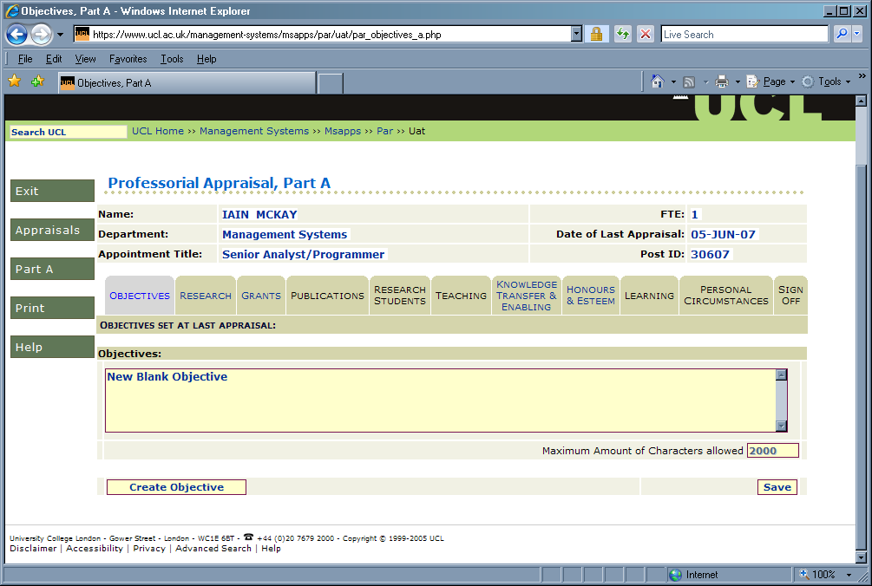
Figure 10: Objectives tab with new Objective

Current objectives can be entered as usual, using the “Save” button to commit changes to the database. If the “Create Objective” button is pressed, any changes made in the tab will be automatically saved.

Please Note: each Objectives field has a maximum of limit of 2,000 characters.

Research Tab
This tab allows the professor to enter a summary of their research progress since their last appraisal. This data can be entered as usual, using the “Save” button to commit changes to the database.

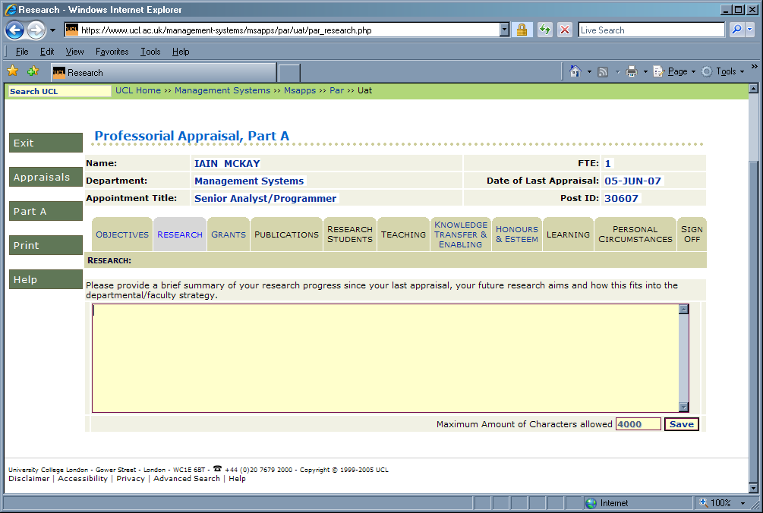
Figure 11: Part A – Research tab

Please Note: the Research field has a maximum of limit of 4,000 characters.

Grants Tab
This tab displays grants currently held by the Professor. This information takes two parts, a read-only section for grants the professor is the Principle Investigator for and an updateable section for grants they are Co-Investigator for.

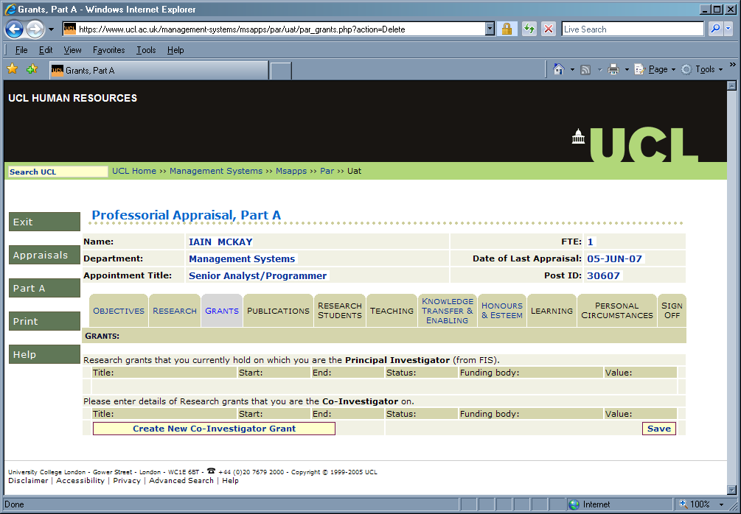
Figure 12: Part A – Grants tab
The Principle Investigator Grant information is from FIS if the appraisal is new, obviously it displays the snapshot of FIS data stored when the Part A of the appraisal was signed off by the Professor. If any Principal Investigator Grants are missing or incorrect in PAR, then FIS should be updated with the correct information. To see any updated data then the Grants tab should be refreshed (or navigated away from by visiting another tab and returning). This, obviously, applies to appraisals which have not been signed off.

There is a link (“from FIS”) which can be used to directly access FIS (clicking on the link will spawn a new browser window).

In terms of the Co-Investigator Grant information, this must be entered by the professor. To create one, press the “Create New Co-Investigator Grant” button and this produce a new grant, as can be seen in the following screen:

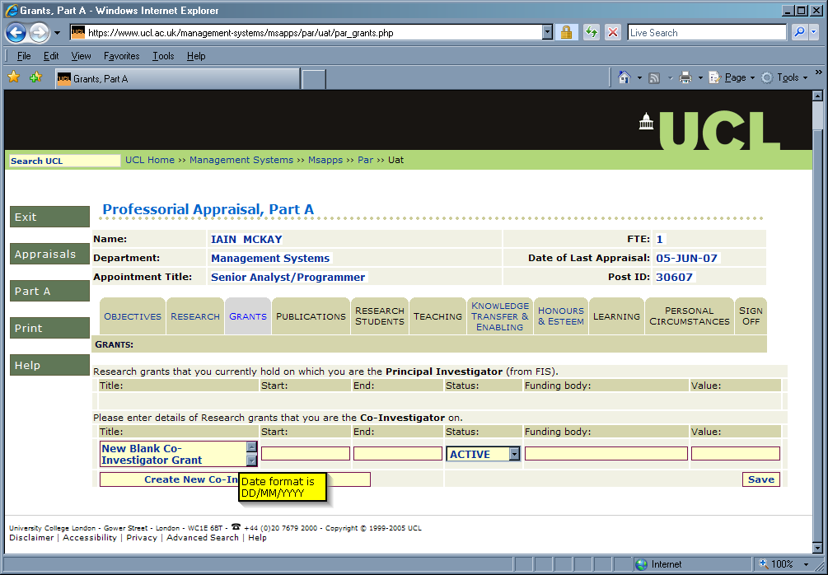
Figure 13: Grants tab with new Co-Investigator Grant

The date fields should be entered in the following format: DD/MM/YYYY. If this is not done, then an error message will be displayed informing the user of this.

Current objectives can be entered as usual, using the “Save” button to commit changes to the database. If the “Create New Co-Investigator Grant” button is pressed, any changes made in the tab will be automatically saved.

Please Note: the Title field has a maximum of limit of 240 characters, the Date fields have a maximum limit of 10 characters (DD/MM/YYYY format), the Funding body field has a maximum of limit of 50 characters and the Value field has a maximum of limit of 10 characters.

Publications Tab
This tab is read-only and displays publications published by the Professor since their last appraisal (or when they started their post). This information is initially from UCL Research Publications Service (RPS) if the appraisal is new, obviously it displays the snapshot of RPS data stored when the Part A of the appraisal was signed off by the Professor.

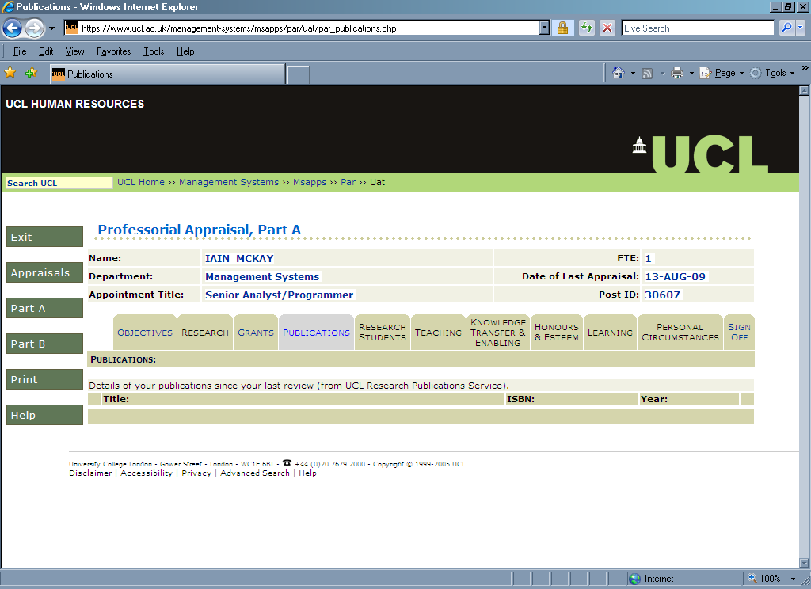
Figure 14: Part A – Publications tab

If any publications are missing or incorrect in PAR, then RPS should be updated with the correct information. It should be noted that PAR is updated with RPS data overnight and so any changes there will not be reflected in PAR until the next day. This, obviously, applies to appraisals which have not been signed off.

There is a link (“from UCL Research Publications Service”) which can be used to directly access RPS (clicking on the link will spawn a new browser window).

Research Students Tab
This tab is read-only and displays Research Students supervised by the Professor since their last appraisal (or when they started their post). This information is initially from Portico if the appraisal is new, obviously it displays the snapshot of Portico data stored when the Part A of the appraisal was signed off by the Professor.

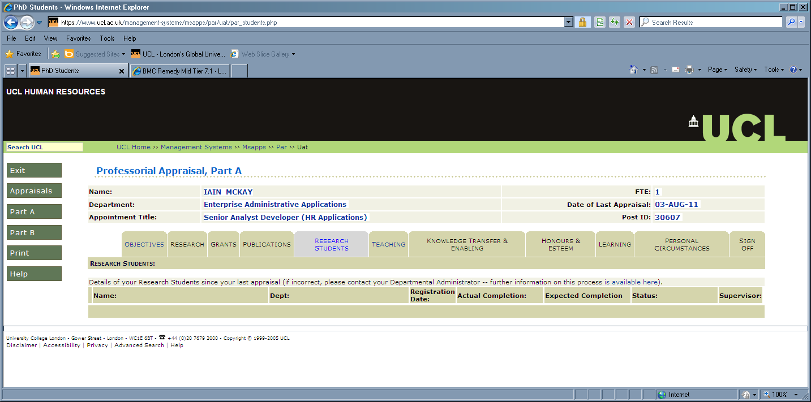
Figure 15: Part A – Research Students tab

The Research Student information is from Portico if the appraisal is new, obviously it displays the snapshot of Portico data stored when the Part A of the appraisal was signed off by the Professor. If any Research students are missing or their details are incorrect in PAR, then Portico should be updated with the correct information. To see any updated data then the Research Students tab should be refreshed (or navigated away from by visiting another tab and returning). This, obviously, applies to appraisals which have not been signed off.

This information can be updated by contacting your Departmental Administrator. This process is described in a link (clicking on “is available here” will spawn a new browser window).

Teaching Tab
This tab allows the professor to enter a summary of their teaching and learning related activities since their last appraisal. This data can be entered as usual, using the “Save” button to commit changes to the database.

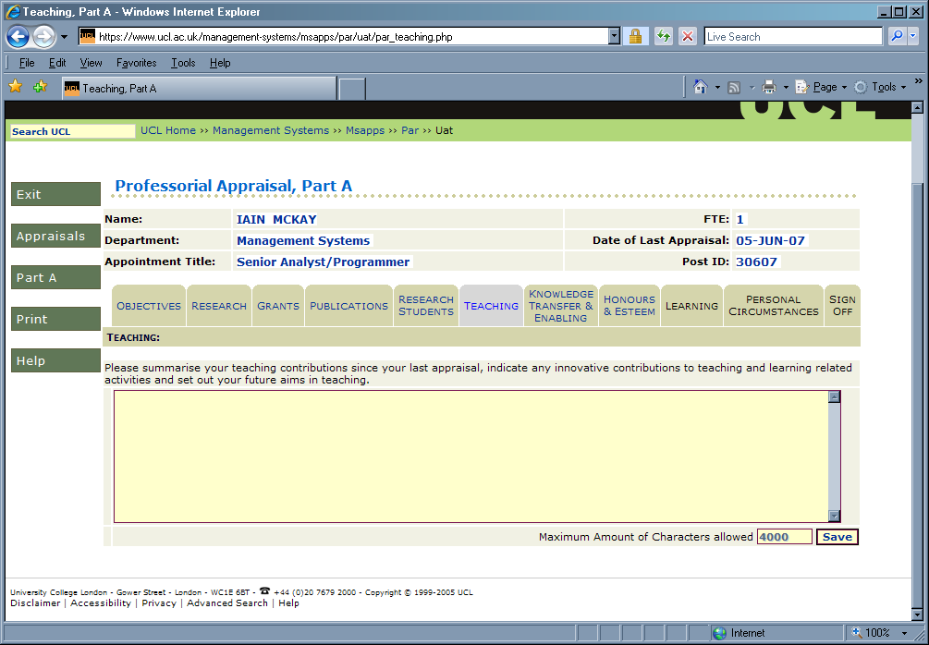
Figure 16: Part A – Teaching tab

Please Note: the Teaching field has a maximum of limit of 4,000 characters.

Knowledge Transfer & Enabling Tab
This tab allows the professor to enter a summary of their knowledge transfer/exchange and any enabling contributions made since their last appraisal. This data is broken up into two fields, one for Knowledge Transfer and the other for Enabling Contributions. This data can be entered as usual, using the “Save” button to commit changes to the database. This will save any data entered or changes made to existing data in both sections of the tab.

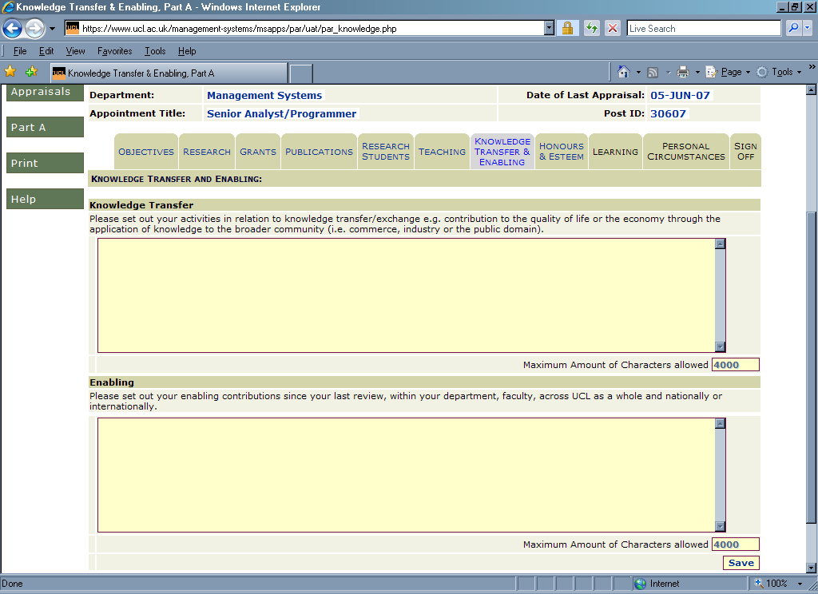
Figure 17: Part A – Knowledge Transfer & Enabling tab

Please Note: the both fields have a maximum of limit of 4,000 characters each.

Honours & Esteem Tab
This tab is in two parts.

The first section allows the professor to enter evidence of national or international recognition achieved since their last appraisal.

The second section displays information of any Honours or Prizes received by the professor. This information is initially from Achievements Application if the appraisal is new, obviously it displays the snapshot of Achievements Application data stored when the Part A of the appraisal was signed off by the Professor.

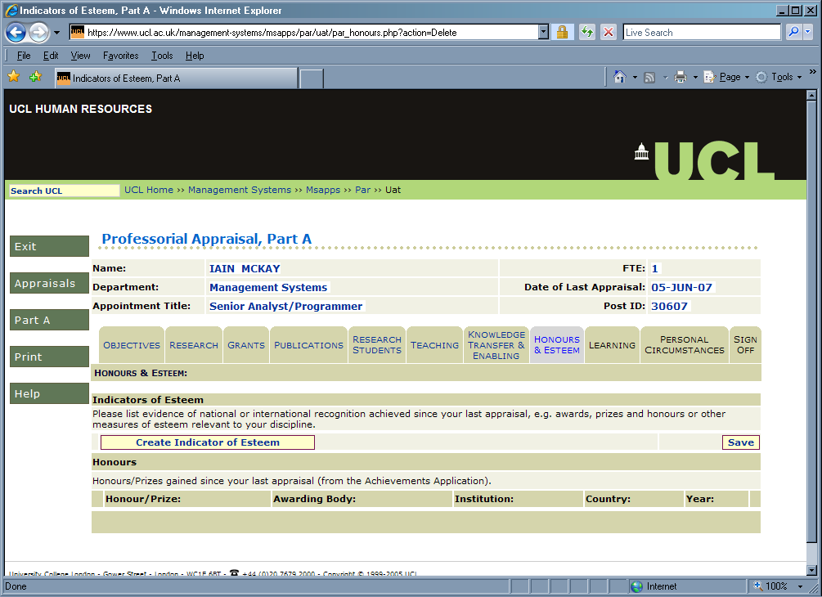
Figure 18: Part A – Honours and Esteem tab

To enter a new Indicator of Esteem, click on the “Create Indicator of Esteem” button and a new Indicator of Esteem box will appear, as in the following screen:

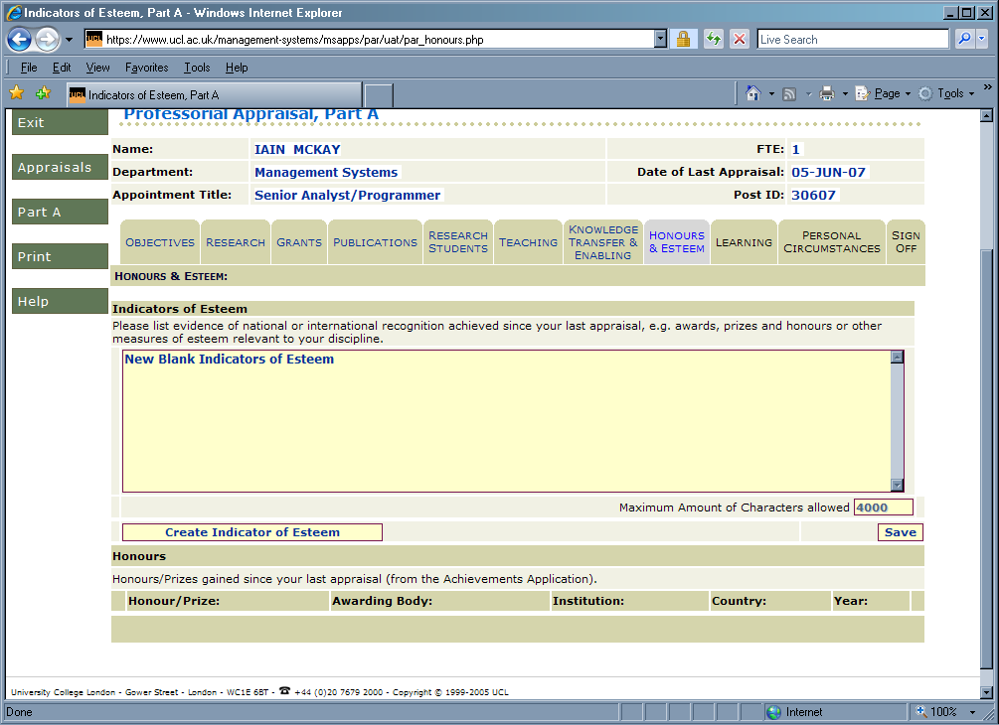
Figure 19: Honours & Esteem tab with new Indicator of Esteem

Indicators of Esteem can be entered as usual, using the “Save” button to commit changes to the database. If the “Create Indicator of Esteem” button is pressed, any changes made in the tab will be automatically saved.

The Honours/Prizes information is from Achievements Application if the appraisal is new, obviously it displays the snapshot of Achievements Application data stored when the Part A of the appraisal was signed off by the Professor. If any information is missing or its details are incorrect in PAR, then Achievements Application should be updated with the correct information. To see any updated data then the Honours and Esteem tab should be refreshed (or navigated away from by visiting another tab and returning). This, obviously, applies to appraisals which have not been signed off.

There is a link (“from the Achievements Application”) which can be used to directly access the Achievements Application (clicking on the link will spawn a new browser window).

Please Note: each Indicator of Esteem field has a maximum of limit of 4,000 characters.

Learning Tab
This tab is read-only and displays any training done by the Professor since their last appraisal (or when they started their post). This information is initially from Resourcelink Training Module (for UCL Learning data) and the Learning Events Recording System (for non-UCL learning data) if the appraisal is new, obviously it displays the snapshot of and data stored when the Part A of the appraisal was signed off by the Professor.

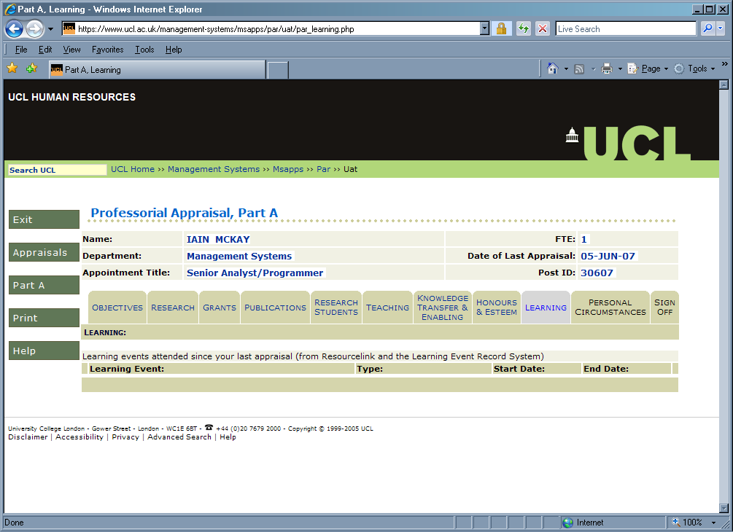
Figure 20: Part A – Learning tab

The Learning information is from Resourcelink and the Learning Events Recording System if the appraisal is new, obviously it displays the snapshot of learning data stored when the Part A of the appraisal was signed off by the Professor. If any Learning information is missing or its details are incorrect in PAR, then the relevant system should be updated with the correct information. To see any updated data then the Learning tab should be refreshed (or navigated away from by visiting another tab and returning). This, obviously, applies to appraisals which have not been signed off.

There is a link (“from Resourcelink and the Learning Events Recording System”) which can be used to directly access the Learning Events Recording System (clicking on the link will spawn a new browser window). For changing Resourcelink training data you will need to contact the appropriate UCL training provider (the Organisational and Staff Development Team, and so on).

Personal Circumstances Tab
This tab allows the professor to outline any factors (either internal or external to UCL) that have affected their contribution/performance since their last appraisal. This data can be entered as usual, using the “Save” button to commit changes to the database.

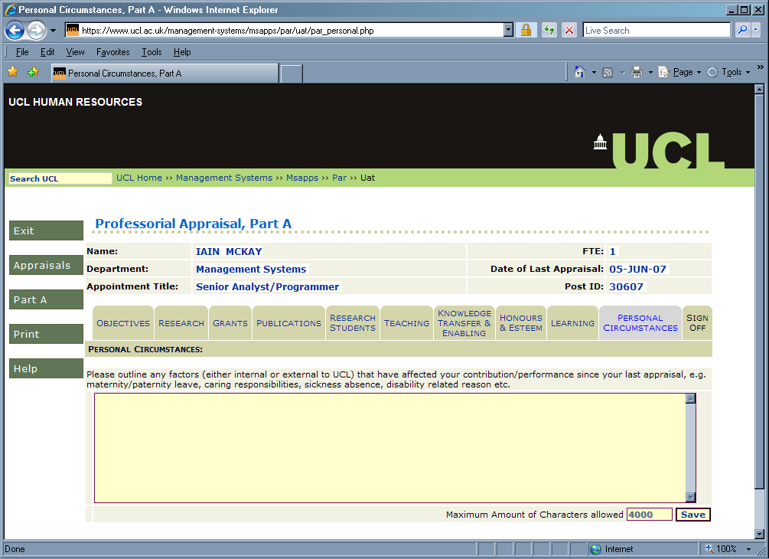
Figure 21: Part A – Personal Circumstances tab

Please Note: the Personal Circumstances field has a maximum of limit of 4,000 characters.

Sign Off Tab
This tab allows the professor to sign off Part A. This is done by pressing the “Sign Off A” button is pressed.

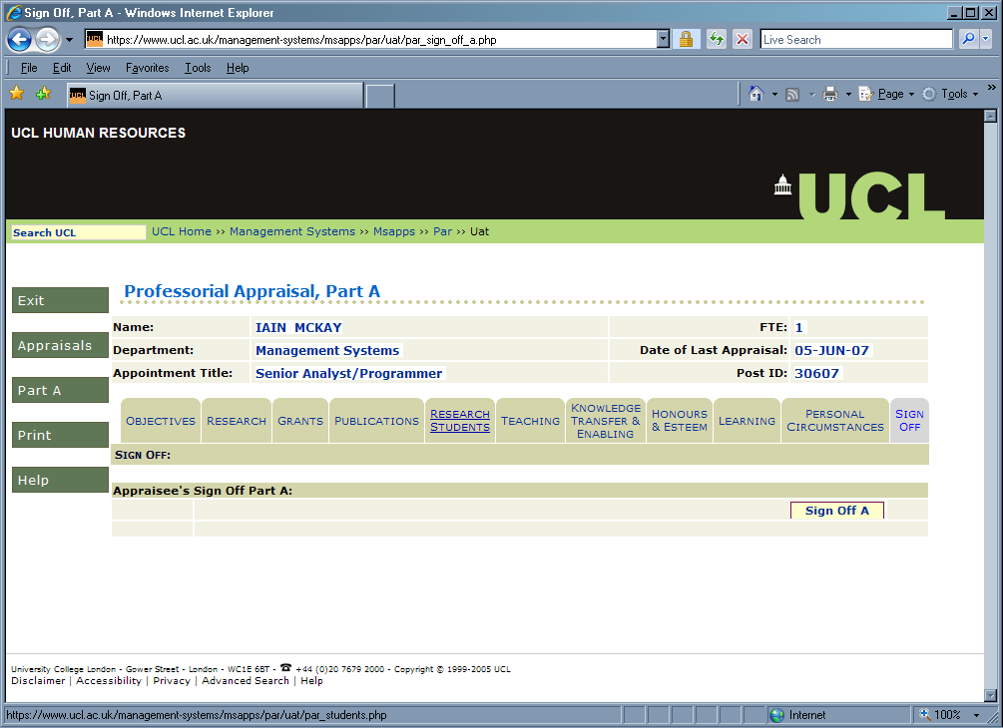
Figure 22: Part A – Sign Off tab

When the “Sign Off A” button is pressed, the following message is displayed:

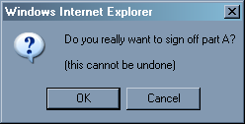
Figure 23: Part A – Sign Off confirmation

Pressing OK will sign off the Appraisal, allowing the professor’s Head of Department access. This displays the following confirmation message:

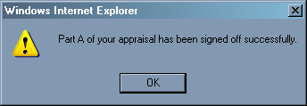
Figure 24: Part A – Sign Off message

When the appraisal was signed off is then displayed, along with Part B on the PAR menu. In addition, an email to the professor’s HoD (using the professor’s email address) is automatically sent.

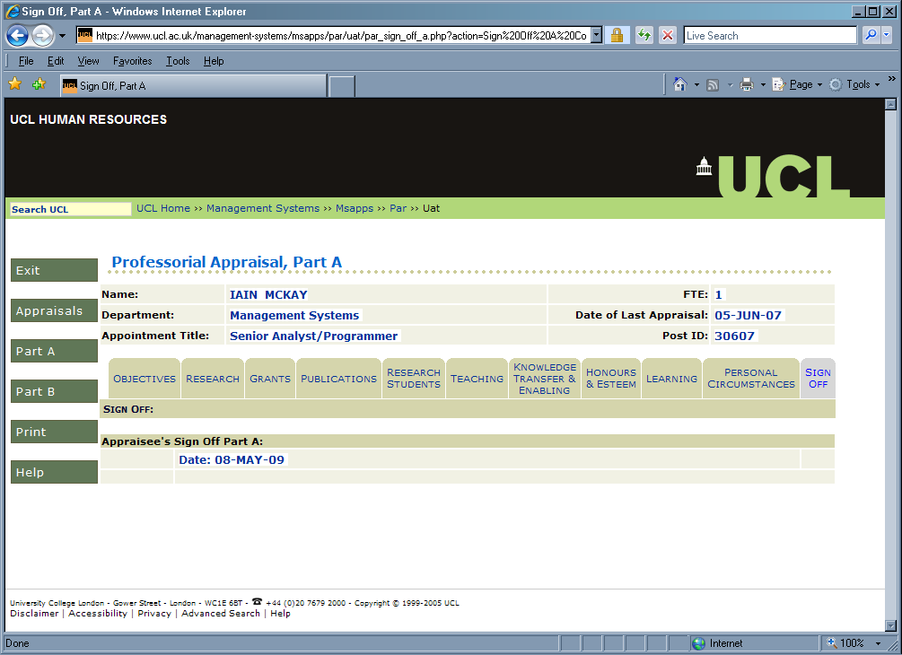
Figure 25: Part A – Appraisal Signed Off

Once an appraisal is signed-off, Part A related data cannot be changed. All data entry fields will be read-only (and greyed-out) and a local snapshot of data from external systems stored within PAR. This means that any subsequent changes to these systems for the period covered by a signed-off appraisal will not be reflected in PAR.

Part B
This is section is mostly entered by the HoD, with the Professor able to add comments and sign-off part B of the appraisal (on the Part B .Sign Off tab). HoDs can enter data in all the tabs. Please note that a HoD can sign-off Part B of an appraisal without the professor also doing so.

When an appraisal is selected, then the user is always taken to Part A:

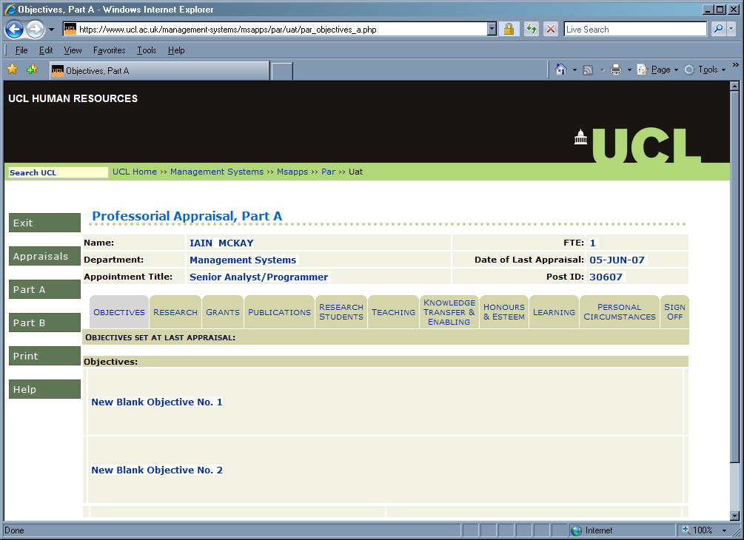
Figure 26: Part B Menu

The Part B tabs are accessed by clicking on the “Part B” button on the PAR menu. When this is done, the user is taken to the Part B progress tab (see section 6.2.1)

Progress Tab
This tab allows the HoD to enter a summary of the progress made since their last appraisal.

The tab lists the Objectives agreed for the Professor’s previous appraisal, with a field for comments against each one. This data can be entered as usual, using the “Save” button to commit changes to the database. This will save any data entered or changes made to existing data in all sections of the tab.

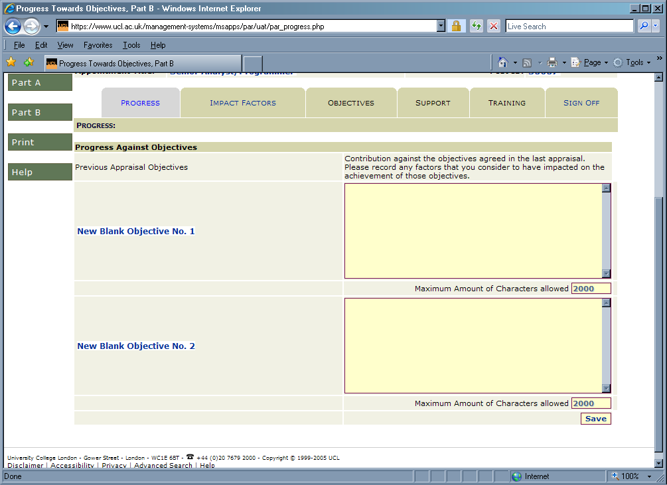
Figure 27: Part B – Progress tab

Please Note: each Progress field has a maximum of limit of 2,000 characters.

Impact Factors Tab
This tab allows the HoD to enter a summary of any factors that may have contributed to how far the previous appraisal’s objectives were reached. This data can be entered as usual, using the “Save” button to commit changes to the database.

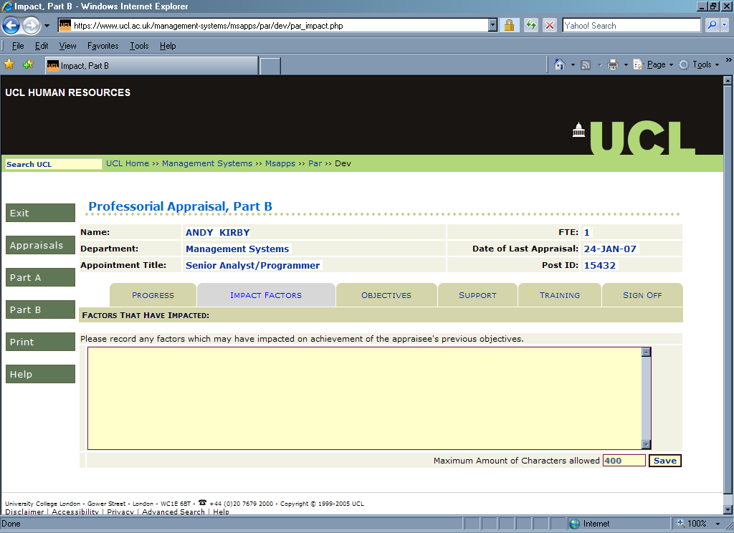
Figure 28: Part B – Impact Factors tab

Please Note: the Impact Factors field has a maximum of limit of 400 characters.

Objectives Tab
This tab allows the entry of any new objectives agreed by the professor and their HoD. At least one new Objective must be entered in order to sign off Part B.

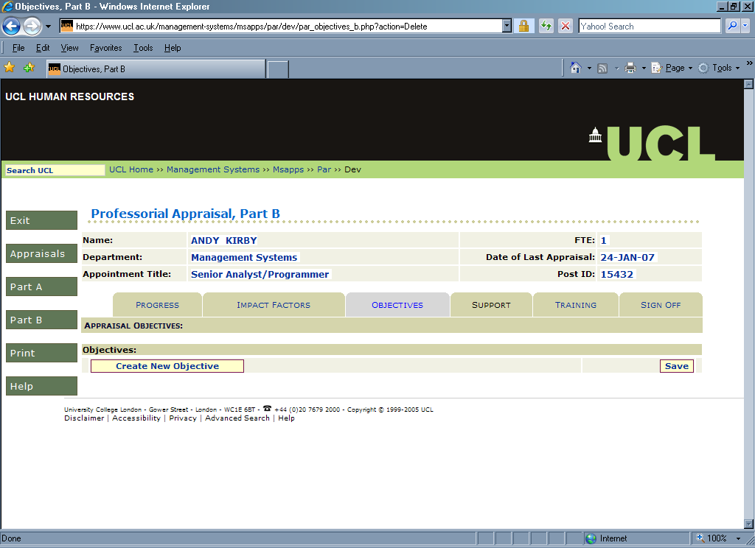
Figure 29: Part B – Appraisal Objectives tab.

To enter a new Objective, click on the “Create New Objective” button and a new objective will appear, as can be seen in the following screen:

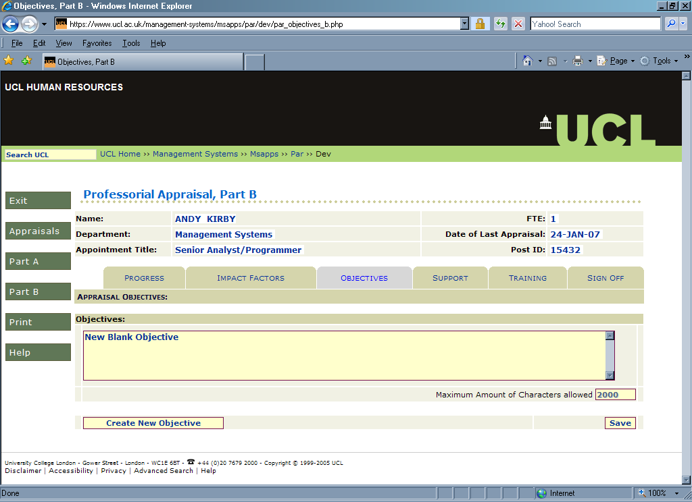
Figure 30: Objectives tab with New Objective

Current objectives can be entered as usual, using the “Save” button to commit changes to the database. If the “Create New Objective” button is pressed, any changes made in the tab will be automatically saved.

Please Note: each Objectives field has a maximum of limit of 2,000 characters.

Support Tab
This tab allows the HoD to indicate why support required to meet the objectives agreed for this appraisal. This data can be entered as usual, using the “Save” button to commit changes to the database.

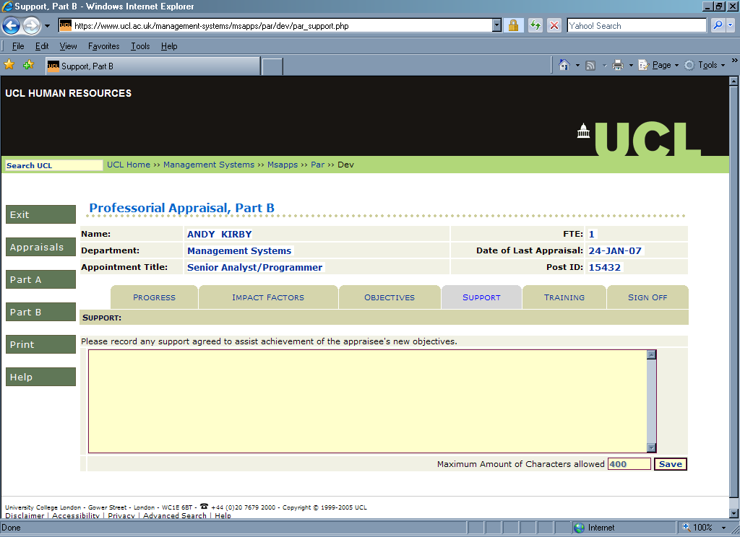
Figure 31: Part B – Support tab

Please Note: the Support field has a maximum of limit of 400 characters.

Training Tab
This tab allows the HoD to specify any training required by the professor required to meet their objectives, subsequent to their appraisal.

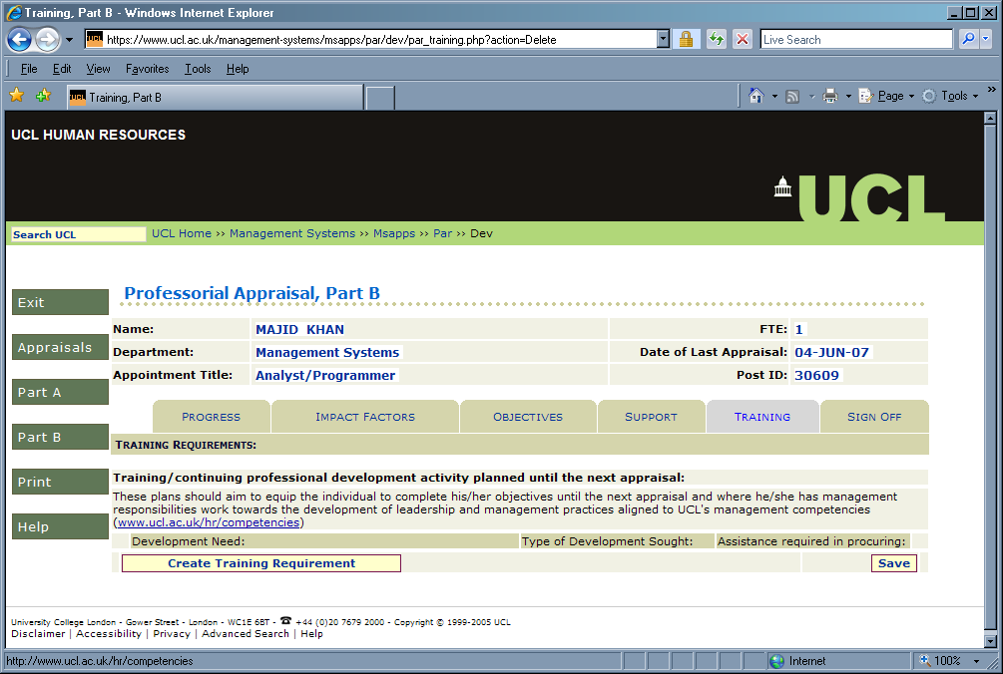
Figure 32: Part B – Training tab

To create training data, press the “Create Training Requirement” button and a new requirement will be automatically created, as can be seen in the following screen:

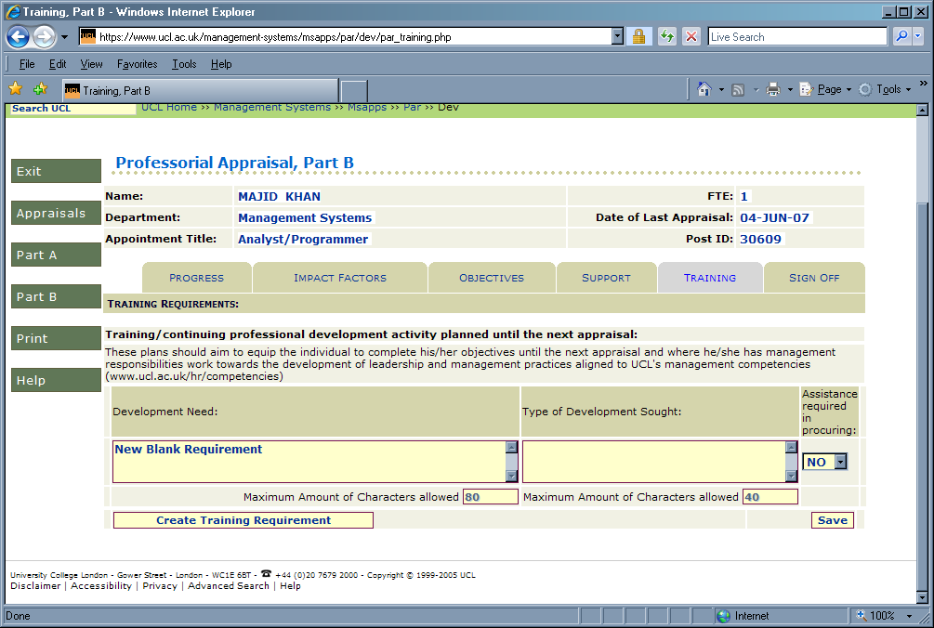
Figure 33: Training tab with new Training Requirement

Current objectives can be entered as usual, using the “Save” button to commit changes to the database. If the “Create Training Requirement” button is pressed, any changes made in the tab will be automatically saved.

Please Note: the Development Need field has a maximum of limit of 80 characters and Type of Development Sought field has a maximum of limit of 40 characters.

Part B Sign Off Tab
Signing off Part B of an appraisal usually involves both the Professor and HoD, however a HoD can sign off an appraisal without the professor signing off their part of it.
Neither a professor nor a HoD can sign-off Part B of an appraisal unless there is a minimum of one New Objective specified.

Professor Part B Sign-Off
When a professor logs in and does to this tab, they will see the following screen:

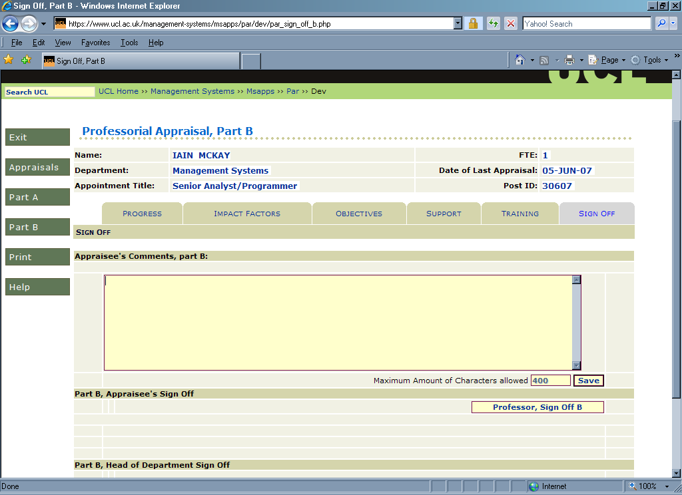
Figure 34: Part B –Sign Off as viewed by a Professor

Any appraisee’s comments can be added and saved as in any other field.

Once the professor is happy with their comments, then they can press the “Professor, Sign Off B” button. It should be noted that any changes made in the comments field will be saved automatically when the button is pressed. The following confirmation message will appear:
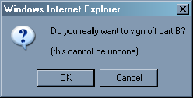
Figure 35: Professor Part B Sign Off confirmation message

This will display who signed off the appraisee’s Part B and the date it was done. Once the sign off is confirmed then the HoD cannot change any of the information within Part B. All they can do is sign off Part B themselves.

Please Note: the Appraisee’s Comments field has a maximum of limit of 400 characters.

HoD Part B Sign-Off
When a HoD logs in and does to this tab, they will see the following screen:

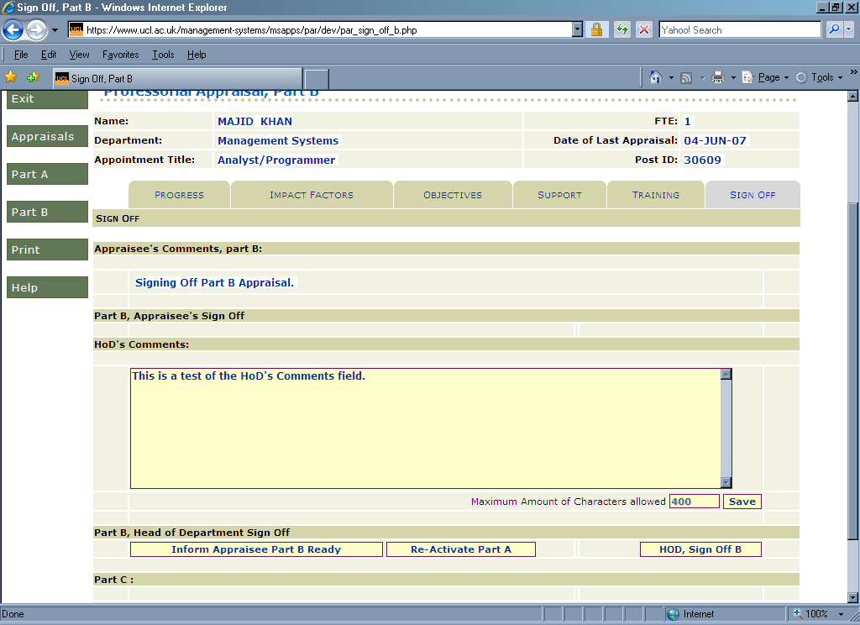
Figure 36: Part B –Sign Off as viewed by a HoD

If Part A of the appraisal is incomplete or otherwise need modification, the HoD can use the “Re-Activate Part A” button to set the status of the appraisal back to “New” if so desired. If this button is pressed then the following message appears:

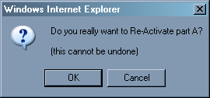
Figure 37: HoD Part A Re-Activation confirmation message

If “OK” is selected then the Appraisal is set to “New” status and an email is sent to the Professor notifying them that their appraisal’s status has been changed. Once this is done PAR returns to the HoD’s list of Appraisals (see Figure 7: PAR HoD/Dean Front Page). This is because a HoD does not have access to an appraisal of “New” status.

Once the HoD is happy with the appraisal, then they can inform the professor that the appraisal is ready for them to sign-off by pressing the “Inform Appraisee Part B Ready” button. This will send an email to the professor and display the following confirmation message:

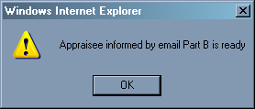
Figure 38: Part B Sign Off ready message

The HoD can also enter information in the “HoDs Comments” field for the Dean to view (this field is only visible to the HoD and Dean). Please note that this field must be entered before Part B is signed off by the HoD.

When the HoD wants to sign off Part B of the appraisal, then they should press the “HoD, Sign Off B” button. The following confirmation message will appear:

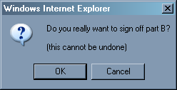
Figure 39: HoD Part B Sign Off confirmation message

This will display who signed off the HoD’s Part B and the date it was done:

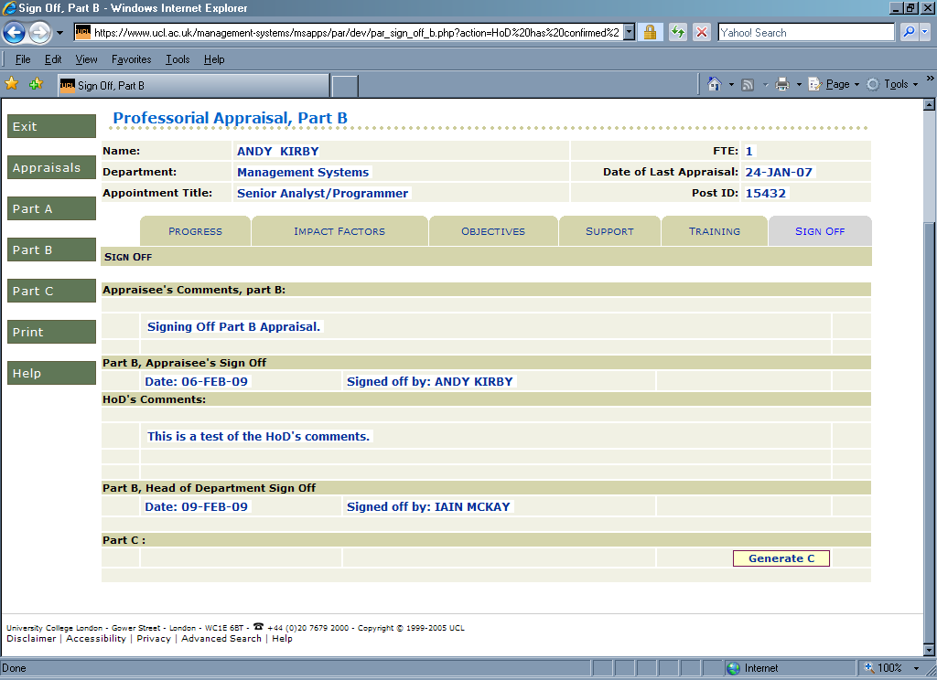
Figure 40: Part B –Signed Off by HoD

Please Note: the HoD’s Comments field has a maximum of limit of 400 characters.

Part C
When a Dean logs in, they will see the following screen once they click on Part C on the PAR menu:

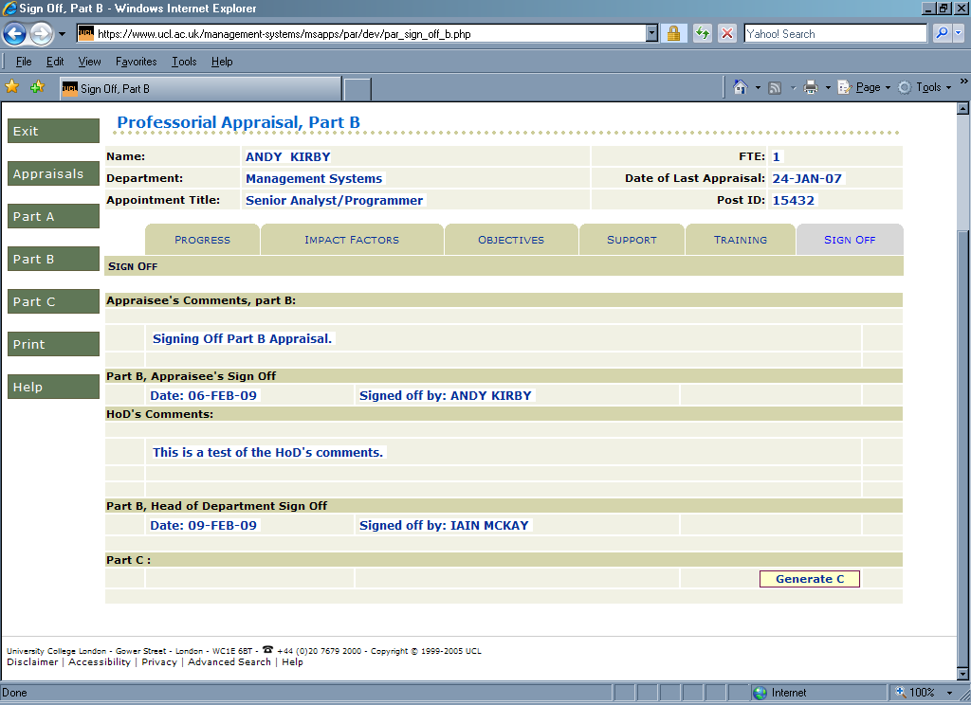
Figure 41: Part C –Dean Sign Off

To sign off an Appraisal, the “Generate C” button should be pressed by the Dean. This produces the following confirmation message:

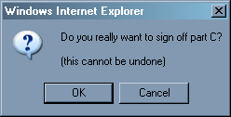
Figure 42: Dean Part C Sign Off confirmation message

Once the sign off is confirmed, PAR will produce a rtf file of the appraisal in a new browser window. This will produce the following dialogue box:
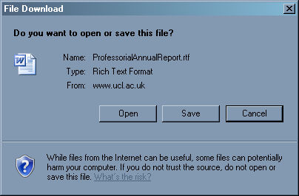
Figure 43: Dean Part C Sign Off dialogue box

With the creation of this file, PAR closes off the appraisal. A confirmation email is sent to both the Professor and HoD.

Printing an Appraisal
It is possible to print an Appraisal as a Rich Text Format (rtf) file. This can be done by printing the “Print” button on each appraisal’s side-menu. This is viewable from all tab pages. If a field has had data entered into it, it will need to be saved before it appears in the printout.

Figure 44: Print Appraisal Button

Clicking on this button will spawn rtf file of the Appraisal which can be either opened into a suitable word processor or downloaded (see Figure 45: Print Appraisal File Download Message)

Figure 45: Print Appraisal File Download Message

Changing data in External System
PAR utilises six external systems for some of its data. To get this data into PAR, you need to enter/change the data in the appropriate system. The external systems are linked to on the appropriate tab (via a hyperlink named after the application in question).

Except for UCL Research Publications Service (RPS) data, the new information will be disappeared once the appropriate PAR tab is visited again or refreshed. RPS data is refreshed overnight.

Please note that when Part A of an appraisal is signed off, PAR takes a copy (snapshot) of the data from the external systems and stores it within PAR. It is this snapshot which is subsequently displayed in PAR. This means that you should ensure that ALL appropriate data is entered into the external systems before signing off Part A; otherwise it will not appear in PAR.

Principal Grants
Data for Principal Grants in PAR (see section 6.1.3 Grants Tab) comes from the Financial Information System (FIS). Any amendments to the Principal Investigator on grants should be notified to Research Administration – Post Award Team:

http://www.ucl.ac.uk/finance/secure/research/post_award/

Publications
Data for publications in PAR (see section 6.1.4 Publications Tab) comes from UCL Research Publications Service (RPS). Information on how to update publications can be found at:

http://www.ucl.ac.uk/research/publications/

Please Note: Any changes made on RPS will be updated on PAR overnight.

Research Students
Data for Research Students in PAR (see section 6.1.5 Research Students Tab) comes from students information system PORTICO. This information can be updated by contacting your Departmental Administrator. This process is described in this webpage:

http://www.grad.ucl.ac.uk/ucleros/

Honours
Data for Honours in PAR (see section 6.1.8 Honours & Esteem Tab) comes the Achievements Application. This can be updated using a self service link at:

https://www.ucl.ac.uk/hr/services/qualifications/

Learning
Data for Learning events in PAR (see section 6.1.9 Learning Tab) comes two sources.

The first is the Resourcelink Training Module. If a training session is missing, please contact the relevant training provider (the Organisational and Staff Development Team, and so on).

The second is from the Learning Event Record System and can be updated at:

https://www.ucl.ac.uk/hr/osd/recording/event_learning/private/index.php

Exiting PAR
To exit the PAR system, either close your browser or visit another webpage (e.g., your home page). Alternatively, use the Exit button of the menu on the left-hand side of the PAR screen. This will take you back to the PAR home page.

Appendix maximum field lengths
PAR fields have various maximum lengths. These are indicated in the descriptions of the various tabs. Here is a summary:

Tab | Field | Maximum numbers of characters
Part A
Objectives | Objectives | 2,000
Research | Research | 4,000
Grants | Title | 240
Grants | Start | 10
Grants | End | 10
Grants | Funding Body | 50
Grants | Value | 10
Teaching | Teaching | 4,000
Knowledge Transfer and Enabling | Knowledge Transfer | 4,000
Knowledge Transfer and Enabling | Enabling | 4,000
Honours & Esteem | Indicators of Esteem | 4,000
Personal Circumstances | Personal Circumstances | 4,000
Part B
Progress | Progress Against Objectives | 2,000
Impact Factors | Factors That Have Impacted | 400
Objectives | Objectives | 2,000
Support | Support | 400
Training | Development Need | 80
Training | Development Sought | 40
Sign Off | Appraisee’s Comments | 400
Sign Off | HoD’s Comments | 400
Table 2: Maximum Field Lengths in PAR

which one depends on whether you are logging in as an Appraisee or Appraiser
The Grants tab is the only exception, with it being impossible to enter more data than the maximum limit for Co-Investigator Grants fields.
Date in DD/MM/YYYY format
Date in DD/MM/YYYY format

