Student Centre floor plan

Contents

* Legend
* Level B2
* Level B1
* Level 0
  + Level 0, mezzanine
* Level 1
* Level 2
* Level 3
* Level 4

# Legend

Icons used throughout this guide:

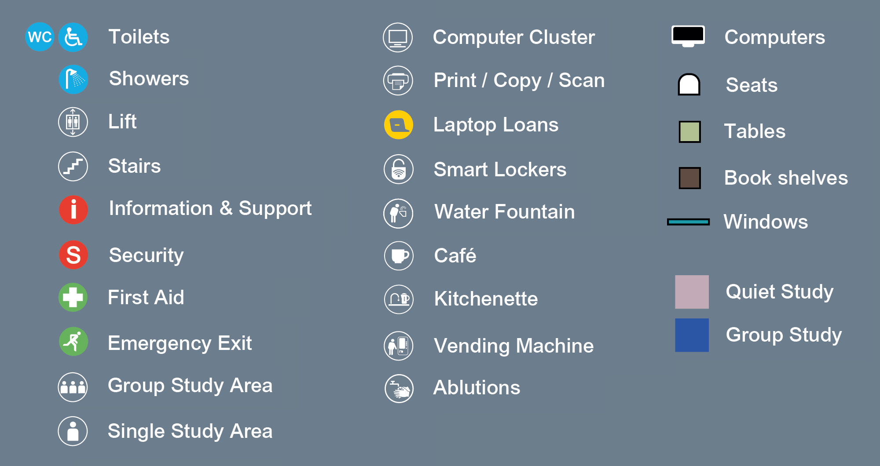

Level B2

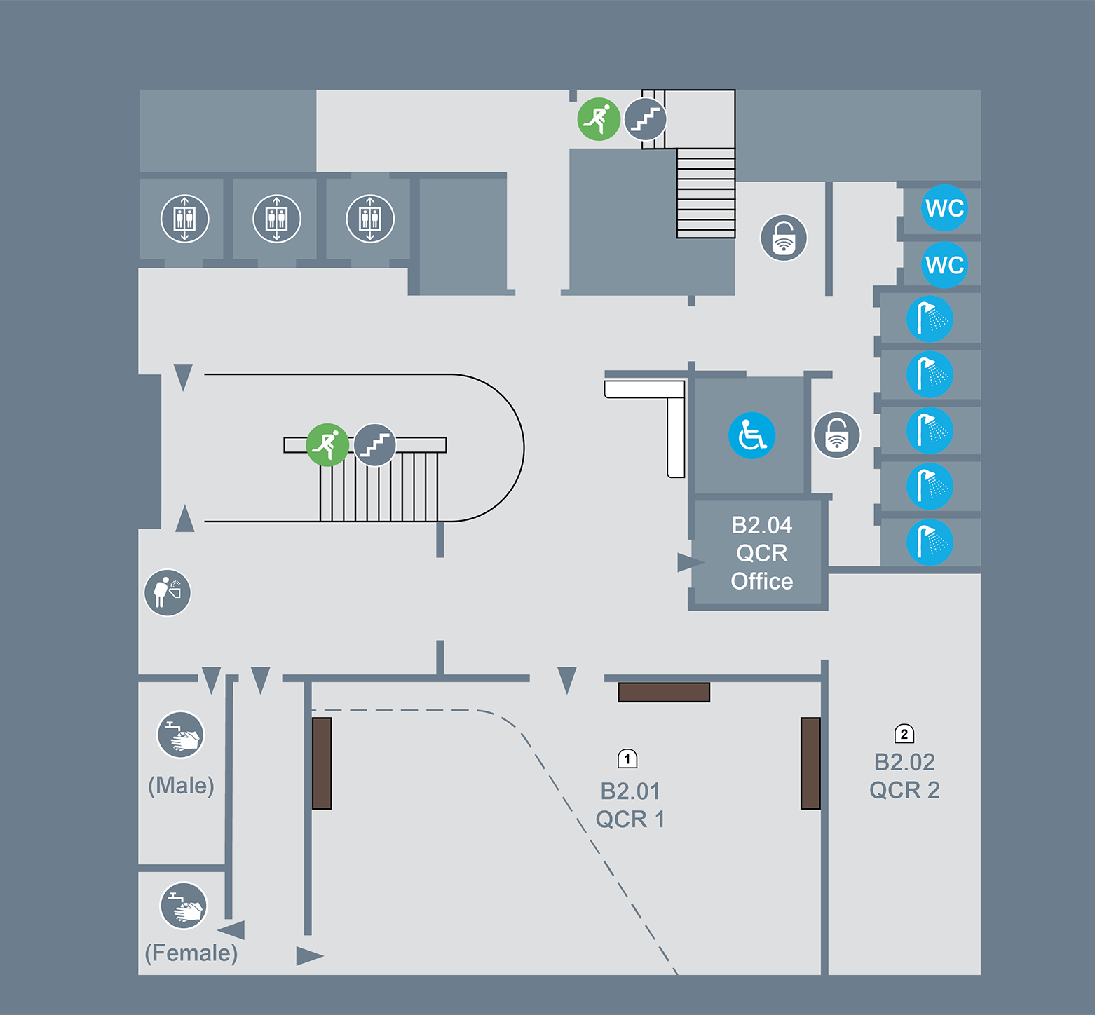

Level B1

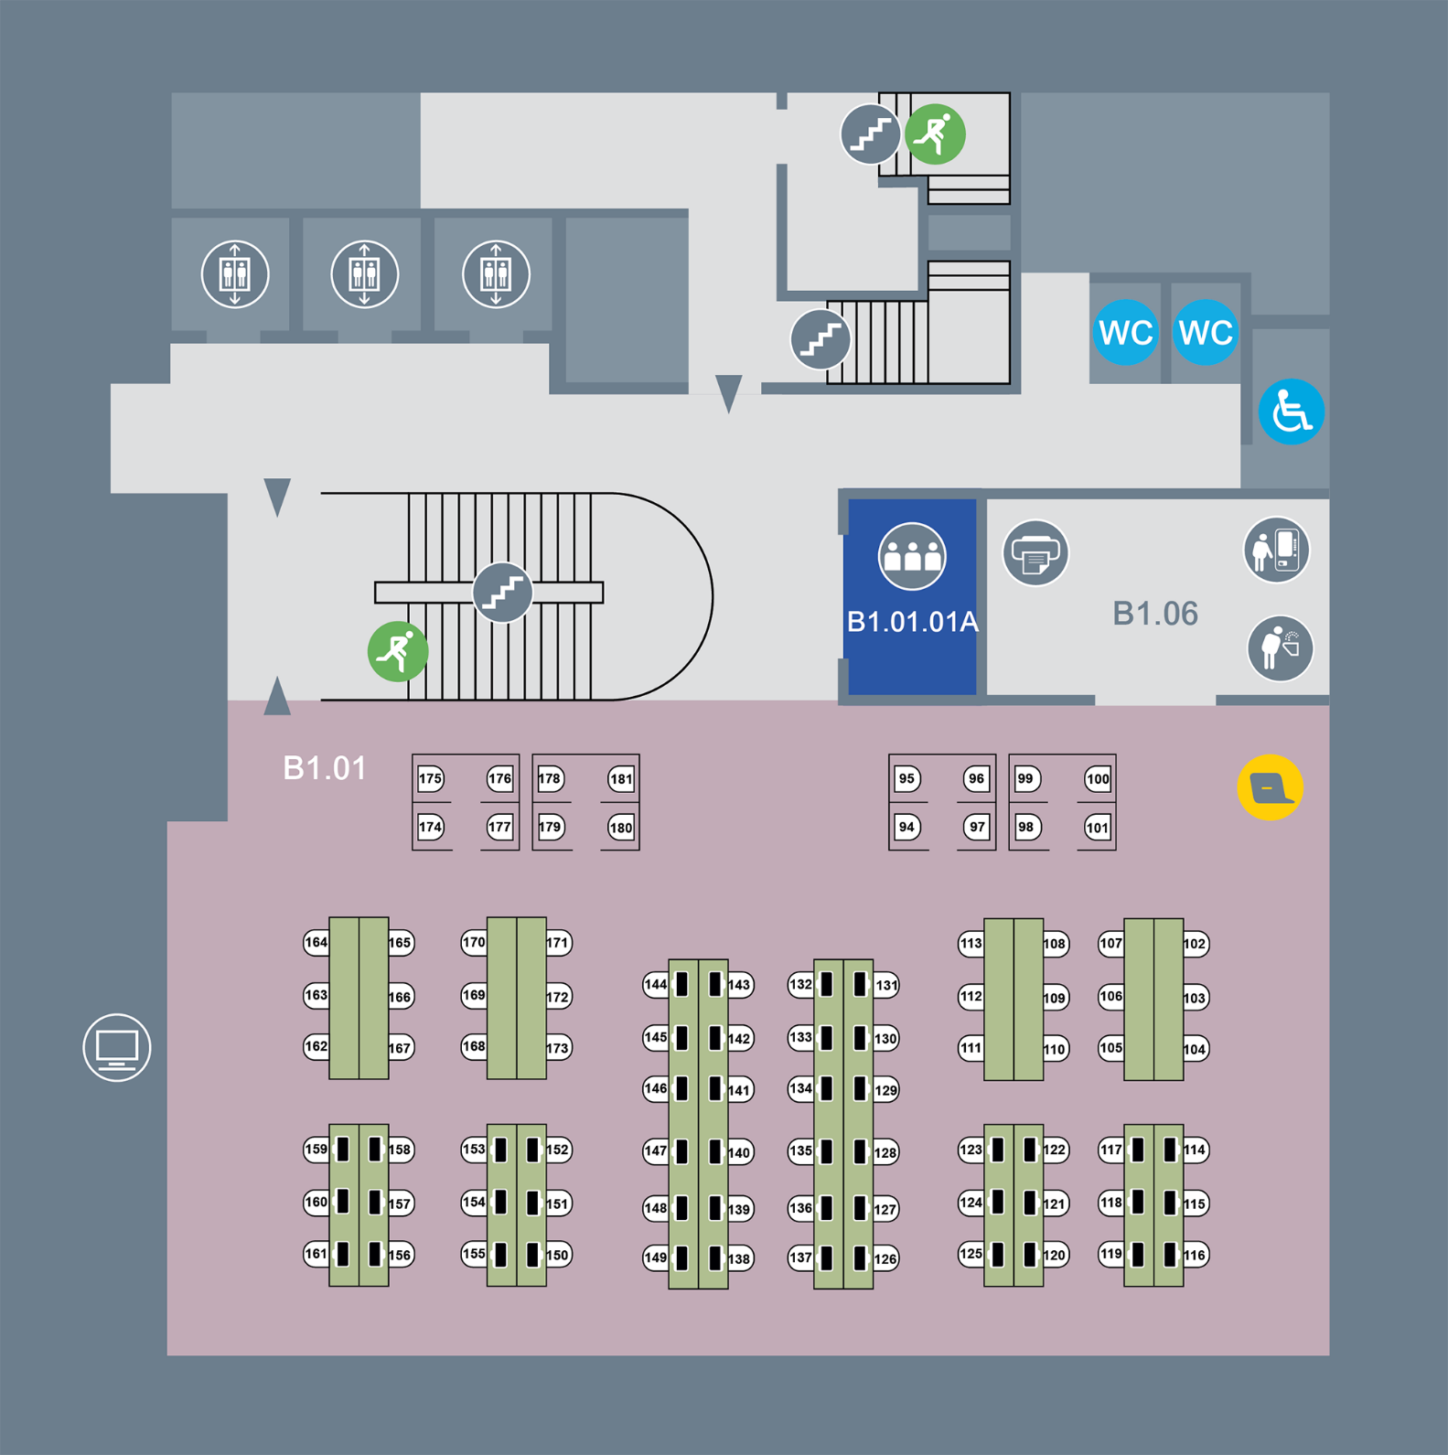

Level 0

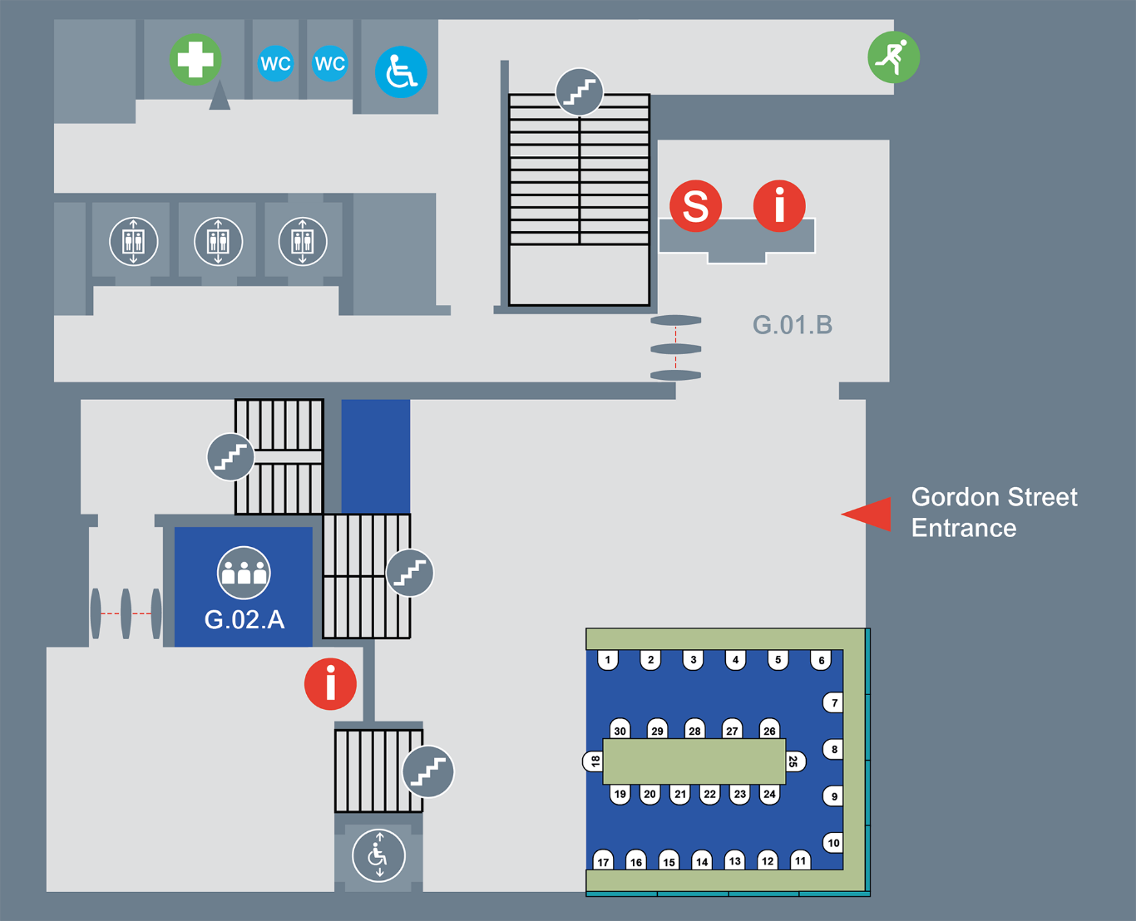

Level 0, mezzanine

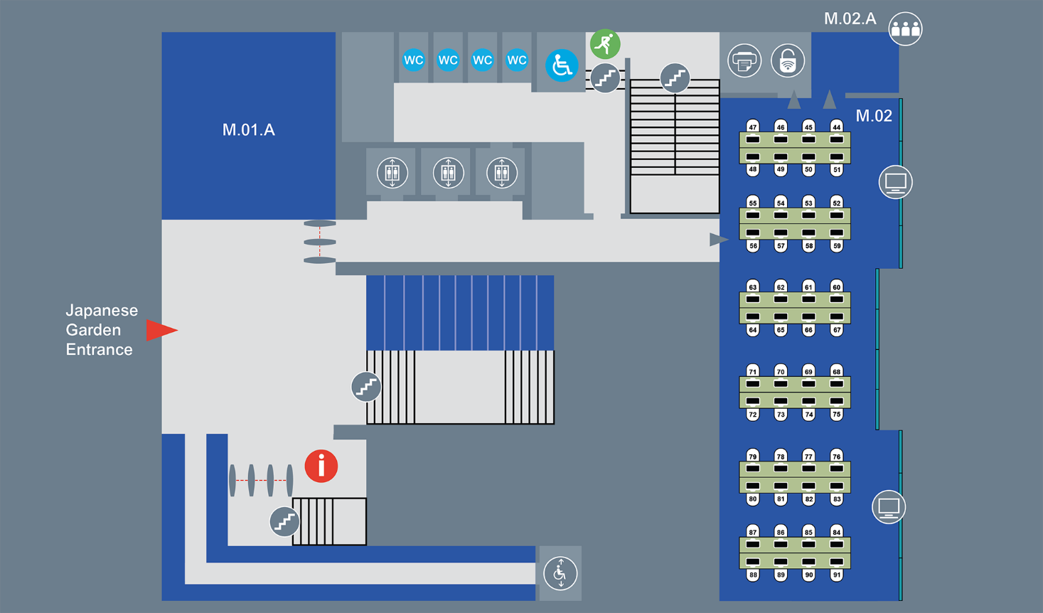

Level 1

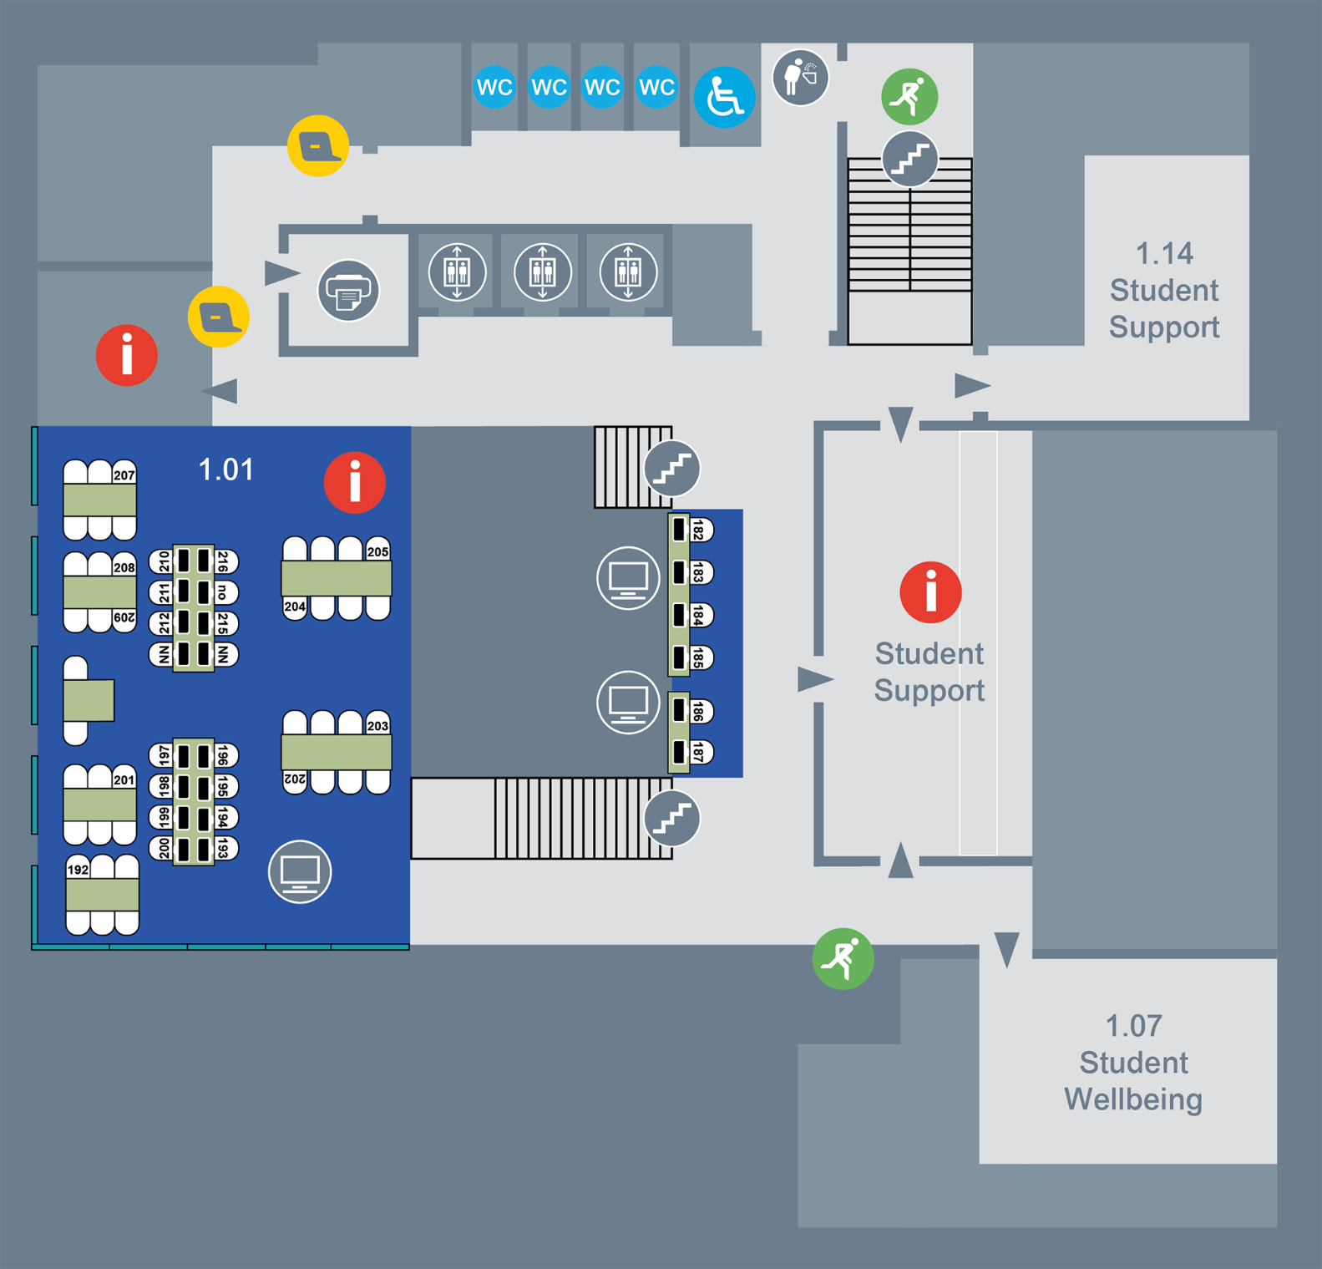

Level 2

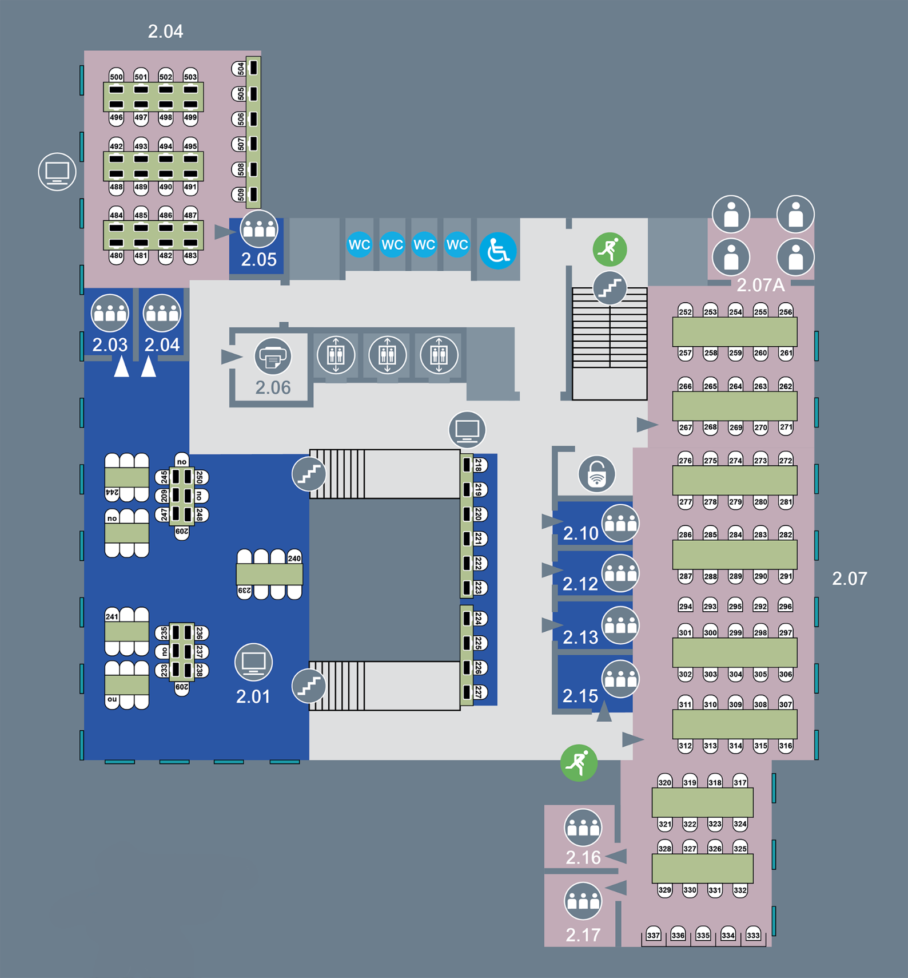

Level 3

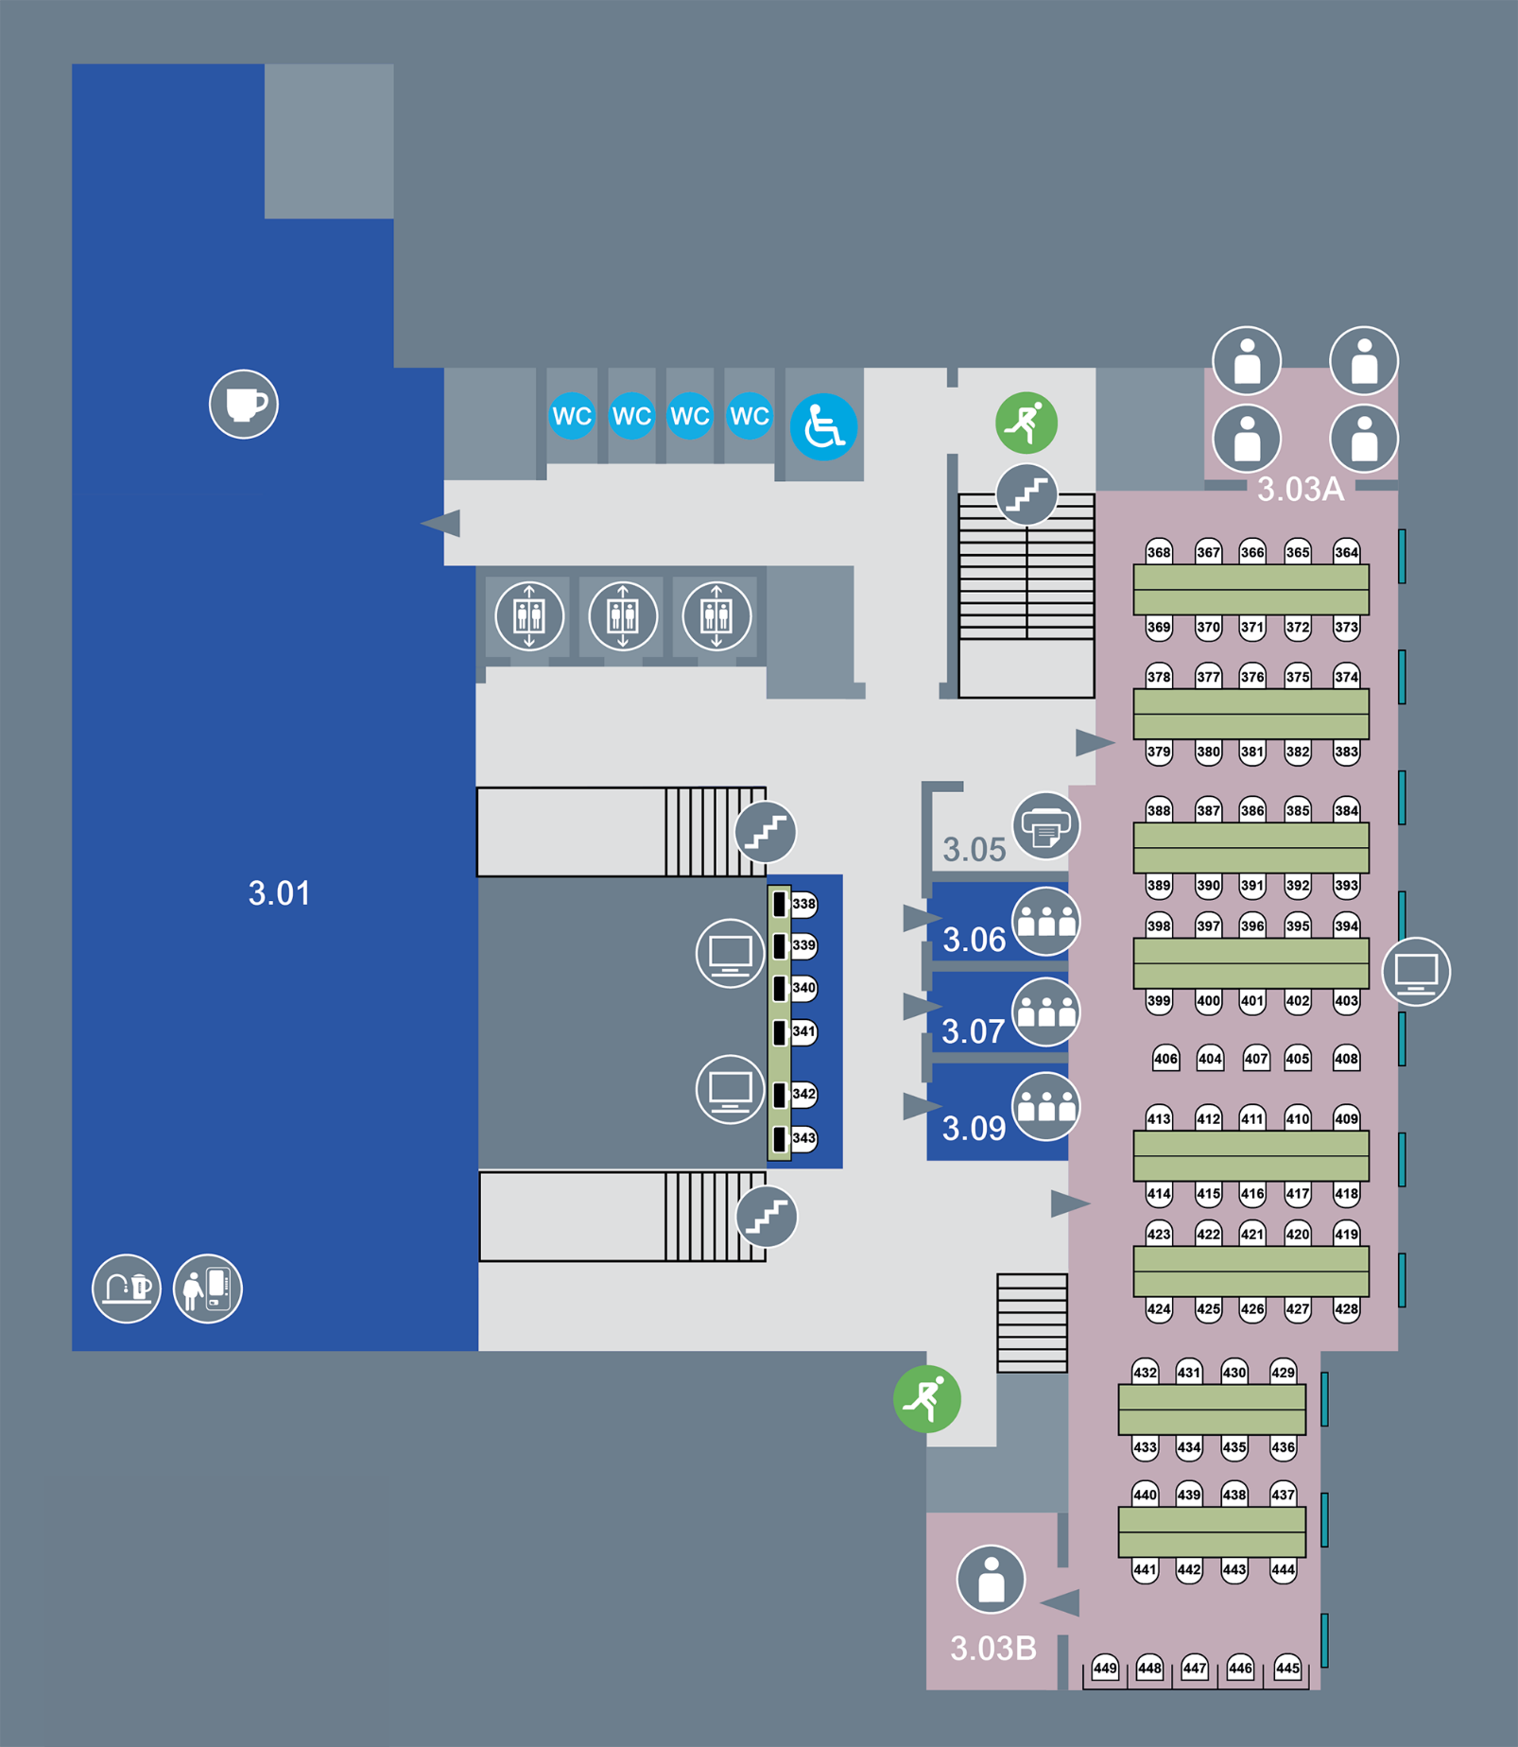

Level 4

