Science Library floor plan

Contents

* Legend
* Ground floor
  + Ground floor, mezzanine
* First floor
* Second floor
* Third floor
* Fourth floor

# Legend

Icons used throughout this guide:

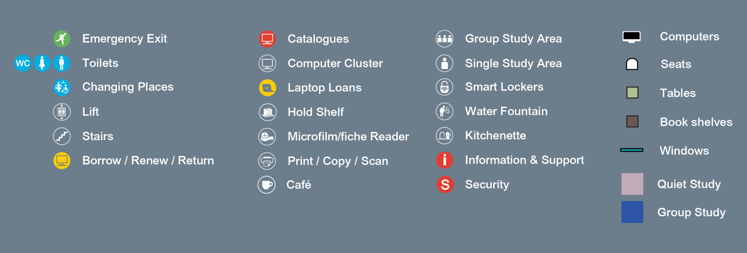

Ground floor

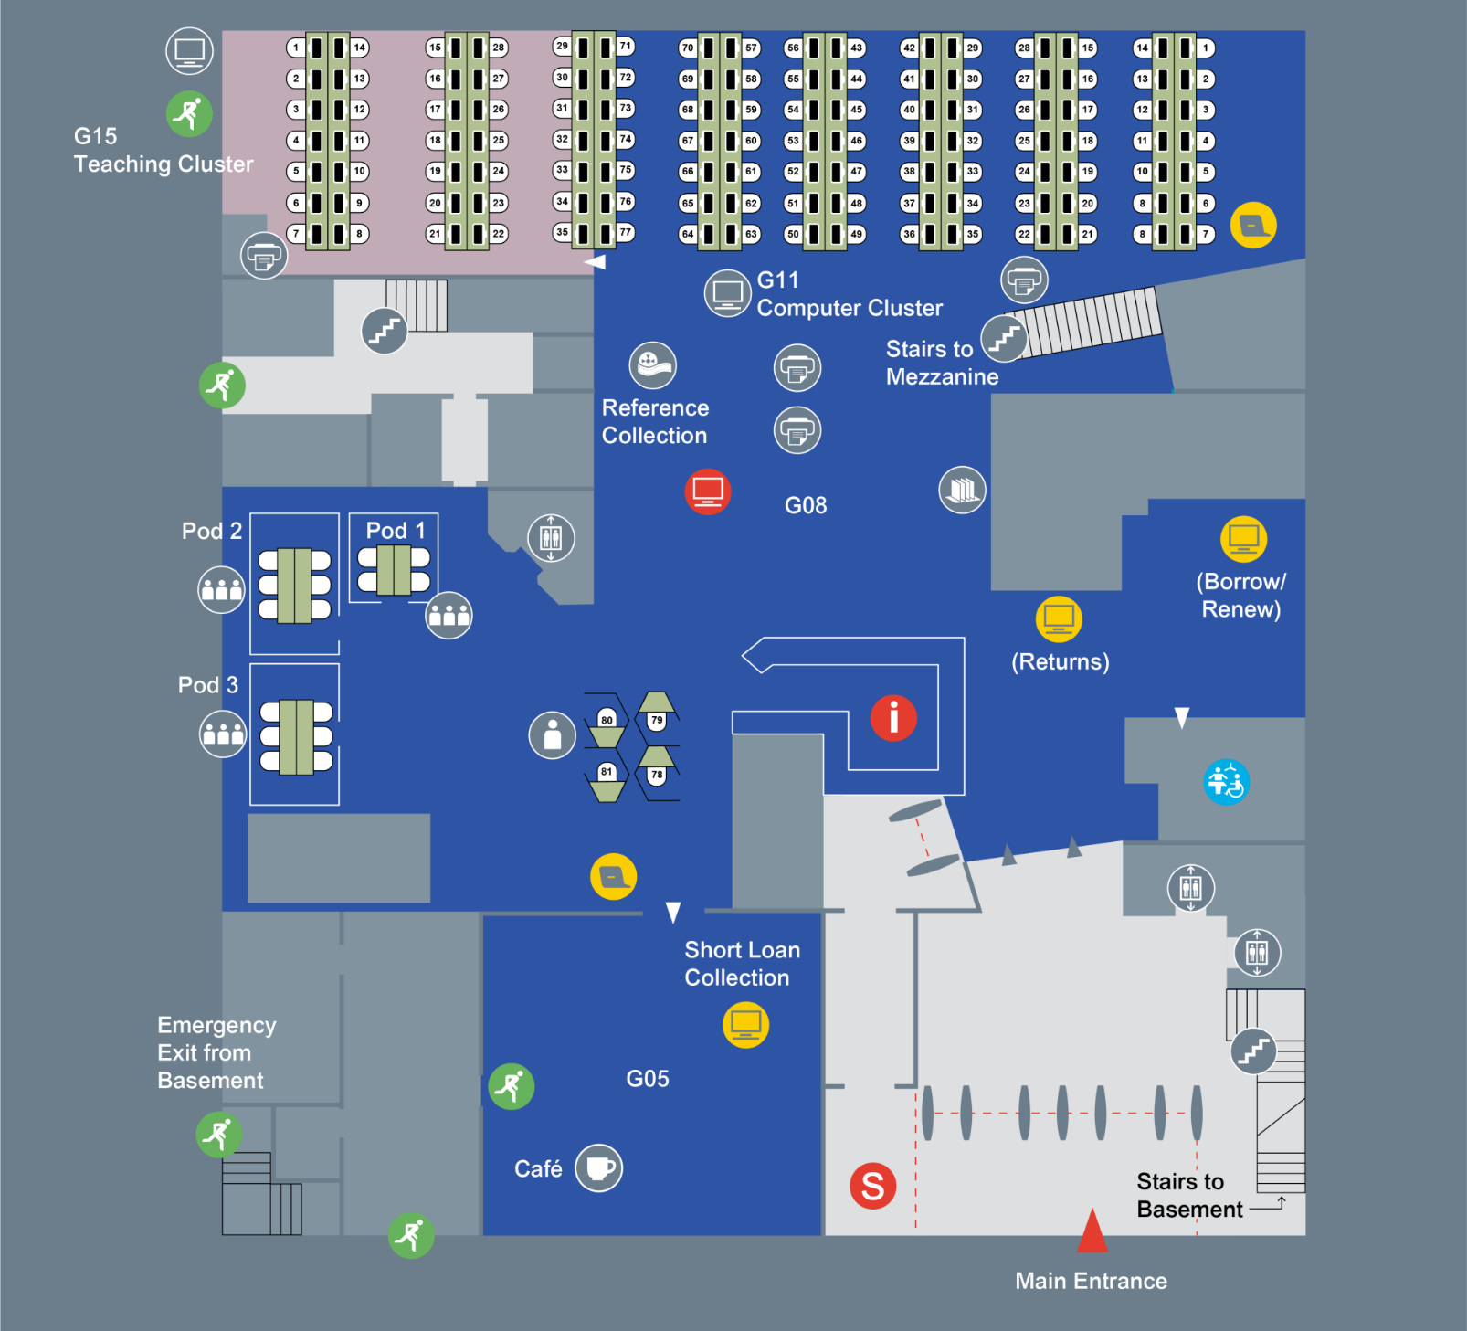

Ground floor, mezzanine

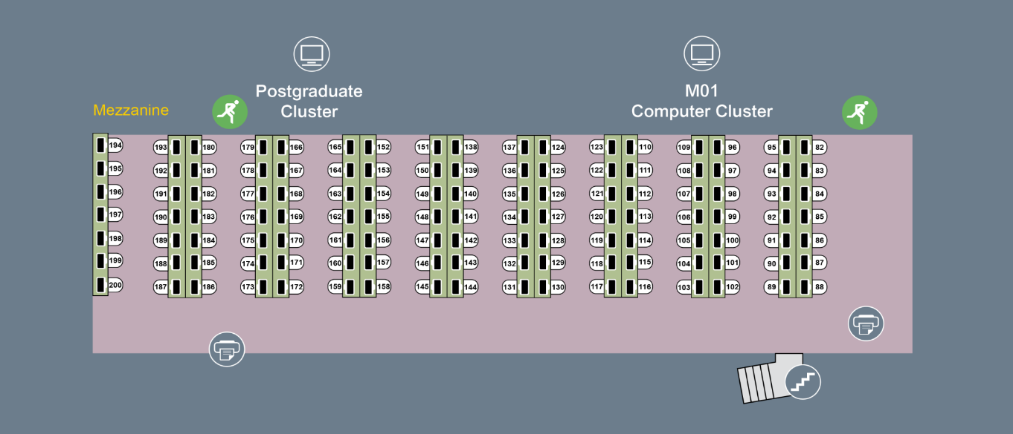

First floor

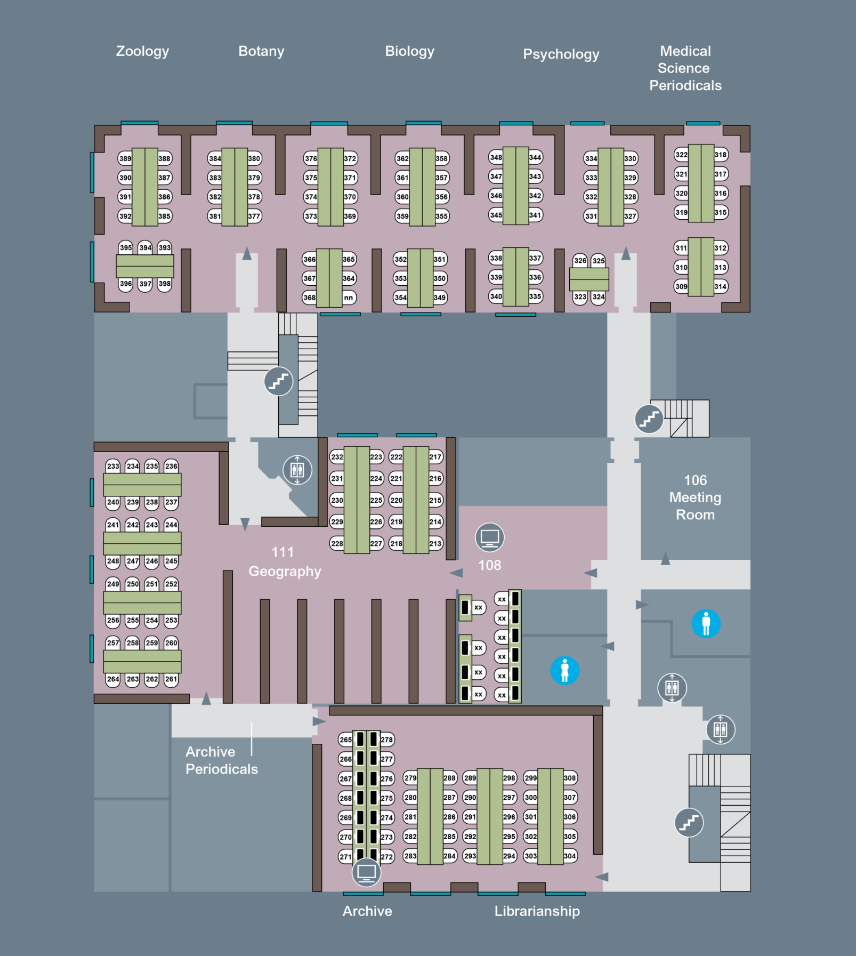

Second floor

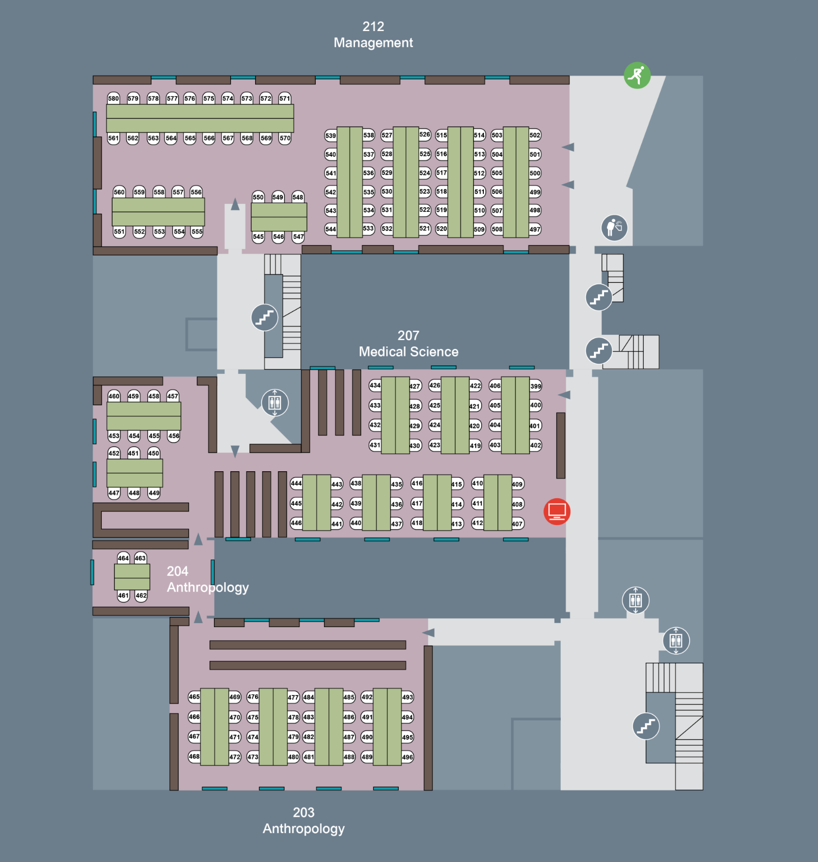

Third floor

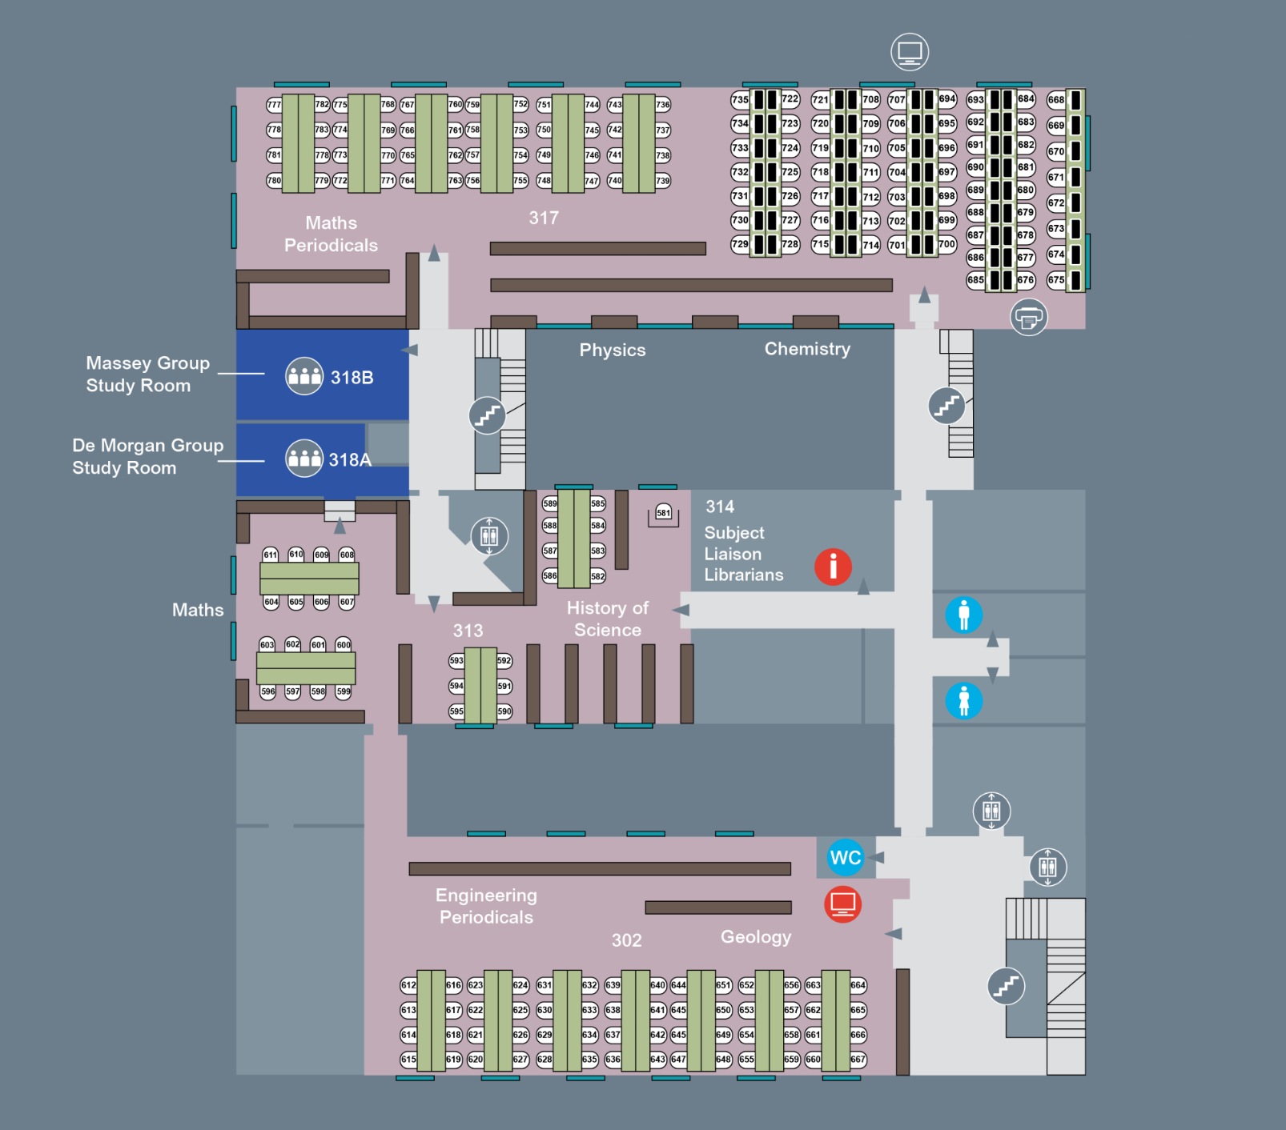

Fourth floor

