UCL Main Library floor plan

Contents
- Legend
- Donaldson reading room
- First floor, south
- Second floor, south
- Second floor, north

Legend
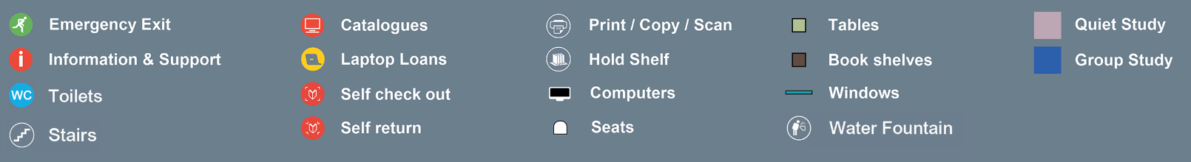

Donaldson reading room

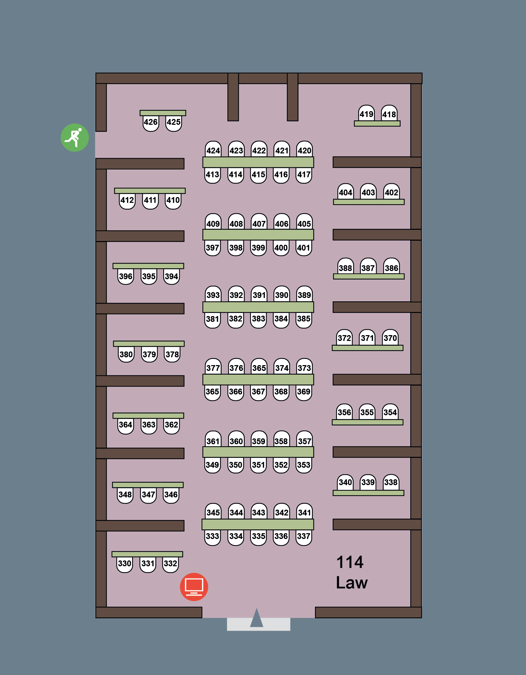

First floor, south
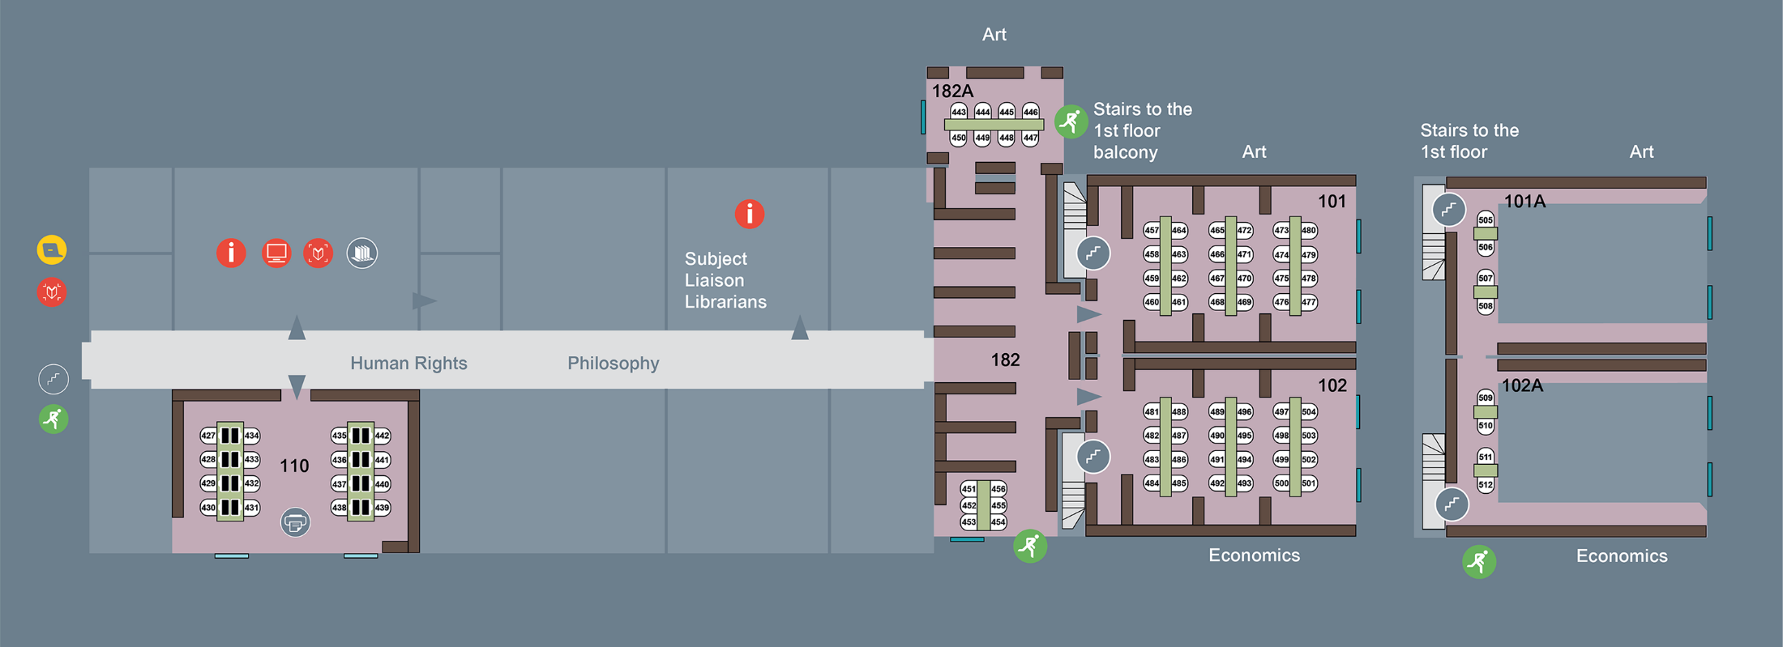

Second floor, south
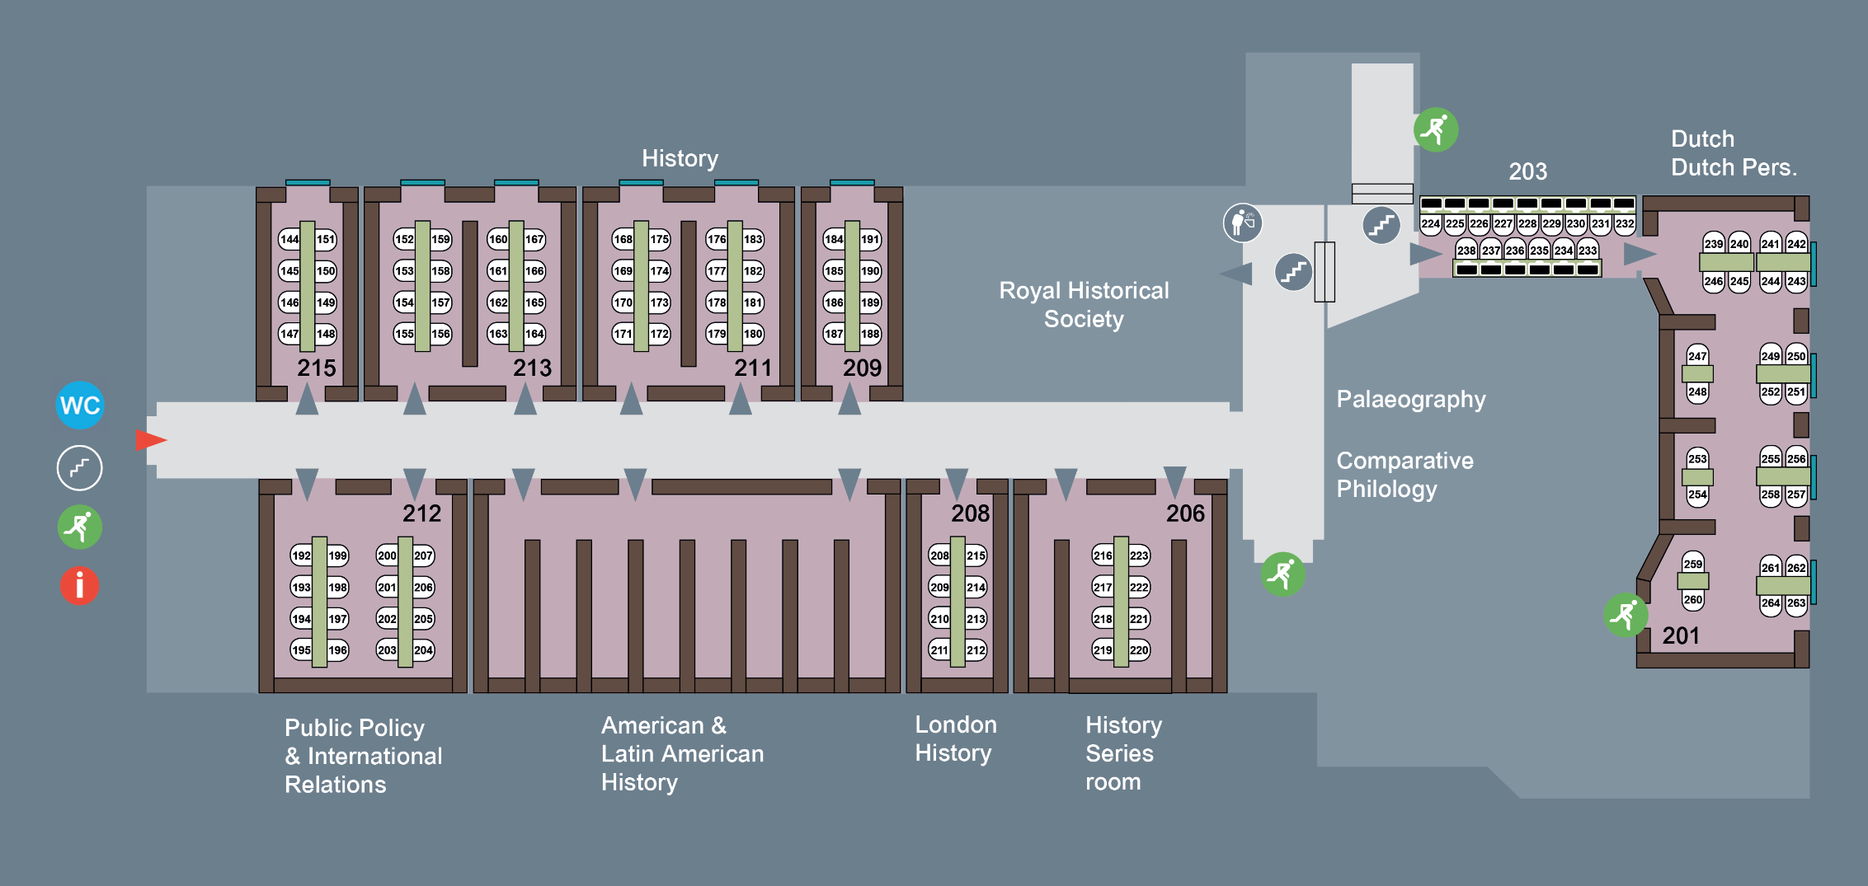

Second floor, north
