IOE Library floor plan

Contents

* Legend
* Level 3
* Level 4
* Level 5

Legend

Icons used throughout this guide:

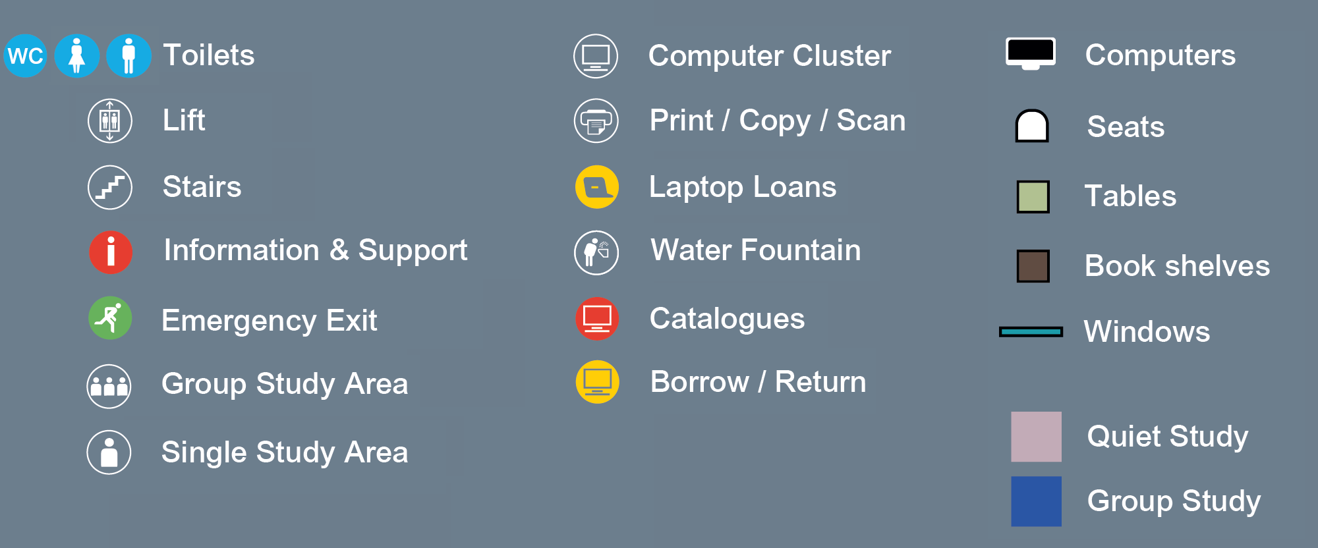

Level 3

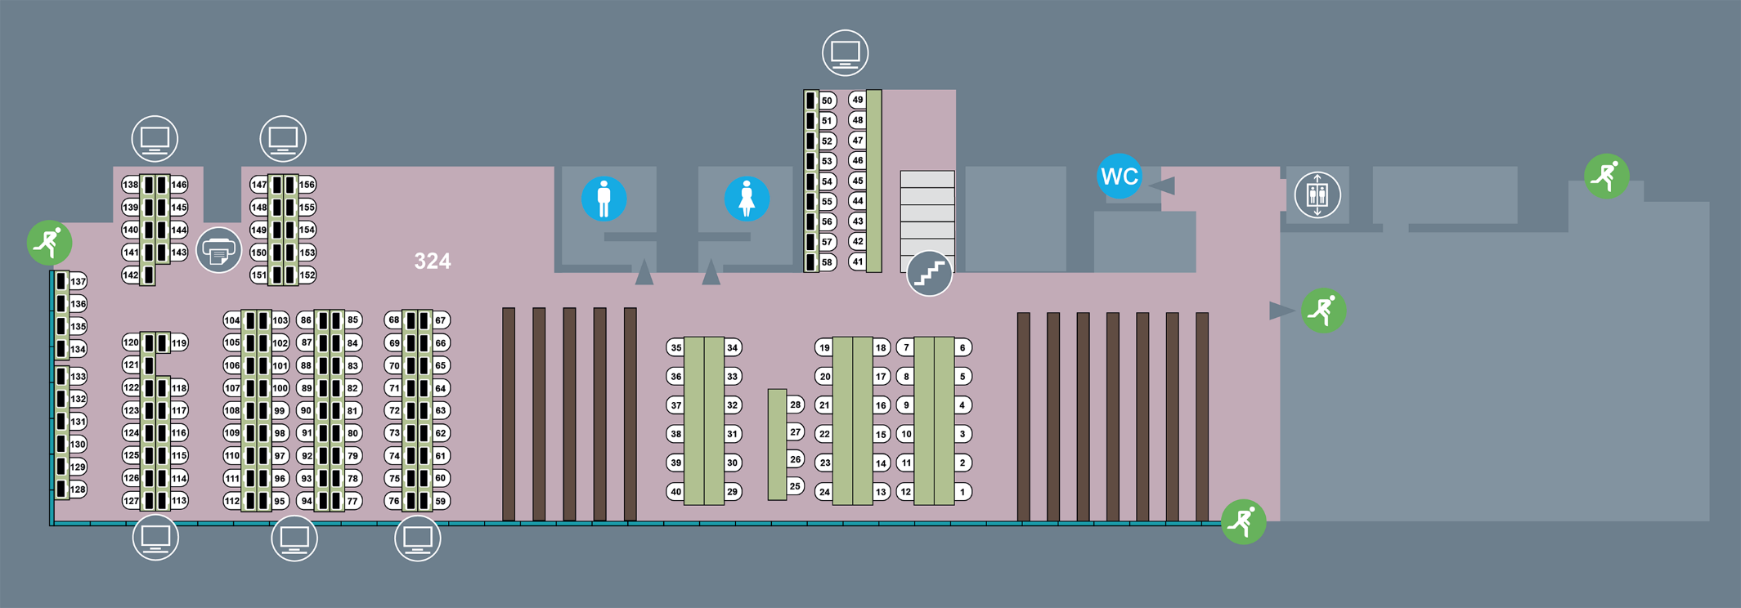

Level 4

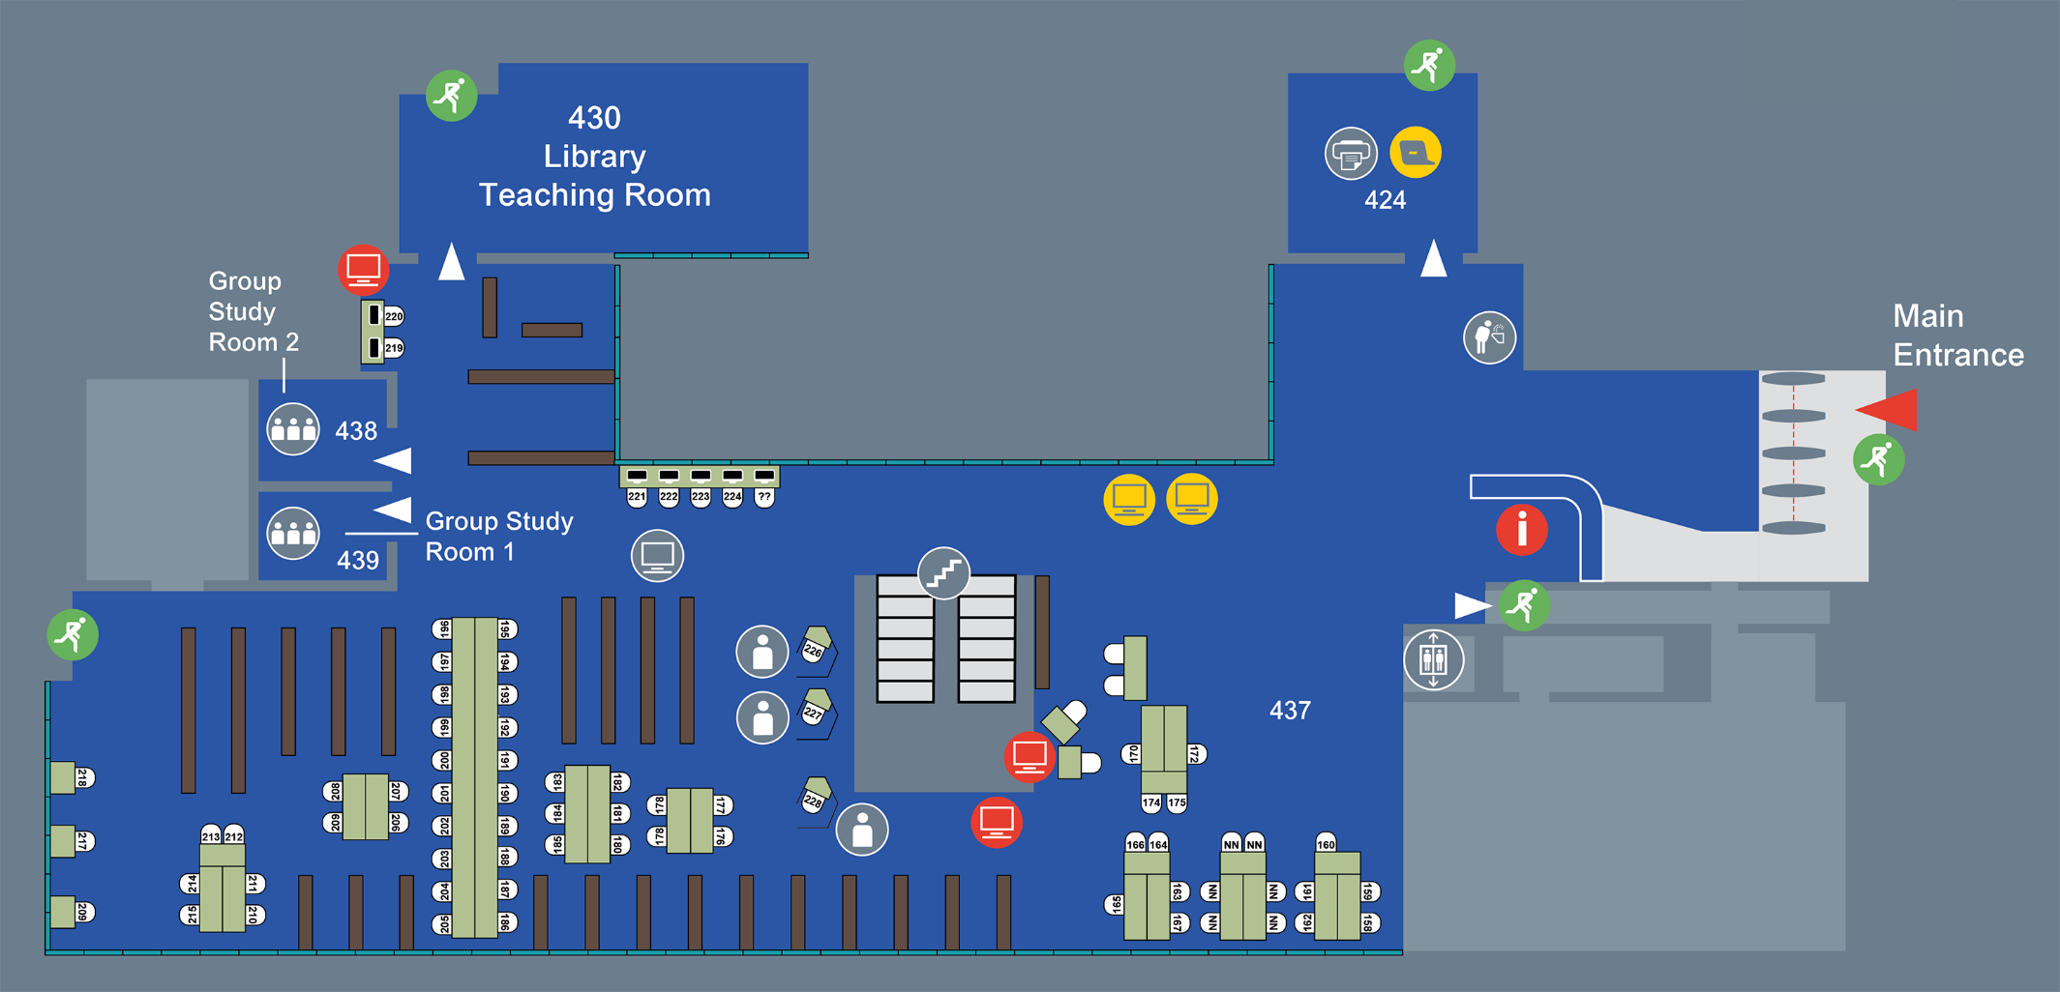

Level 5

