LAIDLAW SCHOLARS
SUMMER RESEARCH PROJECTS 2021

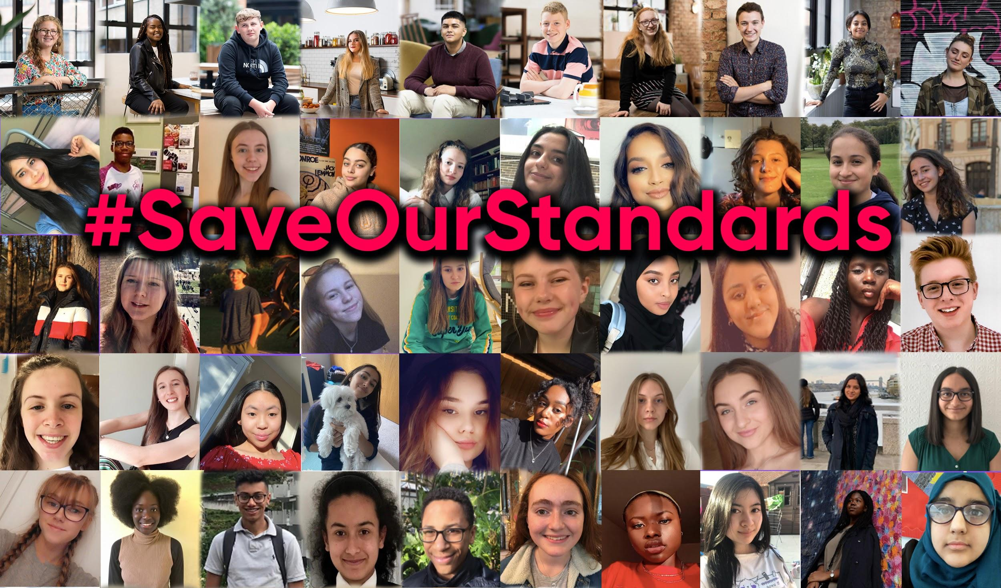

BACKGROUND

Bite Back 2030 is building a youth-led movement for a healthier, fairer food system. Our goal is to halve childhood obesity by 2030

Young people today are consuming too much unhealthy food, processed food, snacks, soft drinks and takeaways, and this is especially prevalent with young people from poorer backgrounds because unhealthy food is cheap and easy to access. 3.3m young people under the age of 18 have overweight or obese and rates among our poorest are double those of our wealthiest young people.

Covid-19 has only further served to highlight the injustices in the food system and sharpen the focus on the impact obesity has on health outcomes. There is a political moment now to accelerate change.

We believe young people are the key voice in driving this change in our food system. It is a really exciting time to join the organisation - we are still a start-up but with ambitious plans for growth and impact.

Co-founded by Jamie Oliver and launched in October 2019, our Youth Board have already led creative, high impact campaigns on a range of issues including Free School Meals, a 9pm watershed on junk food advertising and the upcoming Trade Deals. This summer, 77 new youth leaders joined our movement and we plan to recruit, train and support 1,000 young people over the next three years to deliver high impact national and local campaigns.

We are seeking a group of exceptional Laidlaw Scholars to help us research new issue areas, prepare future campaigns and review our strategy. You will be managed by our Policy and Research Manager, Nika Strukelj and you will collaborate with our small, agile team of 10 aiming to make a big impact on the streets, schools and screens where our young people live. We are impact and youth-led, using creative, content-led campaigns and coalitions to achieve our goals. You may also work directly with our amazing Youth Leaders

We are at the start of our 10-year journey so our campaigns also need to capture the public imagination and drive PR and media interest, as well as social media engagement so they contribute to building a movement. They can also leverage our team of celebrity Ambassadors to amplify the voice and impact of our young people.

We hope you’ll join us this summer! Let’s take a look at some of our campaigns to date...

#DontHideWhatsInside (January to March 2020)

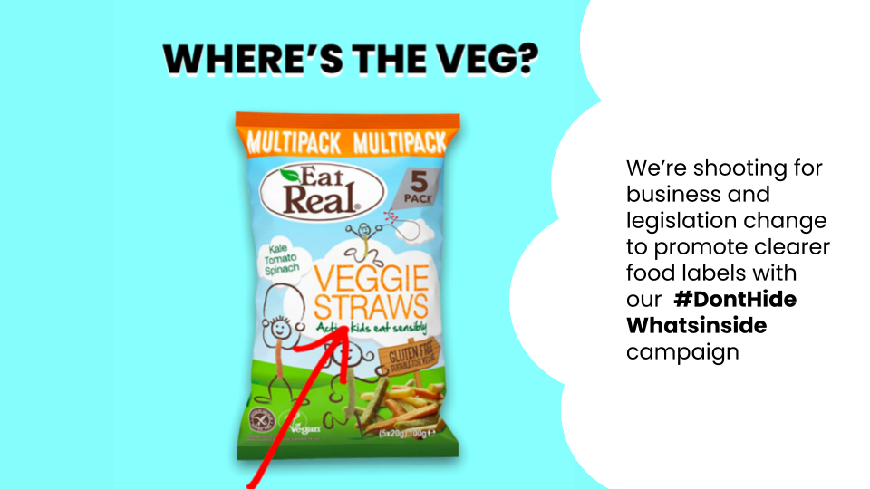

FSM Campaign (April to June 2020)

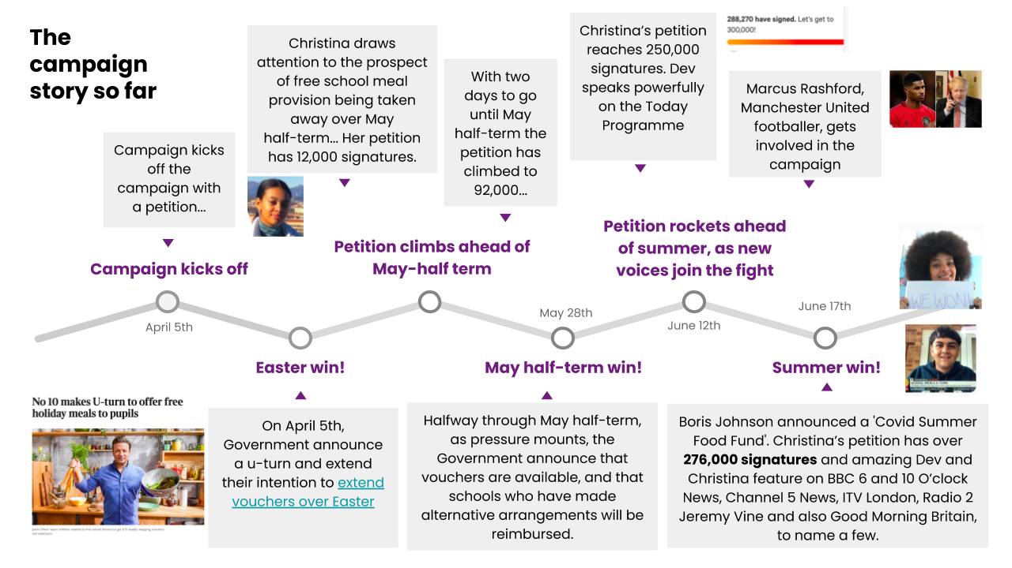

9pm Watershed Campaign to restrict Junk Food Advertising (June-July 2020)

- Tasha’s video viewed 40k times on twitter and shared with No10
- Joint open letter published in The Guardian
- Coalition with Obesity Health Alliance lobbying for change
- Government announced 9pm watershed in Obesity Plan in July

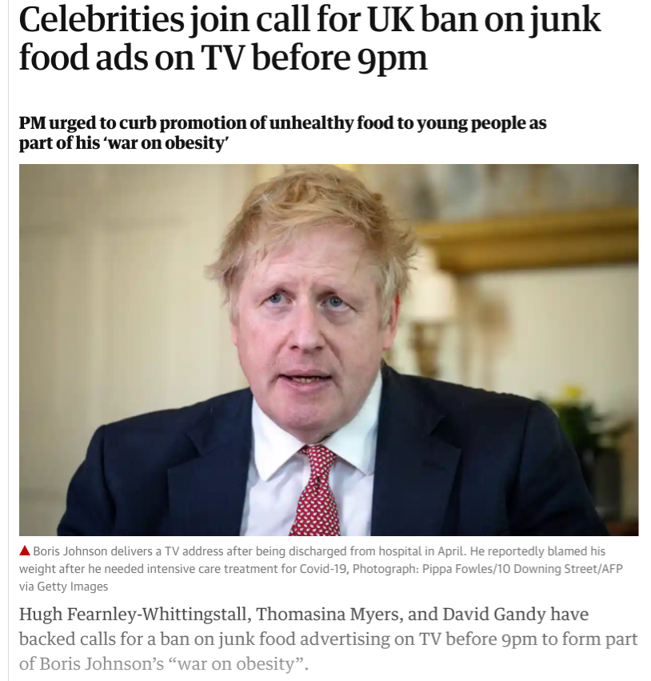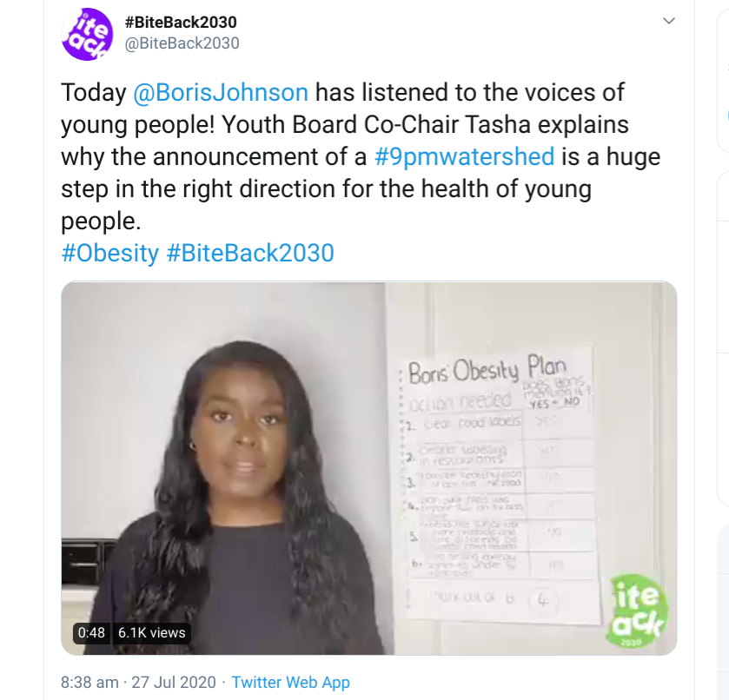

#SaveOurStandards Trade Deals Campaign (September-October 2020)

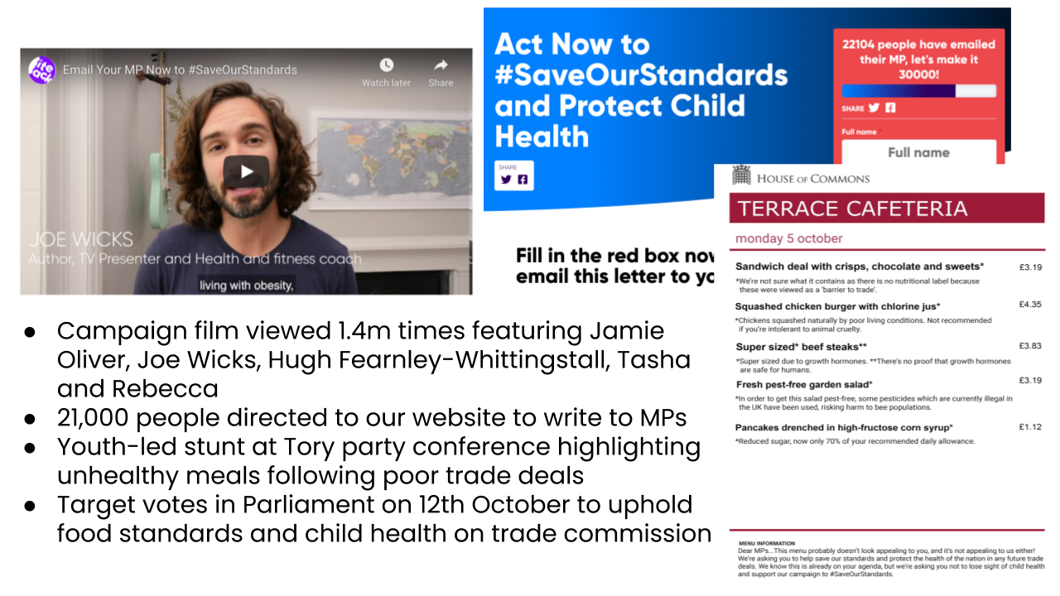

Projects and research disciplines

We have six exciting projects for you to get stuck into. The cover a variety of academic disciplines and all will directly inform our strategy and campaigns for the future.

Below is a brief description of each project, which research fields we think it could be best suited to and what support we can offer. You will work directly with the relevant team at Bite Back 2030 and all projects will be co-ordinated by Sara Zarkovic who supports our Youth Board.

- Local area health mapping: we know our unhealthiest high streets are very often our poorest. But do we really know what they look like? Do we know what its like living there and the options young people walking those streets have? We want to understand the health of our five unhealthiest high streets and the people that live there. Can we map the health of an area through advertising, takeaways, food outlets near schools; can we interview young people in places where they hang out in local communities to develop a plan of how an area could become healthier; can we find a way to bring this lived reality to life for decision makers and public health officials so they make different policy choices? Can you communicate this in a creative way through Google maps, filming high streets, developing an app.
  - Research disciplines: Geography, computer and data science, sociology, public health.
  - Support: We can connect you to leading organisations such as Royal Society of Public Health with data sets in this area, introduce you to Local Authority Public Health teams and provide access to mapping and presentation software to map the High Streets.
  - Team: Policy and Research, Campaigns.

- Water campaign development: support Bite Back 2030 to develop campaigns on major campaign priorities in 2021. Away from convenience stores and offers on fizzy drinks, 50% of young people started drinking more tap water under lockdown. They want it to continue. It’s healthy, sustainable and free. But how do we do it? Water fountains are unattractive, not every young person has a water bottle (is it cool?), and all the marketing pours into energy drinks, soft drinks and fruit juices. How do we shift the system to make water the go to drink for young people?
  - Research disciplines: Design, art, marketing, communications, market research, consumer behaviour.
  - Support: We can connect you to NGOs (Refill, Sustain) and drinks companies to understand water consumption and drivers, access to design software and creative/brainstorming processes to create campaign designs and briefs. Potential to access budget and designers/videographers and editors to make film/creative depending on quality. Access Bite Back’s youth leaders for research.
  - Team: Creative, campaigns.

- Sports sponsorship campaign development: support Bite Back 2030 to develop campaigns on major campaign priorities in 2021. Delayed by a year 2021 will see the Tokyo Olympics. Its main sponsor...Coca Cola and McDonalds. Any idea who the main sponsor was for the 1964 Tokyo Olympics...big tobacco. Think about how our attitudes have changed about tobacco. Is it right our main sponsors for the biggest showcase in world sport are fast food? How do we start a campaign to stop this? 2022 is the Commonwealth Games in Birmingham. Could this be the first healthy games?
  - Research disciplines: Design, art, marketing, communications, market research, consumer behaviour.
  - Support: We can connect you to NGOs and drinks companies to understand water consumption and drivers, access to design software and creative/brainstorming processes to create campaign designs and briefs. Potential to access budget and designers/videographers and editors to make film/creative depending on quality.
  - Team: Creative, campaigns.

- Policy development: Fiscal reform: the Sugar Tax introduced in 2018 has been phenomenally successful. It has driven down sugar in drinks by 28% and generated revenue for school sport. What should be the next wave of incentives, taxes and subsidies to drive healthier food production and consumption? You will build financial models on the impact of potential policies and conduct political analysis to understand how it can be developed into policy and political messages. It ties into sustainability too - there’s been talk of red meat taxes - and health such as a saturated fat tax or salt tax. Help us define how HM Treasury should shift the food market and consumer demand.
  - Research disciplines: Economics, maths, politics, sociology, business.
  - Support: We can share existing research on fiscal subsidies and taxes from around the world and connect you to experts in food industry, NGOs and Public Health England who have data on Sugar tax and done modelling on fiscal subsidies. We can host roundtables with policy makers and think tanks to gauge political messaging and positioning. We could also conduct some polling or organise focus groups.
  - Team: Policy and research, campaigns.

- Youth movements/Bite Back 2030 review: this is a research project looking at digital mobilisation and organising models for activism that will define Bite Back 2030’s strategy. Youth activism and youth-led movements are growing around the world. Fridays for our Future, the A Level marches, the Sunrise Movement. Can you interview young people engaging with Bite Back 2030 to understand our model, find out what is effective, research global organising models like XR and then propose changes to the Bite Back 2030 model to improve it.
  - Research disciplines: Data science, sociology, organisation development, behaviour science and marketing, digital community building, social media and web analytics.
  - Support: You will have access to all the data on Bite Back 2030’s current platforms and channels, introduction to other leading youth movements and models such as Global Citizen, connections to social media platforms and analytics tools.
  - Team: Mobilisation, youth insights, social media.

- Re-framing and youth insights 2.0: when Bite Back 2030 launched, we aimed to communicate our issue differently. We started with three insights that would engage young people in a healthier food system. They were food and sustainability i.e. future of the planet, food and injustice e.g. Rashford’s food poverty campaign, and food and manipulation i.e. how fast food create ads to manipulate young people into buying their products. We want to undertake the next phase of research into youth insights to understand key issues related to young people and the Bite Back 2030 mission and go deeper into what drives their behaviours e.g. why do young people hang out in chicken shops or not eat school food. We can then use this to look at how the youth insights align to our impact goals and shape campaigns and communications. We know major issues like food and sustainability, the connection between race, poverty and obesity are mental health and eating disorders are key. We now want to evolve our narrative and messages for the next phase of growth to reach more audiences.
  - Research disciplines: Research, marketing, communications, sociology.
  - Support: You will have a budget to run surveys and focus groups with access to Bite Back’s youth leaders and other youth groups, you will conduct policy and social analysis to understand key themes as well as test new messaging, studying responses to key messages.
  - Team: Communications.

Application criteria

To apply, please submit a research proposal of no more than 2-pages covering the following questions:

- Project area: which of the six project areas you want to address (1-6)
- Research aims: what you hope the research will show
- Approach: how will you approach the support
- Communication approach: how will you share the findings with our key audiences
- Support: what support you will need to complete the project
- You: why you are motivated by this project and what you hope to learn

We are looking for the following:

- Leadership: Exceptional strategic insight and judgement, knowing how to make things happen and win over key stakeholders;
- Research excellence: high quality and interesting or novel research approaches with real rigour that can generate new findings;
- Creative flair: everything we do needs to resonate with young people so always having an eye on how this will appeal and connect is key;
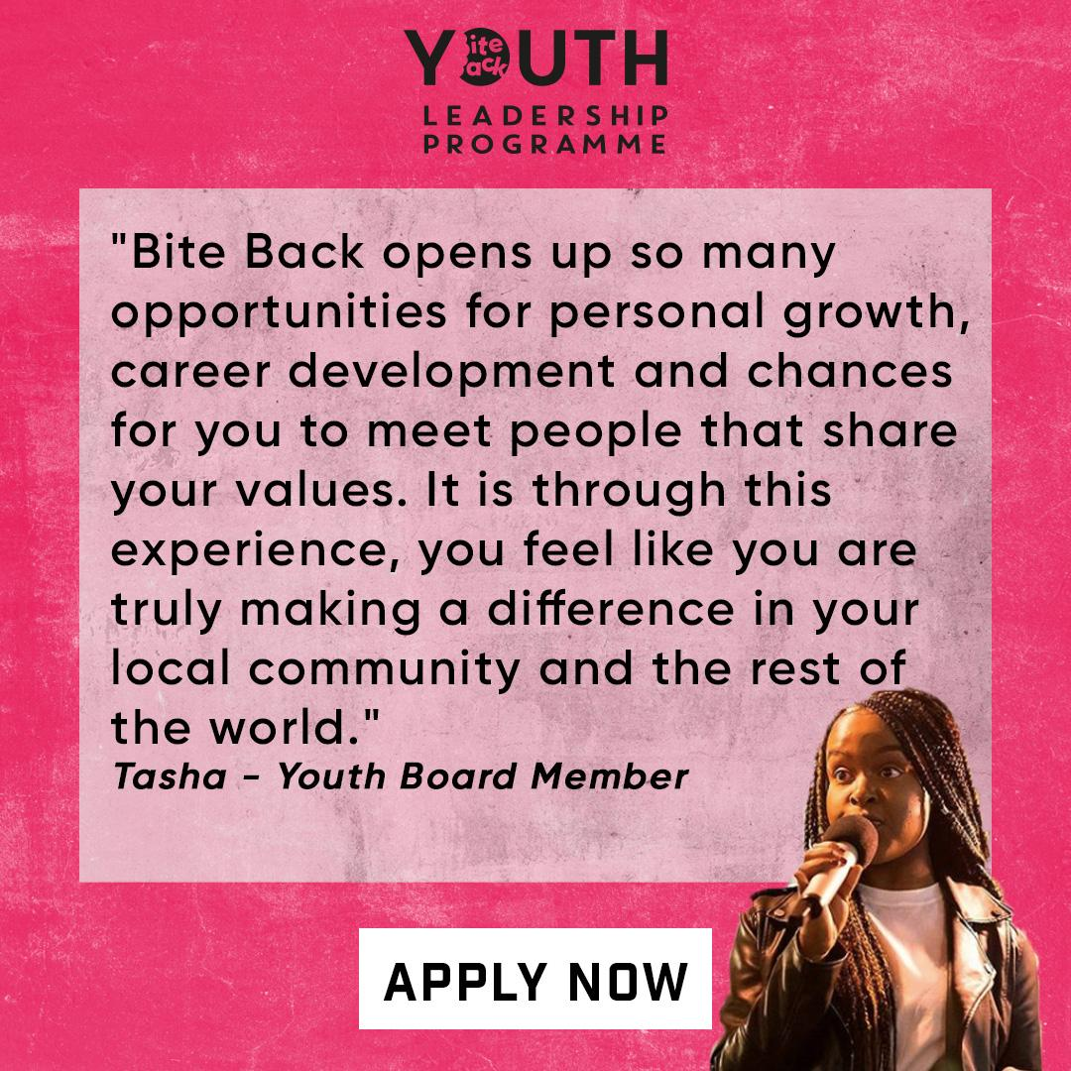
- High ambition, low ego: we are here for our young people to support their development and impact, not personal notoriety;
- Entrepreneurial energy and grit; we are a builders and a doers who enjoy proving people wrong;
- Clear and persuasive communicator.
- A great listener, eager to learn from others and nurture relationships.
- Enjoys working in and building small, flexible teams Organised, action-oriented and results-driven
- Passion for young people’s health, nutrition and social justice

Further information

You can find our more at www.biteback2030.com Please contact Sara Zarkovic sara.zarkovic@biteback2030.com for any more information and to submit your application.

