Joint Research Office

RESEARCH RECORDS TRANSFER FORM

INSTRUCTIONS
- Please contact the UCL Records Office (records.office@ucl.ac.uk) to request boxes first. Boxes not supplied by the UCL Records Office will not be accepted. Box dimensions are as follows 360mm (L) x 140mm (H) x 255mm (W). Please stipulate:
- Number of boxes required
- Location boxes should be delivered to
- Once you have the boxes write a temporary running order (in pencil only) on the front of each box (1,2,3). Do not write or stick anything else on the boxes
- Put the records in the boxes. Remove papers from bulky ring-binders and lever arch files as these take up space. Do not place additional boxes (e.g. magazine files) inside the boxes.
- List the box number, and contents of that box on this form as shown below. Ensure you complete the form in Microsoft Word format and email as an attachment to randd@uclh.nhs.uk.
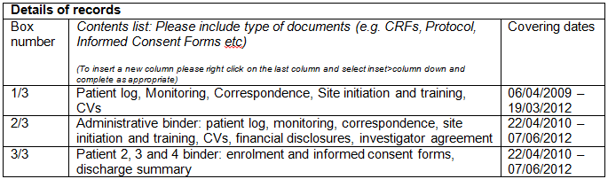
- The boxes will be registered in Records Office System (ROS) by the Joint Research Office and you will be provided with a receipt to put in the box and a unique reference number which will have to be written on the box. One UCL ROS output form per box needs to be included.
- JRO will then arrange collection of the box for storage.

PLEASE NOTE
- Only the Investigator Site File (ISF) and Case Report Forms (CRFs) should be transferred offsite. Under no circumstances should patient notes/medical records or other source documents leave UCLH.
- Please ensure the ISF contains all records stipulated by the study sponsor as per their SOP. In the absence of a sponsor SOP for the Site File please use the UCLH SOP 8 for Essential Documents and the Study File (TMF/ISF).

YOUR DETAILS
Details of depositor
Name of person transferring records
Job Title (e.g. Research Nurse, Data Manager)
Email and telephone number

Details of transfer
Number of boxes
Date form completed
Location to be collected from (please be as specific as possible)

Study details
R&D number
Short title
Full title of study
P.I. name
Sponsor name

Details of records in each box
Box number | Contents list: Please include type of documents (e.g. CRFs, Protocol, Informed Consent Forms etc.)  (To insert a new column please right click on the last column and select inset>column down and complete as appropriate) | Covering dates

(For JRO use ONLY)
------------------------------------------------------------------------------------------------------------------------------------------------------------------------
Short Ref | Box number | R&D No | JRO Ref Number | Archive End Date | ROS Archive Ref Number (This reference will have to be written on the box)

