Hypothesis testing crime analysis
Author: Spencer Chainey
Date: January 2014

Summary brief
Purpose and theory
Hypothesis testing is the first step in the scientific method. It involves posing a true (or false) statement that explains a phenomenon. In science, hypothesis testing is fundamental to the process of developing knowledge.

As the intelligence-led paradigm in policing has developed, with it has been the introduction of management models that aim to improve the production and use of analysis (e.g. the UK’s National Intelligence Model). In practice this has though often led to a procedural production of intelligence products, with content based on standardised templates, which in turn has limited creativity in the analysis process. This can lead to many analysis products only being descriptive in content and offering general findings that many are already aware of. It can also lead to a tendency towards presenting reports with lots of facts and figures, but that are weak in explanatory substance.

Method
In recognising these issues, a hypothesis testing approach to crime analysis has been proposed. This involves the key stakeholders of the crime problem that is under focus (e.g. patrolling officers and the managers of these frontline patrols, community safety officers and other relevant partners) to state their opinions on why they think the crime problem exists. In essence, these opinions are hypotheses. Everyone may not agree with the opinion that a stakeholder may offer, but by testing each hypotheses will determine if there is evidence to support these opinions. This then means that by framing the direction and content of the analysis by testing hypotheses, the findings result in coming to some evidential conclusions that help explain the presence of the crime problem. Practice also suggests that this process improves the commissioning of analysis products and a better dialog between analysts with frontline officers and decision-makers because the process encourages discussion.

Case studies
Since its introduction in 2011 and to date (2014), the hypothesis testing crime analysis approach has been applied to a wide range of crime and community safety issues. This has included theft from vehicles, youth cannabis use, burglary against students, calls for service from mental health hospitals, street violence, anti-social behaviour in town centres, street prostitution, mobile phone theft, metal theft, drug dealing, youth anti-social behaviour on a housing estate, motorbike disorder, cycling casualties and bike theft.

An example of the hypothesis testing crime analysis approach is illustrated in this brief for burglary dwelling. This included testing whether the increase in burglary was due to an increase in the number of prolific burglars operating in an area due to their recent release from prison. Other Crime Briefs (soon to be published) also illustrate the hypothesis testing crime analysis approach for problematic street drinkers, mobile phone theft and night-time economy violence.

Purpose and theory
In the last twenty years, the growth of the intelligence-led paradigm in policing has placed a greater emphasis on the need to conduct analysis. The gathering of information and its interpretation is a key principle that underpins intelligence-led policing, be it for supporting the daily tactical and operational targeting of police patrols, assisting an investigation, or for identifying persistent issues that require a strategic response. The generation of good quality analysis is also at the heart of the problem-oriented policing approach introduced by Herman Goldstein in the 1990s.

The production of analysis has been formalised in several countries with the introduction of more routinised management processes. For example, the adoption of police management frameworks such as the UK’s National Intelligence Model (NIM) are designed to better integrate analysis and intelligence into the core of all police business and decision making (Ratcliffe, 2008). These formal, systematic processes have resulted in the creation of a more standardised approach to analysis report production. In UK NIM terms this includes problem profiles - analytical products that aim to help better understand particular crime problems.

With this increasing demand for analysis and the subsequent standardisation of intelligence products has come the production of templates that aim to determine a consistent structure and content to these materials. Over time, the routine production of these analytical materials has led to many reports being constrained in their analytical creativity, most often only providing a general descriptive narrative of a crime or public safety problem (providing interesting facts and figures on who, what, where, when and how), rather than understanding why the problem exists or has recently emerged.

The hypothesis testing crime analysis approach is designed to help improve the explanatory content of analytical products such as problem profiles. It is based on the principle of identifying a number of plausible reasons for the crime problem (i.e. hypotheses) and using these to frame the direction and content of the analysis. Testing the hypotheses firmly focuses the analysis on determining ‘why’ the problem exists, drawing from techniques analysts would use for exploring who, what, where, when and how. For example, a reason/hypothesis to explain why burglary has increased in an area is “it’s because we have had an increase in burglars, due to an increase in the number of former prolific burglars recently being let out of prison into our area”. This hypotheses can then be tested by determining (using the intelligence available) who has recently been released from prison, where they live, have they committed any burglaries since their release, and if so where have these offences been committed. This will help conclude if the offending of these former prolific burglars is responsible for the entire increase in burglary, part of the increase, or not at all.

The process of deciding on hypotheses is also designed to help improve the commissioning of analysis products. That is, it encourages a better dialog to occur between the person requesting the analysis and the analyst.

Method
Hypothesis testing is an approach routinely applied in science to help establish knowledge. It requires a true (or false) statement to be posed that offers a plausible explanation for the phenomenon. Testing hypotheses results in coming to conclusions. The use of hypothesis testing for crime analysis is for the purpose of helping to better understand (and evidence) why the crime problem exists. The process also identifies the data that are required.

The production of analysis using the hypothesis testing approach involves four stages:
- An overview of the problem
- Deciding on hypotheses
- Analysis
- Conclusions and response recommendations

Stage 1 – The Overview: the overview involves clearly defining the crime problem. It should determine the magnitude and scale of the problem, trends, and any specific information that helps more clearly identify what the problem involves. The overview should be concise (i.e. a maximum of three pages in length), but should provide enough detail for stage 2: deciding on hypotheses.

Stage 2 – Deciding on Hypotheses: in this second stage, the key stakeholders of the problem should review the overview, provide additional information to support the overview, and determine reasons for why they think the problem exists. The key stakeholders are those officers who have an interest in the problem, and/or are in positions of responsibility to potentially do something about it. Ideally, these key stakeholders should come from a number of different local agencies. This helps to ensure a better balance on the reasons why the problem exists and helps gain partner agency buy-in for any responses that are decided later on in the process. It is the role of the analyst to collate the hypotheses and determine with the key stakeholders the hypotheses that should be tested. To produce a shortlist, each hypothesis should be qualified in terms of whether it can be attributed to the problem that is being defined over the timeframe that the problem has emerged/exists, and whether by testing the hypotheses it is anticipated that something can be done with the results. The hypotheses that are determined need to be clear and specific. Practice suggests that three to five hypotheses is the preferred number to test, simply because there is unlikely to be analytical capacity to test any more in the timeframe required.

Stage 3 - Analysis: the hypotheses frame the direction and content of the analysis. The primary objective is to come to some conclusions that provide evidence that does or does not support each hypothesis. The type of analysis to conduct is determined by the hypothesis that is tested. For example, if a hypothesis states that the reason for a recent increase in residential burglaries is related to an increase in homes being left insecure (due to residents leaving windows open because of a recent prolonged period of hot weather), the analysis will need to identify if the volume and proportion of insecure burglaries has increased in line with the burglary increase. This process will also identify where there are intelligence gaps and that data may need to be collected in order to test a hypothesis e.g. a survey of residents.

Stage 4 – Conclusions and response recommendations: the hypothesis testing approach naturally leads to building evidence that can help explain why the problem exists, and in turn makes it easier to interpret these findings into conclusions. Key stakeholders rather than just analysts should be involved in interpreting the analysis and is best conducted by holding a meeting to discuss the findings. It is at this stage that the key stakeholders should use the analysis to help decide how the problem can be addressed. Experience suggests that the better the problem is understood, the easier it is to determine specific tactics and strategies that will counter the issues the analysis has identified.
Case study
This case study provides an illustration of how a police force and Community Safety Partnership (CSP) have used the hypothesis testing crime analysis approach.

Residential burglaries in Oldham
Following an 18% rise in residential burglaries over the winter of 2010/11 in Oldham, Greater Manchester Police (GMP) and the Oldham CSP initiated a hypotheses testing crime analysis approach to better understand the reasons for the increase. The overview did not show any clear seasonal pattern to the burglaries, but certain areas of Oldham had experienced bigger increases than others. The following four hypotheses were determined:
- The increase in burglary is attributable to an increase in burglary offenders living in Oldham as a direct result of an increase in prison releases
- The increase in burglary is attributable to a decrease in the effectiveness of “cocooning” in Oldham, leading to a higher level of repeat and near-repeat victimisation
- The increase in burglary has been driven by an increase in gold jewellery thefts, particularly in Asian neighbourhoods
- The increase in burglary is attributable to an increased opportunity for burglars to offend in the early evening due to the extended hours of darkness over the winter.

In summary, there was little evidence to suggest the increase was due to the work of former prolific offenders who had recently been released from prison, there had been no increase and targeting of Asian households for gold, repeat victimisation levels had fallen, but near repeats had increased to explain 1 in 5 of the additional burglaries.  The fourth hypothesis was a little contentious because GMP and the CSP felt they already knew this, and for a number of years had operated a crime awareness programme in the Autumn to counter the increase in burglaries that is typical in most areas in the UK at this time of year. Figure 1 shows the results of the main piece of analysis that was conducted. By comparing the time of the day when burglaries were committed in Winter months to those in Summer months, the analysis identified that the difference in offending between 12.00 – 21.00 explained the entire burglary increase. This was also evident for the previous three years, suggesting that the crime prevention programme that was expected to counter this seasonal increase was not having the desired effect. | 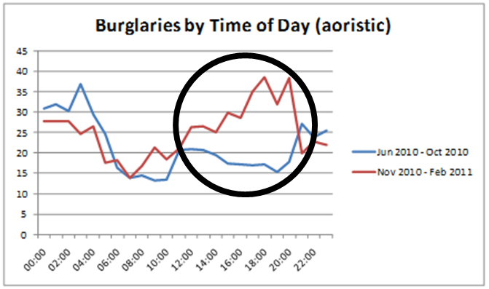  Figure 1. Residential burglaries in Oldham by time of the day, comparing summer months to winter months 2010/2011.  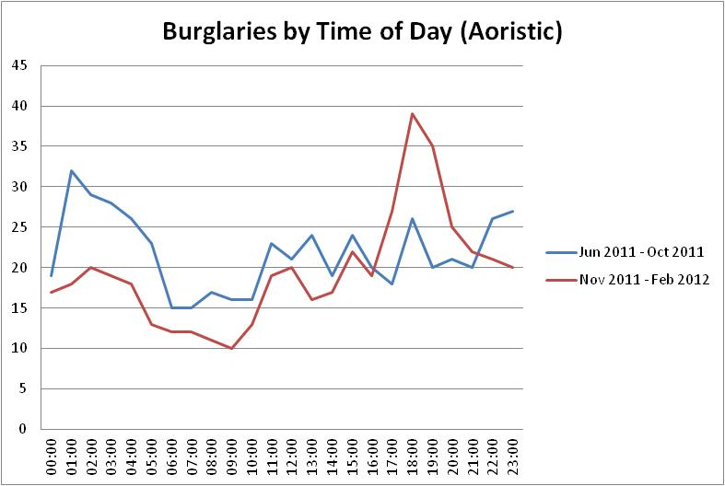  Figure 2. Residential burglaries in Oldham by time of the day, comparing summer months to winter months 2011/2012.
A critical review of the prevention awareness programme indicated it was too general, relied on leaflets and posters, and that messages of burglary risk were not resonating to residents. In response, GMP and Oldham CSP used neighbourhood police officers to knock on the doors of properties within 100m and within 24 hours of a recently burgled property and verbally offer crime prevention advice. Officers would ask residents to report any suspicious behaviour and provided practical crime prevention advice that would help minimise their heightened risk of burglary (e.g. leave a light on if you will be out mid afternoon to early evening). It was felt that by speaking to residents it was more likely that the message would resonate. The presence of officers on the streets in the areas that were considered to be at a heightened risk of burglary would also help deter offenders. This programme began in October 2012, and was considered to be the main reason for a 25% reduction in burglary over the 2012/2013 winter period, and in effect flattening much of the burglary peak between 12.00 – 21.00 that had been evident in the previous years (Figure 2).

Resources
A detailed paper on the hypothesis testing crime analysis approach is available in Policing: A Journal of Policy and Practice
Chainey, S.P. (2012). Improving the explanatory content of analysis products using hypothesis testing. Policing: A Journal of Policy and Practice.
http://iris.ucl.ac.uk/iris/publication/402455/1

Presentation by Spencer Chainey on the hypothesis testing crime analysis approach at the International Crime and Intelligence Analysis Conference, 2012)
Improving the explanatory content of problem profiles using hypothesis testing
http://www.ucl.ac.uk/jdi/events/int-CIA-conf/ICIAC12_slides/ICIAC12_3E_SChainey

A training course that instructs the hypothesis testing crime analysis approach is run at least once every year by the UCL Jill Dando Institute of Security and Crime Science. More details can be found here:
http://www.ucl.ac.uk/jdi/short-courses

JDiBrief case studies (completed or in the planning) that illustrate the hypothesis testing crime analysis approach are posted in the Crime Briefs section
http://www.ucl.ac.uk/jdibrief/crime
- Problematic street drinkers
- Mobile phone theft
- Night-time economy violent crime
- Calls for service from a mental health care facility
- Violent crime recording

References
Ratcliffe, J.H. (2008). Intelligence-led Policing. Willan Publishing, Cullompton.

