Web Accessibility Testing

Contents
Web Accessibility Testing 1
Introduction 2
Chrome and Firefox browser developer tools 2
Chrome Developer Tools (F12) 2
Firefox Developer Tools (F12) 3
Axe 4
Microsoft Accessibility Insights 4
ARC Toolkit 4
WAVE 5
ANDI 7
Screenreader - NVDA 7
NVDA Shortcuts 7

Introduction
Automated checking generally only spots up to a maximum of 40% of errors. Some things they highlight are sometimes false errors. It doesn’t test keyboard accessibility, whether alt tags are correctly labelled, nor certain colour issues.
This guide talks about some of the most used automated tools that will be of some use to developers of software and web content, and testers in general.
There is a good site to look at, which was created as a bad example of accessibility by Washington University, as well as this list of some of the faults with the Washington site. I have used it in the examples throughout this guide.

Chrome and Firefox browser developer tools

Chrome Developer Tools (F12)

This tool allows the developer to assess their work as they progress. Image 1 below shows the main interface with source code, once the F12 key is pressed. When the ‘Accessibility’ Tab is accessed (2nd row on the right), it then opens a section that identifies the main issues with the site allowing the developer to make amendments. See image 2.
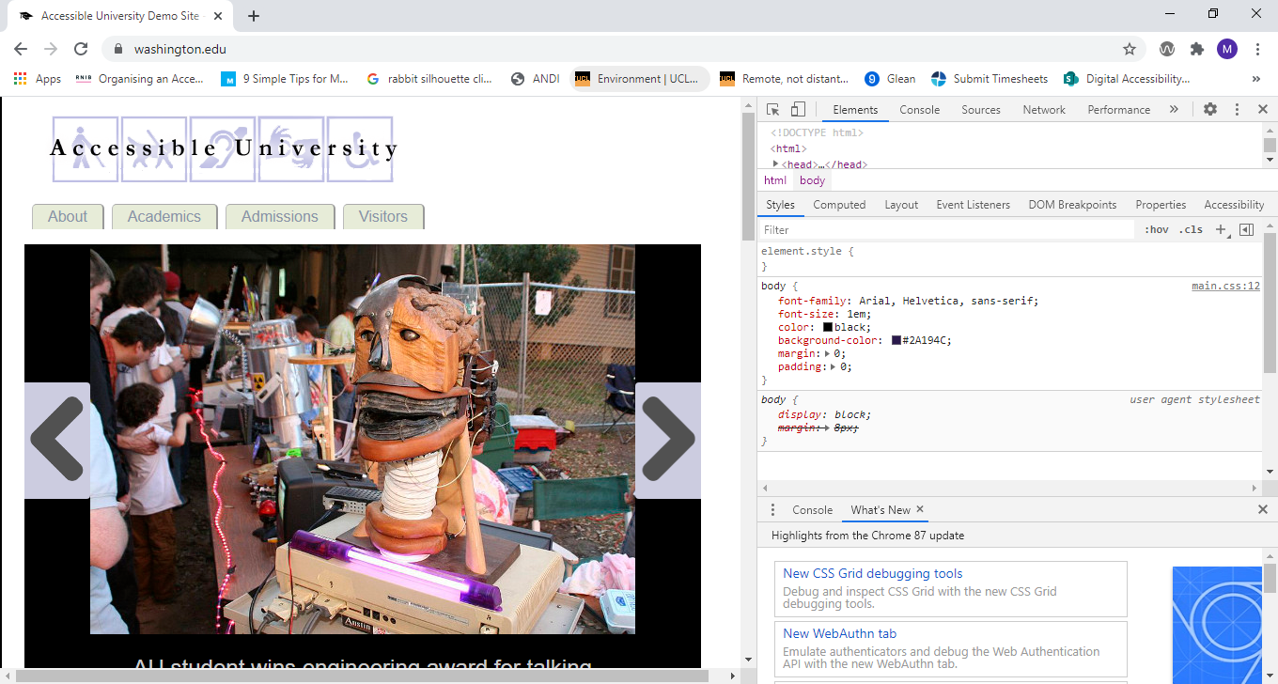
  - Image 1
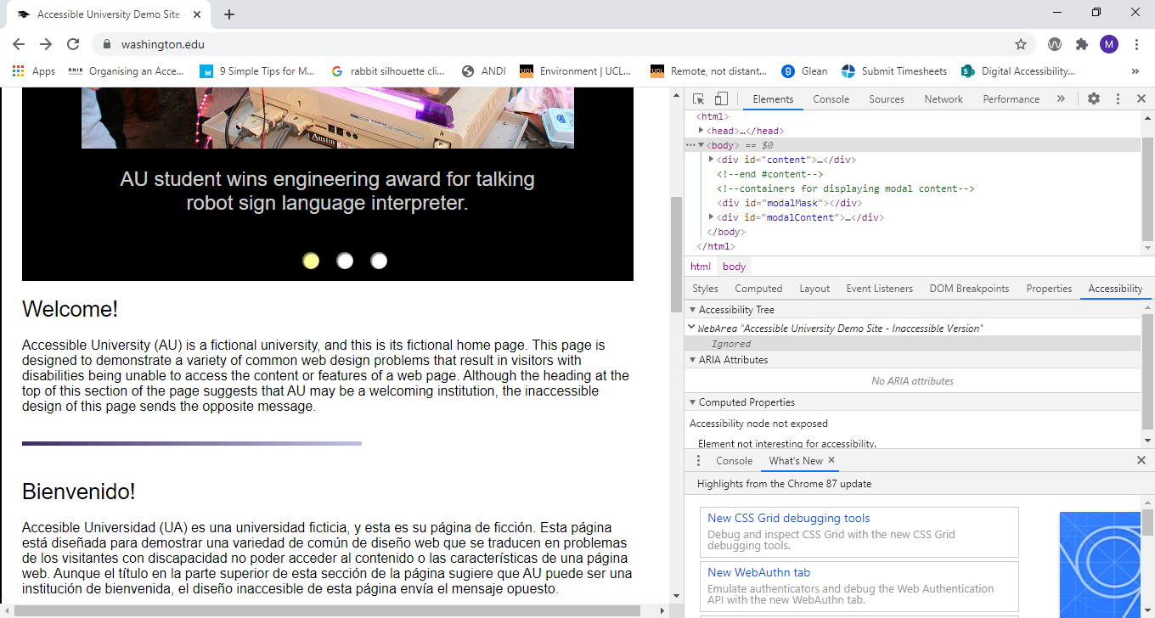
  - Image 2

Firefox Developer Tools (F12)

Firefox works in the same way as the Chrome version. See images 3 and 4 below.
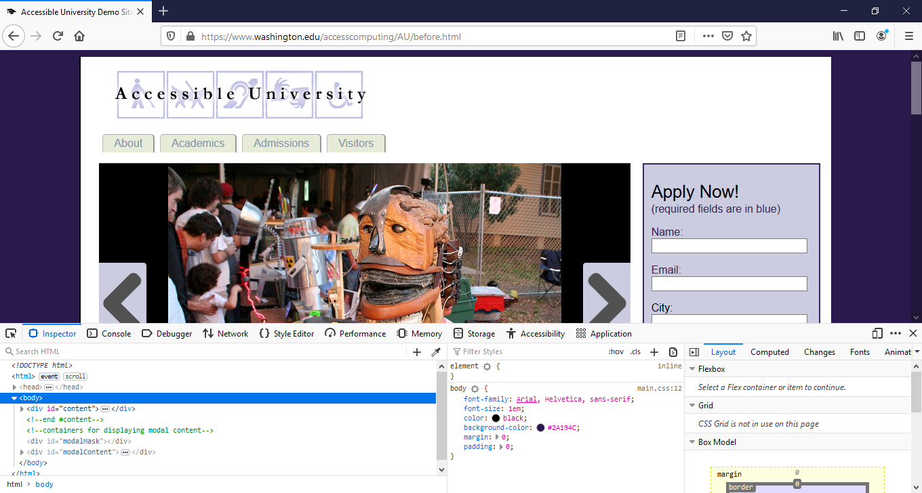
  - Image 3
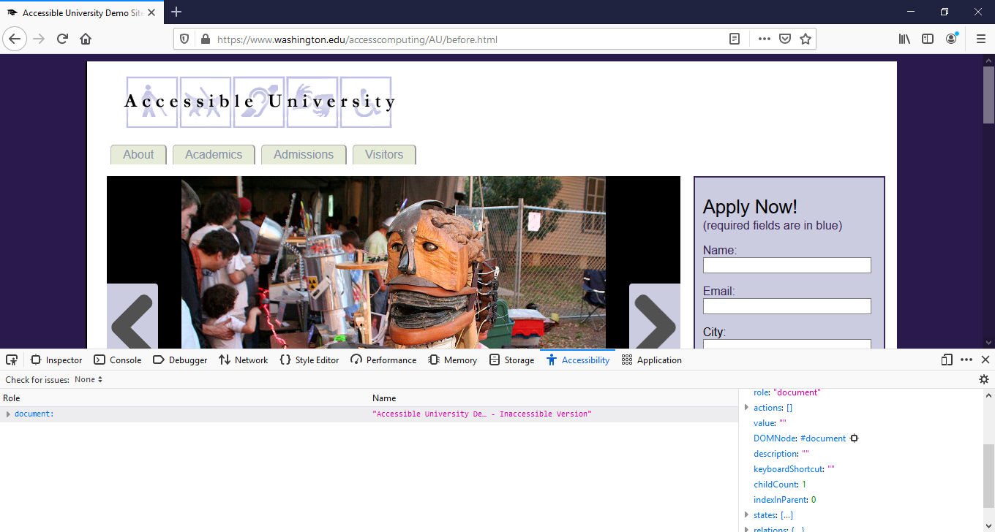
  - Image 4

Axe
Axe (currently in beta) is designed to help developers with both automatic and manual accessibility testing. Axe builds on the existing axe browser extension, supplemented with a new web interface for intelligent guided tests. These guided tests extend your testing coverage and help build issue reports based on the feedback you provide. The detailed list of accessibility issues you collect are easily presented to help you and/or your team make the appropriate fixes in the source code.
Axe in beta is only available for Google Chrome, so make sure that's the browser you're using when you start testing.
Here's a short video to help you get started.
Axe was built to be intuitive and easy to use, so you should be able to jump right in. If you have any problems or questions, please direct them to helpdesk@deque.com.

Microsoft Accessibility Insights
Accessibility Insights is free and open source software that allows you to test and solve accessibility issues before your design is live.
It has three options, web extensions for Chrome and Microsoft Edge and a downloadable app for Windows.

ARC Toolkit
ARC Toolkit is a professional-level accessibility testing tool that gives you the power to quickly and efficiently evaluate screens for accessibility, and uncover issues related to the WCAG 2.1 Level A and AA guidelines. The Chrome extension enables you to easily drill down into code level issues and gain in-depth insight into the accessibility of the screen.

WAVE
WAVE is a suite of evaluation tools that helps authors make their web content more accessible to individuals with disabilities. WAVE can identify many accessibility and Web Content Accessibility Guideline (WCAG) errors, but also facilitates human evaluation of web content.
The image 5 shows the initial results with the number of errors found.
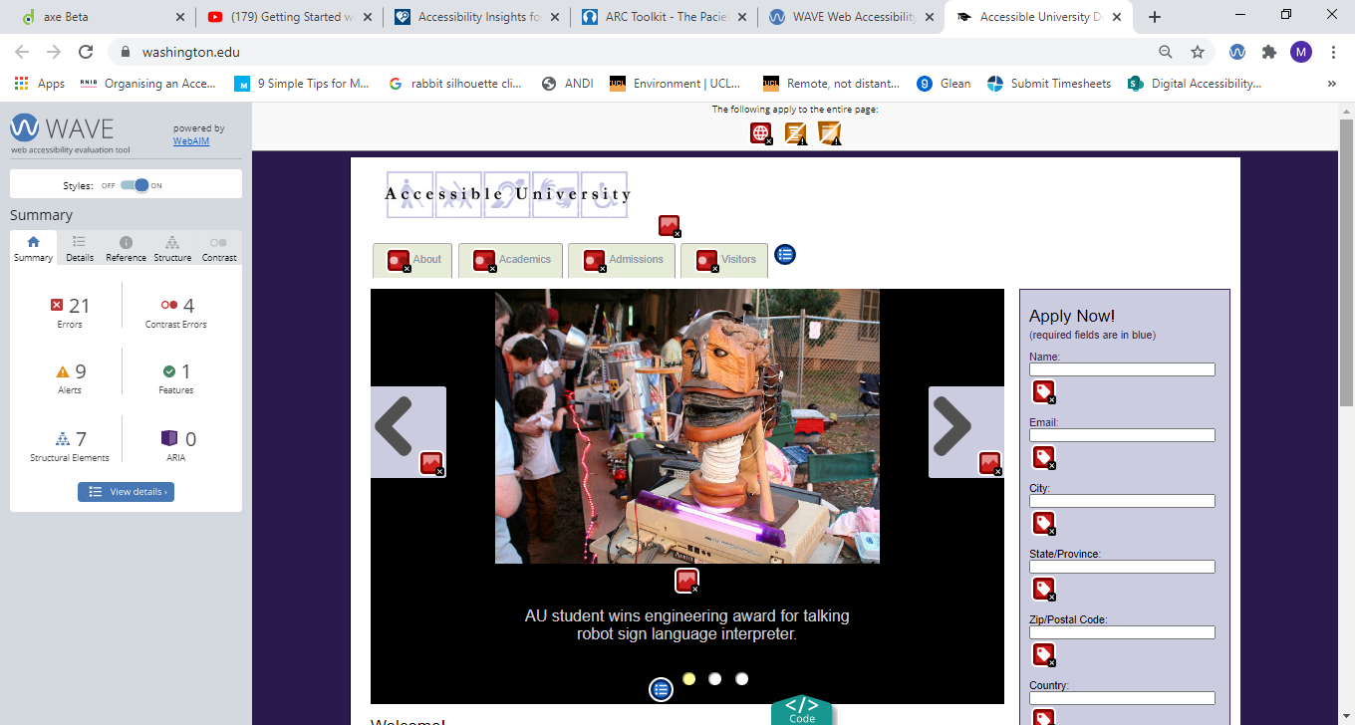
  - Image 5
Image 6 shows a more drilled down version of the results.
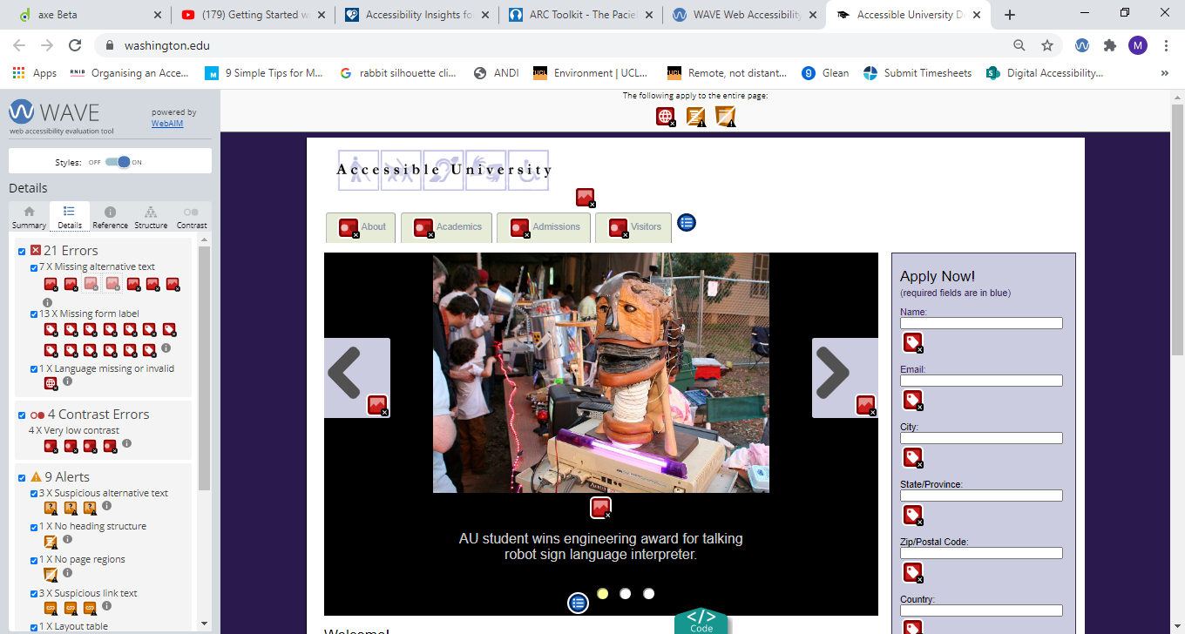
  - Image 6
Image 6 above displays the reason behind the error being flagged and also shows source code and possible solutions to the issue. The way to access this is to click on the error icon on the site page, and which opens a description of the problem, and the reference as well as suggestions for fixing, and the option to display the relevant source code. See image 7
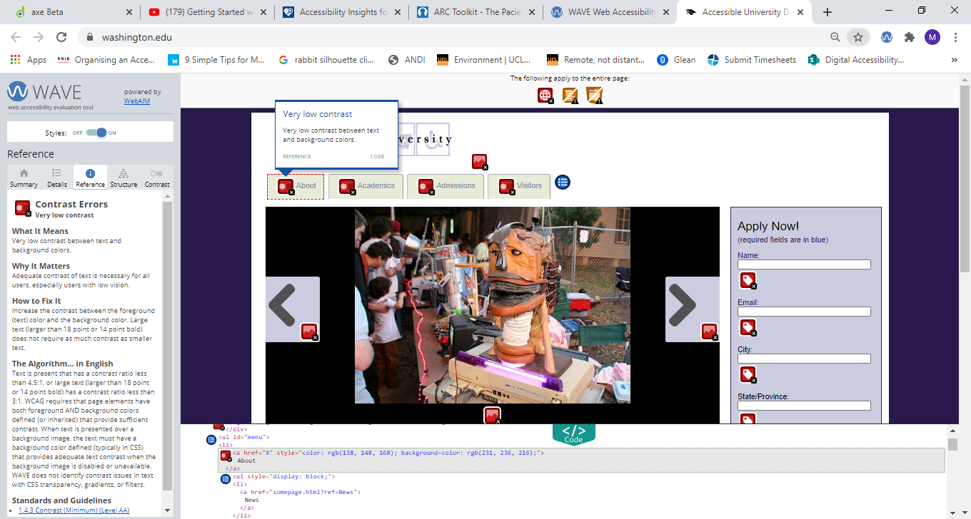
  - Image 7

ANDI
Additional single function plugins and bookmarklets.
Once loaded, you navigate to the site you wish to assess and then click on the ANDI label under the URL bar and then it will display the errors it finds, as shown in image 8 below. It also provides a full guide on how to use it.
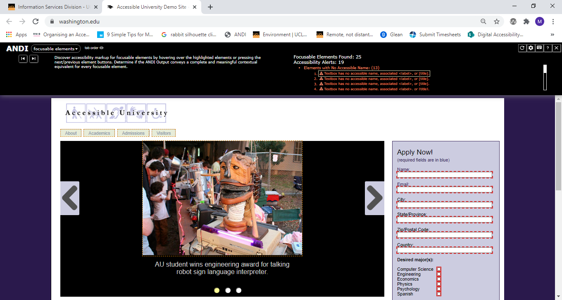
Image 8

Screenreader - NVDA
A screen reader is also a good way to test websites, and NVDA is a free program to help with this.

NVDA Shortcuts

Note
The NVDA key is set to the Insert key by default, but it can be changed to the Caps lock key when installing NVDA for the first time. If you want to change your NVDA key preference later, press Ctrl + NVDA + K.
Reading Text
Command | Description
← or Numpad 1 | Say Prior Character
→ or Numpad 3 | Say Next Character
Numpad 2 | Say Current Character
Numpad 5 | Say Word
Numpad 5 twice quickly | Spell Word
Ctrl + ← or Numpad 4 | Say Prior Word
Ctrl + → or Numpad 6 | Say Next Word
↑ or Numpad 7 | Say Prior Line
↓ or Numpad 9 | Say Next Line
NVDA + ↑ or Numpad 8 | Say Current Line
NVDA + ↑ twice quickly | Spell Current Line
NVDA + ↓ or Numpad + | Read all starting at current position
Shift + Numpad 7 | Top line
Shift + Numpad 9 | Bottom Line
Shift + Numpad 1 | Start of Line
Shift + Numpad 3 | End of Line
Voice Rate
Command | Description
Ctrl + NVDA + ↓ | Decrease Voice Rate
Ctrl + NVDA + ↑ | Increase Voice Rate
Ctrl + NVDA + ←/→ | Change Voice Settings (Inflection, Pitch,etc.)
Headings and Lists
Command | Description
H | Headings Quick Key
1-6 | Headings level 1-6
L | List Quick Key
I | List Item Quick Key
Tables
Command | Description
T | Table Quick Key
Ctrl + Alt + → | Cell to Right
Ctrl + Alt + ← | Cell to Left
Ctrl + Alt + ↓ | Cell Below
Ctrl + Alt + ↑ | Cell Above
Forms
Command | Description
F | Form Quick Key
B | Button Quick Key
Enter or NVDA + Space (in a form element) | Enter Forms Mode
NVDA + Space | Exit Forms Mode
Tab | Navigate to Next form Control
Shift + Tab | Navigate to Previous Form Control
Spacebar | Select and Deselect Checkboxes
Alt + ↓ | Open Combo Box/Jump Menu/Auto-complete Menu
↑/↓ | Select Radio Button
↑/↓ or the First letter | Select Element in Combo Box
X | Checkbox
C | Combo Box
R | Radio Button
Enter (in forms mode) | Submit Form
Links
Command | Description
Tab | Jump to next link/form element
K | Next link
Shift + Tab | Jump to previous link/form element
NVDA + F7 | Elements List - lists page links, headings, and landmarks
U | Unvisited Link Quick Key
V | Visited Link Quick Key
Other Commands
Command | Description
Ctrl + F | Search for a word or a phrase
NVDA+ 1 | Keyboard help
G | Next Image
Ctrl + ↑/↓ | Previous/Next Paragraph
Q | Blockquote
NVDA + F2 | Next key you hit ignores NVDA and is a normal Windows key
NVDA + 2 | Speaks characters typed
NVDA + 3 | Speaks words typed
NVDA + B | Reads the entire foreground window (useful for reading a dialog box)
NVDA + T | Announces the title of the current foreground window
NVDA + Q | Quit NVDA

