Connecting and Managing Devices using the UCL Device Provisioning Portal

Wireless devices only need to be registered on the UCL Device Provisioning Portal if they cannot be connected to the University’s standard eduroam wireless network. Details of how to connect to eduroam can be found here:
https://www.ucl.ac.uk/isd/services/get-connected/wi-fi/eduroam-wi-fi-ucl
To register a device, you will need its MAC address, there are instructions on how to find it at the bottom of this document in the section called ‘Find a device MAC Address’.

- Creating a Device
This will create a single device and generate a different PSK for every device created. This is useful when creating a small quantity of devices. To add multiple devices, repeat this process. If a large bulk import of devices is required – please see section further down.
Open a web browser to:
https://manage-my-devices.ucl.ac.uk/
Log into the Device Provisioning Portal with your UCL username and password:
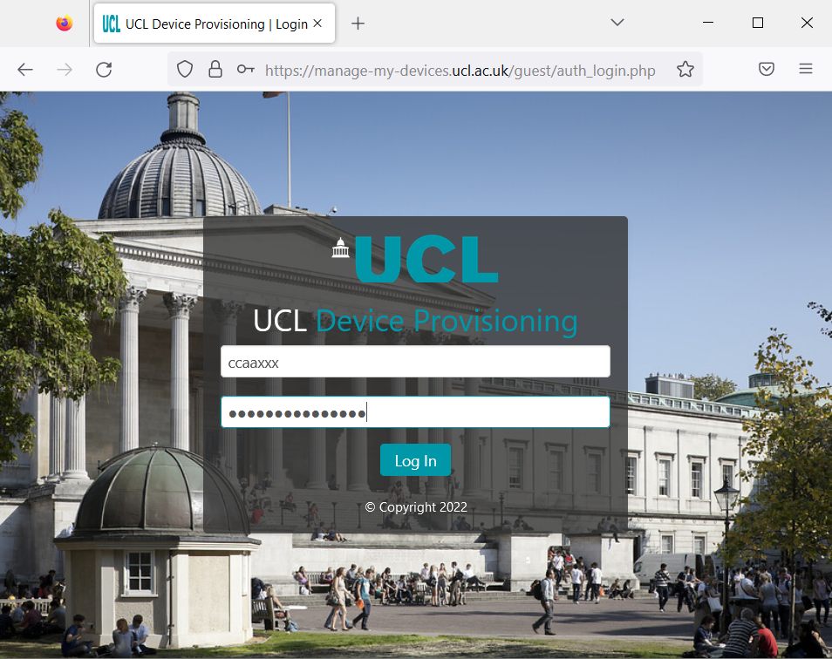

You will see a page that allows you create and manage your devices:
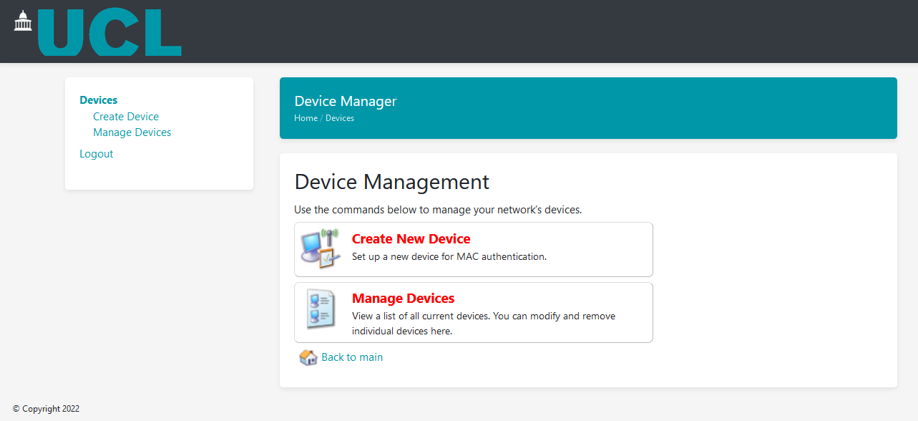

Click ‘Create New Device’.
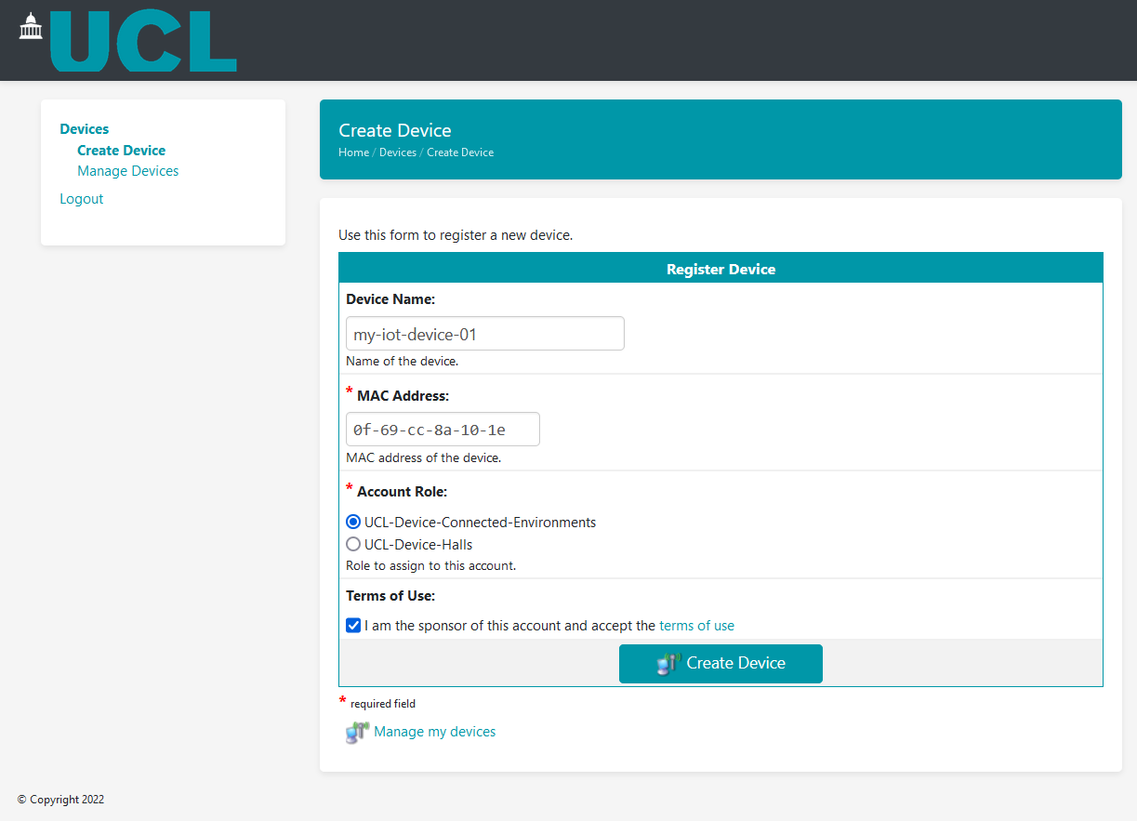

In the ‘Register Device’ form you will need to enter the following details:
Device Name: Enter a descriptive name for the device for your reference.
MAC Address: The unique hardware address given to each device. A device may have both a wired and wireless MAC address, use the appropriate MAC address for the type of connection you need. See the 'Find a Device MAC Address' section to identify the correct MAC address.
Account Role: This determines which network your device will connect to; you can choose only one for each device.
Terms of Use: Tick to agree to the ‘Terms of Use’, more detail can be found on this link:
https://www.ucl.ac.uk/information-security/policies/2021/may/computing-regulations-acceptable-use-policy
Click the ‘Create Device’ button.

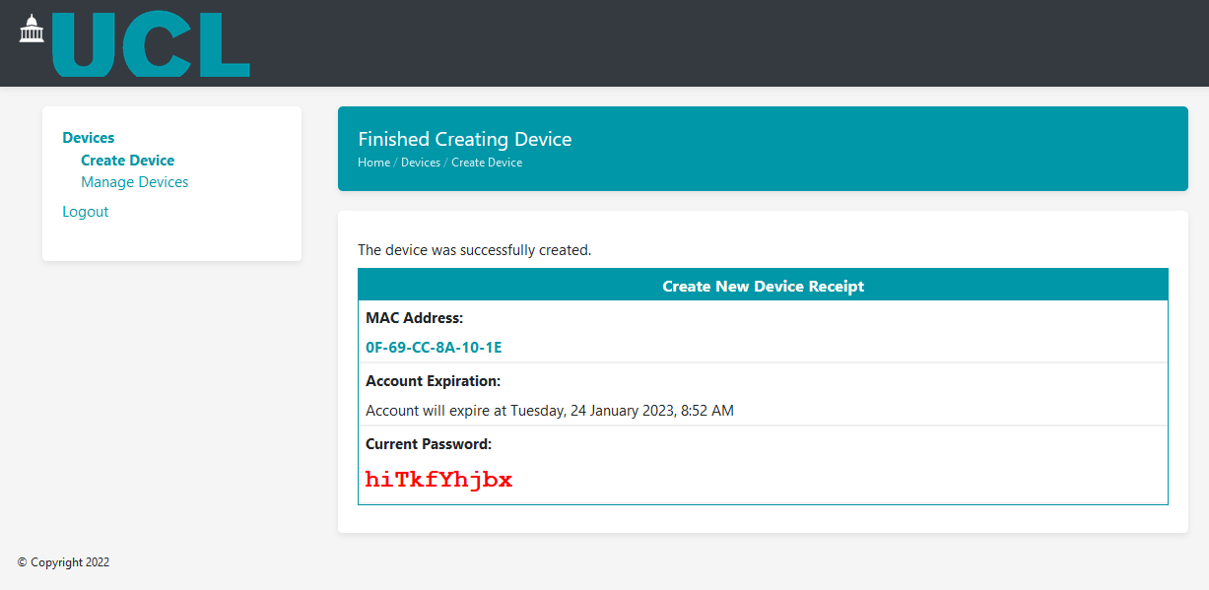
A page will be displayed that shows the following details:
MAC Address: Confirms the entered MAC address.
Account Expiration: The default expiration date is always 3 months from the time of creation, the expiration date gets updated every time the device is seen on the network and the account will not expire unless the device is not seen on the network for a period determined by the role (usually 6 months).
Current Password: This is the WPA2 Pre-Shared Key (PSK) that you will configure your device with to connect to the Wi-Fi network.

- Import Bulk Devices
This will import a bulk quantity of devices and generate a different PSK for every device created. This is useful when creating a large quantity of devices.
Open a web browser to:
https://manage-my-devices.ucl.ac.uk/
Log into the Device Provisioning Portal with your UCL username and password as outlined in earlier section.

You will see a page that allows you to import and manage your devices:
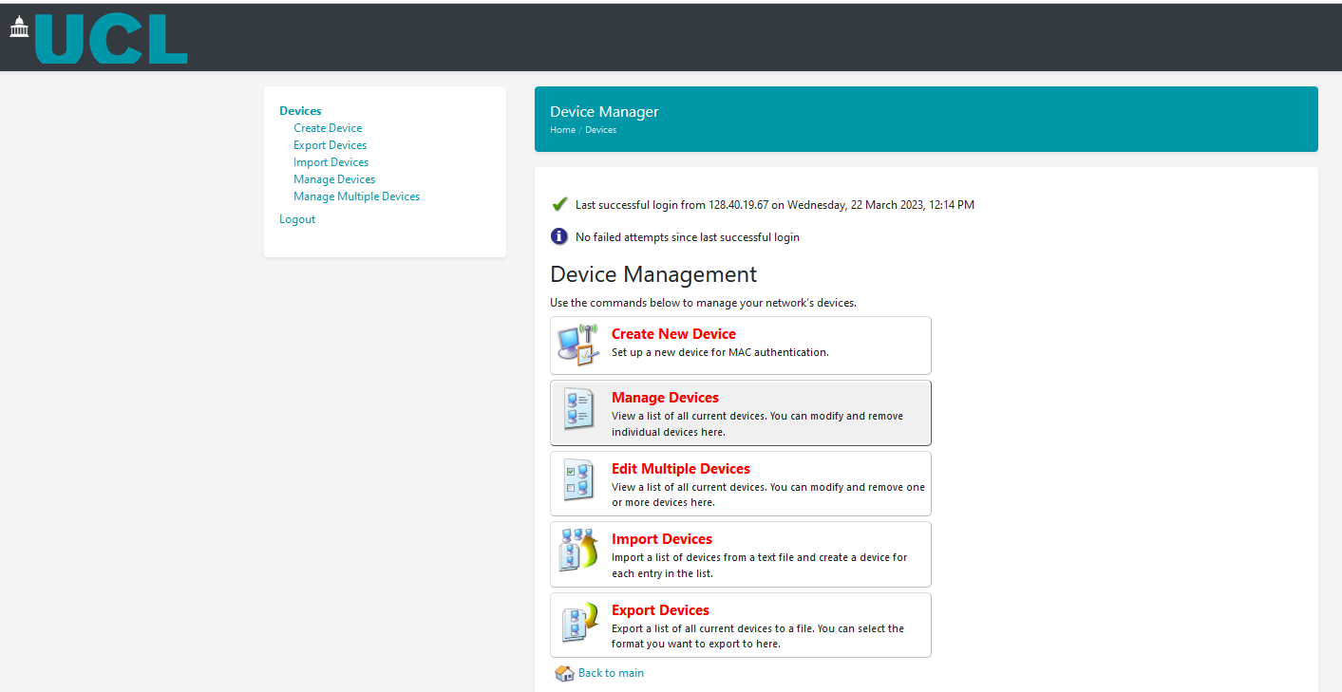

Create a file in csv format, as outlined in the example below, ensure the 4 columns are populated with MAC Address, Device Name, ensure the column Wi-Fi Password is always 1 and optional if the same PSK is required for all devices set this in the last column:
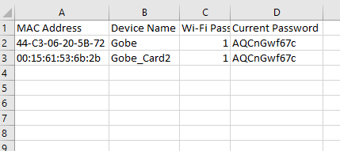

Click on Import Devices, and Browse to the csv file on your machine:
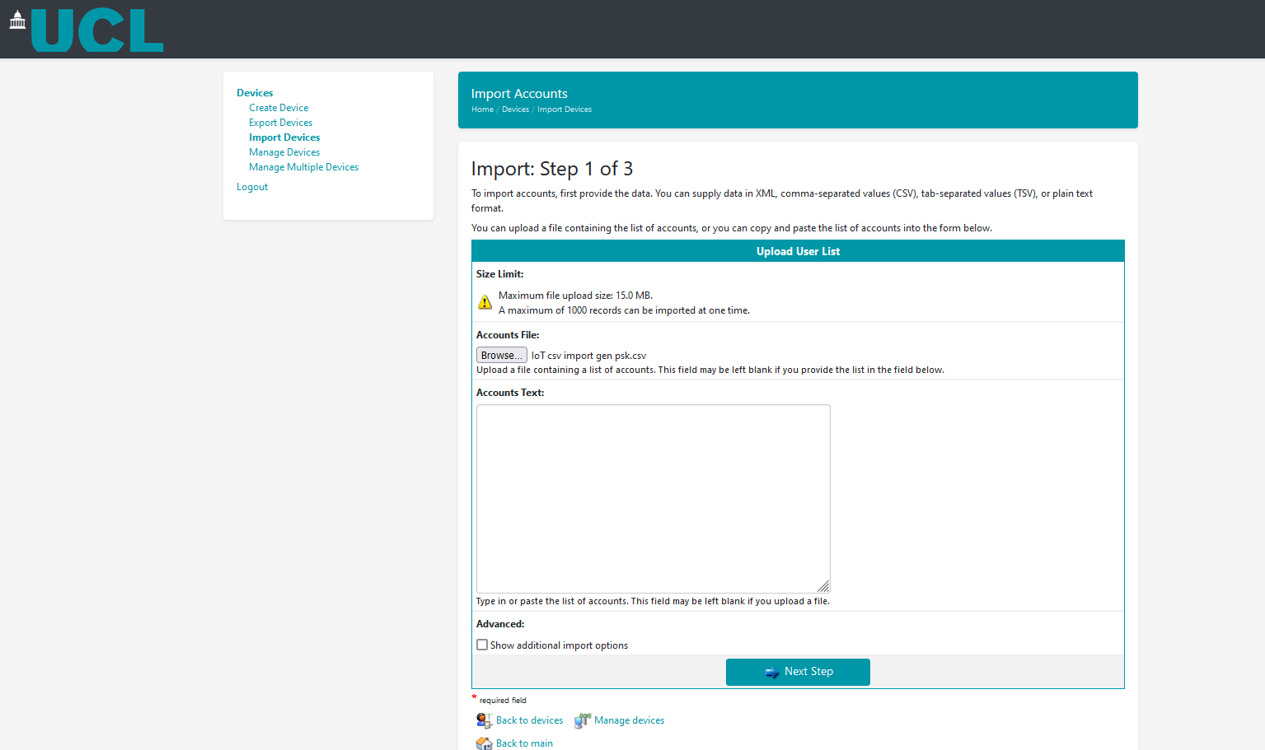

Click Next Step, and you will see the devices listed to be imported, under match fields leave all fields as default:
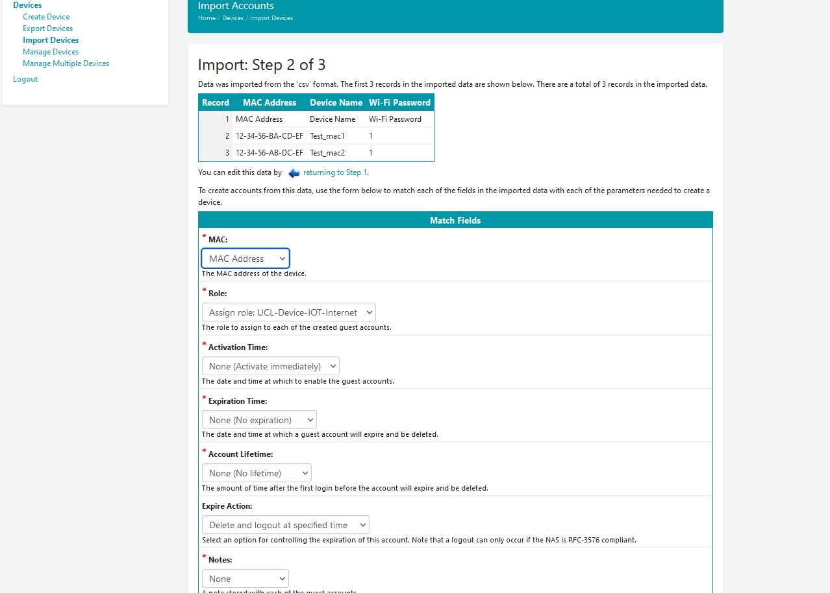
Click Next Step, step 3 of 3 will allow you to create the listed devices
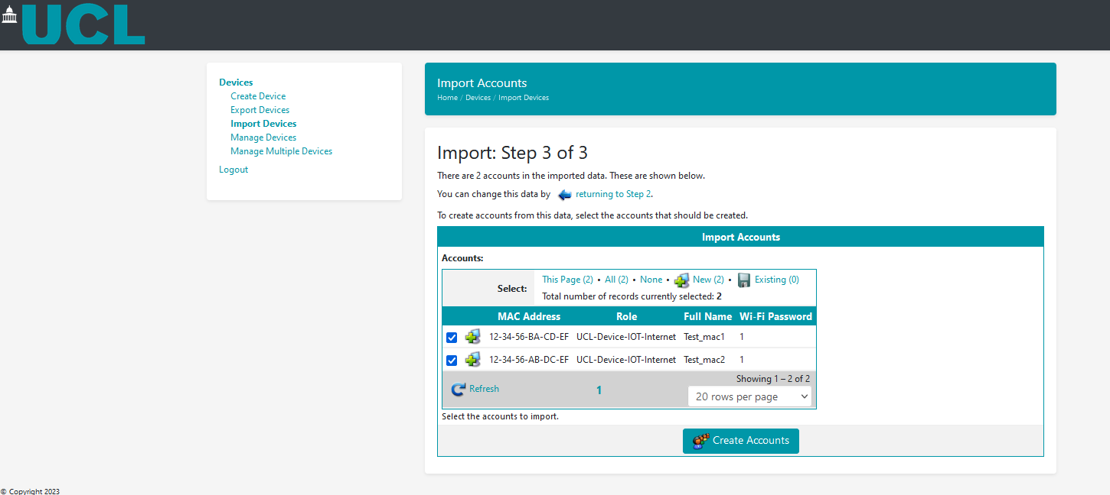
Click on Create Accounts, details will be shown of the imported devices:
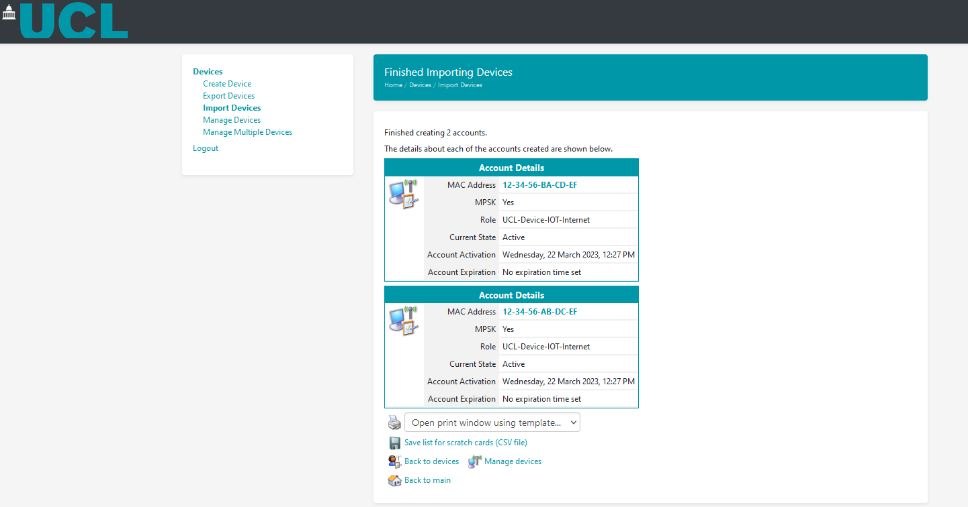
Click on Manage devices, device along with their individual PSK will be listed – see manage devices section below.
Use the PSK to connect the device to the Wi-Fi service.

- Import Bulk Devices with a customized PSK for all Devices
This will allow a bulk import of devices, like the section before but with a PSK chosen by the user and shared by all devices imported.
Follow the same steps outlined in the previous section to Import Bulk Devices, and ensure the csv file created is in the following format, all fields are the same as in previous section except the Current Password column – this is the password you choose for all your devices:
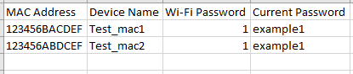
Once you click on Create Accounts, under manage Devices, you will see devices imported but with the same PSK:
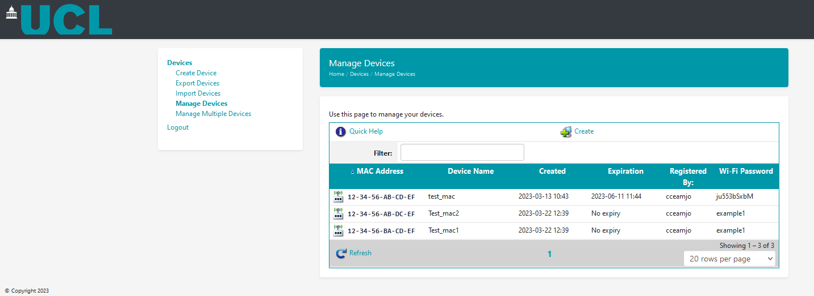

Use the PSK to connect the device to the Wi-Fi service.

- Managing Devices
To Edit an Existing Device:
To make changes to an existing device click on ‘Manage Devices’, all your registered devices will be displayed:
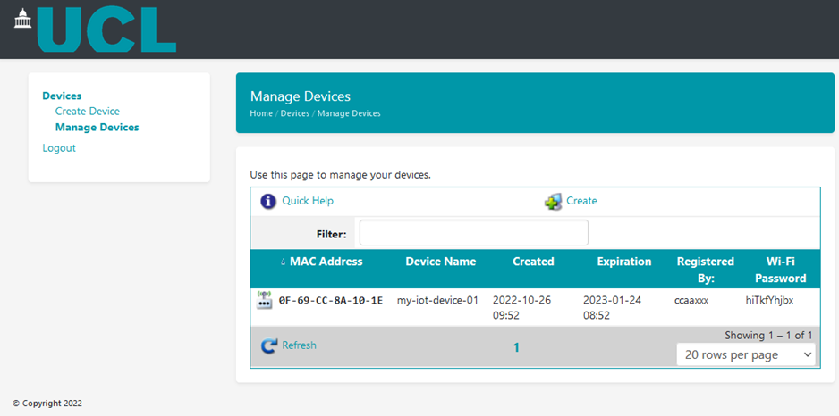
Click on the device you wish to edit and click ‘Edit’: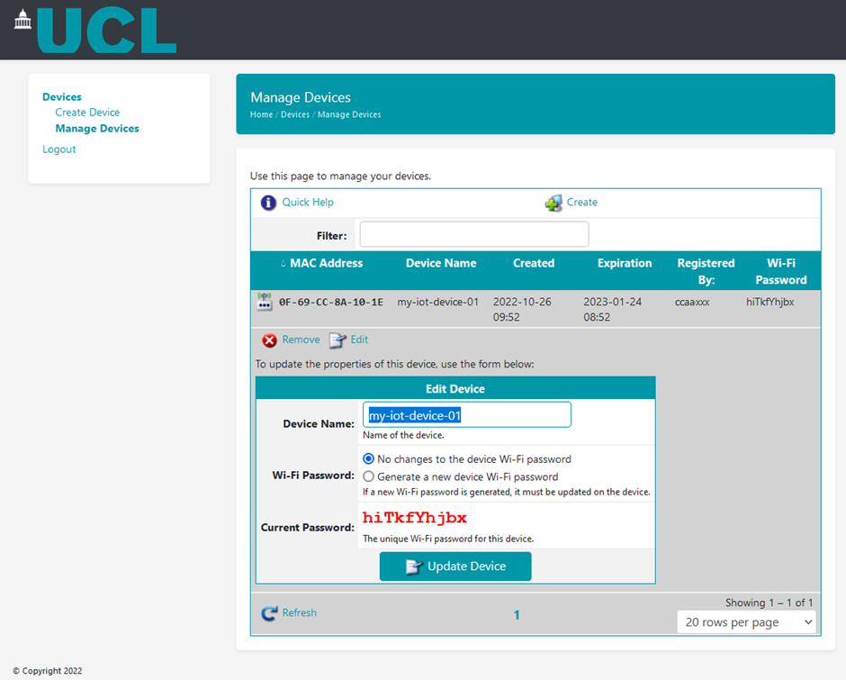
You can change the Device Name or generate a new WiFi password.
To Disable or Delete a Device:
Click on the device you want to disable/delete and click ‘Remove’:
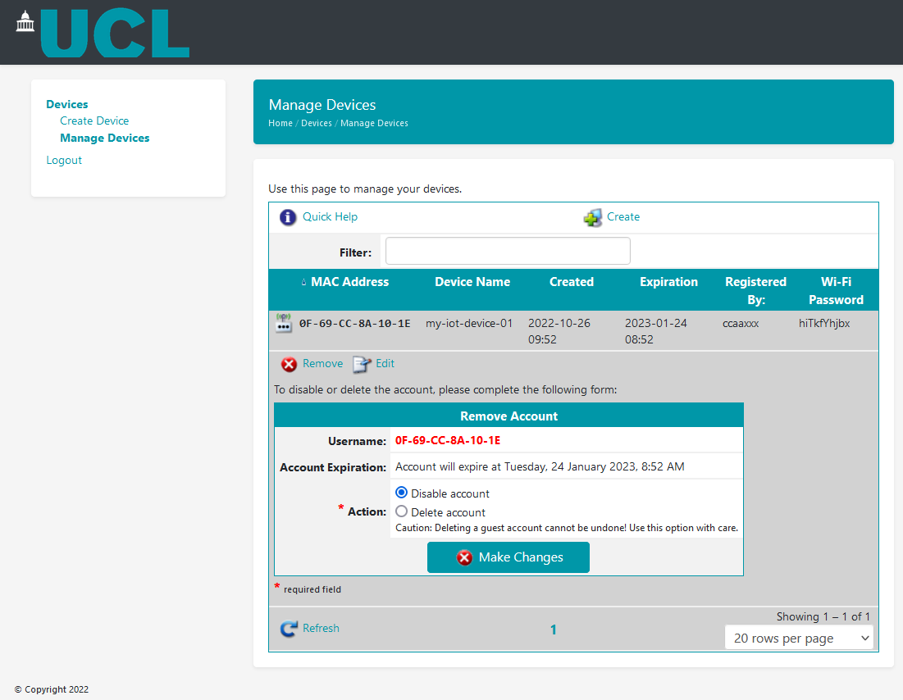
You can then choose to either:
Disable Account: The device details will remain on the ‘Manage Devices’ page and be marked as disabled, the device will no longer be able to connect to the Wi-Fi network. The account can be re-enabled at a later date.
Delete Account: The device and its details will be permanently deleted from the list of managed devices. It can be manually added to the list again at a later date if you wish to connect it again.

Find a device Mac Address:
Laptops
- Windows 10
  - Open the Command Prompt by right-clicking on the Start button (located in the lower-left corner of the screen) and select Command Prompt from the menu. Alternatively, press the Windows Key on your keyboard, type cmd into the Search bar, then press Enter on your keyboard.
  - Enter ipconfig /all into the Command Prompt window and press Enter on your keyboard.
  - The wireless MAC address will be listed under Wireless LAN adapter Wi-Fi next to Physical Address. The wired MAC address will be listed under Ethernet adapter Ethernet next to Physical Address.

- Mac
  - Open the Apple menu.
  - Click System Preferences > Network.
  - Select your network connection and click Advanced.
  - You will find the MAC address on the hardware tab.
- Chrome OS
  - Click the wifi network icon.
  - At the top of the box, click information.
  - You will find the MAC address displayed as the wifi address.
- Linux
  - In a terminal window type ifconfig and return.

  - You'll see a list of interfaces. Your wireless interface will likely be named wlan0 or wifi0. The wireless MAC address will be in the field labeled HWaddr.
  - You can also use iwconfig to find your wireless MAC address if you have it installed.

Smartphones & Tablets
- iPhone & iPad
  - Open the Settings app.
  - Select Wi-Fi > select the network.
  - Wi-Fi Address is listed under Private Wi-Fi Address.
- Android & Pixel
  - The specific instructions for finding the MAC address of an Android device may vary slightly based on the manufacturer.
  - Open the Network & Internet > Internet > SSID > Randomized MAC Address
- Windows Phone
  - On the main Windows phone screen, swipe left and select Settings.
  - In the Settings screen, select About > more info.
  - The MAC address will be listed under phone information.
Streaming Devices
- AppleTV
  - For Wireless MAC address:
Plug in your Apple TV and follow the set up until you reach the step to connect to a network.
Select a wireless network and attempt to connect. This will fail, which is normal.
The wireless MAC address should now be displayed on the Apple TV’s screen.
  - For Wired MAC address:
Connect your Apple TV to an Ethernet port.
On the Apple TV, navigate to Settings > General > Network. Record the MAC address listed.
- Amazon Fire TV
  - Plug in your Amazon Fire TV stick into your TV
  - If this is the first time using this Fire TV device, the wireless MAC address will appear in the list of wireless networks during setup at the far-right of the list.
  - If this Fire TV stick has been used in the past, navigate to Settings > System > About > Network and the wireless MAC address will be listed at this screen.
- Roku
  - From the Roku home screen, select Settings > System > About > Wireless MAC Address
- Chromecast
  - Visit Settings on your Chromecast app.
  - The MAC address will be listed at the bottom of the window.
- Smart TV
  - Each smart tv is unique; however most MAC addresses are visible in the Settings Menu in the Network or About sections.
  - Alternatively, check with the manufacturer of your smart tv for instructions on how to obtain the MAC address for your specific model.
- NVIDIA Shield
  - Select Settings
  - Select Device
  - Select Network
  - Select Status info
Gaming Devices
- Nintendo Switch
  - From the Switch’s Home menu, go to System Settings
  - Scroll down and select Internet.
  - The MAC address will appear under System MAC Address.
- Nintendo Wii U
  - From the Wii U main menu, select System Settings.
  - Select Internet > View MAC Address. The wired/wireless MAC address will be listed.
- Nintendo Wii
  - Select Wii Settings.
  - Select Internet > Console Information.
  - The wireless MAC address is listed under MAC Address. The wired MAC address is listed under LAN Adapter MAC Address.
- Nintendo 3DS
  - From the 3DS’s main menu, go to System Settings > Internet Settings > Other Information.
  - Select Confirm MAC Address. The wireless MAC address will appear.
- NVIDIA Shield
  - Select Settings > Device > Network > Status Info
  - The MAC address will be listed on the Status Info screen.
- Xbox One
  - If you are setting up your Xbox One for the first time:
  - Complete the initial setup until you reach the network connection step.
  - Attempt to connect to Device-Northwestern. This will fail, which is normal.
  - Select Fix it.
  - Wait for the troubleshooter to fail.
  - The MAC addresses will now be listed. Use Wired MAC for Ethernet connections and Wireless MAC for Wi-Fi connections.
  - If you have previously set up your Xbox One:
  - From the Xbox One home screen, select Settings.
  - Under the Console tab, select Network.
  - Select Advanced Settings. The wired and wireless MAC addresses will be displayed
- Xbox 360
  - From the Xbox 360 main menu, go to My Xbox > System Settings > Network Settings > Configure Network
  - Select the Additional Settings tab and then select Alternate Mac Address.
  - The wired and wireless MAC addresses will be listed at the bottom of this screen.
- Xbox
  - Power on the Xbox with no disc in the tray.
  - Visit the Xbox Dashboard.
  - Choose Xbox Live.
  - Visit the Connect Status screen.
  - Select Settings.
  - From the Network Settings screen, you will see the MAC address in the bottom right corner.
- PlayStation Vita
  - Open the Settings and tap Start
  - Tap System
  - Tap System Information
  - The MAC is on this screen
  - Status List.
  - You can find the MAC address listed under MAC Address.
- PlayStation 4
  - On the PlayStation 4 main menu, go to Settings > System > System Information.
  - The wired address will appear next to MAC Address (LAN Cable). The wireless MAC address will appear next to MAC Address (Wi-Fi).
- PlayStation 3
  - From the PlayStation 3 main menu, select Settings > System Settings > System Information.
  - The wireless and wired MAC address will be listed on the screen.
Other Devices
- Amazon Echo
  - Download the Amazon Alexa app to your phone or computer and sign in with your Amazon account.
  - Connect to the wireless network transmitted by your Echo device.
  - The wireless MAC address for your Echo can be found at the bottom of the Echo Setup screen in the Alexa app.

- Google Home
  - Plug in your Google Home.
  - Download and open the Google Home app on your phone.
  - You should see your Google Home listed. Select it then press Set Up.
  - Accept the prompt allowing your phone to connect to your Google Home.
  - Answer the set up questions listed.
  - Enter the location of your Google Home and select Continue.
  - The wireless MAC address will be listed at the bottom right corner of the screen.

