Making Zoom Meetings Accessible

BSL interpreter
If you are going to hire an interpreter, they will need the zoom link and the password sent to them.
e.g.
You can either access this from your UCL Zoom account and ‘Copy invite’ See image 1 and 2 below.
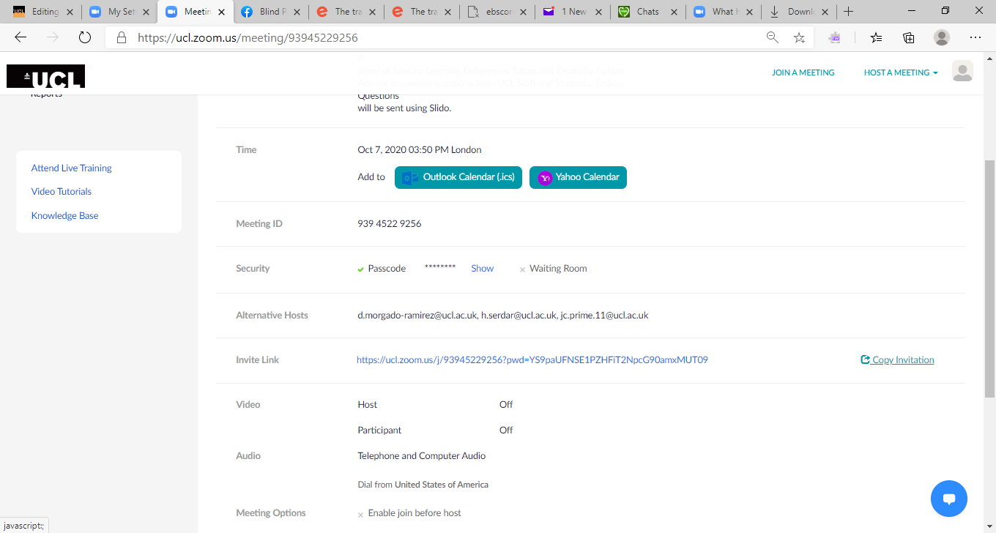Image 1
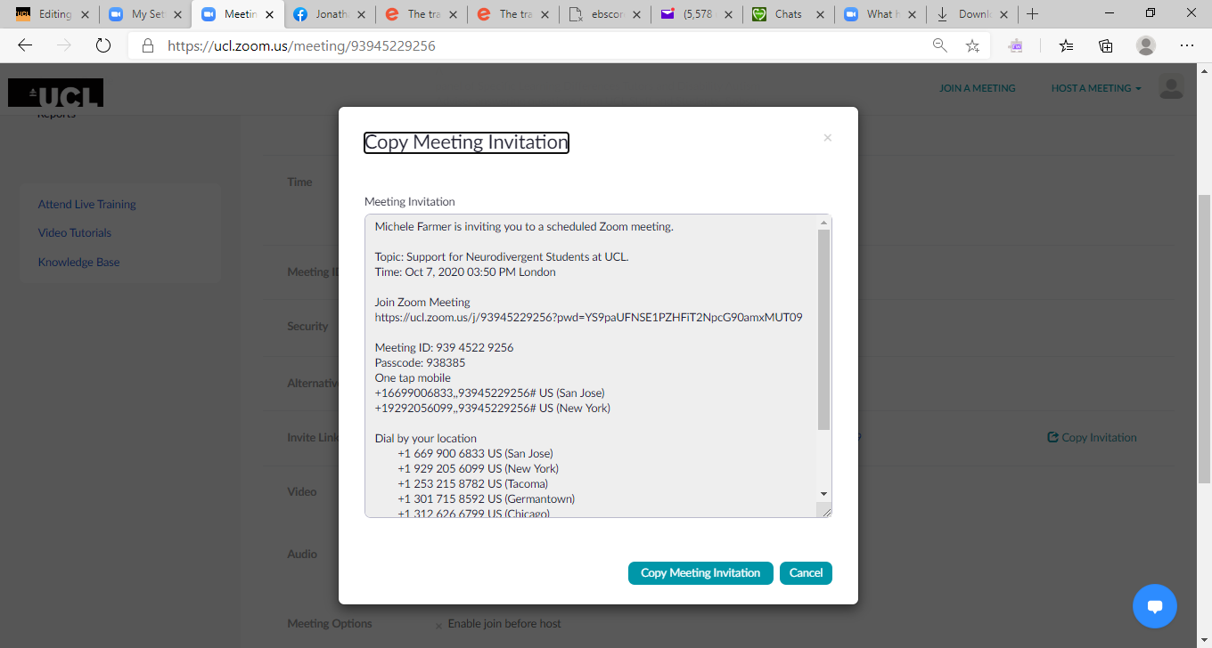
  - Image 2
Or you can go into your Moodle course – if the Zoom session is set up in there and open that event and copy and paste the link and pass code. See image 3 below. The link and code are highlighted in yellow.
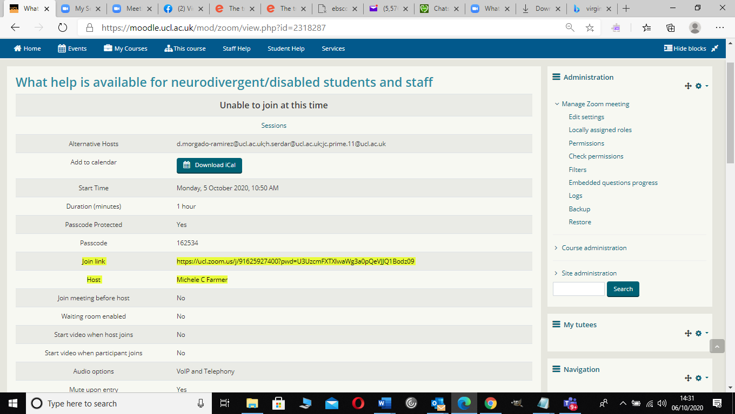Image 3
Once the meeting starts and the interpreter has joined, advise the attendees to go to the ‘View’ menu in the top right of the screen and select ‘Gallery View’ See image 4. After that select the interpreter’s window and click on the three dots and ‘Pin’ the window. Then go back to ‘View’ and select ‘Side by Side Speaker’. This will allow both screens to be visible at all times. You can also ‘hide’ other windows if not needed via the three dots …
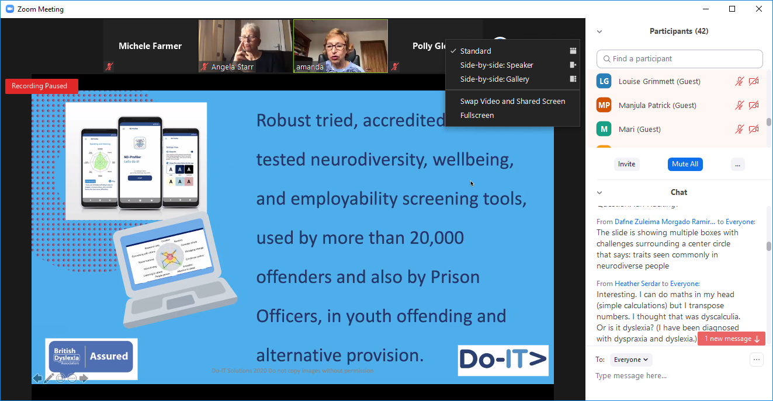
  - Image 4

Live Captioning.
UCL generally uses a company called 121 captions and information on how to go about this can be found at (insert link MF)
The company will need the link and pass code as mentioned above for the interpreter. In addition, they will also need a ‘token’ which can only be generated 24 hours before the meeting, otherwise it lapses.
To generate the token the host needs to go into the UCL Zoom site https://ucl.zoom.us/ and select the meeting and start it. Then click on the ‘More’ button and select the ‘Closed Caption’ option. See image 5
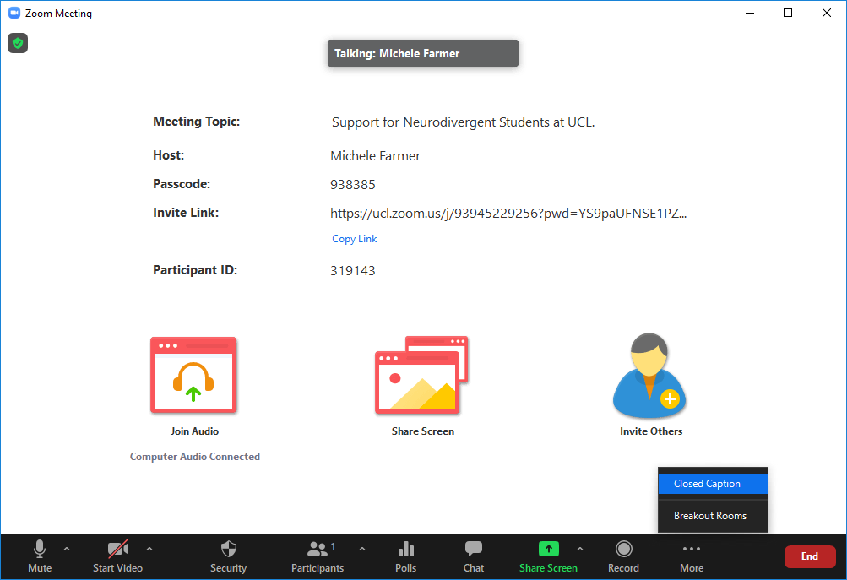
  - Image 5
Once selected a box opens giving you the option to either assign a UCL person already in the meeting to be a captioner, or ‘Copy the API Token’ which is what you would use for the external company such as 121 Captioning. See image 6. Paste this token into an email and send to the company you have hired to do the captioning and this will allow them access to the event.

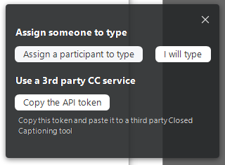
  - Image 6
Once the meeting has started advise attendees that they can access captions by clicking on the ‘More’ button and selecting ‘Show subtitles’ or ‘View Full Transcript’. There is also a ‘Subtitle Settings’ to change text size. See image 7 and 8.

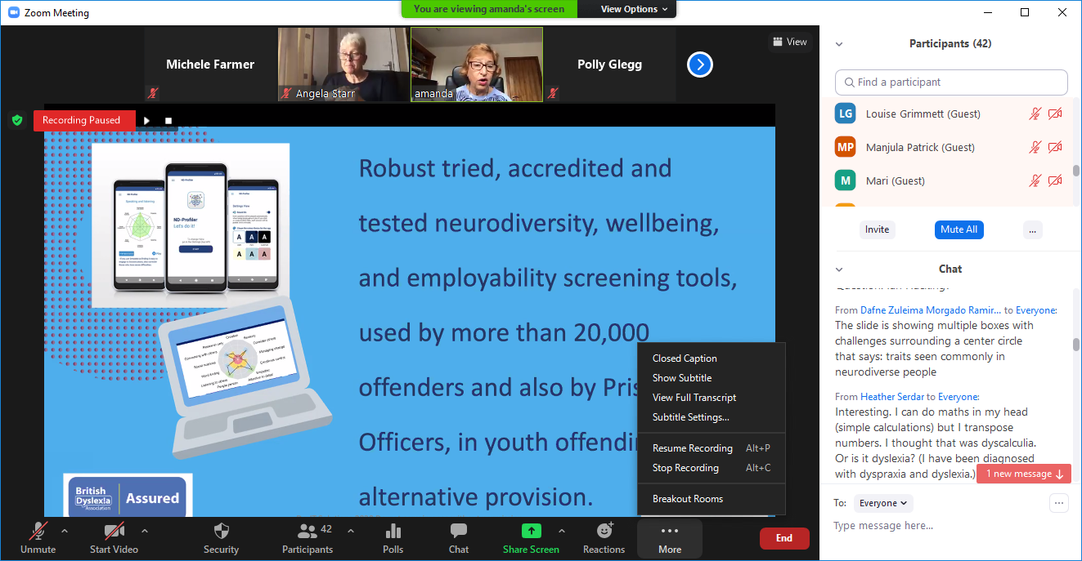Image 7.
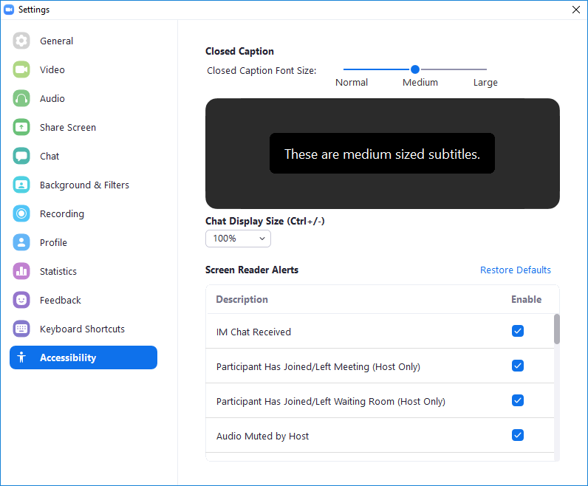Image 8
*IMPORTANT NOTE you must not close the meeting for all at the end, you must just leave one at a time otherwise it prevents the captioning company from saving the transcript to send to you after.

