Introduction

Welcome to the new improved UCL Blogs platform. New themes and plugins have replaced the old outdated ones. You will need to set up your bolgs with the instructions below:
- Customise Theme and choose a colour palette of your choice
- Customise Widgets and sidebar
- Customise Plugins
- Verify that the information is displayed correctly

Login instructions

The new UCL Blog service requires a valid UCL account. Please visit:

https://blogs.ucl.ac.uk/
Scroll to the bottom of the page and click on ‘Login’ and log in with your UCL credentials.
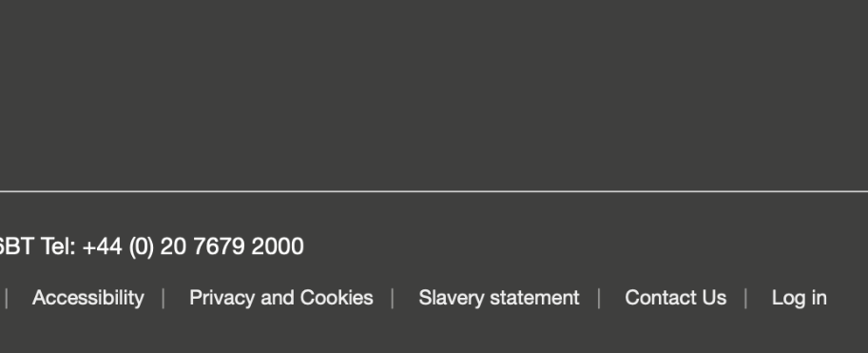
Figure 1
Click on the blue button ‘Use UCL ID’ and login with your UCL credentials.
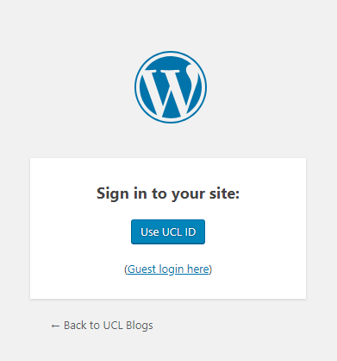
Figure 2

Once logged-in, click on ‘My Sites’ at the top left corner. Your Blog Title should be listed on the drop-down menu. Click on your Blog title and click on Dashboard as shown below.

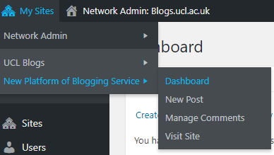
Figure 3
You can now customise and manage your Blog using the Wordpress Admin interface.

Support instruction

User guides are available here: http://help.edublogs.org/user-guide/
We also provide email support via web-support@ucl.ac.uk

Feedback

To Help us gauge the success of this initiative we will open an online survey to collect your feedback during March.

Customise Theme

Your theme is what controls the look and appearance of your blog; this is what people see when they visit your blog. We have developed a UCL theme called Indigo.
It’s a modern theme and we have recently updated so that site owners are now able to choose the colour palette they prefer. There are currently twelve colour schemes you can choose from:
- Bright pink
- Bright green
- Mid red
- Orange
- Dark brown
- Dark red
- Yellow
- Bright blue
- Stone
- Mid purple
- Sky blue
- Blue celeste

Indigo with UCL Colour palette

UCL has defined a colour palette you can use for your Blog. If you need more information about UCL colour guidelines please follow the link below:
https://www.ucl.ac.uk/indigo/design-foundation/indigo-foundation/colours

Change colour set

Once you log in, please follow the instruction below to modify the colour set of your Blog.
From the menu, click on Appearance and then ‘Customize’
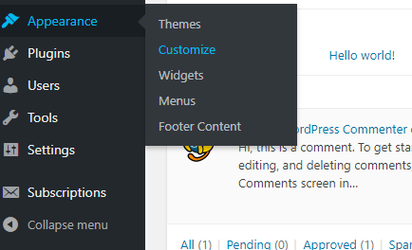
Figure 4

The page should now show the customisation options of the UCL indigo theme.
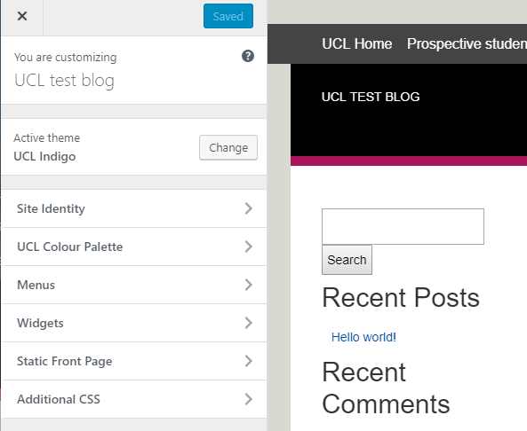
Figure 5

From this page, you can now customise
- Site Identity: Title and Tagline
- Colour Palette
- Menus
- Static front page
- Additional CSS
To choose the colour, click on UCL colour palette. A drop down menu will let you select between the different colours available. The right-side of the page will show you a real time preview of the website.
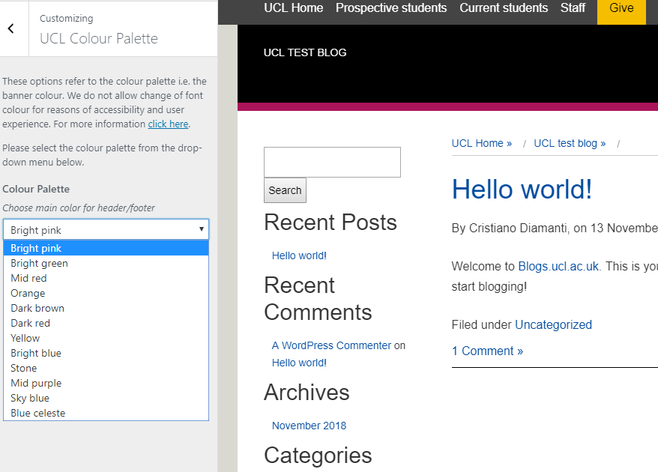
Figure 6
If you need more information about how to customise a theme, you can find useful information following the link below.
http://help.edublogs.org/change-theme/

Customise Widgets and Sidebar

Widgets
The new Theme requires widget to be positioned on the Sidebar 2. If your Blog has been migrated from an old UCL theme, you will have to move widgets from Sidebar 1 to Sidebar 2.

Sidebars
The new theme implements modern design guidelines and rules and allows only one single sidebar on the right. Each widget need to be positioned in Sidebar 2.
Click on Appearance and then Widgets.
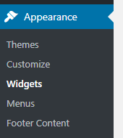
Figure 7
The page will show you all the available widgets and the two Sidebars (1 and 2) where they can be positioned. Sidebar 1 should already be populated with all your widgets.
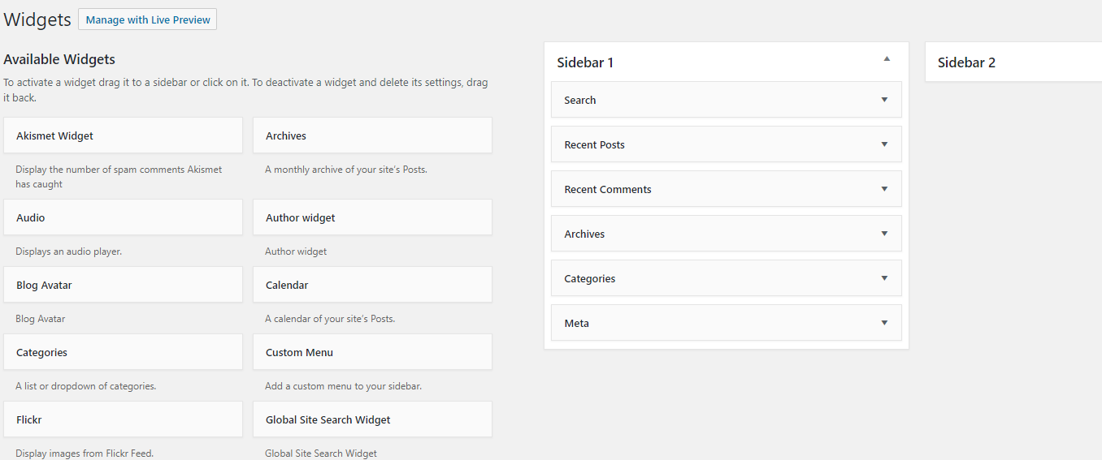
Figure 8

Sidebar 1 is for navigation and can only contain a ‘Custom menu’ widget.
If you use page-menu widget please convert it to a custom-menu.
Please reposition all other widgets, drag&drop each of them from Sidebar 1 to Sidebar 2 as shown below.`
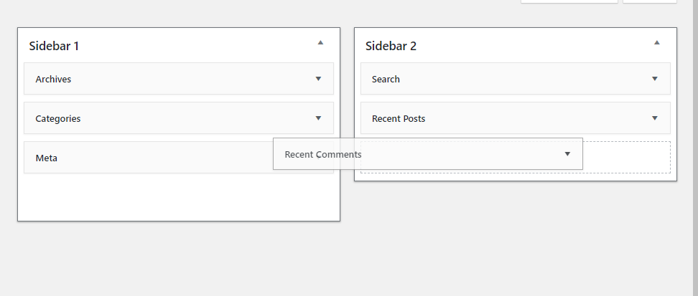
Figure 9

You can find more information about widgets and sidebar here:
http://help.edublogs.org/user-guide/widgets-sidebars/
Since our new Blogging platform offers a wide range of widgets, please feel free to add the ones you think might be useful on your blog.

Other settings
As part of the re-design of the new Blogging service, some functionalities have been removed because they are outdated or unsecure. As a consequence some minor editing changes could be required on widgets. Please check all your widgets and verify their functionality. Replace them or correct their settings if needed.
If you need help, please contact web-support@ucl.ac.uk

Customise Plugins

For security reasons few plugins have been removed. New plugins have been installed in order to provide the same functionalities of our previous Blogging platform. Our new service includes the following plugins and you’re free to choose what to enable and what to enable on your Blog:
https://campuspress.com/docs/plugins/
The following plugins that were available have been substituted by the following ones:
Old plugin | New plugin
Wysija-newsletters | Mailchimp
Comments-notifier | Comment Moderation
Social | Jetpack
Twitter tool | Jetpack
Formbuilder | Formidable-forms
Google-document-embedded | Embed Any Docs
Subscribe2 | Email-subscription
Wordpress SEO | Simple-seo
Yoast SEO | Simple-seo
Google-analyticator | Google Analytics in Settings

If your blog used one of the plugins listed above, please enable and configure the corresponding alternative.
You can find useful information here:
- Newsletter: http://help.edublogs.org/email-subscription/
- Social and Twitter: http://help.edublogs.org/publicize/
- Google document embedded: http://help.edublogs.org/embed-any-document-plugin/
- Subscribe: http://help.edublogs.org/email-subscription/
Please feel free to add, activate and configure all the plugins you want to use on your Blog following the documentation available here:
Plugins available:
- https://campuspress.com/docs/plugins/
User guides:
- http://help.edublogs.org/user-guide/plugins/

Content

Since all the sites have been migrated to the new UCL Indigo theme, some functionalities are no longer available and some tweaking in the content might be necessary.
Iframes
Video or images in iframes are no longer supported. However, it is still possible to embed YouTube videos.
Subtitles
If your blog had a subtitle in the banner, this is no longer supported, please incorporate these as part of your blog introduction text.
Contact Forms
Some of the contact forms might need to be replaced using the new plugins available. Unfortunately it was impossible for us to check every single page on each blog but if you have issue replacing contact-form, please get back to us. We can help.

Subscribe widget
The subscribe widget has now been moved to the sidebar, if your subscribe widget was placed in any other location e.g. the centre of a page can you please remove this to avoid duplication.

Support

There may be certain types of content that will need to be added again due to the migration, please look out for the following on your blog to ensure that nothing is out of place. If you find that something doesn’t look as it did please try to add the content again and this should in most cases resolve the issue:
- Missing author name on posts – please email web-support@ucl.ac.uk
- Small images now look bigger and blurred – Please re-add image to resolve this
- Large white spacing below images and possibly the first paragraph of text – Please remove the space manually
- Text is no longer wrapping around your images – Please re-add image to resolve this
- Text is wrapping around images where it shouldn’t - Please re-add image to resolve this
- Please check your sidebar titles, some may have changed in the transfer
If you are not able to resolve the issue please email web-support@ucl.ac.uk

