Accessibility and the Internet
Contents
Range of Abilities and Quick Tips 4
Auditory Disability (D/deafness) 4
Cognitive and Neurological Disability 4
Physical Disability 4
Speech Difficulties 4
Visual Disability 4
Image Text Alternatives ("alt text") 6
Tips for Appropriate “alt text”: 6
What is not needed in the “alt text”: 6
To check “alt text” with Internet Explorer Web Accessibility Toolbar (IE WAT) 6
To check “alt text” with Firefox Toolbar 7
To check “alt text” with any browser 8
To practice checking “alt text” in W3C’s Before and After Demonstration (BAD) 9
Headings 10
Contrast ratio ("colour contrast") 11
Resize text 13
What to check for when testing text size effects: 14
Resize text checks 14
Keyboard Navigation and Visual Focus 15
How to check navigation 15
Forms and Labels 17
Keyboard access 17
Labels 17
Required fields and other instructions 17
Errors 18
Links 19
Multimedia (video, audio) alternatives 20
What to test for 20
Autostart control 20
Captions/subtitles 20
Transcripts 20
Audio description 21
Basic structure check 22
Important things to be aware of 24
What to test 24
Basic structure checks 25
Considerations for the dyslexic user 25
Colour-blind users 25
Shade-blind users 25
Flash Player 26
PDFs 26
Accessibility Tools For Moodle 26

Web accessibility is a necessary part of web design, allowing disabled users to access all information on the websites in question, regardless of their type of disability. This is also a legal requirement of the Equality Act 2010. W3C has also released a set of guidelines, found here: https://www.w3.org/TR/WCAG20/, for designers’ and editors’ reference.
Additionally, W3C’s Accessible Rich Internet Applications Suite (W3C-ARIA) is aimed at those wishing to include dynamic content in their websites, such as widgets and pop-ups; there is a detailed document available for online viewing, found here: https://www.w3.org/TR/wai-aria-practices.
In this guide, we have used many references to the W3C Web Accessibility Initiative, amongst other sources, such as the British Dyslexia Association and the Royal National Institute of Blind People (RNIB).
More detailed information can be found on the following sites:
http://www.w3.org/WAI/eval/preliminary.html
The following are starting points for gauging the accessibility of your site. This is not exhaustive, but will give you some idea of what you need to consider.
The definition of a disability is a person who ‘has a physical or mental impairment which has a substantial and long-term adverse effect on their ability to carry out normal day-to-day activities.’ (Equality Act 2010)
‘The duty to make adjustments in education (DDA Part 4) and in providing services (DDA Part 3) is an anticipatory one. This means that organisations should continually anticipate the general requirements of disabled people with a wide range of impairments and health conditions rather than simply waiting until a disabled person requests a particular adjustment.’

Range of Abilities and Quick Tips
Disability can cover a multitude of conditions and includes those of auditory, cognitive, neurological, physical, oral and visual types. Some disabilities may occur from birth, be caused by illness or accident, and some are age-related.
Each individual is unique. People have diverse abilities, skills, tools, preferences, and expectations that can impact how they use the Web.
Websites and web tools that are designed for people with a broad range of abilities benefit everyone, including people without disabilities. So, designing a site that is accessible will also make it usable, leading to more people being able to access your site and its data, which will ultimately increase take-up of your service. It is therefore important to consider the broad diversity of functional needs, rather than to categorize people according to medical classifications.

Auditory Disability (D/deafness)
Consideration is needed with all audio content on websites. Make sure to provide an alternative format, be it captions, transcripts, sign language, or ideally all three. Web applications should not rely entirely on voice interaction, such as training materials or podcasts. Media players need to display captions and allow the user to adjust text size and colour, as well as having volume controls for the audio content.

Cognitive and Neurological Disability
Due to concentration, scanning, and short-term memory issues, it is vital to make sure that your website is easy to navigate, has clear layouts, and moving, flashing, or flickering content is avoided. Language should be straightforward, fonts should not be cramped, and good spacing should be standard.

Physical Disability
Avoid overly complex navigation systems and page functions, and remove any time limits for form-filling, to allow the user sufficient time to complete the task without additional stress.

Speech Difficulties
Avoid applications that rely on voice-only interactions; instead, offer other methods of communication besides telephone numbers.

Visual Disability
Ensure that all components of your website have text alternatives (see next section), that video content has audio alternatives, and that the site has simple navigation systems. Be aware of issues with colours and fonts, for those with visual impairments that still have some degree of sight, for whom contrast and clearly-spaced characters may be of particular importance. Avoid red, green, and pink, for the colour-blind, and ensure there is sufficient contrast between the foreground and background colours. Make sure that your website provides full keyboard support for screen-readers such as JAWS (Job Access With Speech). Also avoid the use of images with text superimposed onto the background graphic, which are no more helpful to screen-reader users than images without text.

Image Text Alternatives ("alt text")
Text alternatives ("alt text") convey the purpose of images, describing or explaining them in context. Text alternatives are used by people who have a visual impairment, e.g. people who are blind and use screen-readers can hear the alt text read out.
‘The text should be functional and provide an equivalent user-experience, not necessarily describe the image. (For example, appropriate text alternative for a search button would be "search", not "magnifying glass".)
You don't usually see the alt text on a web page, it is in the web page markup (like this: <img src="pointer_to_image.png" alt="here's where the alternative text goes">). Every image should include alt in the markup.’
(Source: http://www.w3.org/WAI/eval/preliminary.html)
There are automated tests that can tell you if alt is missing. The next section will provide more information. You will however need to check the description against the context in which the image is placed.

Tips for Appropriate “alt text”
- The text needs to convey the same meaning as the image. So if someone is unable to see the image, they get the important information about the image in the alternative text. For example, for an image of a cake on a cookery website, the alt text might include the type of cake; however, the same image on a hotel website may be there just to make the page more interesting, and the image might not need any complex alt text. One way to help think about appropriate alt text is: if you were describing the image to someone over the phone how would you do that?
- Functional images need alt text that is the functional equivalent. The reader needs to know what they do;for example, a submit button.
- If there is text in the image — for example, in an image of a poster — that text needs to be included in the alt text.
- If the image has complex information, such as charts or graphs, the image should have a short alt text to identify the image, and then the detailed description of the information should be provided elsewhere (for example, in a data table). The alt text could say something like this diagram process is described in the text above.

What is not needed in the “alt text”
- The alternative text does not need to include the words "button", "link", or "image of". (Screen readers automatically provide that information.)

To check “alt text” with Internet Explorer Web Accessibility Toolbar (IE WAT)
Download the following and install on Internet Explorer:
http://www.paciellogroup.com/resources/wat-ie-about.html
- Open the web page you are checking.
- In the toolbar, select "Images", then "Show Images". Or, with the keyboard: Ctrl/cmd+Alt+4, then arrow down to "Show Images"
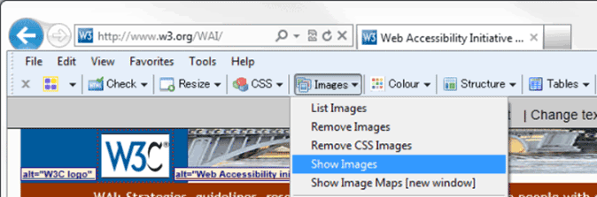
Image Description: Screenshot of IE WAT toolbar
- If there are any images missing alt, a dialog box appears with the number of images without alt attributes.
- The alt text will be displayed before the images in quotes on a light background.
- To check for missing alt: Look for the text "NoAlt!" (visually, or with find-in-page). If you find it, that means the following image is missing alt.
- To check if alt text is appropriate: For each image, see if the alt text adequately conveys the information in the image it is next to, per the Tips above.

To check “alt text” with Firefox Toolbar
To download, and for further information on the Web Developer Extension for Firefox, go to the following link:
http://webaim.org/resources/webdev/
- Open the web page you are checking.
- In the toolbar, select "Images", then "Outline Images", then "Outline Images Without Alt Attributes". Or, with the keyboard: Alt+T, W (to Web Developer Extension), I, O, A
- Red boxes appear around any images missing alt.
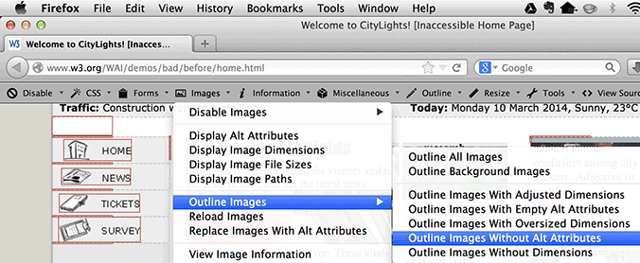
Image Description: Screenshot of FF toolbar; note images without any alt text.
- In the toolbar, select "Images", then "Display Alt Attributes". Or, with the keyboard: Alt+T, W (to Web Developer Extension), I, A
- The alt text will be displayed before the images as white letters on a red background.
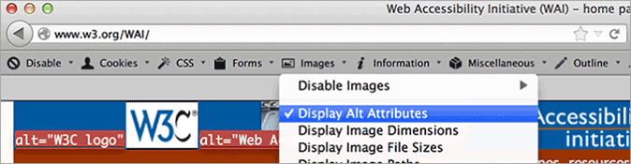
Image Description: Screenshot of FF toolbar
- For each image, see if the alt text adequately conveys the information in the image it is next to, per the Tips above.

To check “alt text” with any browser
- Open WAVE web accessibility evaluation tool web page: https://wave.webaim.org/toolbar/
- Type the website address in the box after "Enter the URL of the web site you want to evaluate:"
- Click the "WAVE this page!" button.
- Your web page will show up in the browser with lots of little icons on it.
- To check for missing alt:
- Look for the red alt icon (), or search for the alt text "ERROR: Missing alt text".
- If you find it, that means the following image is missing alt.
- To test if alt text is suitable:
- Look for the green alt icon (). Next to it is text on a light blue background; the alt text is in between the asterisks (*).
- See if that text adequately conveys the information in the image it is next to, as per the tips above.

To practice checking “alt text” in W3C’s Before and After Demonstration (BAD)
With one of the checks above, use the deliberately-inaccessible home page below as a test page:
www.w3.org/WAI/demos/bad/before/home
Look for missing alt tags as there are many images without tags. Also check for images without the appropriate text such as the ‘Near the top, left, see the long alt text starting with "Red dot with...". That description is much too detailed and includes unimportant information. The appropriate alt text in the accessible page is: "Citylights: your access to the city."’
An example of appropriate alt text is near the top. See the W3C image; the alt text is: "W3C logo".

Headings
Web pages often have sections of information separated by visual headings, for example, heading text is bigger and bold (like "Headings" right above this sentence!). To make this work for everyone, the headings need to be “marked up”. That way people can navigate to the headings — including people who cannot use a mouse and use only the keyboard, as well as people who use a screen reader.
Heading levels should have a meaningful hierarchy, for example:
Heading Level 1 <h1> - there is usually just one page title
Heading Level 2 <h2> this is used for the subtopic of the main heading
Heading Level 3 <h3> these are for different subtopics under the H2 topic
Heading Level 4 <h4> these are used where the H3 covers more than one topic
What to check for:
- That the page has a heading. In almost all pages there should be at least one heading.
- That all text that looks like a heading is marked up as a heading.
- That all text that is marked up as a heading is really a conceptual section heading.
- That the heading hierarchy is meaningful. Ideally, the page will start with an "h1" — which is usually similar to the page title — and will not skip levels; however, these are not absolute requirements.

Contrast ratio ("colour contrast")
Some people cannot read text if there is insufficient contrast between the text and background; for example, light grey text on a light background.
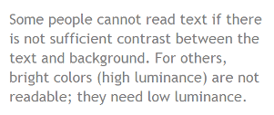
High contrast (for example, dark text on a light background, or bright text on a dark background) is required by some people with visual impairments, including many older people who lose the ability to distinguish between low-contrasting layouts due to ocular degeneration, as well as those with shade blindness.
The following images give text contrast examples:
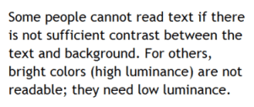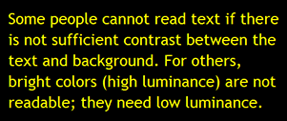
While some people need high contrast, as above, for others — including some people with reading disabilities, such as dyslexia — bright colours (high luminance) are not readable. They need an off white background and a non-glaring contrast, for example, as below.
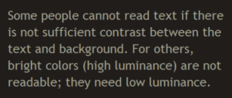
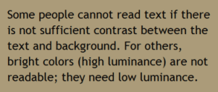
(Image source: http://www.w3.org/WAI/eval/preliminary.html)
Web browsers should allow people to change the colour of both the text and background, and web pages must function the same way even as people change colours.
Here are some things to consider:
Web pages should also have a minimum contrast: a contrast ratio of at least 4.5:1 for normal-sized text is recommended.
There are three main ways to check contrast, each with strengths and weaknesses.
- Table with contrast ratio. The tool displays a table with all the possible contrast ratios in the web page. With some tools, you can click in the table and it will show where that colour combination is in the web page. This is extensive but it can also be inaccurate; it can show some colour combinations that are not really in the displayed page.
http://www.msfw.com/Services/ContrastRatioCalculator
- Eyedropper to select colours. The tool lets you select a text colour and a background colour, then shows you the contrast ratio. It is accurate but can only test one item at a time.
http://webaccess.msu.edu/Tutorials/color-contrast.html
- Turn off colour. The tool shows the page in grayscale. This gives you direct experience of the page’s contrast, but does not generally provide a contrast ratio value.
http://www.unclrd.com/

Resize text
Some people need to enlarge web pages in order to read them. Some need to change other aspects of text display: font, space between lines, etc.
Most browsers allow users to change text size through:
- Text size settings (usually through the Options or Preferences menu)
- Text-only zoom
- Page zoom (which also zooms images, buttons, etc.)
When pages are not designed properly, they can be unreadable when the text size is changed, especially when it is changed through text-only zoom or text settings. Sometimes columns and sections overlap, the space between lines disappears, lines of text become too long, or text disappears, as seen in the following images.
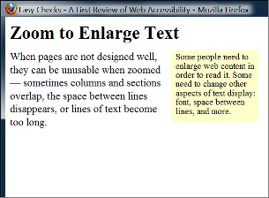
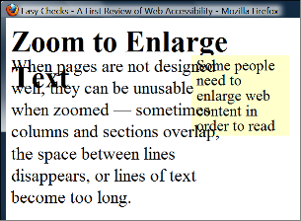
(Image source: http://www.w3.org/WAI/eval/preliminary.html)
The two screenshots above show that when text size is increased on this page, the heading overlaps the main text, the main text overlaps the sidebar text; and the sidebar text is cut off at the bottom.
When text size is increased, sometimes parts of the sentences are not visible and users have to scroll horizontally to read a sentence, as shown in the third image below. Most people cannot easily read text that requires horizontal scrolling, and for some disabled users this is impossible.
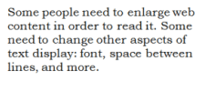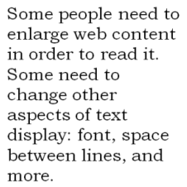
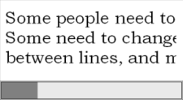
Image Description: The first image, top left, shows normal-size text. In the second image, top right, the larger text "wraps" to fit the width. In the third image, bottom left, some of the larger text is not visible without scrolling horizontally.
(Image source: http://www.w3.org/WAI/eval/preliminary.html)

What to check for when testing text size effects
- All text gets larger. (Be aware that text in images does not get larger when users increase text size.)
- Text doesn't disappear or get cut off when the zoom facility is used.
- Text, images, and other content do not overlap.
- All buttons, form fields, and other controls are visible and usable.
- Horizontal scrolling is not needed to read sentences.
The best practice is as follows: when text size is increased, all the text in a sentence is visible. It is acceptable to have to scroll horizontally for a short distance to get to different sections of a page.

Resize text checks
Each browser will have its own shortcut keys for this operation.

Keyboard Navigation and Visual Focus
Some disabled people cannot use a mouse, and so rely on the keyboard to interact with webpages. People who are blind and/or physically disabled rely on the keyboard, or on assistive technologies and strategies that rely on keyboard commands, such as voice recognition (i.e. Dragon NaturallySpeaking speech-to-text software).
Keyboard focus should be visible and should follow a logical order through the page elements. Visible keyboard focus could be a border or highlight, as shown below, that moves as you “tab” through the web page.
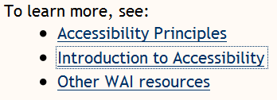
Image Description: Three bullet points, the text of each visually indicating (coloured and underlined) that they contain hyperlinks. The second bullet point’s text is surrounded by a dotted rectangular border.
(Image source: http://www.w3.org/WAI/eval/preliminary.html)
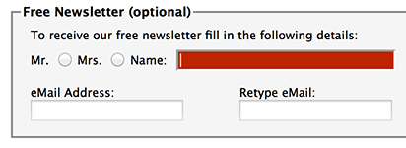
Image Description: The subscription form for a free newsletter is shown, containing radio buttons enabling selection of “Mr” or “Mrs”, text fields labelled “Name:”, “eMail Address:”, and “Retype eMail:”. The name field is highlighted red, with a white cursor inside.
(Image source: http://www.w3.org/WAI/eval/preliminary.html)

How to check navigation
Perform the checks using a browser that supports keyboard navigation with the Tab key (for example, Firefox, IE, Chrome, and Safari).
For browsers on Mac OS, enable keyboard navigation to all controls. This will enable you to use the keyboard fully to navigate around your computer.
In newer browsers this can be done by the following:
- Select System Preferences > Keyboard > Shortcuts
- Select the "All controls" option button
In older browsers:
- Select System Preferences > Keyboard > Keyboard Shortcuts
- In the "Full Keyboard Access" section, check "All Controls"
Use your mouse to click into the web address bar, then let go of it and use the ‘Tab’ key to navigate forward through the site. (To go backwards use the Shift and Tab’ keys together, and to move around combo and drop down boxes use the arrow keys.) When an item has focus, press the Enter key or spacebar to select that item.
Check that:
- You can tab to all the elements, including links, form fields, buttons, and media player controls. (A common problem is that you cannot tab to media player controls.)
- You can tab away from all elements that you can tab into. (A common problem is that the keyboard focus gets caught in media controls and you cannot get out; it's called the "keyboard trap".)
- The tab order follows the logical reading order (e.g., for left-to-right languages: top to bottom, left to right) in sequence.
- The focus is clearly visible as you tab through the elements, that is, you can tell which element has focus, e.g., links have a grey outline around them or are highlighted.
- You can do everything with the keyboard that you can with the mouse; that is, you don't need the mouse to activate actions, options, visible changes, and other functionality. (A common problem is that some functionality is available only with mouse hover, and is not available with keyboard focus.)
- After you tab into a drop-down list, you can use the arrow keys to move through all the options without triggering an action. (A common problem for drop-downs used for navigation is that as soon as you arrow down, it automatically selects the first item in the list and goes to a new page — you cannot get to other items in the list.)
- When images are links, they have clear visual focus and can be activated using the keyboard (usually by pressing the Enter key).

Forms and Labels
Labels, keyboard access, clear instructions, and effective error handling are important for forms’ accessibility.
Form fields and other form controls usually have visible labels, such as "Email Address:" as the label for a text field.
When these labels are marked up correctly, people can interact with them using only the keyboard, using voice input, and using screen readers. The label itself also becomes clickable, which enables a person who has difficulty clicking on small radio buttons or checkboxes to click anywhere on the label text.
Labels, links and buttons need to be labelled consistently, as this will enable the user to have an easier journey through the site.

Keyboard access
Check that all form controls are keyboard-accessible by following the keyboard access checks in the previous section, including checking that you can get to all items in any drop down lists.

Labels
Check that:
- Every form control has a label associated with it using 'label', 'for', and 'id', as shown in the label checks below. (This is best practice in most cases, though not a requirement because a form control label can be associated in other ways.)
- The labels are positioned correctly. For left-to-right languages, labels should usually be:
  - Left of text boxes and drop-down lists.
  - Right of radio buttons and checkboxes.
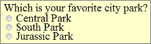
(Image source: http://www.w3.org/WAI/eval/preliminary.html)

Required fields and other instructions
Check that any fields that are required/mandatory are clearly indicated, and that the indicator does not rely on colour alone; for example, if required fields were only indicated by red-coloured labels, they would not be accessible to people who are colourblind.
Make sure the indicator (such as asterisks (*)) is included in the marked up field label for text boxes and drop-down lists, or caption for radio buttons and checkboxes, as shown in the label checks below.
General instructions should usually be at the top of the form or the section they relate to.
Check that required formats, such as dates (year-month-date in the format 0000-00-00), are included in the marked up label, using the labels checks below.

Errors
If you suspect your form(s) may cause error messages, test it; try leaving required fields blank or entering incorrectly-formatted information (such as telephone number or e-mail address), then submit the form. If it doesn’t accept the submission and errors show, look to see that:
- Clear guidance is provided to help people understand and fix the error. If the error concerns a format such as date, time, or address, check that the correct format is clearly explained. E.g. ‘password is too short and must be at least 8 characters long’
- The errors are logically placed. It is generally best if the error messages are before the form, rather than after the form.
- The fields without errors are still populated with the data you entered. (This is best practice though, not a requirement.) People should not have to re-enter all the information in the form, except for some sensitive data such as credit card numbers or passwords.
There should also be an option to change or reverse submission in case of mistakes. The user should not need to have good eyesight or hearing to pass a spam control to submit a form; provide a simple question form instead. Also try to avoid time-limited completions.

Links
All links need to have text content. However, the mistake of just labelling the link ‘Click Here’ is a common one; bear in mind that a blind user will have no way of knowing to where or what this link refers.
If a link needs to open a new window, provide a warning that this will happen, either within or before the link.

Multimedia (video, audio) alternatives
Information in podcasts or other audio or video is not available to people who are deaf or some people who are hard of hearing, unless it is provided in an alternative format, such as captions/subtitles and/or text transcripts. Visual information in videos is not available to people who are blind or some people what have low vision, unless it is provided in an alternative format such as audio or text, ideally both. (Text can be read by a screen reader or Braille display, or enlarged and reformatted for people with low vision.)
Remember these easy checks are not comprehensive or definitive.

What to test for
Follow the steps for keyboard access, given in a previous section, to ensure that the media player controls are labelled and keyboard-accessible.

Autostart control
It is best if audio (including background noise and video with sound) does not start automatically when a web page opens. If it does start automatically, it should either:
- Stop after 3 seconds.
- Include controls to pause or stop the audio, which are clearly defined and ideally not reliant on mouse control alone.
- Include controls to turn down the volume, which are clearly defined and ideally not reliant on mouse control alone.

Captions/subtitles
Most video on the web that provides captions has "closed captions" that can be turned on and off. ("Open captions" are always shown.) For example, in YouTube, you turn on captions with the text image button, which is a small oblong box with lines representing text near the bottom. If there is no text image button visible, there are no captions available for that video.
Best practice is as follows:
- The captions should seem in sync with the spoken content
- The people who are speaking should be identified when they speak
- Important sounds other than dialogue — e.g., footsteps approaching, doors closing, glass breaking — should be included

Transcripts
It is best practice to provide both captions and transcripts, although not always required, and the transcripts should be easy to find near the audio/video itself.
Check that transcripts include all audio information, including dialogue with the speakers identified, and all important sound; for example, footsteps approaching, doors closing, glass breaking. A person should be able to access all the content of the video by reading the text.

Audio description
This is the description of important visual information in a video, in order to make it accessible to people with visual impairments. For example, some videos start out with a title in text, have speaker names in text, and have illustrations. That visual information needs to be provided to people who cannot see the video.
It can be provided through two formats. Audio description, where the audio track includes someone describing the important visuals, and can be included in the main video, or it can be provided in a separate video. Text transcripts include description of all meaningful visual information (much like a screenplay). Again, ideally both formats should be provided, since your video may have viewers with both auditory and visual impairments.

Basic structure check
Websites are usually designed with multiple columns, sections, and colours, to aid understanding of the information. However, many disabled people have difficulties accessing these layouts, and have to modify them. These include those with visual impairments as well as scanning difficulties, as is commonly faced by dyslexics. The blind may use screen readers or a Braille display to access the data; others may have to modify the page layout into a linear format, as well as change the text size and other elements.
A major issue is how the web page works when it is linearised into one column and the presentation is changed, as shown in the images below.
The images below illustrate how a web page is displayed in 3 columns by default and how it can be changed.
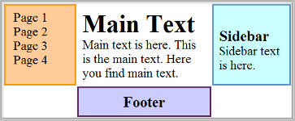
Image Description: The default display of three columns, with the navigation at the left.
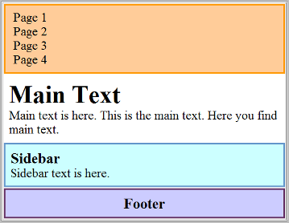
Image Description: The same page as in the previous figure, converted into one column, with the navigation at the top.
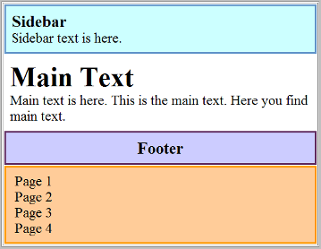
Image Description: The same converted page as in the previous figure, with the navigation at the bottom. The order of the sections (e.g., navigation at top or bottom or elsewhere) depends on how the web page has been developed — the user usually cannot control the order, and therefore the developer needs to be aware of this.
(Image source: http://www.w3.org/WAI/eval/preliminary.html)
When you follow the basic structure checks, your page will look like something like this:
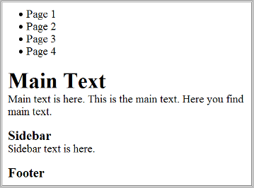
Image Description: The same converted page as in the previous figures, with styles turned off.
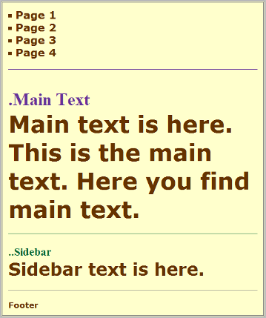
Image Description: The same page as in the previous figures, this time changed to make it more readable; for example, the main text is big, the footer text is very small, and the headings are a different colour.
(Image source: http://www.w3.org/WAI/eval/preliminary.html)
Having an experienced screen reader user check the web pages is ideal, but this is not always possible, so below are the steps describing how to disable images, disable styles for how the page is usually displayed, and linearise the page to check the page structure.

Important things to be aware of
- Data tables will not make sense when linearised — this is not an issue, because screen readers have functionality to make data tables usable, as long as they are marked up correctly.
- BAD provides a clear example of how the basic structure check reveals accessibility barriers. Use the inaccessible home page at: www.w3.org/WAI/demos/bad/before/home

What to test
- Turn off images and show the text alternatives (see previous section for this)
- Turn off style sheets (CSS), which specifies how the page is displayed with layout, colours, etc
- Linearise the page or the tables

Basic structure checks
- The information makes sense when read in the order it is shown; for example, headings are right above the information they apply to
- The alternative text provides adequate information for the missing images
- Blocks of information have clear headings (see also the Headings section above).

Considerations for the dyslexic user
- Use a plain font such as Arial or Comic Sans that are evenly spaced and ‘sans serif’
- Avoid underlining and text in block capitals, instead use bold styling
- Left justified text with a ragged right edge
- Avoid dense paragraphs and lines that are too long. Try to use a direct simple style to get your information across. You can check the readability of your text in Word by going to File – Options – Proofing and under spelling and grammar tick the ‘Show readability statistics’ or by using the following application:
http://www.hemingwayapp.com/beta/index.html
- Bullet points and numbering are helpful for clarity
- Avoid image carousels and flashing imagery
- Space out phone numbers in “blocks” to make them easier to read, e.g. 0207 679 2000
- Most users prefer an off white background

Colour-blind users
Try to avoid green, red, or pink as distinguishing colours, as these are difficult for colour-blind individuals.

Shade-blind users
Avoid too many subtle shades of colour as they make it difficult for the shade-blind user to read the information.
Note: A tip for designers is to print out the website in monochrome, to see how shades affect the legibility and clarity of the page’s appearance.

Flash Player
Info for accessible video: http://www.adobe.com/uk/accessibility/products/flash.html

PDFs
Adobe Acrobat has an inbuilt accessibility feature that will help you make your documents more accessible to the disabled user. This can be found under the Edit menu – Accessibility – Setup Assistant.
https://helpx.adobe.com/acrobat/using/create-verify-pdf-accessibility.html

Accessibility Tools For Moodle
There is a version of ATbar which allows you to embed the code for ATbar within your website, and this should work with Moodle. This provides accessibility tools from within your webpages.
https://moodle.org/plugins/view.php?plugin=block_accessibility

http://www.access-for-all.ch/en/pdf-lab/pdf-accessibility-checker-pac.html
labelling decorative
https://www.w3.org/WAI/tutorials/images/decorative/

http://webaim.org/techniques/alttext/#decorative

labelling functional
http://webaim.org/techniques/alttext/
http://webaim.org/techniques/alttext/#functional
labelling informative
https://www.w3.org/WAI/tutorials/images/informative/
http://webaim.org/techniques/alttext/#basics
text
https://www.w3.org/WAI/tutorials/images/textual/
Complex images
https://www.w3.org/WAI/tutorials/images/textual/
http://webaim.org/techniques/alttext/#complex

group images
https://www.w3.org/WAI/tutorials/images/groups/

Image maps/organisational charts
https://www.w3.org/WAI/tutorials/images/imagemap/
http://webaim.org/techniques/alttext/#imagemaps

