Do… |  | Don’t…
Use a combination of colour, shapes, and text to convey meaning |  | Use colour alone to convey meaning
Align all text left and use 1.5 line spacing |  | Justify text or align to centre or right
Use headings in sentence case, sub-headings, and bullets to break up information |  | Make complex or cluttered layouts and menus
Use heading styles in online text boxes and Microsoft Word documents | <h1>  AaBbCc | Rely on text size and layout for structure | 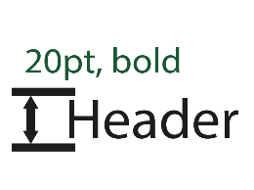
Add alternative (alt) text to images and transcripts for videos | <alt> | Provide rich media content without a text alternative
Use good colour contrasts and a readable font | 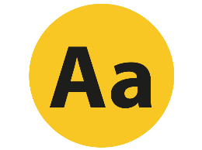 | Underline words, use italics, or write in capitals | DON’T DO THIS
Use a textbox to increase contrast between images and text |  | Use text over images or patterned backgrounds
Write descriptive and meaningful headings and hyperlinks | Contact us | Write uninformative links and headings | Click here
Add captions to audio and video content | 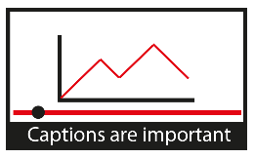 | Automatically play audio and video content

Remember…
In depth guidance, tips, and further support relating to the design of digitally accessible material can be found at www.ucl.ac.uk/digital-accessibility or email digital-accessibility@ucl.ac.uk
‘Digital accessibility guidance’ by UCL Digital Education is adapted from the Government Digital Service‘s ‘Dos and don'ts, designing for accessibility’ posters, ‘Designing for diverse learners’ developed by Lee Fallin and Sue Watling at the University of Hull, and ‘Digital Accessibility Checklist’ from York St John University.

