Communication through Art
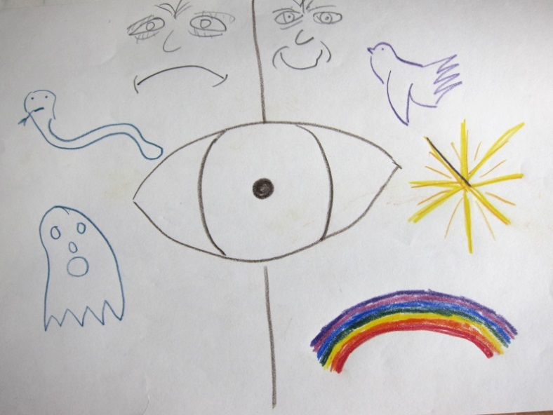
Picture 1 (from the patient): This displays a view of life with an eye condition. The rainbow is an expression of support for the hospital and the hope that it brings.

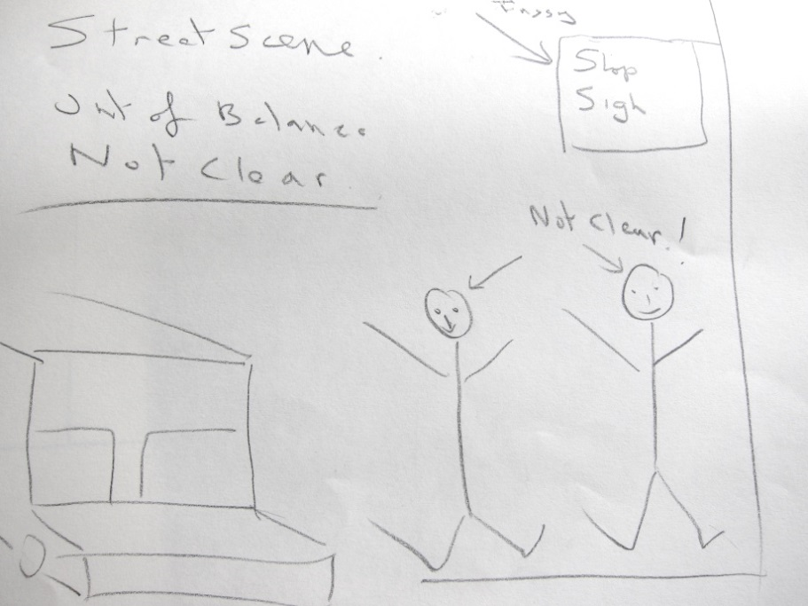
Picture 2 (from the patient): This demonstrates the experience of change in vision and the frustrations of living with a retinal disease and ultimately the restrictions it can have on daily life.

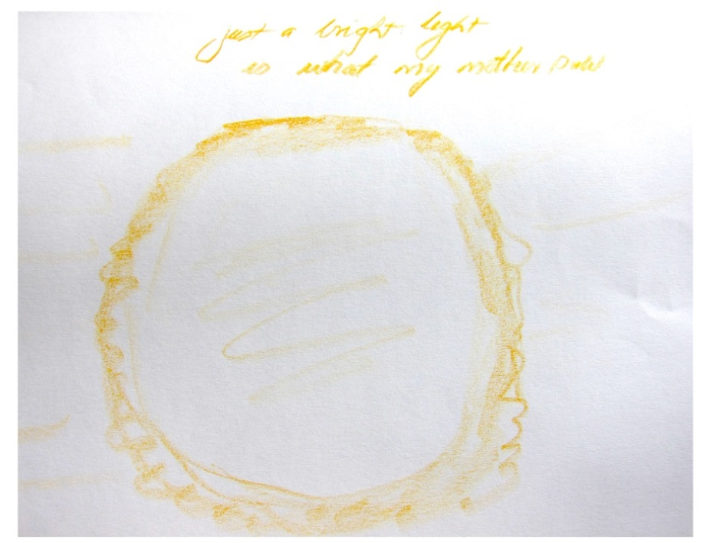
Picture 3: A supporter describing his mother’s eye sight and her level of vision; perception of light.

