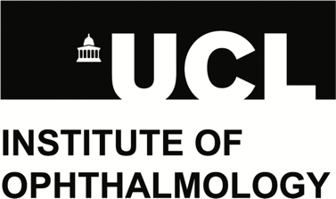

UCL Institute of Ophthalmology
Research Pathways in Advanced Therapeutics Scholarship
2021/22
Motivation Letter Form

Motivation Letter Form
Personal data given to the UCL Institute of Ophthalmology will be processed in accordance with the UK Data Protection Act 2018 which incorporates the General Data Protection Regulations (GDPR). The information you give will be used for the following purposes:
- to enable UCL Institute of Ophthalmology to create a record of your application
- to enable the application to be processed
The information will be kept securely, and will be kept no longer than necessary.
Part 1: Personal details
This section will not influence the outcome of your application.
Title (Ms, Miss, Mrs, Mr etc)
Full name
Date of birth
UCL Student ID
Programme Applied
Nationality
Email address
Contact number

Part 2: Personal Statement

This section will influence the outcome of your application. You are advised not to copy and paste content from your Personal Statement or from the internet.

Please give a brief description in no more than 250 words about your motivation for applying to the scholarship.

You can save your statement as a Word/PDF file if you prefer and email it to ioo.admissions@ucl.ac.uk. Please make sure the file name includes “UCL Institute of Ophthalmology Adv. Therapeutics Scholarship” and your full name.

