Clause

HEAD OF BRAIN BANK:
Professor T Warner BM BCh PhD FRCP
DIRECTOR OF RESEARCH:
Professor T Lashley PhD
NEUROPATHOLOGIST:
Dr Z Jaunmuktane MD FEBP EFN FRCPath

QSBB MTA ADMINISTRATORS:
Mrs Kate Strand and Miss Cheryl Pearce
All correspondence to:
QUEEN SQUARE BRAIN BANK FOR NEUROLOGICAL DISORDERS
UCL QUEEN SQUARE INSTITUTE OF NEUROLOGY

1 WAKEFIELD STREET

LONDON WC1N 1PJ

TEL: 020 7837 8370
FAX: 020 7278 4993
email: qsbbmtas@ucl.ac.uk

MTA EXPIRY DATE: [INSERT DATE]. UCL PI 2021-01-26 v8A.

QUEEN SQUARE BRAIN BANK FOR NEUROLOGICAL DISORDERS:

IoN HTA MTA UCL REF.: QSBB ............ 202-.

SUPPLY AGREEMENT FOR PROVISION OF HUMAN TISSUE SAMPLES AND

TISSUE DONOR INFORMATION WITHIN UNIVERSITY COLLEGE LONDON FOR RESEARCH PURPOSES ONLY (IoN HTA)

BETWEEN:
- Name, Department and address of the Principal Researcher

(“RECIPIENT”)
AND
2. University College London, Gower Street, London WC1E 6BT, England.
("PROVIDER")

WHEREAS
A. This Material Transfer Agreement (MTA; “Agreement”) contains the terms and conditions under which the PROVIDER, acting through the UCL Queen Square Institute of Neurology, 23 Queen Square, London WC1N 3BG, has agreed to provide the RECIPIENT with human samples which consist of or include whole cells, namely post-mortem tissue, surplus biopsy or surgical tissue, non-transplantable tissue, body fluids, primary cell cultures (whole explant/biopsy present) or microdissected cells, as described in the Appendix A (the “RESEARCH PROJECT”) of this Agreement. The term “TISSUE” means human material (excluding gametes, embryos, or cells that have

divided in culture) which consists of or includes human cells and so is considered to be “Relevant Material” for the purposes of the Human Tissue Act 2004 and the Human Tissue Authority (HTA).

B. The TISSUE is for use only in the specific research project as described in Appendix A (“RESEARCH PROJECT”) to be undertaken by [INSERT NAME] (the “PRINCIPAL RESEARCHER”) who is an employee of University College London (UCL). If the PRINCIPAL RESEARCHER is replaced the RECIPIENT will provide the name and contact details of the replacement PRINCIPAL RESEARCHER to the PROVIDER.

C. The MTA Approval Committee or the equivalent approval system for the PROVIDER’S Tissue Bank must approve the scientific merits of the RESEARCH PROJECT described in Appendix A. In some Tissue Banks the MTA Approval Committee is also able to give ethical approval if the Tissue Bank has authorization from their NHS Research Ethics Committee (REC). If confirmation that the Tissue Bank can provide ethical approval is included in the Letter of Approval in Appendix B, the RECIPIENT may request ethical approval in Appendix A. The ethical approval granted by a MTA Approval Committee is only for the specific RESEARCH PROJECT described in Appendix A, and will not be valid when this Agreement expires or is terminated, and is for a RESEARCH PROJECT which is conducted in the U.K.. If the Tissue Bank is unable to grant ethical approval the RECIPIENT must obtain a NHS Research Ethics Committee approval letter for the RESEARCH PROJECT, and this letter must be attached at Appendix E.

D. TISSUE will be provided with information (“TISSUE INFORMATION”) about the individual samples listed in Appendix A under ‘Request by Recipient’. A Tissue Bank representative will determine the information about Donors ("DONOR INFORMATION”) of the provided samples which would be made available to the RECIPIENT. The DONOR INFORMATION may be the basic information of age, gender, disease duration, cause of death and the interval between death, or sample removal from living donors, and the preservation of samples for research studies. Any additional DONOR INFORMATION must be requested in Appendix A under ‘Request by Recipient’ of this MTA, or subsequently in an Amendment to this MTA. The PROVIDER will fully anonymise all DONOR INFORMATION with study-specific coding. The RECIPIENT shall not attempt to identify any of the tissue donors.

E. The TISSUE INFORMATION and DONOR INFORMATION will be sent by e-mail to the RECIPIENT after the samples have been received. The RECIPIENT will hold the TISSUE, TISSUE INFORMATION and DONOR INFORMATION on the terms of this Agreement and solely for the purpose of the RESEARCH PROJECT as described in Appendix A within the Research Group of the PRINCIPAL RESEARCHER. If small amounts of additional TISSUE with TISSUE INFORMATION, basic DONOR INFORMATION, or additional DONOR INFORMATION relevant to this study are needed, the PRINCIPAL RESEARCHER should contact the Tissue Bank to request a MTA AMENDMENT Form (Clause 17).

IT IS HEREBY AGREED AS FOLLOWS

1. The PROVIDER represents and warrants that the consent obtained for TISSUE donation, and the procurement and storage of TISSUE and the DONOR INFORMATION for research studies are in accordance with the Human Tissue Act 2004, the HTA Codes of Practice, the PROVIDER'S relevant NHS Research Ethics Committee approval(s), and other relevant laws and guidelines. The UCL Queen Square Institute of Neurology has been granted the HTA Licence Number 12198 in the Research Sector. A copy of the PROVIDER’S NHS Research Ethics Committee approval(s) which is relevant to the TISSUE and DONOR INFORMATION supplied is attached at Appendix B.

2. The TISSUE and DONOR INFORMATION supplied to the RECIPIENT have been obtained from living donors for whom written informed consent was given by the donor, next of kin or person with power of attorney for the donor's TISSUE and DONOR INFORMATION to be used for research purposes, and/or for whom written informed consent was given after the death of the donor by their next of kin or person with power of attorney. Sample copies of the current Tissue Bank, Laboratory or Hospital Consent Form(s) used by the PROVIDER are attached to this Agreement at Appendix C. Should an individual donor, or donor’s next of kin, rescind consent the PROVIDER will notify the RECIPIENT and the RECIPIENT will agree to discontinue use of the TISSUE and return any remaining TISSUE concerned to the PROVIDER in accordance with the PROVIDER’S instructions.
3. The PROVIDER warrants to the RECIPIENT that no payments were made or other inducements given to any donor or next of kin or other consenting person to procure the TISSUE or DONOR INFORMATION.

4. The RECIPIENT hereby agrees to comply and procure that the PRINCIPAL RESEARCHER and all their personnel who work with the TISSUE, TISSUE INFORMATION and DONOR INFORMATION comply with the terms and conditions in this Agreement. The RECIPIENT may pass the TISSUE, TISSUE INFORMATION and DONOR INFORMATION on to its employees solely for performance of this RESEARCH PROJECT, but may not transfer, receive payment for, or licence the TISSUE, TISSUE INFORMATION or DONOR INFORMATION to any third party. The exception to this is the permitted outsourcing, without prior written consent from the PROVIDER, of TISSUE samples to a third party only for the purposes of using methodology(ies) not available in the RECIPIENT’S Laboratory that are necessary for performance of this RESEARCH PROJECT. The RECIPIENT shall ensure that relevant terms and conditions of this Agreement are formally agreed through a Third Party Agreement (TPA) between University College London and the third party, and DONOR INFORMATION should not be given to such third parties. The RESEARCH PROJECT may include DNA and RNA analyses and gene expression studies in line with the donor consent and the Codes of Practice of the Human Tissue Authority. All TISSUE is for research purposes only and the RECIPIENT will not use the TISSUE for Human Application (i.e. patient treatment), as that term is defined in the Human Tissue (Quality and Safety for Human Application) Regulations 2007 (or equivalent as may be replaced or amended from time to time), or for any other clinical or diagnostic purposes.

5. The RECIPIENT shall make no payment for the TISSUE samples, but the RECIPIENT will make appropriate payment to assist with the costs for TISSUE retrieval, assessment and storage, and reasonable administration costs for TISSUE INFORMATION, DONOR INFORMATION and arranging sample transport. These costs will be agreed between the PROVIDER and the RECIPIENT prior to any transfer of the TISSUE, TISSUE INFORMATION and DONOR INFORMATION. No payment will be made to the PROVIDER by the RECIPIENT in respect of any invention or discovery arising from the use of the TISSUE and DONOR INFORMATION. The RECIPIENT shall own the results of the research and resulting intellectual property rights arising from the RECIPIENT’S use of the TISSUE, TISSUE INFORMATION and DONOR INFORMATION.

6. Upon the RECIPIENT'S request, the PROVIDER shall provide the RECIPIENT with technical information necessary for the safe handling, storage and use of the TISSUE. The PROVIDER will retain for reference any tissue sections which have been stained by the PROVIDER to characterize TISSUE passed to the RECIPIENT.

7. The PROVIDER will arrange for and the RECIPIENT will cover the costs for all transport of the TISSUE. The RECIPIENT will supply the PROVIDER with, or pay the PROVIDER for, all slides, tubes, containers, packaging and labelling as required by the PROVIDER to provide the RECIPIENT with the TISSUE. To minimize the possibility of damage or loss, the required packaging must be robust and clearly labelled with the RECIPIENT'S name, address and contact details. Prior to sample transport to the RECIPIENT, the PROVIDER will e-mail the RECIPIENT the "Dispatch and Confirmation of Receipt Form" attached to this Agreement at Appendix D. Also in advance of transportation the PROVIDER must give the courier company or the individual who would be transporting the samples detailed information on how the samples are to be preserved during transport, including maintenance of the correct temperature, and on any known potential biological (e.g. infection), chemical (e.g. formalin) or other hazards (e.g. transport in dry ice).

8. The courier must endeavour to prevent damage, loss or theft of the transported TISSUE. It must be ensured by the courier that the transport containers are held in place securely to prevent them moving during transport, and that the specified optimal temperature conditions are maintained throughout all stages of the delivery process. The vehicle transport compartment must be windowless and kept locked until delivery to the RECIPIENT. To acknowledge the safe receipt of TISSUE, the RECIPIENT must as soon as possible send by e-mail or fax the completed "Dispatch and Confirmation of Receipt Form" (Appendix D) to the PROVIDER. The storage conditions for preservation of the tissue samples by the RECIPIENT and any associated hazards are specified on this Form. If TISSUE is transported by a courier company RECIPIENT must also send a copy of the courier company’s signed delivery Form to the PROVIDER. The risk and responsibility (i.e. custodianship) for the TISSUE shall pass to the RECIPIENT when the courier company’s delivery form has been signed at the RECIPIENT’S institution, or the RECIPIENT has collected the TISSUE from the PROVIDER.

9. On receiving custodianship of the TISSUE, TISSUE INFORMATION and DONOR INFORMATION, the RECIPIENT will then be responsible for their appropriate secure storage and use. The RECIPIENT may use the TISSUE, TISSUE INFORMATION and DONOR INFORMATION only for the RESEARCH PROJECT stated in Appendix A, and in accordance with the RECIPIENT’S NHS Research Ethics Committee approval(s) attached at Appendix E if ethical approval is not granted by the Tissue Bank. The RECIPIENT agrees to obtain the written consent of the PROVIDER if there is any change to the proposed use of the TISSUE and DONOR INFORMATION.

10. Both Parties shall keep confidential all details of this Agreement and any Amendment to this Agreement, but if requested by other Parties approved by the Recipient organization the following information only may be given: The name and address of the Recipient organization; name of Principal Investigator and academic Department; name and address of University College London; name of Tissue Bank; title of the Research Project as given in Appendix A; and the duration of the Agreement. This obligation of confidentiality shall survive termination of the Agreement for five years. The obligations of confidentiality shall not apply to any information (i) that the receiving party can show was known to the receiving party in advance of receipt from the disclosing party; (ii) is in the public domain or subsequently becomes publicly known through no fault, act or omission of the receiving party; (iii) is received by the receiving party without restriction from a third party lawfully entitled to make the disclosure to the receiving party without any such restriction; (iv) is developed by the receiving party independently and without the aid or benefit of the information obtained from the disclosing party; (v) the receiving party is required to disclose by law, government regulation or court order provided the receiving party notifies the disclosing party of such requirement in advance of disclosure.

11. Each Party shall ensure that its activity under this Agreement shall comply fully with applicable laws and guidance, including but not limited to the current Codes of Practice of the Human Tissue Authority and all other relevant local and government laws, regulations and guidelines which are applicable during the period of this Agreement. These include Health and Safety, environmental laws, and the General Data Protection Regulation (GDPR) 2018 together with the U.K. Data Protection Act 2018 with regard to the DONOR INFORMATION.

12. To comply with safety legislation, the RECIPIENT is required to carry out formal Risk Assessments and produce Standard Operating Procedures for all research work involving the TISSUE and DONOR INFORMATION. As samples may contain viruses, latent viral genomes or other infectious agents, the RECIPIENT must ensure that samples are stored, utilized for research, and also disposed of when rendered acellular as if not free from such possible contamination. The RECIPIENT warrants to assume full responsibility for training all personnel in procedures for the safe handling of human tissues. The PROVIDER warrants to have taken all reasonable precautions in supplying the TISSUE to the RECIPIENT and accepts no liability for any potential risks associated with the RECIPIENT'S use of the TISSUE. Except as expressly stated herein, the RECIPIENT acknowledges that the TISSUE is experimental in nature and the PROVIDER makes no representation and gives no warranty or undertaking of quality or fitness of the TISSUE, TISSUE INFORMATION or DONOR INFORMATION for any particular purpose or that their use will not infringe any patent, copyright, trade mark or other property right owned by any third party.

13. The PROVIDER will send the RECIPIENT Annual Progress Report Forms on Sample Use (Appendix F), which include the Final Progress Report on the RESEARCH PROJECT that is described in Appendix A. The PROVIDER will send the first Progress Report Form to the RECIPIENT about one year after the date of the most recently received samples and/or DONOR INFORMATION. The completed Form will be held in confidence by the PROVIDER.

14. The PRINCIPAL RESEARCHER agrees to provide appropriate acknowledgement of the Tissue Bank as the source of the TISSUE, TISSUE INFORMATION and DONOR INFORMATION in all written publications, both in the Methods and Acknowledgements Sections, or in oral presentations reporting on the use of the TISSUE and/or DONOR INFORMATION (Appendix F). The PRINCIPAL RESEARCHER will provide a copy of written publications at least twenty (20) days in advance of submission for publication. The PROVIDER agrees not to share such advance copy with any third party until published. To avoid the identification of DONORS, only the very minimum amount of fully anonymised DONOR INFORMATION should be published in any format, which includes genomic, genetic or any other type of database that would be available for either public or restricted access. The RECIPIENT must obtain written consent from a Tissue Bank representative to publish any additional DONOR INFORMATION that may be made available by the PROVIDER.

15. At any time, the PRINCIPAL RESEARCHER and Tissue Bank representative(s) may agree that collaborating with each other in the performance of this RESEARCH PROJECT will be of mutual benefit, further research objectives and foster the development of scientific knowledge. If this has been agreed the Tissue Bank representative(s) will be included in any publication as co-author(s), unless requested otherwise by a Tissue Bank representative. These obligations shall survive termination of this Agreement indefinitely.

16. Unused tissue must be returned when this Agreement expires, or the RECIPIENT notifies the PROVIDER that the RESEARCH PROJECT is completed or terminated, or if any remaining TISSUE is no longer required, or if the RECIPIENT’S non-generic Research Ethics Committee approval(s) attached at Appendix E expires, whichever is the sooner. Samples which have been homogenized or rendered acellular by other means should be disposed of by the RECIPIENT under the regulations of their establishment. However samples containing whole cells, or tissue sections on slides or in tubes, must be returned to the PROVIDER for disposal in a lawful and respectful manner in compliance with the Human Tissue Act 2004, HTA Codes and UCL Policies (Appendix F). The RECIPIENT must document in detail and return all unused TISSUE to the PROVIDER in appropriately labelled containers and packaging unless a new Agreement is approved by the PROVIDER, and/or new Research Ethics Committee approval is obtained. A copy of any non-generic new approval by the RECIPIENT’S Research Ethics Committee must be sent to the PROVIDER within thirty (30) days of notification of such approval.

17. This Agreement shall take effect from [insert date, 202x], and shall be for a maximum period of [insert number] (digit) years, expiring on [insert date, 202x]. Within the duration of this MTA if the RECIPIENT wishes to request small amounts of additional TISSUE with TISSUE INFORMATION; basic DONOR INFORMATION; additional Donor Information; or to make minor changes to the methodologies included in Appendix A, the PRINCIPAL RESEARCHER should utilize a UCL Queen Square Institute of Neurology MTA AMENDMENT document. This MTA would be modified only to the extent expressly stated in the AMENDMENT(S). All other provisions specified in the MTA would remain unchanged and in full force and effect, including the expiry of the MTA and also the AMENDMENT(S) on the date stated in the MTA. In the event of breach of this MTA, or any Amendment to this, by the RECIPIENT and following failure to remedy such breach within 30 days, the PROVIDER may terminate the MTA on 30 days written notice being given to the RECIPIENT.

18. Official notices shall be in writing and may be given by hand or sent by first class post, as a PDF e-mail attachment, or facsimile addressed to the signatories of this Agreement. If delivered by hand, service shall be deemed to have been given upon delivery. If sent by post, service shall be deemed to have been given 48 hours after posting, and if sent electronically as a PDF attachment or facsimile shall be deemed to have been given on the date of transmission provided that a successful transmission report is held by the sender and a copy of the PDF attachment or facsimile and the transmission report is sent by post to the RECIPIENT. Informal comments and concerns may be made in writing by either party by post, e-mail or facsimile to the relevant Tissue Bank or Laboratory Manager, contact details for whom are given in Appendix A.

IN WITNESS WHEREOF this Agreement, HTA MTA UCL PI REF: QSBB ........ 202-, has been signed by the duly authorised representatives of the RECIPIENT and the PROVIDER.

For and on behalf of the RECIPIENT

Title: Principal Researcher.

Signature:

Name in capitals:

Date:

For and on behalf of the PROVIDER

Confirmation by the HTA Person Designated (PD) for the Queen Square Brain Bank for Neurological Disorders at the 1, Wakefield Street Satellite Site under the UCL Institute of Neurology HTA Licence number 12198 (Research Sector) that the RESEARCH PROJECT detailed in Appendix A has been approved by this tissue bank's MTA Approval Committee, and has also granted Tissue Bank ethical approval: OR the RECIPIENT has NHS Research Ethics Committee approval:

Signature:

Name in capitals: DR. ZANE JAUNMUKTANE

Date:

Title: HTA Designated Individual for the UCL Queen Square Institute of Neurology HTA Licence number 12198.

Signature:

Name in capitals: PROFESSOR MARIA THOM

Date:

HTA MTA UCL PI REF.: QSBB ........ 202-.

APPENDIX A
TO BE COMPLETED BY THE PRINCIPAL RESEARCHER FOR THIS PROJECT
TITLE OF RESEARCH PROJECT:

PLEASE OUTLINE OF YOUR PROJECT IN LAY TERMS

SCIENTIFIC BACKGROUND:

AIMS OF THE RESEARCH PROJECT:

Continued.

Appendix A Continued:
INVESTIGATION PLAN:

Continued.

Appendix A Continued:
SAMPLES REQUESTED BY THE RECIPIENT:

Neurological disease(s) and number of cases from which samples are required:

Number of normal control cases from which samples are required:

Sample Preservation: Flash frozen, snap frozen, slow frozen, formalin-fixed and paraffin-embedded, formalin-fixed, other fixative, unpreserved or other format:

Sample Type: Tissue blocks, slices, finely dissected samples, sections on slides, sections in tubes, cells, primary cultures, body fluids or other sample type:

Required sample size, weight, thickness or volume:

CNS area(s) and numbers of each type of sample from these CNS areas:

Continued.

Appendix A Continued.
PRINCIPAL RESEARCHER FOR RESEARCH PROJECT (Title; full name):

Position:

Laboratory address for TISSUE delivery:

e-mail address:
Tel. No.: Fax No.:
Name of research funding bodies for the proposed RESEARCH PROJECT:

- In signing this Agreement the PRINCIPAL RESEARCHER on behalf of the RECIPIENT confirms a Third Party Agreement will be in place prior to transfer of TISSUE under the RESEARCH PROJECT to any third party(ies) only for the purpose of outsourcing methodologies.
- The PRINCIPAL RESEARCHER will send the PROVIDER an annual Progress Report on Sample Use, and also the Final Report (Appendix F).
- The PROVIDER would appreciate information on individual anonymised cases obtained through the RECIPIENT'S research studies which could further characterize TISSUE held by the PROVIDER.
- I agree to acknowledge the Tissue Bank as the TISSUE and/or DONOR INFORMATION source in all publications, and to provide a copy of all written publications at least twenty (20) days in advance of submission for publication. If this is a collaborative project, Tissue Bank representative(s) will be included as co-author(s).
PRINCIPAL RESEARCHER’S signature:

Name in capitals:

PLEASE STATE YES OR NO:
Ethical approval for the specific RESEARCH PROJECT described in Appendix A is requested from the PROVIDER'S Tissue Bank MTA Approval Committee: YES / NO
OR
A copy of the RECIPIENT’S current NHS Research Ethics Committee Letter of Approval for this RESEARCH PROJECT is attached to this Agreement at Appendix E: YES / NO
If required this RESEARCH PROJECT has also been approved by the RECIPIENT’S Research and Development (R & D) Department or equivalent organization.
Name and address of PROVIDER Tissue Bank/Laboratory Manager: QUEEN SQUARE BRAIN BANK FOR NEUROLOGICAL DISORDERS INFORMATION
e-mail address:
Tel. No.: Fax No.:

APPENDIX B

COPY OF THE NHS ETHICS COMMITTEE APPROVAL FOR THE PROVIDER’S RESEARCH TISSUE BANKS, MAY 2018
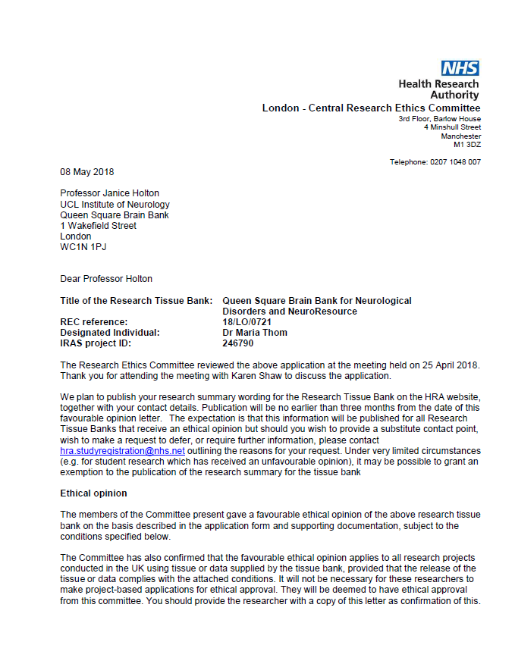
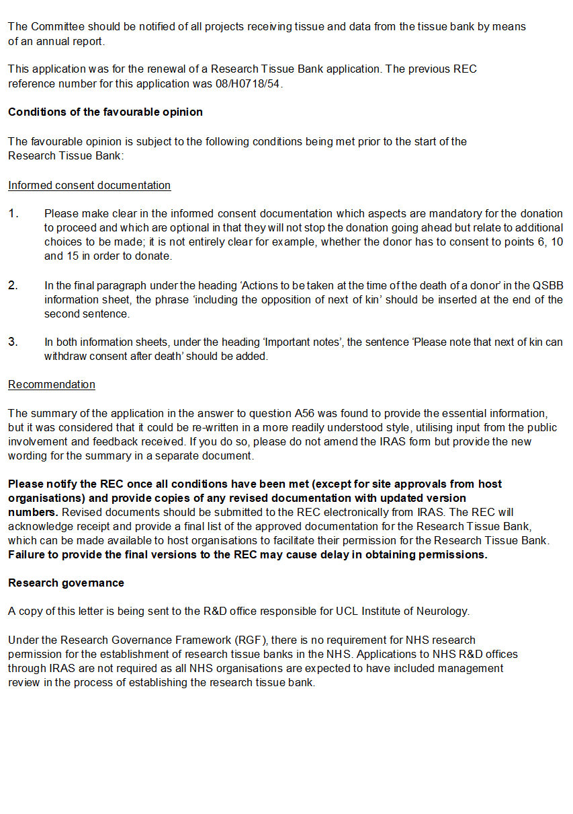

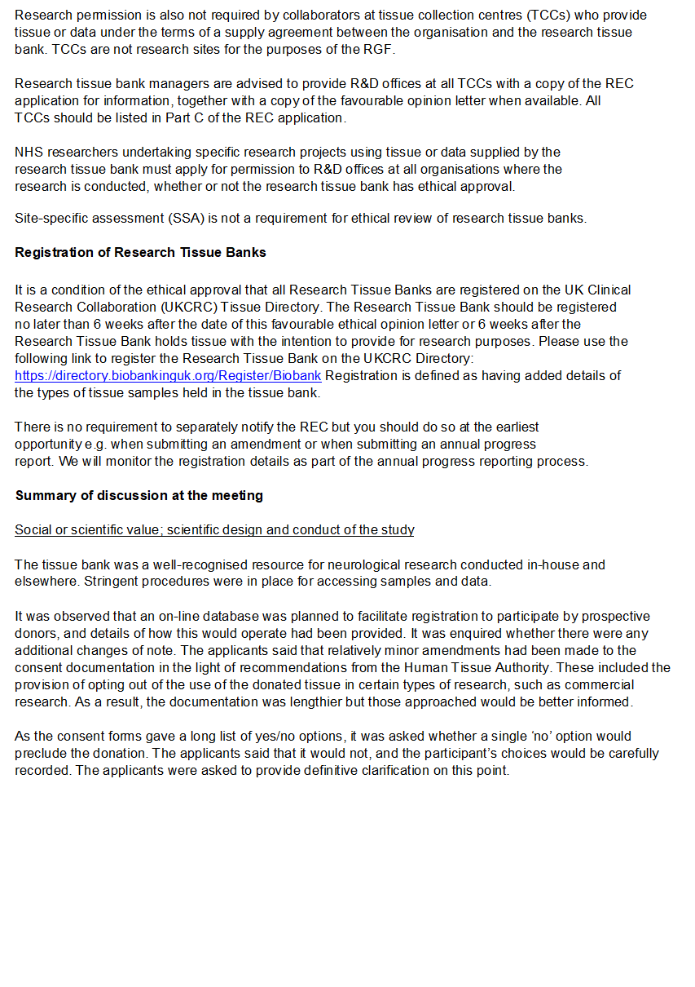

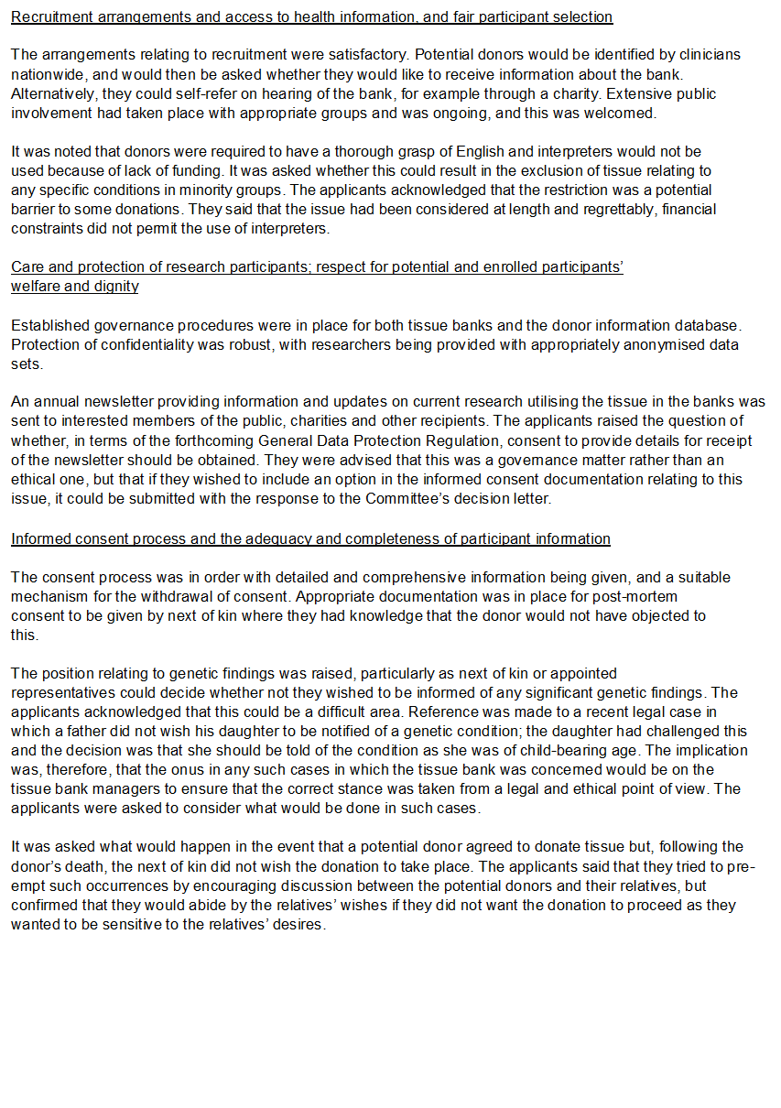

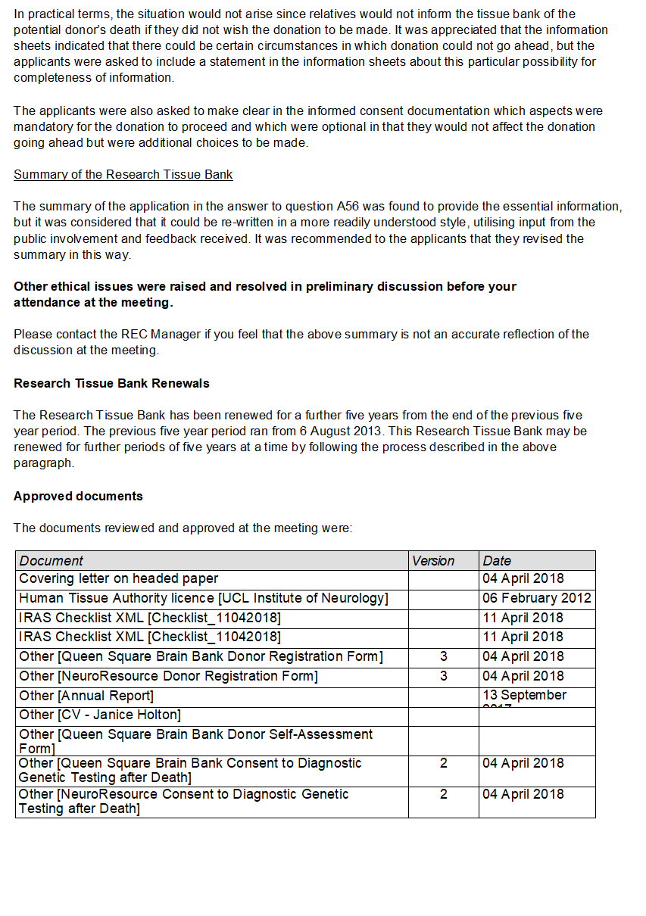

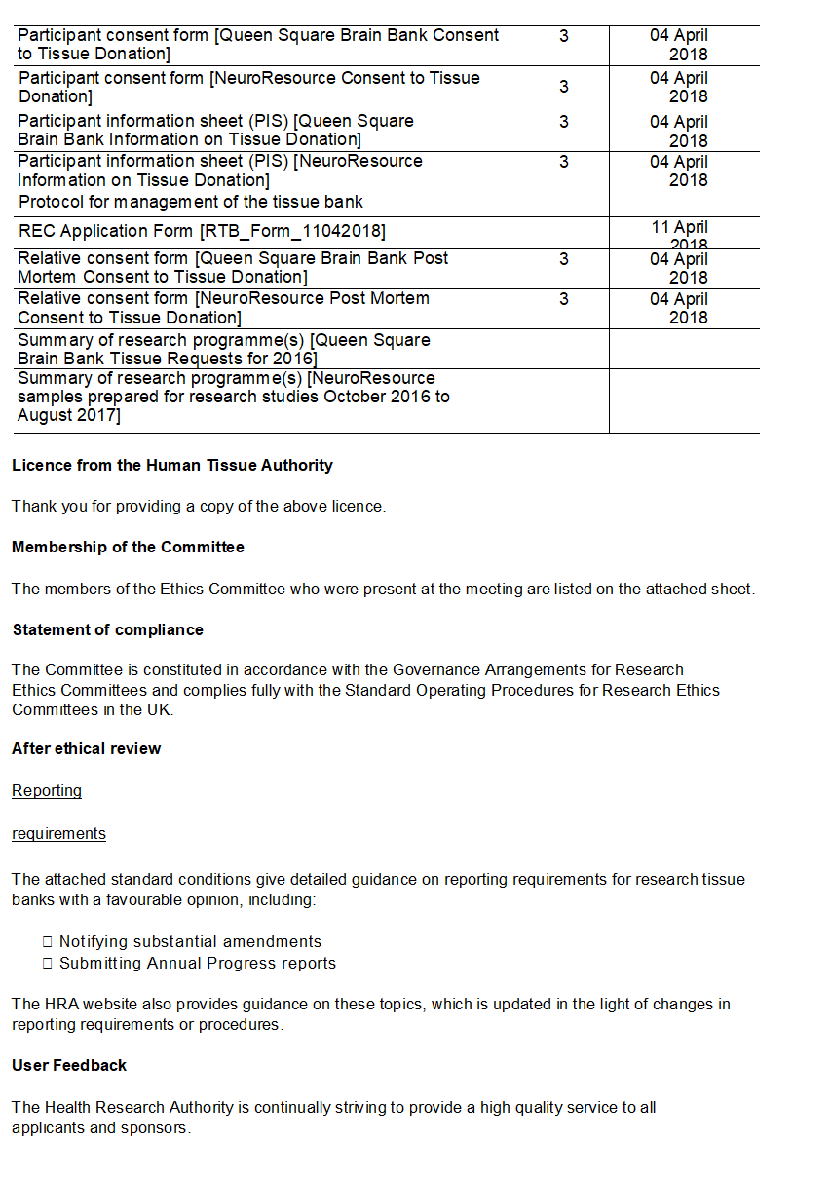
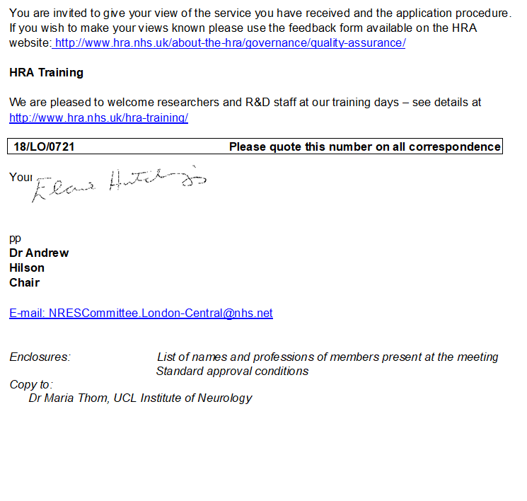
AMENDMENT TO THE PROVIDER’S NHS ETHICS COMMITTEE APPROVAL, MARCH 2019
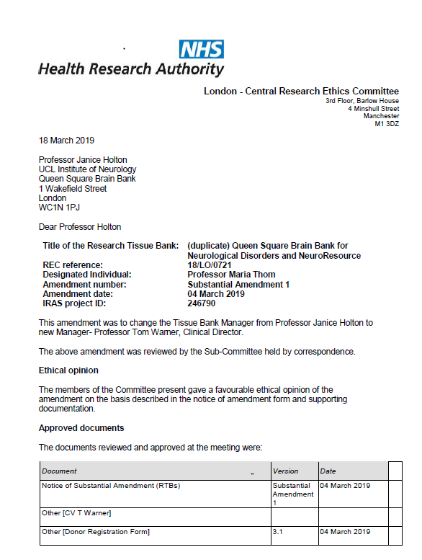
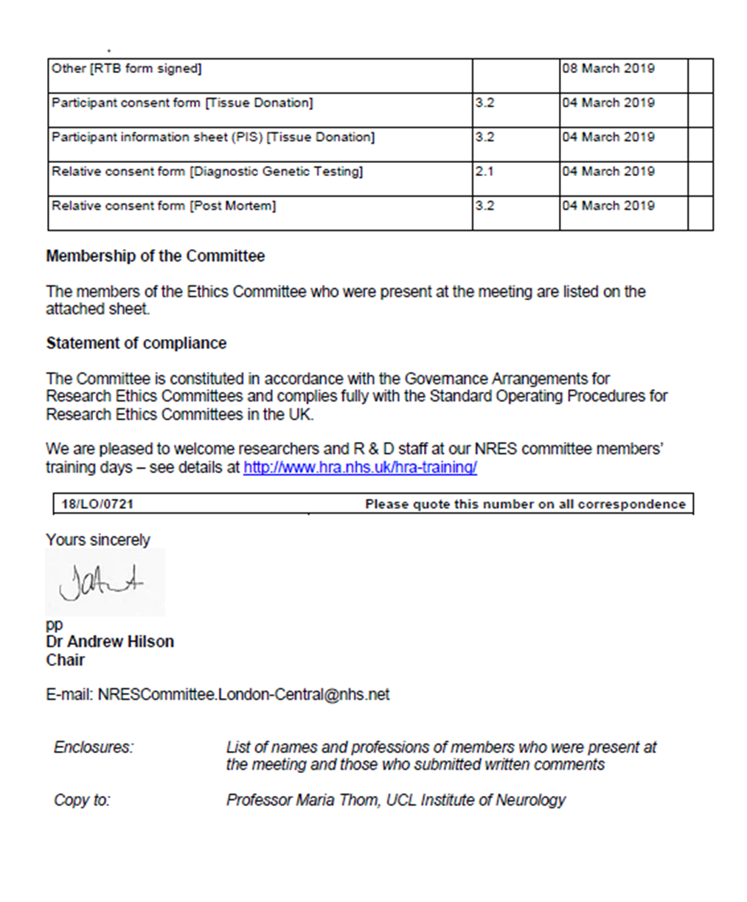

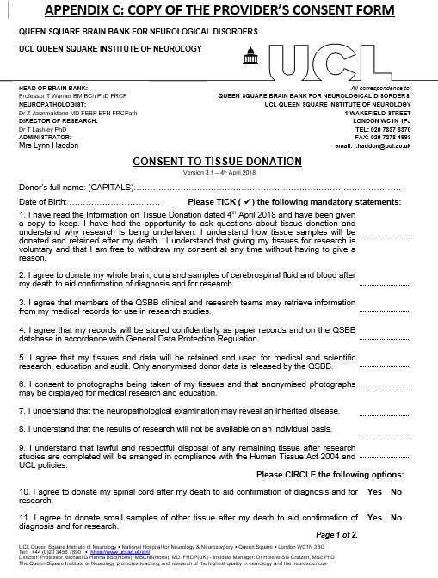

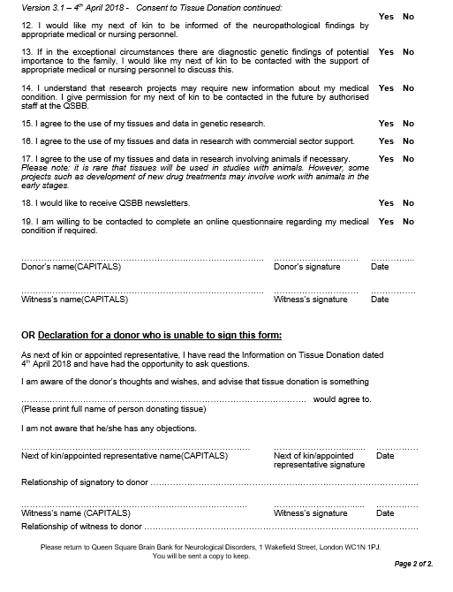

2021-01-26 v8A. APPENDIX D Page 1 of 1.
DISPATCH AND CONFIRMATION OF RECEIPT FORM FOR HUMAN
SAMPLES, HTA MTA UCL PI REF.: QSBB ........ 202-.
This form should be e-mailed to the recipient before samples are dispatched.
DISPATCH INFORMATION
Proposed date and time of dispatch:
RECIPIENT name and address for delivery:

e-mail address and phone number:
SAMPLES: Group Reference codes(s):
Format(s): Frozen and in dry ice □ In wet ice □ At room temperature □
In fixative: Type: Fragile contents, e.g. glass slides □
Other information, including potential biological hazards: None known □ or:
...........................................................................................................................................
SENDER name and address:

e-mail address and phone number:
Courier/collector name and phone number:
Courier tracking number: Airway bill number:
If to be tracked, this will be carried out by: Sender □Recipient □ Both □

If any problems arise during transit, all parties should be alerted and action taken as necessary.

CONFIRMATION OF RECEIPT OF SAMPLES
Date and time of arrival: …………………………….…...................................……………….…………………
All samples were unpacked and stored under appropriate conditions at:
-80ºC □ +4ºC □ Room temperature □ Other .......................................
In additional fixative: □ Fixative type: ........................................................................

Signed: ………………………...…………………………...................…….………………….…….......…….............

Name in capitals: ……………….…………….………..................….....………….……………...………………...…

Please would you scan and e-mail or fax this page to: Add: QUEEN SQUARE BRAIN BANK FOR NEUROLOGICAL DISORDERS INFORMATION
e-mail address:
Tel. No.: Fax No.:

APPENDIX E

If ethical approval is not provided by the Tissue Bank:

COPY OF THE RECIPIENT’S RELEVANT NHS RESEARCH ETHICS
COMMITTEE APPROVAL

UCL PI 2021-01-26 v8A.
FROM THE HTA MTA UCL PI REF.: QSBB ........ 202-.
APPENDIX F: PROGRESS REPORT ON SAMPLE USE
For completion by the MTA Principal Researcher. The Report will be held in confidence.
TITLE OF RESEARCH PROJECT:

MTA expiry date:
Ethical Approval expiry date:
Name of the Principal Researcher:
Date of the most recently received samples and/or Donor Information:

For our Tissue Request Audit, with reference to Clauses 14, 15 and the final page of Appendix A in this MTA:
Have the samples, Tissue Information and Donor Information from the (name of Tissue Bank) utilized for your research resulted in submitted or published publications, abstracts, presentations, PhD or MSc/BSc projects, with appropriate acknowledgements to the Tissue Bank? Please give details:

Is there a collaboration between you and the (name of Tissue Bank) for your research on samples and Donor Information under this MTA (Clause 15)?:

Will any further samples and/or Donor Information be required in the near future?:

If this is the Final Report:
With reference to the MTA Clause 16, do you have any unused samples which contain whole cells, or tissue sections on slides or in tubes?
If so, please arrange to return these samples to the (name of Tissue Bank) for disposal under Human Tissue Authority (HTA) regulations.

If any publication occurs after the Final Report, please e-mail details to the tissue bank.

Do you have any comments, please?:

Date:

Please e-mail this Report to: QUEEN SQUARE BRAIN BANK FOR NEUROLOGICAL DISORDERS INFORMATION

The Human Tissue Act 2004 applies to the use of “Relevant Materials” which include human cells (but not cell lines), tissue and organs from a living or deceased person for the removal, storage and use in “Scheduled Purposes” which include research on disorders or the function of the human body, and education relating to human health (from the HTA Code A – Guiding Principles and the Fundamental Principle of Consent, and also the Code E – Research Code of Practice). If a sample contains even a single cell from a human body it is classified as Relevant Material. The HTA have published a 'List of materials considered to be ‘relevant material’ under the Human Tissue Act 2004'.
Applicable laws and guidance means all laws, rules, regulations, research governance or ethical guidelines, or other requirements of any Regulatory Authority, that may apply to the use of the Material by the RECIPIENT from time to time, including (but not limited to) the Human Tissue Act 2004 or the Human Tissue (Scotland) Act 2006, and the current HTA Codes of Practice and Directions.

