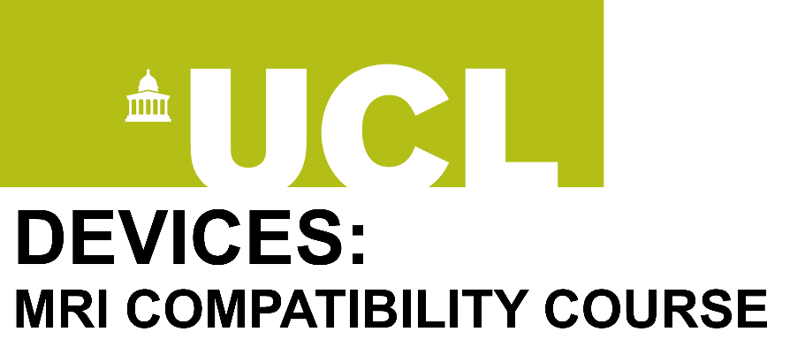 | 2020  Edition

A 3-Day Course on Devices and MRI Compatibility
3-5 June 2020, London, UK
The course aims to promote the concept of device future- and in particular health system-proofing based on MRI compatibility and disseminate knowledge on the safe use and development of devices for the MR environment.
The target audience includes: Device engineers, designers and inventors; MR specialists (radiologists, technologists, physicists and engineers); medical physicists and biomedical engineers; Safety officials and engineers; Researchers and practitioners.

Course Outline
Day 1
Theme: Can I Put this Person with this Thing inside the Scanner?
Overview of MRI
Introduction to devices and the MR compatibility problem
Current regulations; Applications and clinical management of devices in MRI
Clinical and research governance
Day 2
Theme: Physical Principles for Device Design and Applications
Theory of MR scanners
Hazards associated with the presence of devices in the MR environment
MR and device performance
Case studies
Day 3
Theme: Towards Getting a Device Approved: Standards and Regulations
Passive vs. Active devices in the MRI scanner
Evaluation of device-MR interactions
REGISTRATION

Course Director: Professor Louis Lemieux, UCL Queen Square Institute of Neurology and the National Hospital for Neurology and Neurosurgery.
The course is organised with the help of the Education Team at the UCL Queen Square Institute of Neurology. If you have any questions concerning your booking please contact us via email: d.blundred@ucl.ac.uk and devmrcomp@ucl.ac.uk

