Queen Square Brain Bank for Neurological disorders

UCL queen square Institute of Neurology

All correspondence to:

QUEEN SQUARE BRAIN BANK FOR NEUROLOGICAL DISORDERS
UCL QUEEN SQUARE INSTITUTE OF NEUROLOGY
1 WAKEFIELD STREET
LONDON WC1N 1PJ

Telephone: 020 7837 8370
Email: qsbbmtas@ucl.ac.uk

HEAD OF BRAIN BANK:
Professor T Warner BM BCh PhD FRCP

DIRECTOR OF RESEARCH:
Professor T Lashley PhD FRCPath

NEUROPATHOLOGISTS:
Associate Professor Z Jaunmuktane MD FEBP EFN FRCPath
Associate Professor K Frontzek MD PhD

ADMINISTRATORS:
Miss Cheryl Pearce and Miss Natalie Woodman

MTA EXPIRY DATE: DD-MM-202-.

EXPIRY DATE: DD-MM-202-. MRC PI 2023-03-07, v1A.

QUEEN SQUARE BRAIN BANK FOR NEUROLOGICAL DISORDERS:

IoN HTA MRC PI MTA REF.: QSBB ........ 202-.

SUPPLY AGREEMENT FOR PROVISION OF HUMAN TISSUE SAMPLES AND

TISSUE DONOR INFORMATION FOR RESEARCH PURPOSES ONLY (IoN HTA)

BETWEEN:

1. Name and address of the Recipient Institution:

(“RECIPIENT”)
AND

2. University College London, Gower Street, London WC1E 6BT.
("PROVIDER")

WHEREAS
A. This Material Transfer Agreement (MTA; “AGREEMENT”) contains the terms and conditions under which the PROVIDER, acting through the UCL Queen Square Institute of Neurology, 23 Queen Square, London WC1N 3BG, has agreed to provide the RECIPIENT with human samples which consist of or include whole cells, namely post-mortem tissue, surplus biopsy or surgical tissue, non-transplantable tissue, body fluids, primary cell cultures (whole explant/biopsy present) or microdissected cells, as requested in the Appendix A (the “RESEARCH PROJECT”) of this Agreement. The term “TISSUE” means human material (excluding gametes, embryos, or cells that have

divided in culture) which consists of or includes human cells and so is considered to be “Relevant Material” for the purposes of the Human Tissue Act 2004 and the Human Tissue Authority (HTA)¹.

B. The TISSUE is for use only in the specific RESEARCH PROJECT as described in Appendix A to be undertaken by [INSERT NAME] (the “PRINCIPAL RESEARCHER”) who is an employee of the RECIPIENT. If the PRINCIPAL RESEARCHER is replaced the RECIPIENT will provide the name and contact details of the replacement PRINCIPAL RESEARCHER to the PROVIDER.

C. The MTA Approval Committee or the equivalent approval system for the PROVIDER’S Tissue Bank must approve the scientific merits of the RESEARCH PROJECT described in Appendix A. In some Tissue Banks the MTA Approval Committee is also able to give ethical approval if the Tissue Bank has authorization from their NHS Research Ethics Committee (REC). If confirmation that the Tissue Bank can provide ethical approval is included in the Letter of Approval in Appendix B, the RECIPIENT may request ethical approval in Appendix A. The ethical approval granted by a MTA Approval Committee is only for the specific RESEARCH PROJECT described in Appendix A, and will not be valid when this Agreement expires or is terminated, and is for a RESEARCH PROJECT which is conducted in the U.K.. If the Tissue Bank is unable to grant ethical approval the RECIPIENT must obtain a NHS Health Research Authority (HRA) Research Ethics Committee approval letter for the RESEARCH PROJECT, and this letter must be attached at Appendix E.

D. The RECIPIENT should list the samples that are required in Appendix A under ‘SAMPLES REQUESTED BY THE RECIPIENT’. The TISSUE will be provided with basic data on the samples (“TISSUE INFORMATION”) which describes the individual samples, and may include information on the interval between death and/or sample removal, or sample removal from living donors; the preservation of samples for the studies; and pathological data. Information on tissue donors (“DONOR INFORMATION”) may be basic clinical information on age; gender; diagnosed disease and duration; and cause of death. The basic and any additional information must be requested in Appendix A under TISSUE AND DONOR INFORMATION REQUIRED. A Tissue Bank representative will determine the information that would be made available to the RECIPIENT. The PROVIDER will fully anonymise all information with study-specific coding. The RECIPIENT shall not attempt to identify any of the tissue donors.

E. The TISSUE INFORMATION and DONOR INFORMATION will be sent by e-mail to the RECIPIENT after the samples have been received. The RECIPIENT will hold the TISSUE, TISSUE INFORMATION and DONOR INFORMATION on the terms of this Agreement and solely for the purpose of the RESEARCH PROJECT as described in Appendix A within the Research Group of the PRINCIPAL RESEARCHER. Subsequent to this MTA being fully approved, if for the RESEARCH PROJECT there is a requirement for small amounts of additional TISSUE, or further TISSUE INFORMATION or DONOR INFORMATION, the PRINCIPAL RESEARCHER should contact the Tissue Bank to request a MTA AMENDMENT template document (Clause 18).

IT IS HEREBY AGREED AS FOLLOWS

1. The PROVIDER represents and warrants that the consent obtained for TISSUE donation, and the procurement and storage of TISSUE and the DONOR INFORMATION for research studies are in accordance with the Human Tissue Act 2004, the HTA Codes of Practice, the PROVIDER'S relevant NHS Research Ethics Committee approval(s), and other relevant laws and guidelines. The UCL Queen Square Institute of Neurology has been granted the HTA Licence Number 12198 in the Research Sector. A copy of the PROVIDER’S NHS Research Ethics Committee approval(s) which is relevant to the TISSUE and DONOR INFORMATION supplied is attached at Appendix B.

2. The TISSUE and DONOR INFORMATION supplied to the RECIPIENT have been obtained from living donors for whom written informed consent was given by the donor, next of kin or person with power of attorney for the donor's TISSUE and DONOR INFORMATION to be used for research purposes, and/or for whom written informed consent was given after the death of the donor by their next of kin or person with power of attorney. Sample copies of the current Tissue Bank, Laboratory or Hospital Consent Form(s) used by the PROVIDER are attached to this Agreement at Appendix C. Should an individual donor, or donor’s next of kin, rescind consent the PROVIDER will notify the RECIPIENT and the RECIPIENT will agree to discontinue use of the TISSUE and return any remaining TISSUE concerned to the PROVIDER in accordance with the PROVIDER’S instructions.

3. The PROVIDER warrants to the RECIPIENT that no payments were made or other inducements given to any donor or next of kin or other consenting person to procure the TISSUE or DONOR INFORMATION.

4. The RECIPIENT hereby agrees to comply and procure that the PRINCIPAL RESEARCHER and all their personnel who work with the TISSUE, TISSUE INFORMATION and DONOR INFORMATION comply with the terms and conditions in this Agreement. The RECIPIENT may pass the TISSUE, TISSUE INFORMATION and DONOR INFORMATION on to its employees solely for performance of this RESEARCH PROJECT, but may not transfer, receive payment for, or licence the TISSUE, TISSUE INFORMATION or DONOR INFORMATION to any third party. The exception to this is the permitted outsourcing, without prior written consent from the PROVIDER, of TISSUE samples to a third party only for the purposes of using methodology(ies) not available in the RECIPIENT’S Laboratory that are necessary for performance of this RESEARCH PROJECT. The RECIPIENT shall ensure that relevant terms and conditions of this Agreement are formally agreed between the RECIPIENT and the third party. Only necessary TISSUE INFORMATION but no DONOR INFORMATION should be given to such third parties. The RESEARCH PROJECT may include DNA and RNA analyses and gene expression studies in line with the donor consent and the Codes of Practice of the Human Tissue Authority. All TISSUE is for research purposes only and the RECIPIENT will not use the TISSUE for Human Application (i.e. patient treatment), as that term is defined in the Human Tissue (Quality and Safety for Human Application) Regulations 2007 or equivalent as may be replaced or amended from time to time, or for any other clinical or diagnostic purposes.

5. The RECIPIENT shall make no payment for the TISSUE samples, but the RECIPIENT will make appropriate payment to assist with the costs for TISSUE retrieval, assessment and storage, and reasonable administration costs for TISSUE INFORMATION, DONOR INFORMATION and arranging sample transport. These costs will be agreed between the PROVIDER and the RECIPIENT prior to any transfer of the TISSUE, TISSUE INFORMATION and DONOR INFORMATION. No payment will be made to the PROVIDER by the RECIPIENT in respect of any invention or discovery arising from the use of the TISSUE and DONOR INFORMATION. The RECIPIENT shall own the results of the research and resulting intellectual property rights arising from the RECIPIENT’S use of the TISSUE, TISSUE INFORMATION and DONOR INFORMATION.

6. Upon the RECIPIENT'S request, the PROVIDER shall provide the RECIPIENT with technical information necessary for the safe handling, storage and use of the TISSUE. The PROVIDER will retain for reference any tissue sections which have been stained by the PROVIDER to characterise TISSUE passed to the RECIPIENT.

7. The PROVIDER will arrange for and the RECIPIENT will cover the costs for all transport of the TISSUE. The RECIPIENT will supply the PROVIDER with, or pay the PROVIDER for, all slides, tubes, containers, packaging and labelling as required by the PROVIDER to provide the RECIPIENT with the TISSUE. To minimise the possibility of damage or loss, the required packaging must be robust and clearly labelled with the RECIPIENT'S name, address and contact details. Prior to sample transport to the RECIPIENT, the PROVIDER will e-mail the RECIPIENT the TISSUE BANK’S own Tissue Dispatch Form, or the "Dispatch and Confirmation of Receipt Form" attached to this Agreement at Appendix D. Also in advance of transportation the PROVIDER must give the courier company or the individual who would be transporting the samples detailed information on how the samples are to be handled and preserved during transport. This includes the careful handling of samples on glass slides, maintenance of the correct temperature, and on any known potential biological (e.g. infection), chemical (e.g. formalin) or other hazards (e.g. transportation in dry ice).

8. The courier must endeavour to prevent damage, loss or theft of the transported TISSUE. It must be ensured by the courier that the transport containers are held in place securely to prevent them moving during transport, and that the specified optimal temperature conditions are maintained throughout all stages of the delivery process. The vehicle transport compartment must be windowless and kept locked until delivery to the RECIPIENT. To acknowledge the safe receipt of TISSUE, the RECIPIENT must as soon as possible send by e-mail the completed TISSUE BANK’S own Tissue Dispatch Form or the "Dispatch and Confirmation of Receipt Form" (Appendix D) to the PROVIDER. The storage conditions for preservation of the tissue samples by the RECIPIENT and any associated hazards are specified on this Form. If TISSUE is transported by a courier company RECIPIENT must also send a copy of the courier company’s signed delivery Form to the PROVIDER. The risk and responsibility (i.e. custodianship) for the TISSUE shall pass to the RECIPIENT when the courier company’s delivery form has been signed at the RECIPIENT’S institution, or the RECIPIENT has collected the TISSUE from the PROVIDER.

9. On receiving custodianship of the TISSUE, TISSUE INFORMATION and DONOR INFORMATION, the RECIPIENT will then be responsible for their appropriate secure storage and use. The RECIPIENT may use the TISSUE, TISSUE INFORMATION and DONOR INFORMATION only for the RESEARCH PROJECT stated in Appendix A, and in accordance with the RECIPIENT’S NHS HRA Research Ethics Committee approval(s) attached at Appendix E if ethical approval is not granted by the Tissue Bank. To avoid the identification of DONORS, as little as possible of the anonymised basic or additional TISSUE INFORMATION and DONOR INFORMATION should be published in any format, which includes genomic, genetic or any other type of database that would be made available for either public or restricted access. The RECIPIENT agrees to obtain the written consent of a Tissue Bank representative if there is any change to the proposed use of the TISSUE or the basic and additional DONOR INFORMATION.

10. The RECIPIENT warrants that it is legally unable to purchase an insurance policy to provide legal liability due to the negligence of MRC. PROVIDER understands and accepts that the RECIPIENT shall meet any such liability through a program of self-insurance and shall indemnify the PROVIDER fully against all such liabilities, direct loss, damage, cost or expenses incurred by the PROVIDER as a result of any third party claims arising from the use, handling, storage or disposal of the TISSUE by the RECIPIENT or its collaborators except where such liability, direct loss, damage, cost or expenses are the result of the gross negligence of the PROVIDER. Neither party shall be liable to the other for any consequential loss, damage, claims or demands which may arise from the use that the RECIPIENT may make of TISSUE and DONOR INFORMATION, whether direct or indirect.

11. Both Parties shall keep confidential all details of this Agreement and any Amendment to this Agreement, but if requested by other Parties approved by the Recipient organization the following information only may be given: The name and address of the Recipient organization; name of Principal Investigator and academic Department; name and address of University College London; name of Tissue Bank; title of the Research Project as given in Appendix A; and the duration of the Agreement. This obligation of confidentiality shall survive termination of the Agreement for five years. The obligations of confidentiality shall not apply to any information (i) that the receiving party can show was known to the receiving party in advance of receipt from the disclosing party; (ii) is in the public domain or subsequently becomes publicly known through no fault, act or omission of the receiving party; (iii) is received by the receiving party without restriction from a third party lawfully entitled to make the disclosure to the receiving party without any such restriction; (iv) is developed by the receiving party independently and without the aid or benefit of the information obtained from the disclosing party; (v) the receiving party is required to disclose by law, government regulation or court order provided the receiving party notifies the disclosing party of such requirement in advance of disclosure.

12. Each Party shall ensure that its activity under this Agreement shall comply fully with applicable laws and guidance²,including but not limited to the current Codes of Practice of the Human Tissue Authority and all other relevant local and government laws, regulations and guidelines which are applicable during the period of this Agreement. These include Health and Safety, environmental laws, and the U.K. General Data Protection Regulation (U.K. GDPR) 2021 and the amended U.K. Data Protection Act 2018 with regard to data on TISSUE samples and the DONOR INFORMATION.

13. The RECIPIENT agrees to have in place formal Risk Assessments and Standard Operating Procedures for all research work involving the TISSUE and DONOR INFORMATION. The RECIPIENT acknowledges that as the samples may contain viruses, latent viral genomes or other infectious agents, the RECIPIENT must ensure that samples are stored, utilised for research, and also disposed of when rendered acellular as if not free from such possible contamination. The RECIPIENT warrants to assume full responsibility for training all personnel in procedures for the safe handling of human tissues. The PROVIDER warrants to have taken all reasonable precautions in supplying the TISSUE to the RECIPIENT and accepts no liability for any potential risks associated with the RECIPIENT'S use of the TISSUE. Except as expressly stated herein, the RECIPIENT acknowledges that the TISSUE is experimental in nature and the PROVIDER makes no representation and gives no warranty or undertaking of quality or fitness of the TISSUE, TISSUE INFORMATION or DONOR INFORMATION for any particular purpose or that their use will not infringe any patent, copyright, trade mark or other property right owned by any third party.

14. The PRINCIPAL RESEARCHER agrees to provide appropriate acknowledgement of the Tissue Bank as the source of the TISSUE, TISSUE INFORMATION and DONOR INFORMATION in all written publications, both in the Methods and Acknowledgements Sections, or in oral presentations reporting on the use of the TISSUE and/or DONOR INFORMATION. The PRINCIPAL RESEARCHER will provide a copy of written publications at least twenty (20) days in advance of submission for publication. The PROVIDER agrees not to share such advance copy with any third party until published.

15. At any time, the PRINCIPAL RESEARCHER and PROVIDER may confirm in writing to collaborate on this RESEARCH PROJECT. Collaboration in the performance of this RESEARCH PROJECT may be of mutual benefit, further research objectives and foster the development of scientific knowledge. If this has been agreed the Tissue Bank representative(s) will be included in any publication as co-author(s), unless requested otherwise by Tissue Bank representative(s). The obligations in Clauses 14 and 15 shall survive termination of this Agreement indefinitely.

16. The RECIPIENT must send the PROVIDER the completed REPORT FORM (Appendix F) for the RESEARCH PROJECT described in Appendix A BEFORE THE DATE OF THE MTA EXPIRATION, or the date of termination when the RESEARCH PROJECT is completed, or any remaining TISSUE is no longer required, or the RECIPIENT’S Ethics Committee approval(s) attached at Appendix E expire, whichever is the sooner. The PROVIDER will send a copy of this Form to the RECIPIENT at about two months before the date of the MTA expiration or on request if terminated. The completed Form will be held in confidence by the PROVIDER.

17. ALL UNUSED TISSUE MUST BE RETURNED WITHIN ONE MONTH OF THE DATE OF THE MTA EXPIRATION OR TERMINATION DATE. Samples which have been homogenised or rendered acellular by other means should be disposed of by the RECIPIENT under the regulations of their establishment. However samples containing whole cells, or tissue sections on slides or in tubes, must be returned to the PROVIDER for disposal in a lawful and respectful manner in compliance with the Human Tissue Act 2004, HTA Codes and UCL Policies (Appendix F). The RECIPIENT must document in detail and return all unused TISSUE to the PROVIDER in appropriately labelled containers and packaging unless a new Agreement is approved by the PROVIDER, and/or new Research Ethics Committee approval is obtained. A copy of any non-generic new approval by the RECIPIENT’S Research Ethics Committee must be sent to the PROVIDER within thirty (30) days of notification of such approval.

18. This Agreement shall take effect from [insert date, 202x], and shall be for a maximum period of [insert number] (digit) years, expiring on [insert date, 202x]. Within the duration of this MTA, if the RECIPIENT wishes to request small amounts of additional TISSUE with TISSUE INFORMATION and basic DONOR INFORMATION; or additional DONOR INFORMATION; or to make minor changes to the methodologies included in Appendix A, the PRINCIPAL RESEARCHER should utilise a UCL Queen Square Institute of Neurology MTA AMENDMENT template document. This MTA would be modified only to the extent expressly stated in the AMENDMENT(S). All other provisions specified in the MTA would remain unchanged and in full force and effect including the expiry of the MTA and any AMENDMENT(S) on the date stated in the MTA. In the event of breach of this MTA, or any Amendment to this, by the RECIPIENT and following failure to remedy such breach within 30 days, the PROVIDER may terminate the MTA on 30 days written notice being given to the RECIPIENT.

19. Neither party shall be entitled to assign its obligations under this Agreement save with the prior written consent of the other.

20. Nothing in this Agreement shall create or be deemed to create a partnership between the parties.

21. Each party acknowledges that in entering into this Agreement it does not do so on the basis of or rely on any representation warranty or condition except as expressly provided in this Agreement, and accordingly all conditions, warrants or other items implied by statute or common law are hereby excluded to the fullest extent permitted by law.

22. If any provision of this Agreement is held by any Court or other competent authority to be void or unenforceable in whole or in part, the other provisions of this Agreement and the remainder of the unaffected provision shall continue to be valid.

23. Official notices shall be in writing and may be given by hand or sent by first class post, as a PDF e-mail attachment, or facsimile addressed to the signatories of this Agreement. If delivered by hand, service shall be deemed to have been given upon delivery. If sent by post, service shall be deemed to have been given 48 hours after posting, and if sent electronically as a PDF attachment or facsimile shall be deemed to have been given on the date of transmission provided that a successful transmission report is held by the sender and a copy of the PDF attachment or facsimile and the transmission report is sent by post to the RECIPIENT. Informal comments and concerns may be made in writing by either party by post, e-mail or facsimile to the relevant Tissue Bank or Laboratory Manager, contact details for whom are given in Appendix A.

24. This Agreement shall be governed by the laws of England and Wales and the parties submit to the exclusive jurisdiction of the Courts in London, England.

IN WITNESS WHEREOF this Agreement, IoN HTA MRC PI MTA REF.: QSBB ........ 202- has been signed by the duly authorised representatives of the RECIPIENT and the PROVIDER.

For and on behalf of the RECIPIENT

Title of the Recipient’s Legal Representative:

Signature:

Name in capitals:
Date:

Title: Principal Researcher:

Signature:

Name in capitals:
Date:

For and on behalf of the PROVIDER

Confirmation by the HTA Person Designated (PD) for the Queen Square Brain Bank for Neurological Disorders at the 1, Wakefield Street Satellite Site under the UCL Institute of Neurology HTA Licence Number 12198 (Research Sector) that the RESEARCH PROJECT detailed in Appendix A has been approved by this tissue bank's MTA Approval Committee. The Committee has also granted the ethical approval for the study: OR The RECIPIENT has NHS HRA Research Ethics Committee approval: OR The RECIPIENT has provided an approval letter in English from a recognised Ethics Committee:

Signature:

Name in capitals: MISS NATALIE WOODMAN
Date:

Title: HTA Designated Individual for the UCL Queen Square Institute of Neurology HTA Licence Number 12198.

Signature:

Name in capitals: PROFESSOR MARIA THOM
Date:

Title: Authorised UCL Signatory:

Signature:

Name in capitals:
Date:

MRC PI 2023-03-07, v1A. IoN HTA MRC PI MTA REF.: QSBB ........ 202-
APPENDIX A: THE RESEARCH PROJECT
TO BE COMPLETED BY THE PRINCIPAL RESEARCHER FOR THIS PROJECT.
TITLE OF RESEARCH PROJECT:

PLEASE OUTLINE OF YOUR PROJECT IN LAY TERMS:

PROJECT SCIENTIFIC BACKGROUND:

AIMS OF THE RESEARCH PROJECT:

INVESTIGATION PLAN:

SAMPLES REQUESTED BY THE RECIPIENT:

Neurological disease(s) and number of cases from which samples are required:

Number of normal control cases from which samples are required:

Sample Preservation: Flash frozen, snap frozen, slow frozen, formalin-fixed and paraffin-embedded, formalin-fixed, other fixative, unpreserved or other format:

Sample Type: Tissue blocks, slices, finely dissected samples, sections on slides, sections in tubes, cells, primary cultures, body fluids or other sample type:

Required sample size, weight, thickness or volume:

CNS area(s) and numbers of each type of sample from these CNS areas:

TISSUE AND DONOR INFORMATION REQUIRED:

Please see Clause D.

Specify the basic TISSUE INFORMATION (including pathology) and any additional information required:

Specify the basic clinical DONOR INFORMATION and any additional information required:

Appendix A Continued:
PRINCIPAL RESEARCHER FOR RESEARCH PROJECT (Title; full name):

Position:

Laboratory address for TISSUE delivery:

e-mail address: Tel. No(s).:

Name of research funding bodies for the proposed RESEARCH PROJECT:

- In signing this Agreement the PRINCIPAL RESEARCHER confirms that they will send the PROVIDER their completed RECIPIENT’S END OF RESEARCH PROJECT REPORT FORM (Appendix F) on this RESEARCH PROJECT, and return any unused tissues or sections (Clauses 16 and 17).

- I agree to acknowledge the Tissue Bank as the TISSUE and/or DONOR INFORMATION source in all publications, and to provide a copy of all written publications at least twenty (20) days in advance of submission for publication. In addition, if this is a collaborative project the PROVIDER’S representative(s) will be included as co-author(s) (Clauses 14 and 15). These obligations shall survive termination of this MTA indefinitely.
PRINCIPAL RESEARCHER’S signature:

Name in capitals:

Date:

PLEASE STATE YES OR NO:
Ethical approval for the specific RESEARCH PROJECT described in Appendix A is requested from the PROVIDER'S Tissue Bank MTA Approval Committee: YES / NO
A copy of the RECIPIENT’S current NHS HRA Research Ethics Committee approval letter for this RESEARCH PROJECT is attached to this Agreement at Appendix E: YES / NO

If required this RESEARCH PROJECT has also been approved by the RECIPIENT’S Research and Development (R & D) Department or equivalent organization.
QUEEN SQUARE BRAIN BANK FOR NEUROLOGICAL DISORDERS, UCL QUEEN SQUARE INSTITUTE OF NEUROLOGY, 1 WAKEFIELD STREET, LONDON WC1N 1PJ.
e-mail address: qsbbmtas@ucl.ac.uk Tel. No.: 020 7837 8370

APPENDIX B
1: COPY OF THE NHS HRA RESEARCH ETHICS COMMITTEE APPROVAL FOR THE PROVIDER’S RESEARCH TISSUE BANK: FEBRUARY 2023

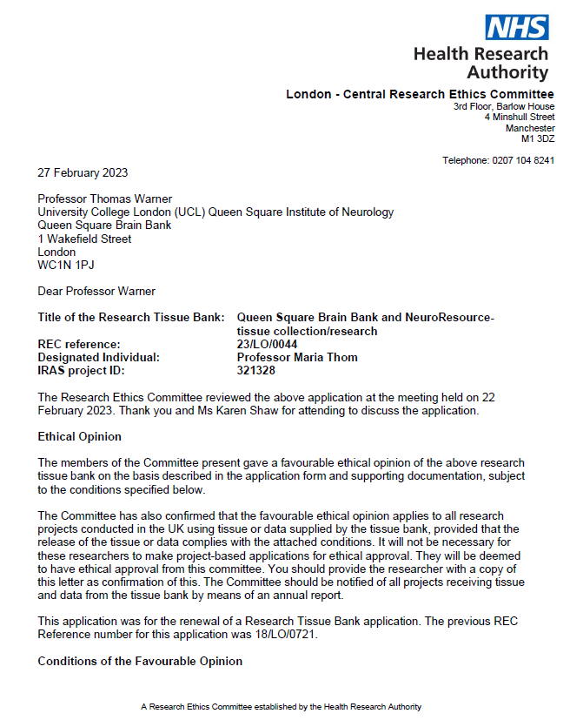
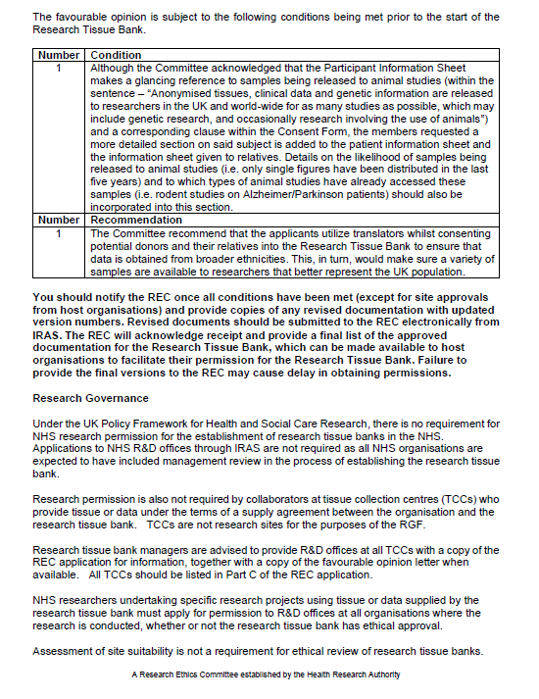
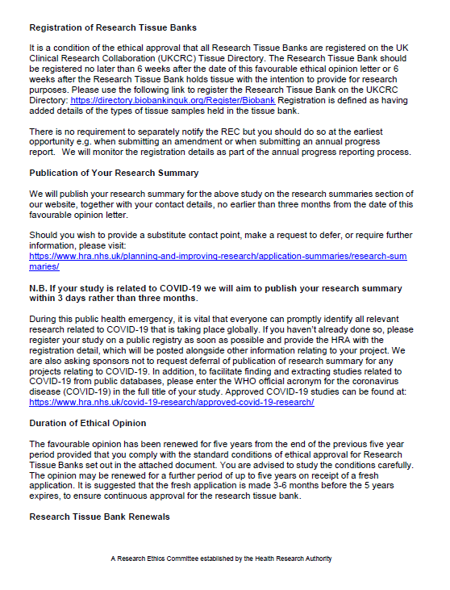
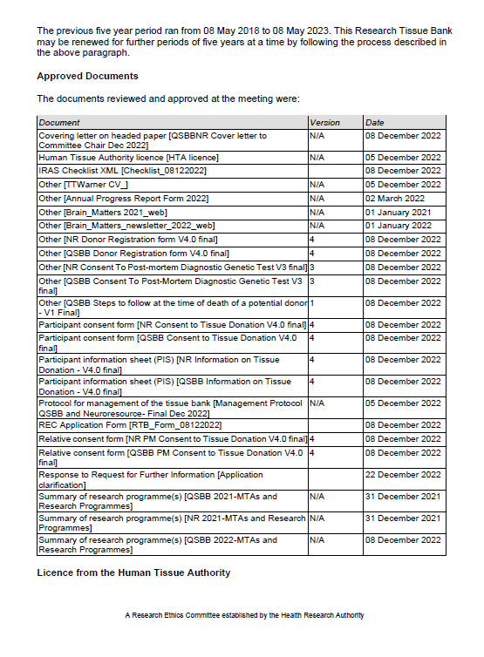
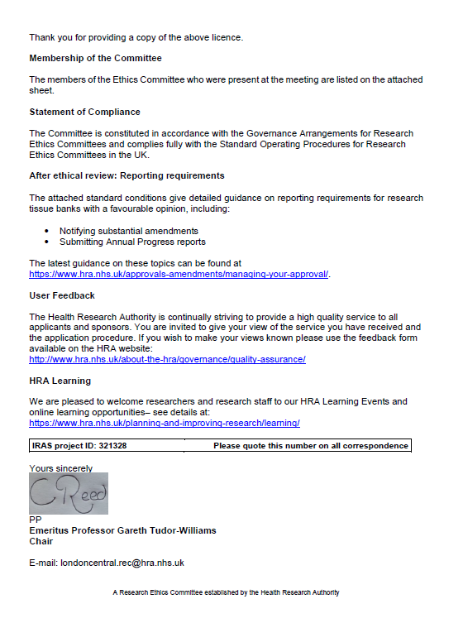
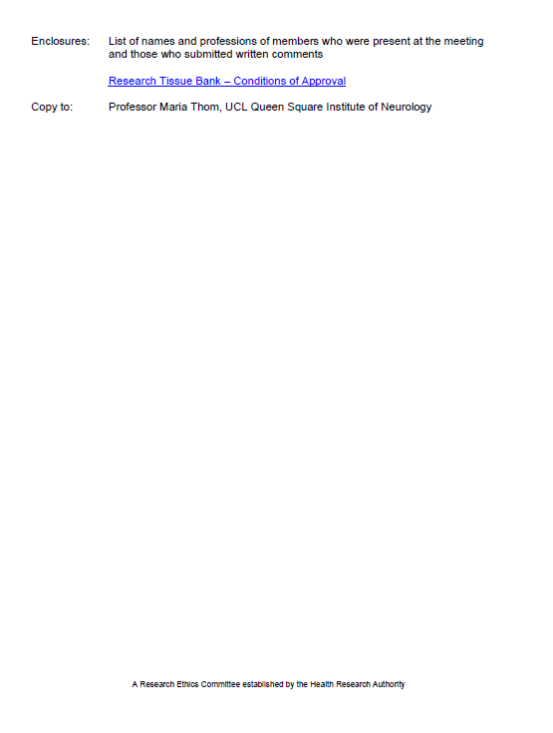
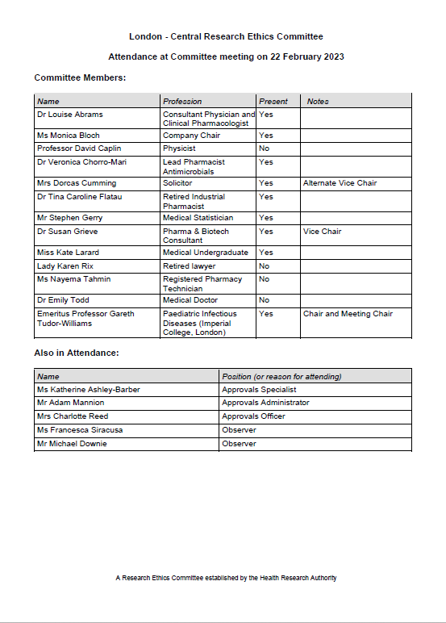
2: COPY OF THE NHS HRA RESEARCH ETHICS COMMITTEE APPROVAL FOR THE PROVIDER’S RESEARCH TISSUE BANK: MARCH 2023

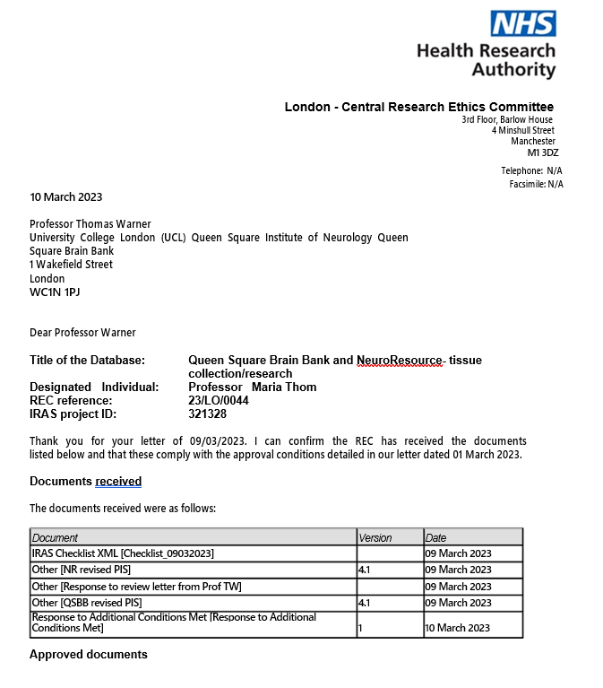

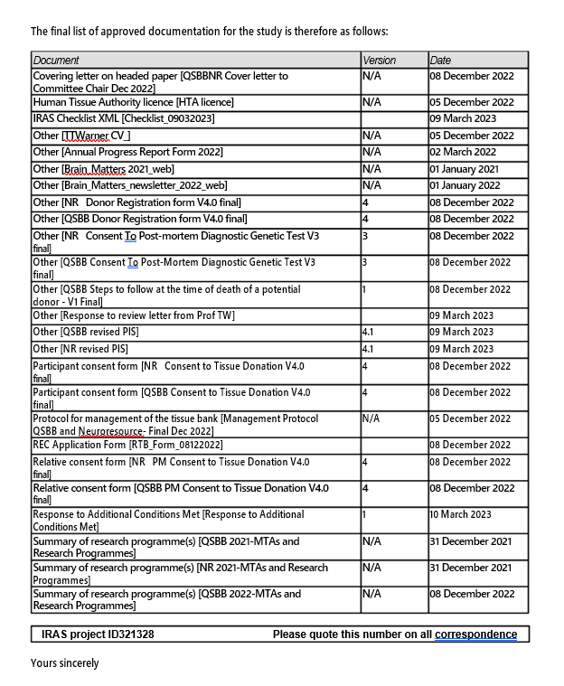

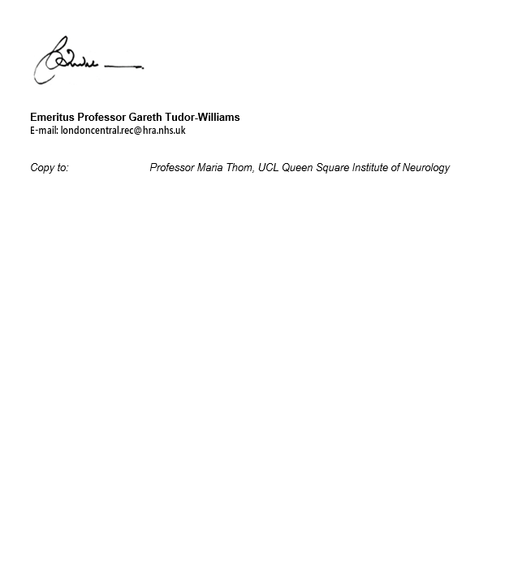

APPENDIX C: COPY OF THE PROVIDER’S CONSENT FORM
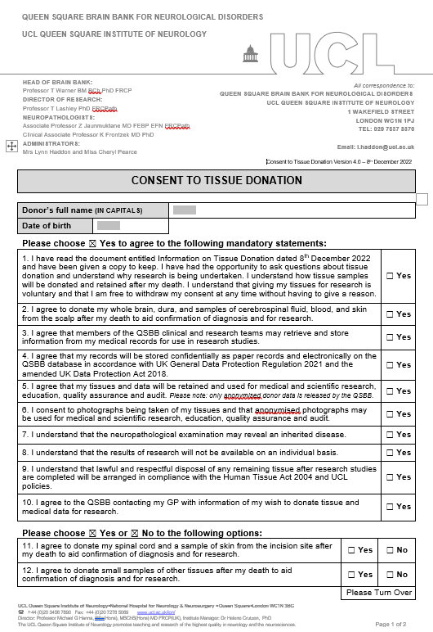
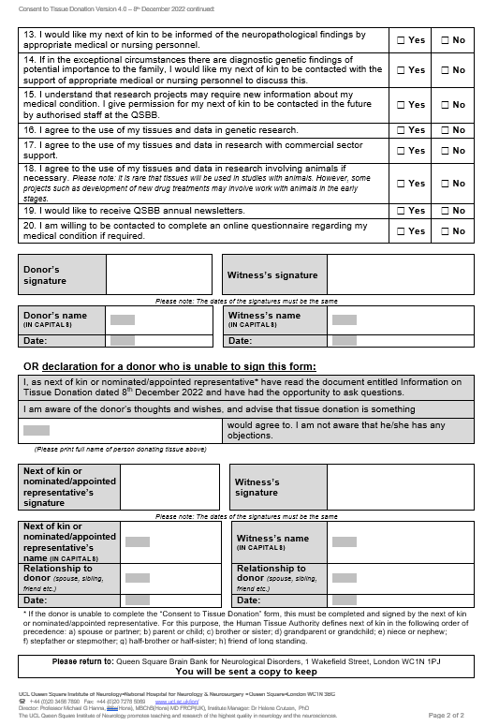

MRC PI 2023-03-07, v1A. APPENDIX D Page 1 of 1.
DISPATCH AND CONFIRMATION OF RECEIPT FORM FOR HUMAN
SAMPLES, IoN HTA MRC MTA PI REF.: QSBB ........ 202-.

This form should be e-mailed to the recipient before samples are dispatched.

DISPATCH INFORMATION
Proposed date and time of dispatch:
RECIPIENT name and address for delivery:

e-mail address and phone number:
SAMPLES: Group Reference codes(s):
Format(s): Frozen and in dry ice □ In wet ice □ At room temperature □
In fixative: Type: Fragile contents, e.g. glass slides □
Any additional information, including potential biological hazards: None known □
OR: .......................................................................................................................................
SENDER name and address:

e-mail address: Tel. No.:
Courier/collector name and phone number:
Courier tracking number: Airway bill number:
If to be tracked, this will be carried out by: Sender □ Recipient □ Both □

If any problems arise during transit, all parties should be alerted and action taken as necessary.

CONFIRMATION OF RECEIPT OF SAMPLES
Date and time of arrival: …………………………….…...................................……………….…………………
All samples were unpacked and stored under appropriate conditions at:
-80ºC □ +4ºC □ Room temperature □ Other .......................................
In additional fixative: □ Fixative type: ........................................................................

Signed: ………………………...…………………………...................…….………………….…….......…….............

Name in capitals: ……………….…………….………..................….....………….……………...………………...…

Please would you scan and e-mail this page to: QUEEN SQUARE BRAIN BANK FOR NEUROLOGICAL DISORDERS
e-mail address: qsbbmtas@ucl.ac.uk Tel. No.: 020 7837 8370

APPENDIX E

If ethical approval is not provided by the Tissue Bank:

COPY OF THE RECIPIENT’S RELEVANT NHS HRA RESEARCH ETHICS

COMMITTEE APPROVAL LETTER

MRC PI 2023-03-07, v1A. First page.
APPENDIX F:

RECIPIENT’S END OF RESEARCH PROJECT REPORT FORM
At about two months before the MTA will expire, this Form will be sent to the MTA Principal Researcher. Please return the completed Report to the (name of Tissue Bank) before the MTA expiration date, or when terminated. The Report will be held in confidence.
_____________________________________________________________________________
MTA DETAILS

IoN HTA MRC PI MTA REF.: .................. , UCL Queen Square Institute of Neurology.
If applicable, Amendment REF(s).:
MTA Expiry or Termination Date:
Ethical Approval Source and Expiry Date:
Name and Address of the Principal Researcher:
Telephone and e-mail address:

Title of Research Project in Appendix A:

SAMPLES THAT HAVE NOT BEEN UTILISED

With reference to the MTA Clause 17, do you have any unused samples which contain whole cells, or tissue sections on slides or in tubes?:

If so, WITHIN ONE MONTH AFTER THE EXPIRY OR TERMINATION DATE please send information on these samples to Tissue Bank Staff and arrange with them to return the samples to the Tissue Bank for disposal under Human Tissue Authority (HTA) regulations.

ADDITIONAL SAMPLES AND/OR DONOR INFORMATION

Will any further samples and/or Donor Information be required from the TISSUE BANK in the near future?:

PUBLICATIONS

These two obligations shall survive the termination of this MTA indefinitely:

With reference to Clauses 14, 15 and the final page of Appendix A in this MTA, have the samples, Tissue Information and/or Donor Information from the Tissue Bank that have been utilized for your research resulted in submitted or published publications, abstracts, presentations, PhD or MSc/BSc projects, with appropriate acknowledgements to the Tissue Bank? Please give full research output information:

For current and future manuscripts, I agree to acknowledge the Tissue Bank as the source of the TISSUE, TISSUE INFORMATION, and/or DONOR INFORMATION in all publications. The

PRINCIPAL RESEARCHER will provide a copy of written publications at least twenty (20) days in
advance of submission for publication.
For studies which are collaborative, in addition the Tissue Bank collaborator(s) will be included in all publications as co-author(s).

Do you have any comments, please?:

Signature: Date:

Please e-mail this Report to: QUEEN SQUARE BRAIN BANK FOR NEUROLOGICAL DISORDERS e-mail address: qsbbmtas@ucl.ac.uk

The Human Tissue Act 2004 applies to the use of “Relevant Materials” which include human cells (but not cell lines), tissue and organs from a living or deceased person for the removal, storage and use in “Scheduled Purposes” which include research on disorders or the function of the human body, and education relating to human health. If a sample contains even a single cell from a human body it is classified as Relevant Material (from the HTA Website on the Codes of Practice web page in the ‘Code A – Guiding Principles and the Fundamental Principle of Consent’, and also in Code E – Research).
2 Applicable laws and guidance means all laws, rules, regulations, research governance or ethical guidelines, or other requirements of any Regulatory Authority, that may apply to the use of the Material by the RECIPIENT from time to time, including (but not limited to) the Human Tissue Act 2004 or the Human Tissue (Scotland) Act 2006, and the current HTA Codes of Practice and Directions.

